You can modify this report template, and upload your results in PDF format. Reports in other forms/formats will result in ZERO point. Reports written in either Chinese or English are both acceptable. The length of your report should NOT exceed 6 pages (**excluding bonus**).

Name: 林棋祥 Dep.:電機四 Student ID:B04505004

1. 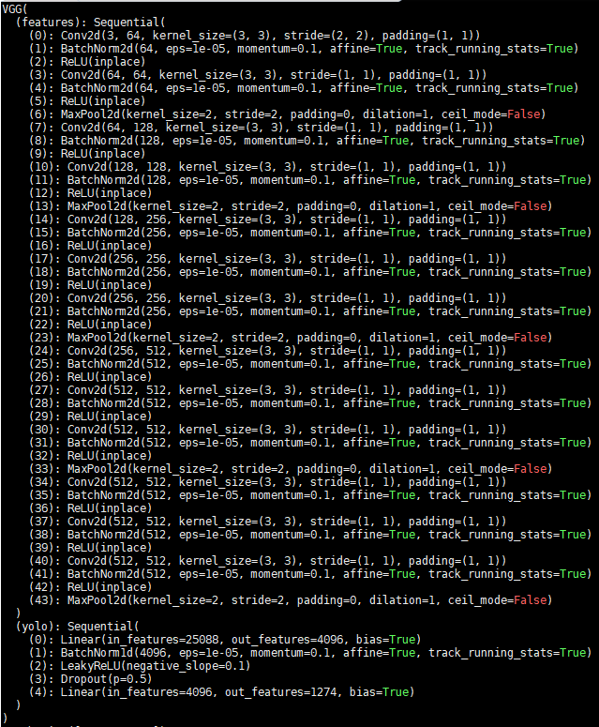( 5%) Print the network architecture of your YoloV1-vgg16bn model and describe your training config. (optimizer,batch size….and so on)

Optimizer: SGD, momentum=0.9, weight_decay=0.00005

Epoch: 100

Batch_size: 25

Learing rate:0.001, decay to 0.0001 at epoch 60

1. 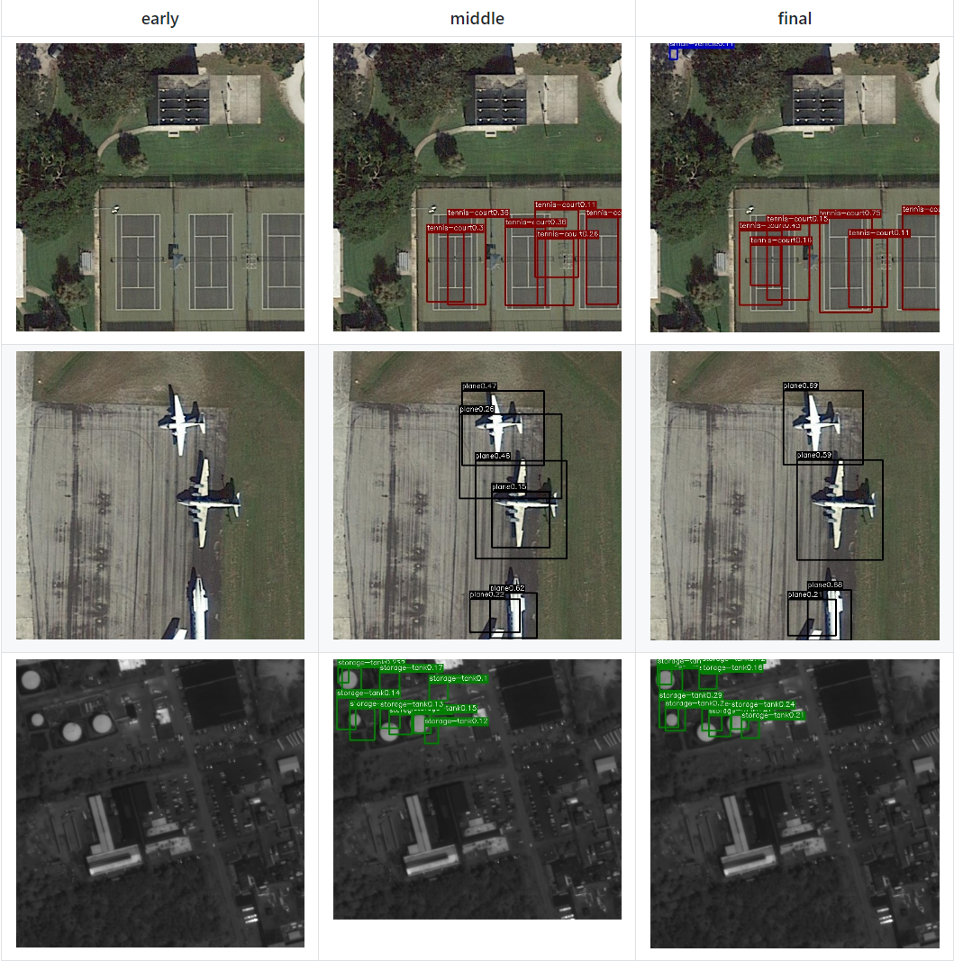(10%) Show the predicted bbox image of “val1500/0076.jpg”, “val1500/0086.jpg”, “val1500/0907.jpg” during the early, middle, and the final stage during the training stage. (For example, results of 1st, 10th, 20th epoch)
2. (10%) Implement an improved model which performs better than your baseline model. Print the network architecture of this model and describe it.

Improved model 跟 baseline的backbone一樣，但是改掉了loss function。由於觀察到class imbalance，發現某些類別的樣本數較少，mAP較低，所以把loss function改成class weighted loss，其中的weight與**該class在整個dataset裡的樣本數**成**反比**。

然而如果單純這麼做，會使training不穩定，所以更進一步的，將weight改成與**該class在每個batch裡的樣本數**成**反比**，也就是，在每個batch根據sample到各個class的樣本數，重新計算每個class weight，稱其為batch-wise weighted loss。

1. 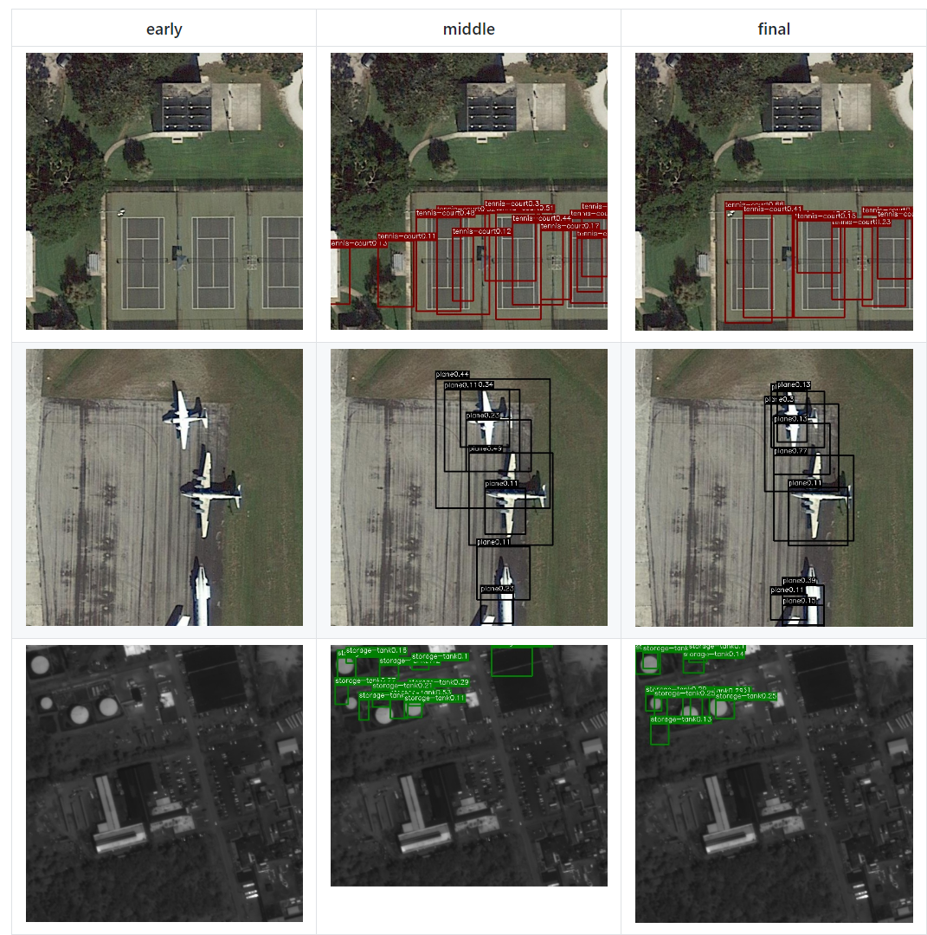(10%) Show the predicted bbox image of “val1500/0076.jpg”, “val1500/0086.jpg”, “val1500/0907.jpg” during the early, middle, and the final stage during the training process of this improved model.
2. (15%) Report mAP score of both models on the validation set. Discuss the reason why the improved model performs better than the baseline one. You may conduct some experiments and show some evidences to support your reasoning.

Baseline model: **10.5%**

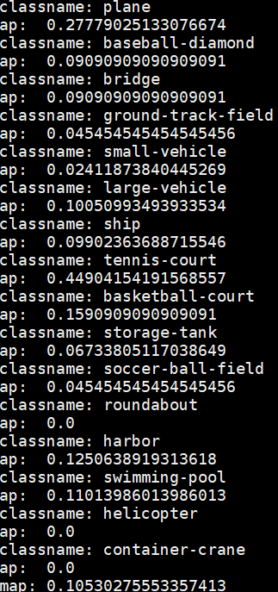

Improved model: **13.8%**

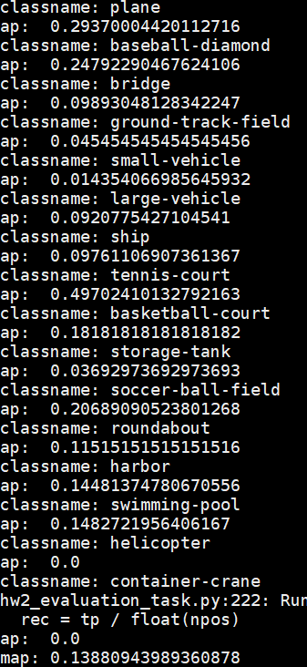

可以觀察到樣本數較少的baseball-diamond、roundabout跟soccer-ball-field都有顯著的進步，證實batch-wise class weighted loss對class imbalance 有幫助。

1. **bonus (5%)** Which classes prediction perform worse than others? Why? You should describe and analyze it.



上圖為每個class的樣本數(from plane to container-crane)，可以發現baseline model在樣本數較少的class(baseball-diamond、roundabout、soccer-ball-field、helicopter and container-crane)表現特別差，明顯為class imbalance。