**LCD “adm1602k”**

Here I am going to write the pins of this LCD, functions to use in Arduino, and explaining the codes to interface the LCD.

* **LCD pins**

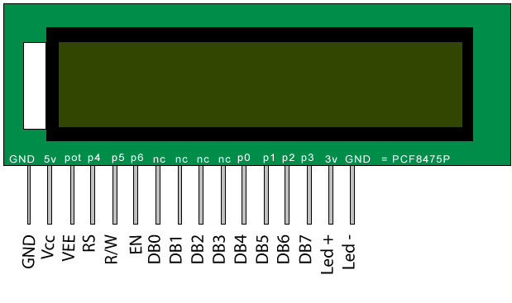

Figure 1: LCD pins

As you can see this LCD has 16 pins. They are as follows:

GND:

Ground

VCC:

5V

VEE:

Is the contrast adjuster, this is where we can control the brightness of the screen. In order to make it work you need to a 10k potentiometer. Connect one of the side legs to 5V, the other leg to a ground, and connect the pin 3 VEE to the middle leg. Why are we doing this? Well the VEE can vary between 0V and 5V that is proving by the VCC, and the ground, so the variable resistor in can control how much current allow the VEE to get.

RS:

Is the register select signal. This pin lets you choose between sending commands and sending characters to the screen. Sending command means for example if you already has something on the screen, and you want to clear it, that way you send a command to clear it. Sending characters means sending numbers, letters, and symbols.

R/W:

Is the read/write select signal. This is the one controls if you want to only write on the LCD, or you want to read some data from the LCD.

EN:

Is the enable signal. This is the like the switch of the LCD.

D0-D7

Are the pin to which we can control what we want to display on the LCD. We can only use four pins instead of 8 pins. Pins from D4-D7 can be used like we were using all 8 pins. The only disadvantage might be slower than using the 8 pins. However, it’s not obvious to us, and we want to save up 4 pins.

Pin 15 back light

Here put 3V

Pin 16

Ground.

* **LCD on Arduino**

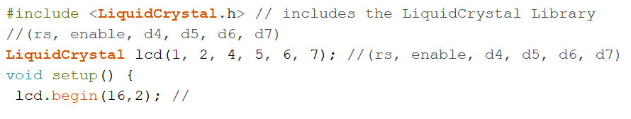

The first line is including the LCD library. Second line is the LCD pins that has been used in the Arduino or in our case in the microcontroller ATmega328. The third line, is the lcd.begin (16, 2), which indicate the dimension of the LCD.

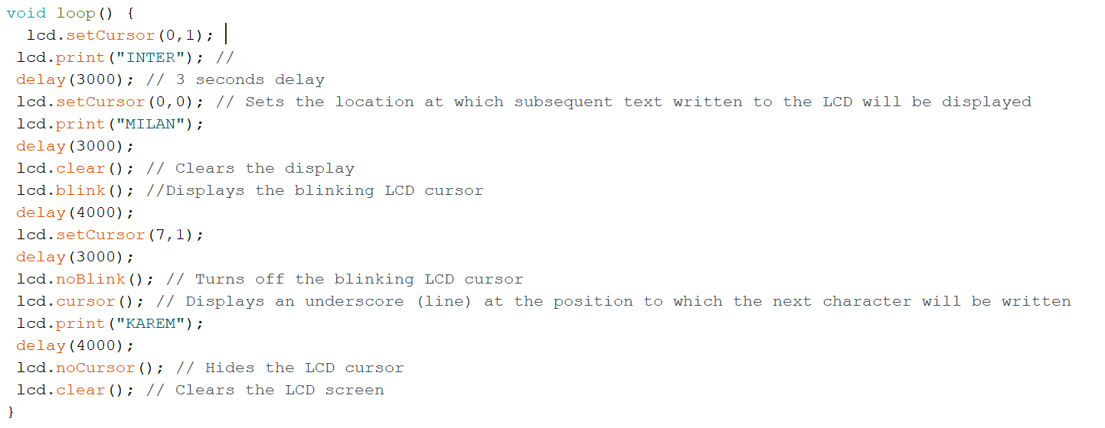

Cursor-set is where you want to write on the screen. 0 means the first line, 1 means the second line. The other number next to it is what square you want your writing to show. Example: (1, 5) means the second line, and the five spaces to the right.

Blink: is where no character is appearing, just blinking on and off.

Clear: the clear function clears the screen.

No cursor: is the character under line “_”.