**DBS Interview**

**Changes Made by Divik**

**Changes Made by Rahul Sirwani**

**Changes made by deepak**

Q. Explain about static Keyword in java ?

Q. What advantage Overloading and Overriding adds?

Q. What advantage Dynamic Polymorphism adds.

Q. Write a code to create Immutable class?

Q. Explain about Exception Handling?(All)

Q. Write a code to sort Employee Object based on Id.

Q. What Advantage Collections adds?

Q. Explain how ConcurrentHashMap works Internally ?

Q. Scenario based questions on Collection.

Q. What is Serialization?

Q. All about MultiThreading ?

Q. In what scenario you go for Threading?

Q. Difference between Abstract class and Interface?

Q. Advantages of Abstract class and Interface?

Q. What Abstract class can do and Interface can’t do or

What Interface can do and abstract class can’t do ?

Spring

Q. What all Components of Spring Have you worked?

Q. Explain DI and IOC How are they releated?

Q. Explain Spring AOP?

Q. Explain Transaction Management.How did you implemented in your Application ?

Q. What is Difference between @Component and @Service ?

Q. Explain about Spring security?

Q. How did you connect to DB?

Q. What is Spring boot?

Q. Create a simple Spring boot Application.

Q. Explain Spring bean Life Cycle?

Q. Explain What is DispatcherServlet ?

Q. Explain how did you validate user in your application?

Q. What is JWT tocken ?

Q. Explain about REST Architecture ?

Q. How do you check coding standards ?

Q. How do you checks if there are Memory leaks?

Q. Do you write Junits ? What frameworks do you use?

Q. Tell me some best practices while Designing REST API’s ?

Q. What is most technical difficult challenge you ever faced?

Innominds Interview Experience

Q. Write code to compare two objects Using comparator?

Q. In which scenario we will use Comparable and in which scenario we will us Comparator ?

Q. Write code to create Immutable class? And what if the class has Instance Reference?

Q. Write code to swap two numbers without using third variable?

Q. What is preferred Synchronized method or synchronized block?

Q. What’s wrong with using HashMap in a Multi –threading environment ?

Q. Do all properties of Immutable objects need to be final ?

Q. Overriding a hashCode() method have any performance implication ?

Q. What is difference between Factory and Abstract-Factory patterns ?

Q. Suppose you have Threads T1 , T2 , T3 .How will you ensure that thread T2 run after T1 and thread T3 run after T2.

Q. How will you awake a blocked thread in java ?

Micro services

Q. According to you what are micro services ?

Q. Advantages and Dis-advantages of micro services ?

Q. What is Difference between RESTful web services and SOAP web services ?

Q. How to create Simple Spring boot Application?

Q. Explain what are the Spring boot Starters ?

Q. What do Dev Tools in Spring boot means ?

Q. Would we be able to use Spring boot with applications which are not using Spring ?

Q. What is AutoConfiguration in Spring boot ?

Q. @GetMapping Vs @RequestMapping ?

Q. What does @SpringBootAppliction annotation do internally ?

Q. How to exclude any package without using the base package filter ?

Q. How to enable/disable the Actuator ?

Q. How do you perform End to End Testing ?

Q. How do you call one API service from Another ?

Q. How do you deploy your code on servers ?

Q. How do you know the code is following all coding standards?

Q. What is Sprint Review ?

Q. Do you follow Agile? Explain what is it?

HR

Q. Why are you looking for Job change ?

Q. How long will you work for us ?

Q. Are you attending the interview of other companies as well ?

L&T Infotech

Q. Tell me About Yourself ?

Q. What is your day to day Activity?

Q. Explain how did you validate user in your application?

Q. How did you create cache in your Application?

Q. What is Flyweight Design Pattern?

Q. Why do we create jars what benefit it adds?

Q. What is Encapsulation? How do you achieve it?

Q. What all do we need to run the Java application? (Like JDK , JRE ,JVM).

Q. Explain the Singleton Design Pattern?

Q. What Advantage Collections adds to java?

Q. What all Collections have you worked?

Q. Write a code to override hashCode() and equals() method?

Q. What happen if we not properly override hashCode() and equals() method ?

Q. What is Advantage of Methods in Interface?

Q. Explain switch with String and what benefit it is providing?

Q. How Try with Resource work internally?

Q. What all Exception we need to handle and why?

Q. Explain how to create a Custom Exception?

Q. Can we access static methods using null reference of the class?

Q. How do you find the given number is the Highest, First highest, Second highest or Third highest Number in the given unsorted Array?

**Spring**

Q. On what all Modules of Spring have you worked?

Q. Explain IOC?

Q. What is Autowiring?

Q. What is difference between concern and cross-cutting concern in Spring AOP?

Q. What are the different Advice types in Spring?

Q. Explain Spring AOP proxy?

Q. Explain Join Point, Point Cut?

Q. What is Difference between Spring AOP and AspectJ AOP?

Q. What makes Spring boot Special?

Q. Difference between @Controller & @RestController?

Q. Explain how Transaction Management works in your Application?

Q. When do you use @Qualifier annotation?

Q.

----------------------------------------------------------------------------

Deepak Data

Q-- I am going through your resume you have 3+ years experience can briefly describe your role

and responsibilities?

A-- I am full stack developer, My responsibilities are to develop code, develop unit

test-cases, and peer code review.

Q-- Do you have any experience about front end technologies like angular and react?

Q-- How do you rate yourself in java,spring & spring boot and hibernate out of 10?

Q-- Can you expalain in detail what are all oop concept?

Q-- can you expalin what is exception handling and what kind of exceptions we need to handle.

Q-- what kind of exceptions we need to handle explicitly?

Q-- what is runtime and complie time exceptions? why they are divided in such a way?

Q-- which keyword we used to thow the exception?

Q-- what is the difference between throw and throws?

Q-- can we use throw in try bolck?

Q-- what are the collection you have explicitly work?

Q-- can you explain in detail how hashmap works?

Q-- can you tell me what are all the features of hashmap?

Q-- In which scenario we go for hashMap?

Q-- can we create our own hashmap class?without extending map and hashmap.

Q-- if extending map interface than what are the methods we need to override if create our own hashmap?

Q--explain static keyword in which we can use that?

Q-- can a class can be static ?

Q-- are the static class and nasted class is same?

Q-- whar is singleton class?

Q-- how can create our own custom singleton class?(using singleton keyword).

Q-- what is immutable class?

Q-- what is immutable in java?

Q-- have you ever work on string,stringbuffer,stringbuilder?

Q-- on what modules you have worked on spring?

Q-- what is spring boot?

Q-- what is the difference between ioc and depandancy injection?

Q-- what is autowiring?

Q-- how many types of joints are there?

Q-- what is inner joint?

Divik Area- 51

**Divik Questions Area**



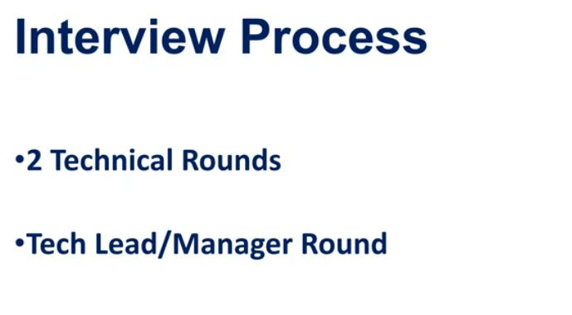

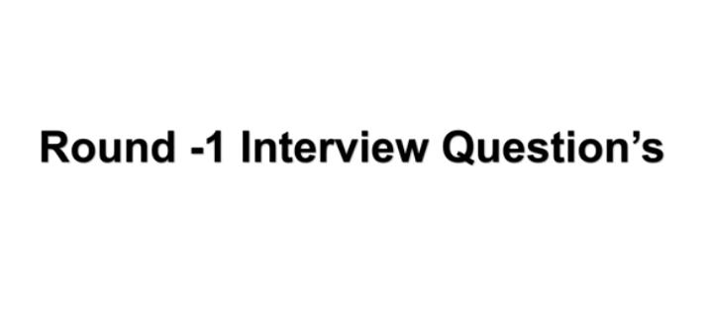

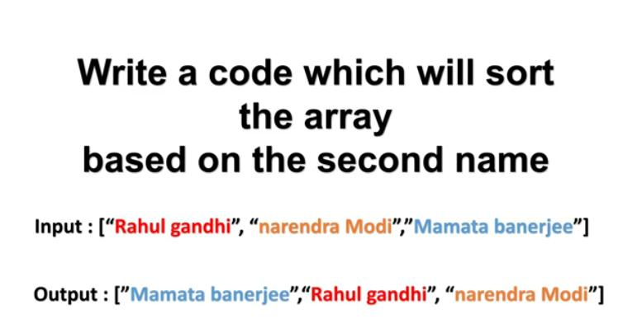

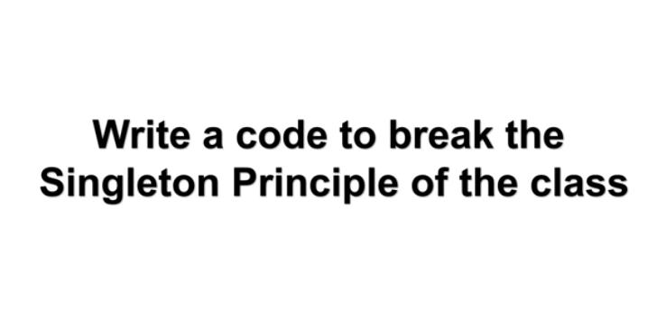

1)By Reflexion Api , 2)de-serialization, 3) Cloning

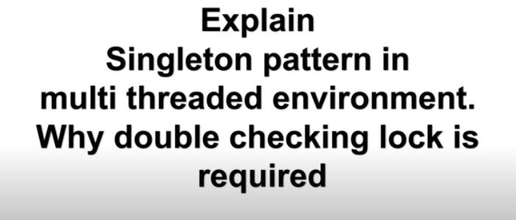

Explain about singleton and double checking lock

When ever getInstance method called asynchronously, chances that two object is created for that purpose we must have double check

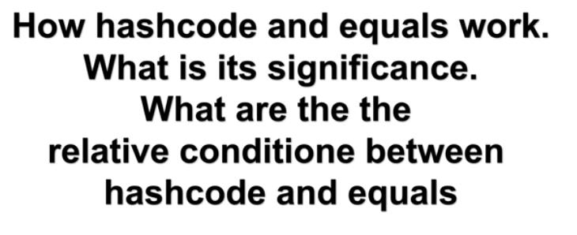

By taking the example of hashmap what roll they place and retrieve the object from hashmap

On relative condition, whenever two hashcode’s are equal there are chances are objects may not be

Equal but if objects are equal hashcode must be equal.

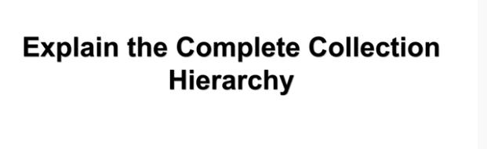

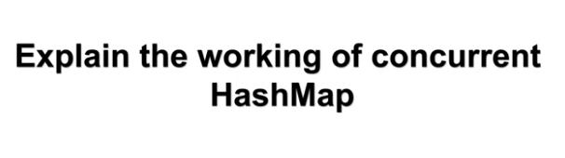

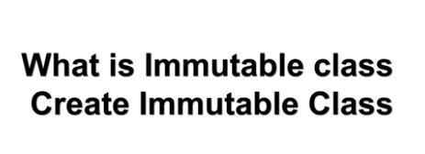

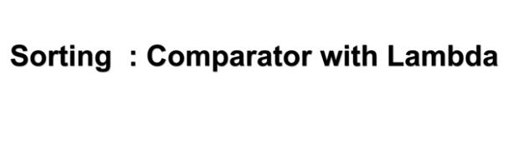



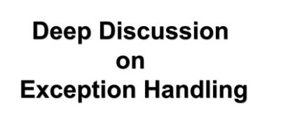

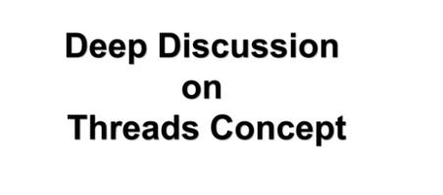

What framework of thread, what is importance of thread why should we go for multithread and which scenario we go for multithreading.

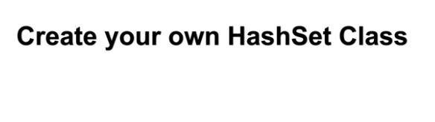

Hashset internally works on hashmap create own hashset

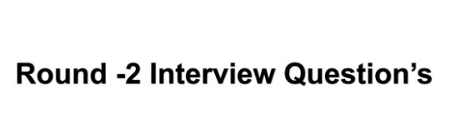



E:\ScreenShot\Screen Tut\2020-05-20 at 00-23-02.jpg

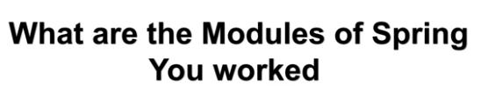

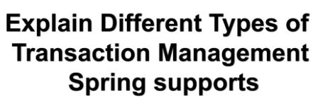

Spring support two type programmatic and declarative and which scenario which one use.



E:\ScreenShot\Screen Tut\2020-05-20 at 00-26-23.jpg

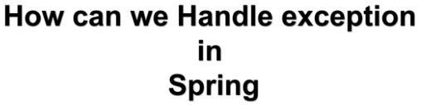

@controllerAdvice and customize classes imbuild spring classes to handle the exception



What will happen If you take scope of child class and what scope child class take.

E:\ScreenShot\Screen Tut\2020-05-20 at 00-32-16.jpg

Explain the jdbc and what difficulty and what advantage it got.

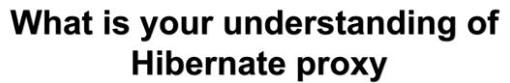

To keep It simple hibernate create proxy like it is a sub class instead of quering database directly.

Proxy will load the read object from database whenever method is called





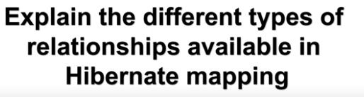

Three relationship in hibernate 1) one to one 2) one to many 3)Many to many

E:\ScreenShot\Screen Tut\2020-05-20 at 00-39-17.jpg

Wheather to load child object for loading the parent object itself or not we need to settings in mapping file like lazy = true it will not put child class related to parent class

Default lazy loading is true.



Different states are transient, persistence and detached.

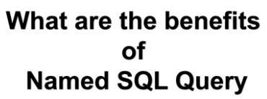

1>Compiled and validation at startup time itself

2>Easier to maintain then string literal imbedded in code.



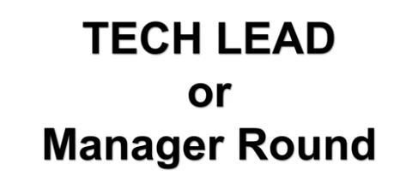

E:\ScreenShot\Screen Tut\2020-05-20 at 00-49-03.jpg

We basically support the client and client side also have architect we are just service provider company

Who is just following there guide lines and build as per requested by client.

But that is not complete.