Gastón Cocktail Serving Robot

Current Status:

The buttons for glass presence detection and user interfacing are connected and working
The 3-color LED-stripe for cocktail indication and optical feedback are connected and working
The LED/sensor pair for line following is connected and works
The RFID reader chip is connected and works

Gastón can follow a line and stop whenever he passes an RFID-Chip. The RFID-Reader is connected to the Arduino Pro Micro via UART (baudrate 9600) (RX, Arduino side). The codes for the particular RFID-chips which are used to identify different station are defined as global variables in the c-code.

It is possible to play various sound effects or songs through the additional Teensy mictrocontrolelr (+ Teensy Audio shield) which is connected to the same UART (TX, Arduino side). Sounds are stored on the Teensy's SD card and filenames are "1.wav", "2.wav", … For playing a file, the Arduino Pro Micro sends a character (e.g. '1' or '2' …) to the Teensy microcontroller.

Planned / ToDos:
Drink dispenser via IR-Codes
Station management
Improvement of Opto/Acoutstic Feedback
Add a moving eye-lid as an additional gadget which indicated robot mood/state

Toolchain / Prerequisites:
The Arduino Pro Micro is programmed at register level (using AVR-GCC and a makefile), the Teensy is programmed via the Arduino+Teensyduino environment (for easier access of wav-file playback from SD card)

Pin Setup / HW description

The table below shows the peripherals connected to the pins of the Arduino Pro Micro (ATMEGA32U4, main microcontroller). The corresponding register and pin names are written in brackets:
Connected to | Pro Micro Pins |  | Connected to
LEDStripe Green | 10 (B6) | 9 (B5) | l. motor backward
LEDStripe Red | 16 (B2) | 8 (B4) | l. motor forward
LEDStripe Blue | 14 (B3) | 7 (E6) | r. motor forward
IR-Led for delivery station | 15 (B1) | 6 (D7) | r. motor backward
- | A0 (F7) | 5 (C6) | Button green
- | A1 (F6) | 4 (D4) | Button white
Servo PWM | A2 (F5) | 3 (D0) | Button cup recognition
Sensor for line following | A3 (F4) | 2 (D1) | Big green LED
LED for line following | VCC | GND | GND
Button on circuit board (reset) | RST | GND | GND
GND | GND | RX(D2) | UART Receive: RFID-module TX
- | RAW | TX(D3) | UART Send: Teensy RX

The circuit board
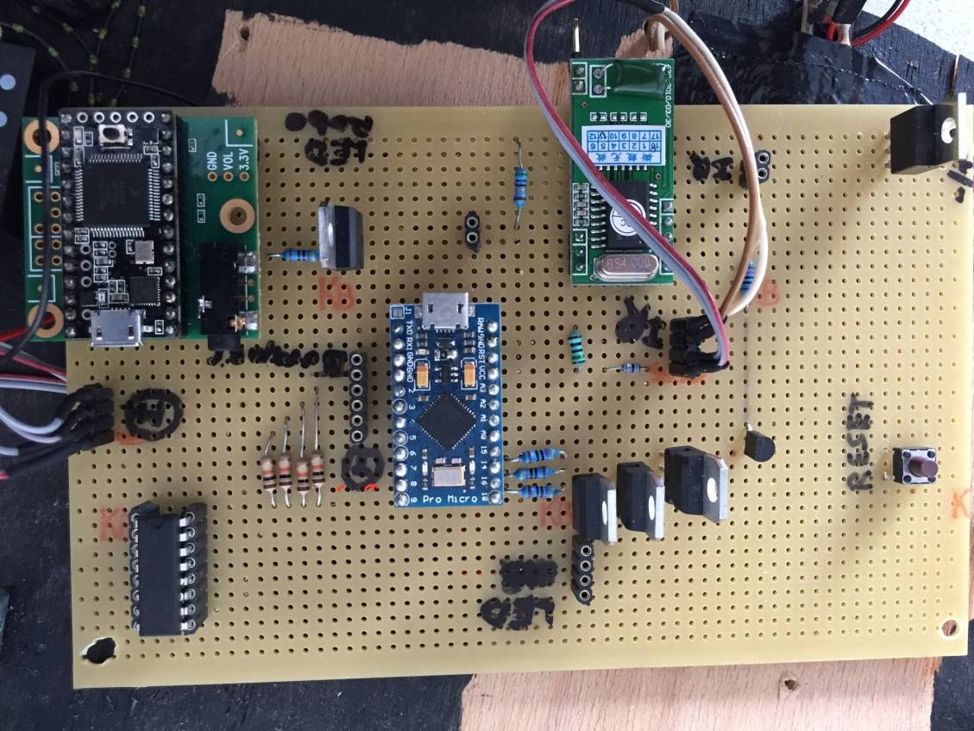
The following picture shows an overview of the components mounted on the perfboard:
(TBD: schematics, links to datasheets)

Power Regulator
5V regulator
Teensy

←RFID processing unit
RFID reader module

Buttons inputs →
Arduino ProMicro

motor connector
Arduino Pro Micro
Led Stripe connector →
LED driver transistors

motor driver

Flashing the atmega32u4

In order to flash this specific processor, avrdude can be ued with following parameters (under Linux, fpr other OSes the -P parameter for the COM port must be adapterd):
avrdude -p ATmega32u4 -b 115200 -c avr109 -P /dev/ttyACM0 -U flash:w:gaston.hex
(see also src/Makefile)

It is obligatory to reset the chip (connecting RST with GND), then wait for about 2 seconds before flashing your code into the chip. Also, you have exactly eight seconds to do so, counted right after resetting.

