SENG 410 – Senior Design Project 1

Requirements Document

SALEM

A Multi-Featured Smart Pet Feeder

Prepared by

|  |  |
| --- | --- |
| **Ugur Cem Ozturk** | *12070006006* |
| **Pelin Fidangul** | *12070001011* |
| **Ugur Ilter** | *13070006026* |

**Advisors:**

Korhan Karabulut

İbrahim Zincir

**November, 2016**

**İZMİR**

1. **What is Salem?**

Salem is a multi-featured smart pet feeder that basically determines the amount of food/water inside pet foods bowl in real-time and re-fills the bowl if necessary. This project will be helpful for the pet owners who want to feed their pets remotely. Additionally, for those who want to watch their pets in real-time, one of the targeted outcome is making a video stream through the webcam.

1. **Major Features**

* User defined weekly feeding schedule,
* Controlling levels of pet food and water inside the bowls and re-fill on need,
* Continuous live stream of animal,
* Controlling levels of pet food and water inside the storage and warn the user if below user specified level,
* Games and other features to keep the pet accompanied,
* Mobile and web interfaces for accessing to the system.

1. **Requirements**

* User should be able to login to the web and mobile applications using his / her credentials (Figure 1).
* User should be able to watch his / her pet through the webcam live-stream (Figure 2).
* User should be able to see water and pet food levels inside the bowls (Figure 2).
* User should be able to view his / her pet’s profile (Figure 3).
* User should be able to edit his / her pet’s profile (Figure 3).
* User should be able to add new vaccination date to his / her pet’s profile (Figure 3).
* User should be able to edit existing vaccination dates on his / her pet’s profile (Figure 3).
* User should be able to remove existing vaccination dates from his / her pet’s profile (Figure 3).
* User should also be able to add new and view, edit or remove existing sicknesses or surgeries his / her pet went through (Figure 3).
* User should be able to create new weekly feeding schedule (Figure 4).
* User should be able to view existing weekly feeding schedule (Figure 4).
* User should be able to edit existing weekly feeding schedule (Figure 4).
* User should be able to remove existing weekly feeding schedule (Figure 4).
* User should be able to add new meal to existing schedule (Figure 5).
* User should be able to create new meal type (Figure 5).
* User should be able to view and edit his / her profile (Figure 6).
* System should continuously live stream using a webcam (Figure 1).
* System should be accessible through both web browsers and mobile devices.
* System should automatically drop food and fill water in to the bowls according to the set schedule.
* User should be able to see storage levels and details via LCD screen on the device.

1. **User Interfaces**

**4.1 Mobile UI**

4.1.1 LOGIN

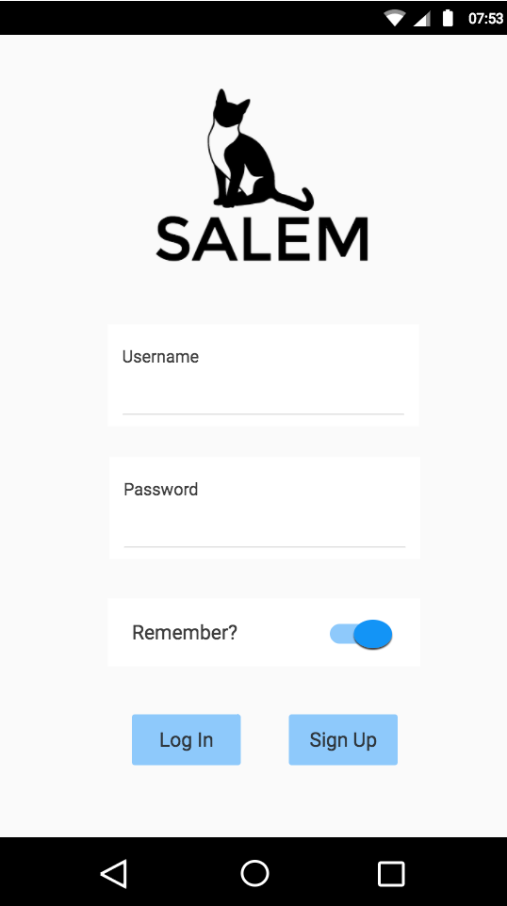

4.1.2 Home

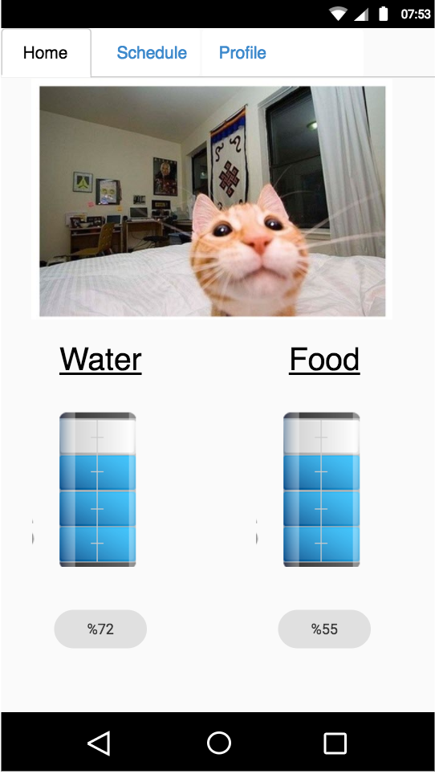

4.1.3 Schedule

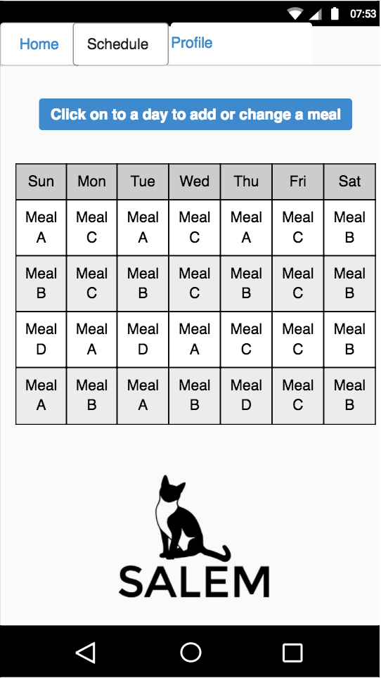

4.1.4 SCHEDULE - 2

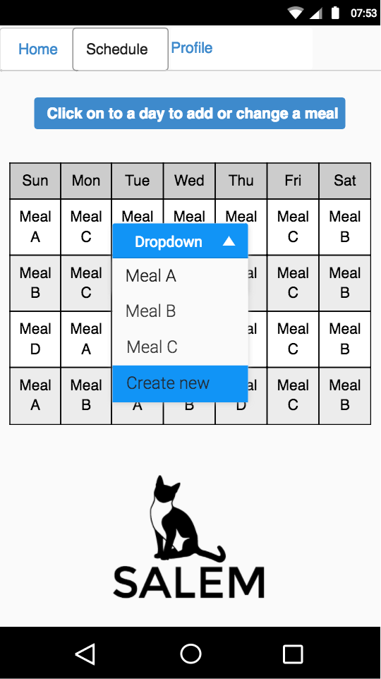

4.1.5 SCHEDULE - 3

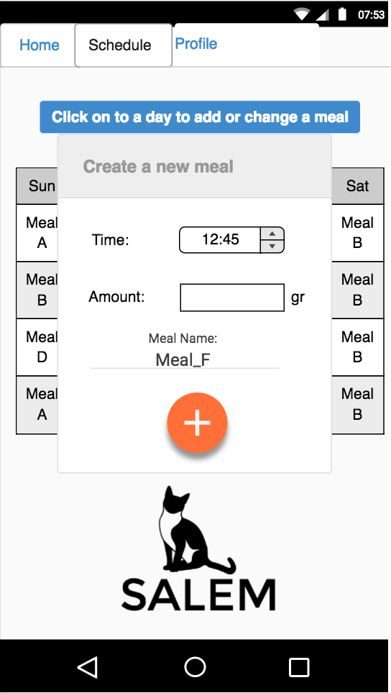

**4.2 Web UI**

* + 1. Login

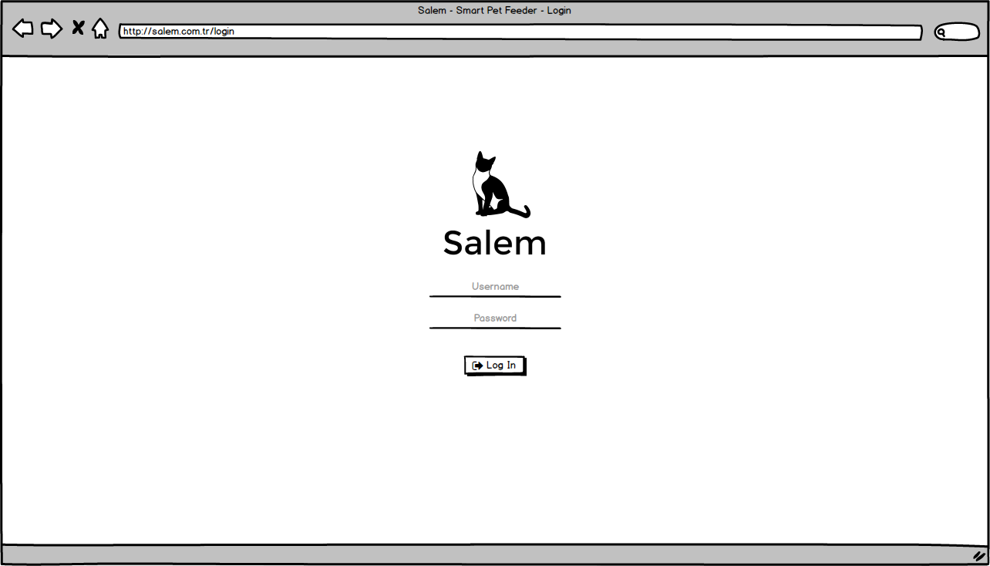

Figure 1 - Login

* + 1. HOME

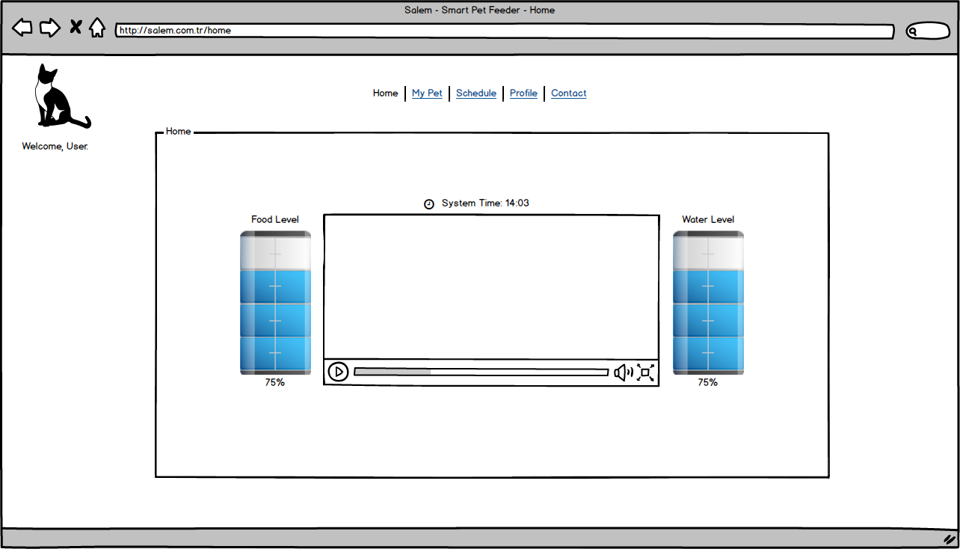

Figure 2 - Home

* + 1. MY PET

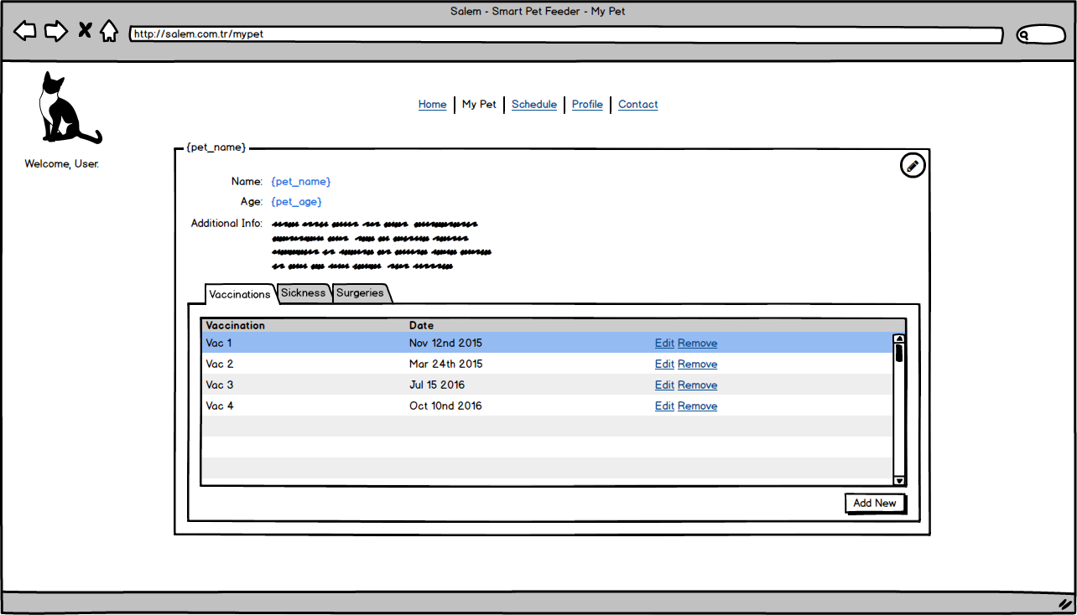

Figure 3 – My Pet

* + 1. schedule

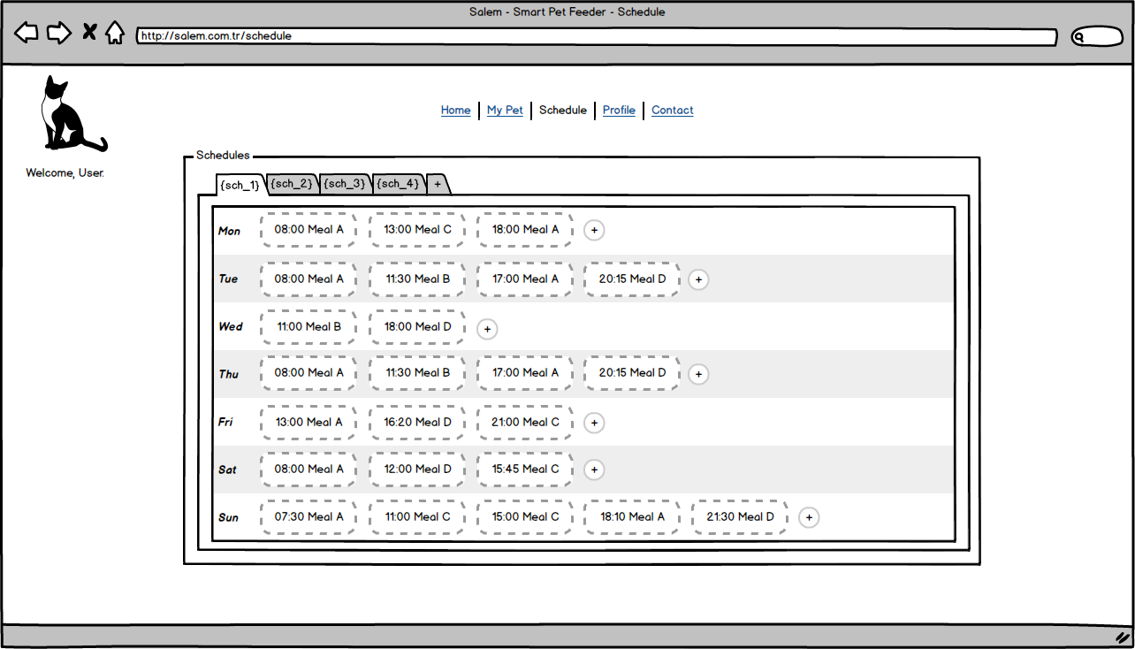

Figure 4 - Schedule

* + 1. new meal & create new meal type modals

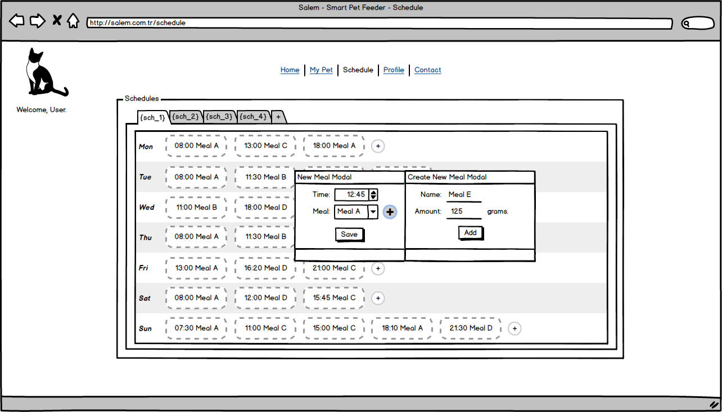

Figure 5 – New Meal & Create New Meal Type Modals

* + 1. profıle

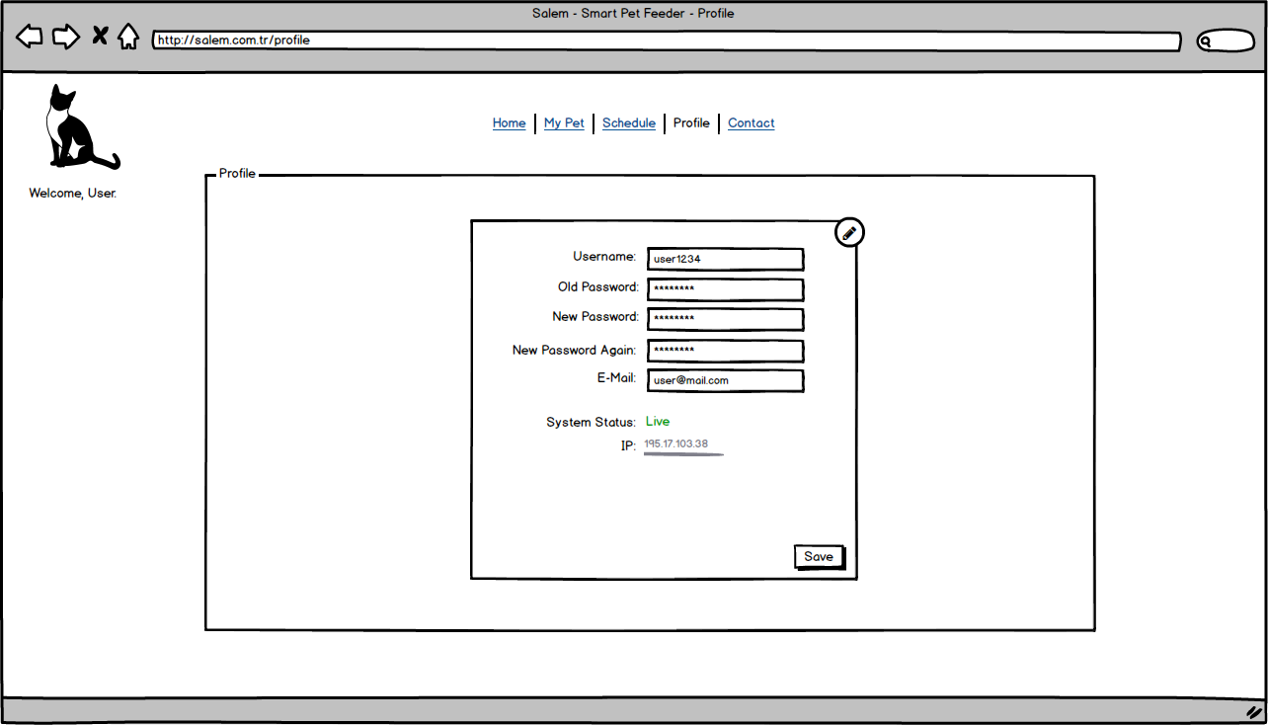

Figure 6 - Profile