**Scaling Sherpa**

**Vagrant Setup**



**We found ourselves thinking about the potential costs associated with load testing a micro-service. In order to remove complexity and allow others to easily replicate the test attack scenario we decided to use vagrant.**

**BuzzTitle: How to setup Vagrant like a boss in order to simulate a cloud service.**

**Vagrant**



**What will you get?**

Type: vagrant up

You will have a new machine , with node, npm , and the application running on port 5000 ready to be tested.

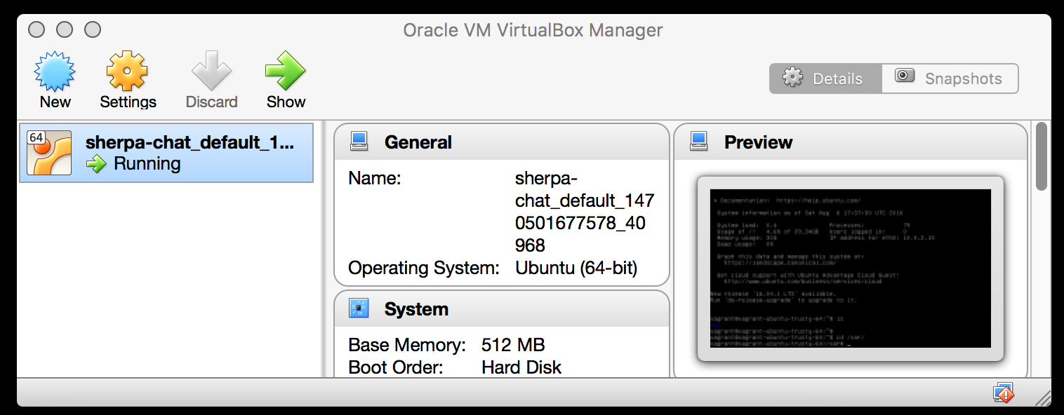

If you go to localhost:8080 you will see the linux-dashboard.

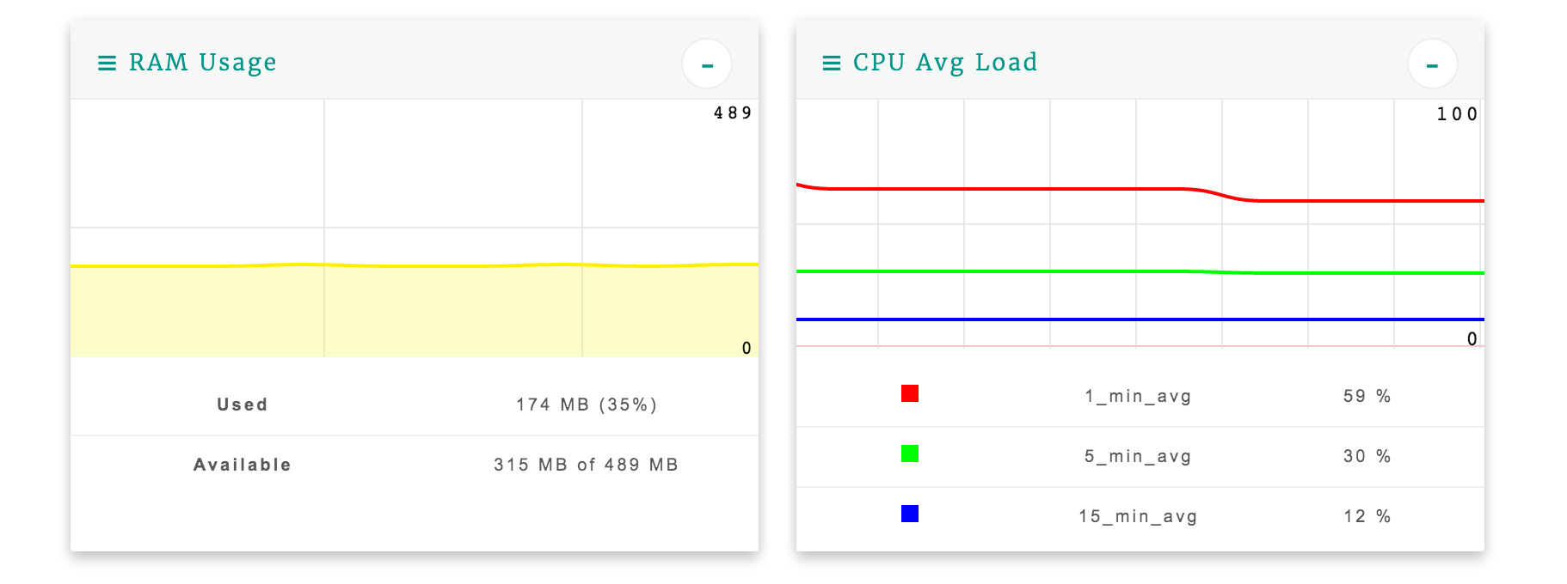

**How it was done?**

To spin up a vagrant Ubuntu 16.04

1)Go to <https://www.vagrantup.com/downloads.html>

2) Install the appropriate file for you environment.

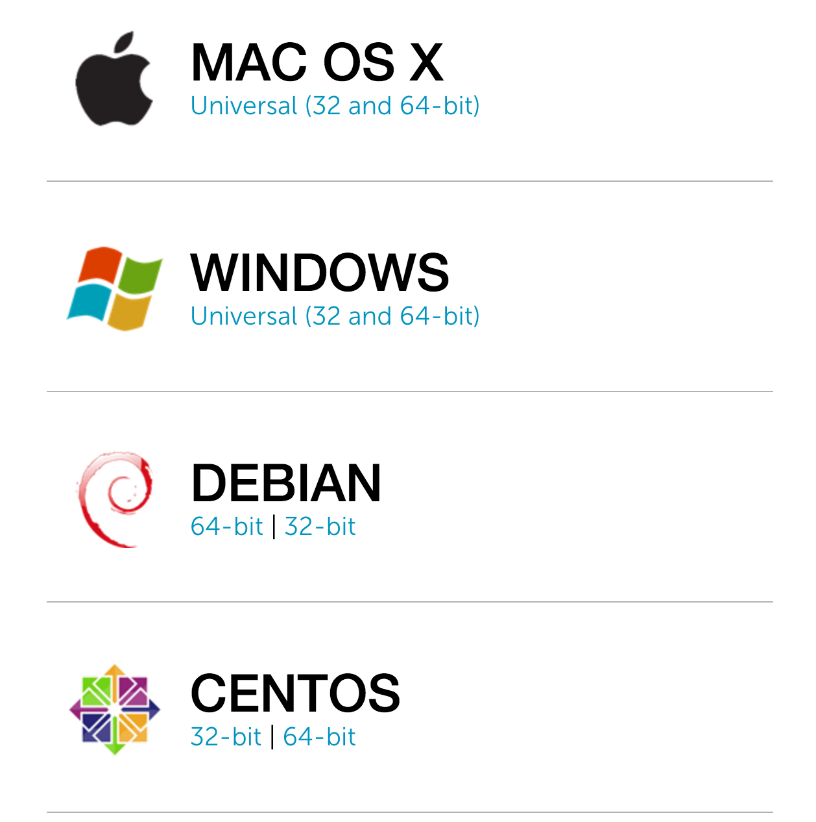

3) setup a directory to store your vagrant setup

Mkdir vagrant location

4) Spin up the Vagrant Instance with:

vagrant init ubuntu/trusty64; vagrant up --provider virtualbox

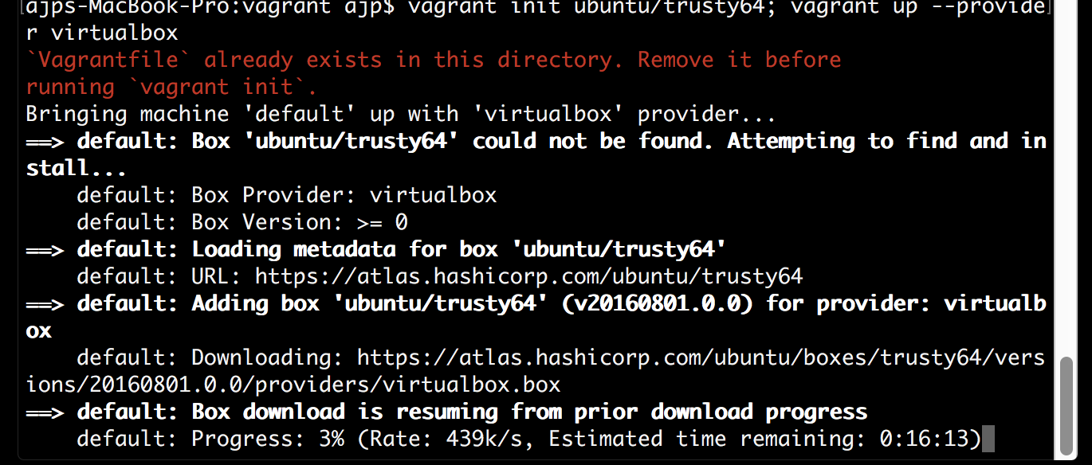

5) Since we want to be able to run our git repository code within the virtual machine and expose ports for attack we need to modify the Vagrantfile

*#Vagrantfile*

*Vagrant.configure("2") do |config|*

*config.vm.box = "ubuntu/trusty64"*

*config.vm.network "forwarded_port", guest: 5000, host: 5000*

*config.vm.synced_folder ".", "/var/www/project"*

*config.vm.provision "shell", inline: <<-SHELL*

*apt-get update*

*apt-get install -y nodejs*

*SHELL*

*end*

6) Now you can commit this vagrant to your git repository and have a god way to test the application.