Customer Churn Analysis and Retention Strategy

Project Overview
This project analyzes customer behavior to identify patterns leading to churn customers leaving a service. Using historical data, which is E-commerce dataset, it builds a classification model to predict churn risk and inform retention strategies. The project involves three main milestones: data collection and preprocessing, model development, and deployment with actionable insights.

Project Planning
The project follows a structured pipeline with the following milestones:
1. Data Collection, Exploration, and Preprocessing
- Gather and clean customer data.
- Perform exploratory data analysis and handle missing values.
2. Predictive Model Development
- Train classification model is XGBoost.
- Evaluate model performance using metrics like Accuracy, Precision, Recall, and ROC-AUC.
3. Deployment and Retention Strategy
- Deploy the model using Streamlit.
- Develop business insights and churn-reduction strategies.
Tools Used: Python, Pandas, Scikit-learn, Streamlit, Matplotlib, Jupyter Notebook, Microsoft SQL Server.

Database Design
The database is designed to store customer information, purchase history, and churn details. The ER diagram defines relationships among key entities such as Customer, Product, Purchase, Purchase_Details, and Payment_Method.
ERD
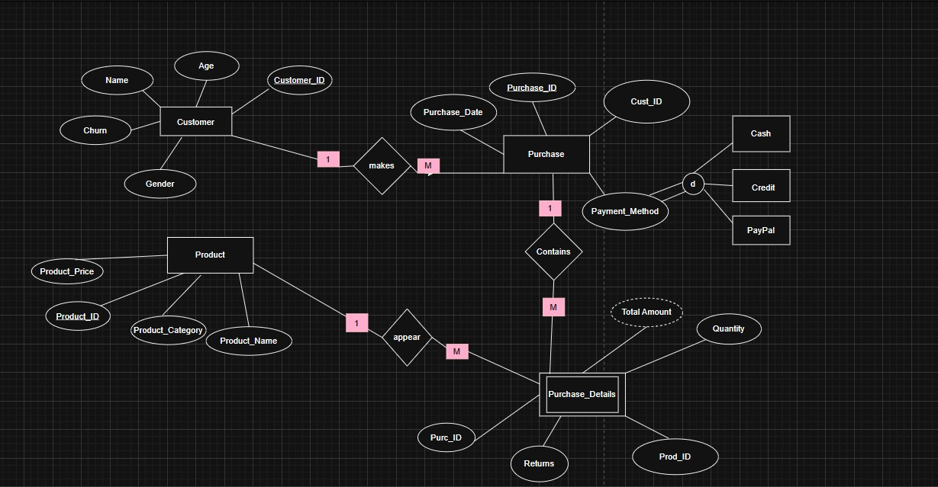
Entity Descriptions:
- Customer(Customer_ID, Name, Age, Gender, Churn)
- Product(Product_ID, Product_Name, Product_Category, Product_Price)
- Purchase(Purchase_ID, Customer_ID, Purchase_Date)
- Purchase_Details(Purc_ID, Purchase_ID, Prod_ID, Quantity, Total_Amount, Returns)
- Payment_Method(Payment_ID, Method_Type [Cash, Credit, PayPal])
Relationships:
- Customer makes Purchase (1-M)
- Purchase contains Purchase_Details (1-M)
- Product appears in Purchase_Details (1-M)
- Payment_Method linked to Purchase (1-1)

UI/UX Design
The user interface is built with Streamlit for easy model deployment.
Key Screens:
1. Home Screen – Overview of churn prediction purpose and navigation.
2. Data Input Form – Fields for customer attributes such as tenure, complaints, and usage.
3. Prediction Result – Displays churn probability and recommendation (e.g., offer discount to high-risk customers).
Design Principles: simplicity, clarity, minimal user input, responsive layout.

Conclusion & Future Work
This project successfully demonstrates the use of predictive analytics to reduce customer churn. Future improvements could include integrating live customer data, adding advanced model interpretability tools, and automating retention strategy recommendations based on prediction outcomes.

