Hi Dr. Jaramillo,

We were having problems to create the runnable JAR file. It seems there is some kind of problem with the Watson connection and sometimes, it did not find the main class, even when we created the MANIFEST.MV file through the command line. Therefore, we are running the code inside the YouTube video with all details for your grade. Also, we upload the last version of the code that was created on Eclipse, you can watched here: <https://www.youtube.com/watch?v=7JFeHXJWP6o&feature=youtu.be>

Below are the steps to run the Nina Project inside the Eclipse, you will need to add the IBM JAVA SDK as an external library.

***Step 1)***

Import the code or copy and paste the *.java files in a new project. (If you copy and paste the code professor, make sure you delete the packages on top of the files and add the package you created)

***Step 2)***

Right click on the project folder > build path > Add external archives…

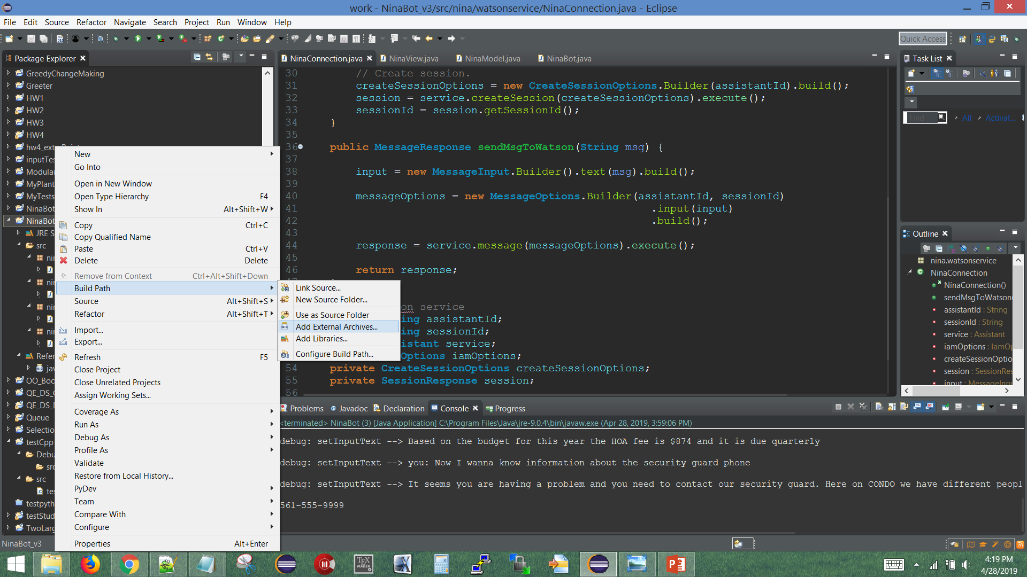

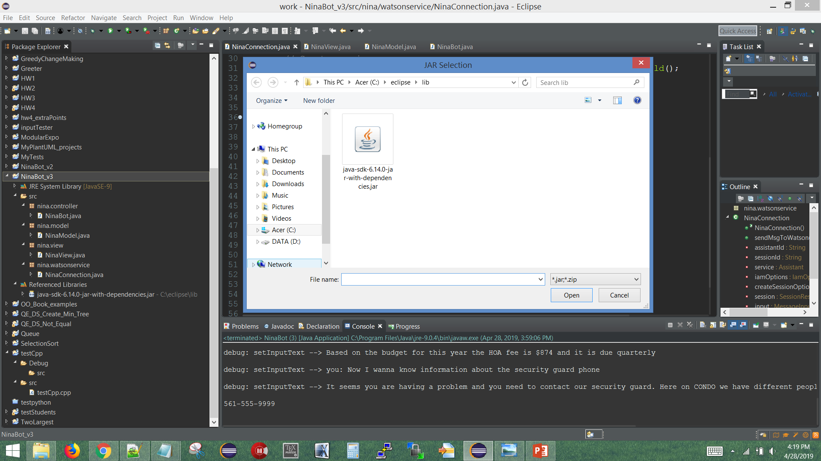

You have to see it as a Referenced Libraries

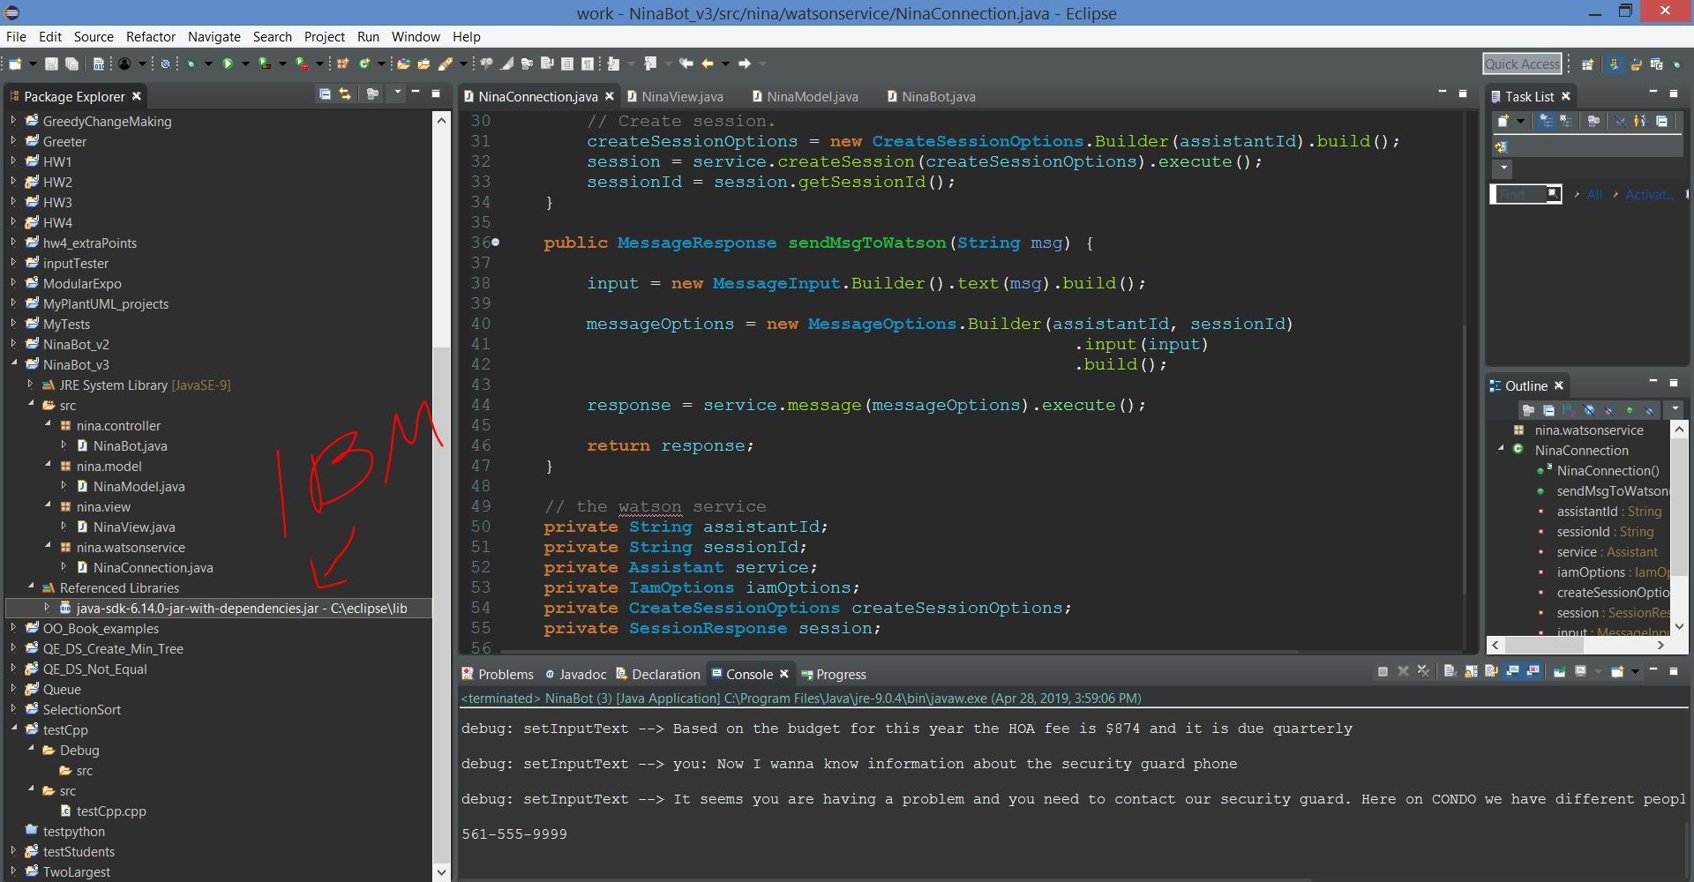

***Step 3)***

Right click on NinaBot.java and run as JAVA application

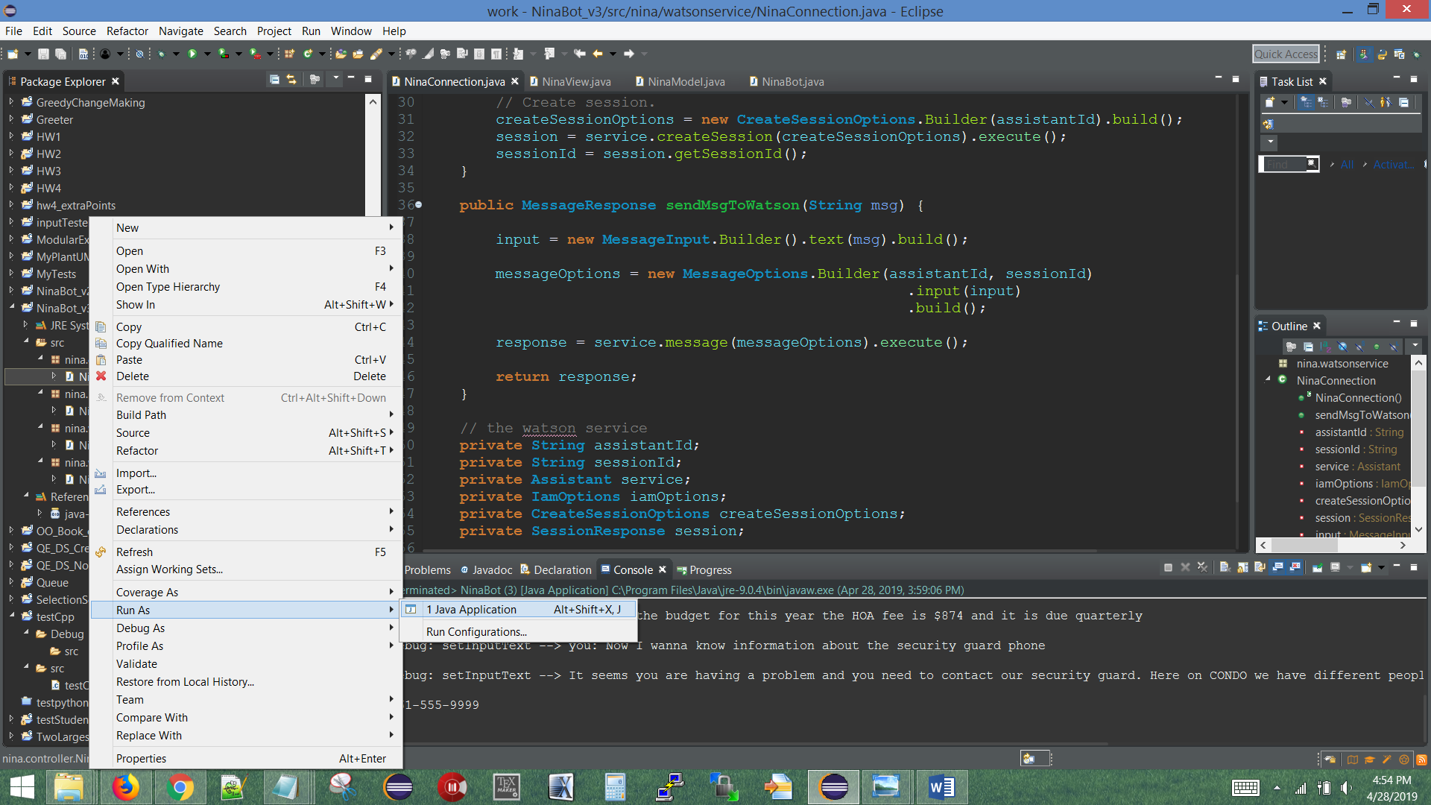

***Step 4)***

Enter a message on the bottom text area and press enter to interact with the bot.

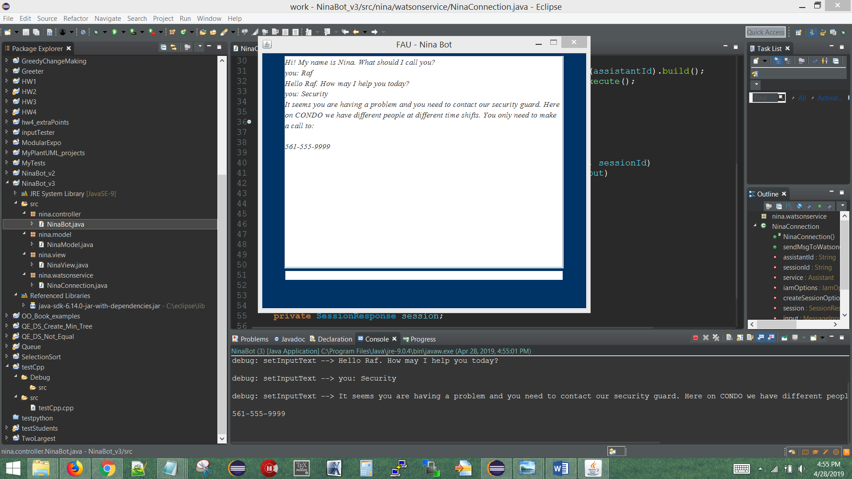

You can say fees, security, rules we live by, everything inside the functional specification below:

