**FRAUD DETECTION IN CREDIT CARD DATA USING UNSUPERVISED MACHINE LEARNING BASED SCHEME**

**OBJECTIVE:**

Fraud transactions in credit card data transaction are increasing each year. We are developing a novel technique to detect and prevent such frauds in credit card data transaction. The technique we are using to detect fraud is by using Neural Network (NN) which is an unsupervised learning technique.

**ABSTRACT:**

Development of communication technologies and ecommerce has made the credit card as the most common technique of payment for both online and regular purchases. So, security in this system is highly expected to prevent fraud transactions. In this paper, researchers are also trying the novel techniques to detect and prevent such frauds. However, there is always a need of some techniques that should precisely and efficiently detect these frauds. This paper proposes a scheme for detecting frauds in credit card data which uses a Neural Network (NN) based unsupervised learning technique. Proposed method outperforms the existing approaches of Auto Encoder (AE), Local Outlier Factor (LOF), Isolation Forest (IF) and K-Means clustering.

**KEYWORDS:** Unsupervised Learning, Anomaly Detection, Fraud Detection, Auto-Encoder, Credit Card.

**EXISTING SYSTEM:**

In existing system, the algorithms like Auto Encoder (AE), Local Outlier Factor (LOF), Isolation Forest (IF) and K-Means clustering. By using machine learning algorithms or methods are AE, IF, LOF and K Means gives less accuracy respectively.

**DISADVANTAGES:**

* Low reliability.
* Low accuracy.
* High complexity.

**PROPOSED SYSTEM:**

Proposed work as represented in the flow chart show the steps to detect the frauds. It demonstrates that pre-processing is done to clean the data and to extract the features. Then we train the model and apply testing with various unsupervised learning models. Then performance is measured on various metrics. For identifying the outliers, we used five algorithms (NN, AE, IF, LOF, K-Means) one by one and evaluated the performance. We found that NN outperforms the other schemes.

**BLOCK DIAGRAM:**

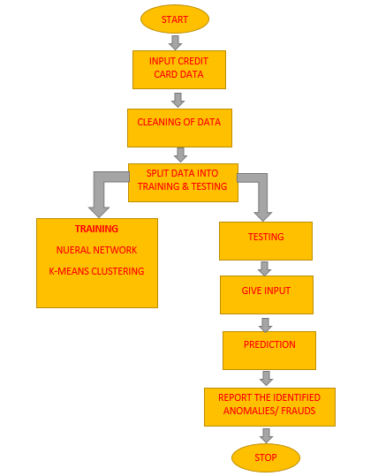

**ADVANTAGES:**

* High reliability.
* High accuracy.
* Low complexity.

**APPLICATIONS:**

* Used for preventing credit card frauds by banks.

**SYSTEM SPECIFICATIONS:**

# **H/W SPECIFICATIONS:**

# Processor - I3/Intel Processor

# RAM - 4GB (min)

* Hard Disk - 128 GB
* Key Board - Standard Windows Keyboard
* Mouse - Two or Three Button Mouse
* Monitor - Any

**S/W SPECIFICATIONS:**

* Operating System : Windows 7+
* Server side Script : Python 3.6+
* IDE : PyCharm
* Libraries Used : Pandas, Numpy, os, sklearn, Pillow, Tensorflow.

**LEARNING OUTCOMES:**

* Scope of Real Time Application Scenarios.
* What is a search engine and how browser can work.
* What type of technology versions.
* About dataset.
* Working of Support vector machine.
* About Machine learning.
* Need of Pycharm-IDE to develop a web application.
* Working of computer vision and role of open cv2.
* Features of OpenCV.
* Working Procedure.
* Testing Techniques.
* Error Correction mechanisms.
* How to run and deploy the applications.
* Introduction to basic technologies.
* How project works.
* Input and Output modules.
* How test the project based on user inputs and observe the output.
* Project development skills:
* Problem analysing skills.
* Problem solving skills.
* Creativity and imaginary skills.
* Programming skills.
* Deployment.
* Testing skills.
* Debugging skills.
* Project presentation skills.
* Thesis writing skills.