Elijah's New Slide

On Saturday, the kids, my friend Louie Holliday, and I picked up a used slide for Elijah that's shaped like an Elephant. We needed Louie's help because the slide was too big to fit inside our cars, and he drives a van. After buying the slide, we ate a late lunch at Culver's. Elijah had already eaten lunch, but he did try a couple of French Fries, and Kayla fed him some of her applesauce. Then, we went to Sam's Club and Wal-Mart. We connected with Theresa as she was getting off of her shift, and then headed home. Elijah continues to show a lot of curiosity and independence. He loved exploring the shelves at Wal-Mart, under our close supervision. I think what he liked the most was having a lot of open space to just wander around in. Louie dropped off the slide while Elijah was napping. After dinner, we took him out to the backyard to show it to him. Elijah liked standing up on top of the slide, and riding down it, but he seemed to like climbing back up the slide the most. It took him a while and a lot of tries, but he finally was able to climb up the slide to the top. At first we discouraged him from doing this, but he was so focussed it was hard to tell him no.
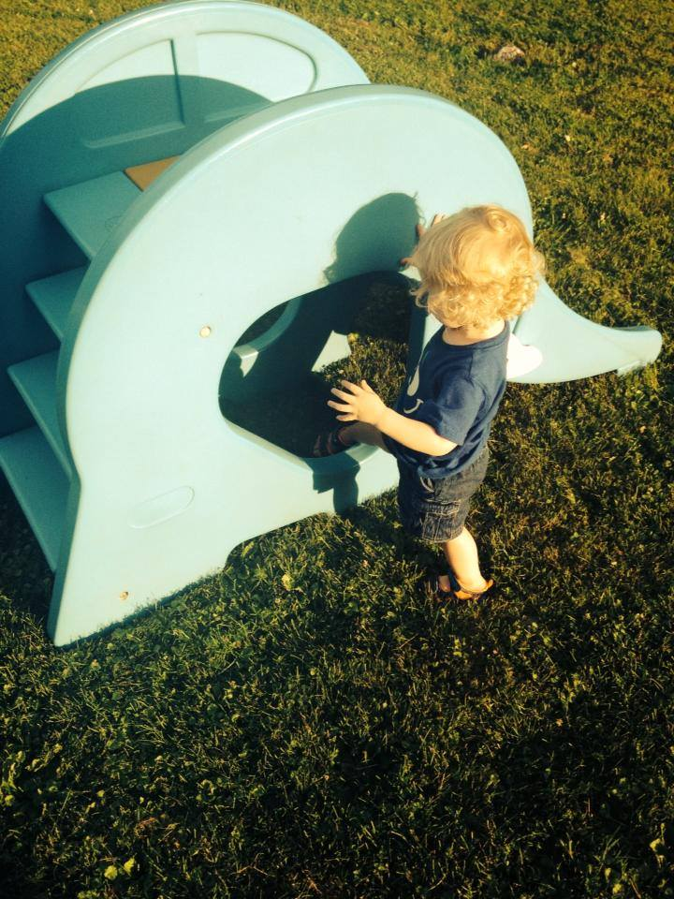
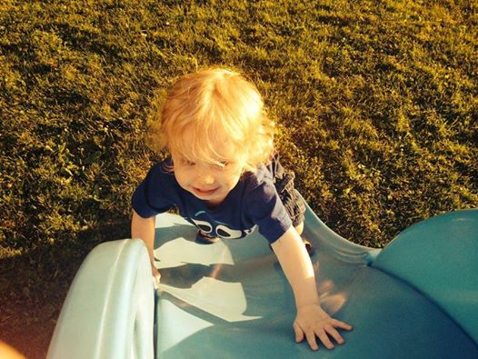
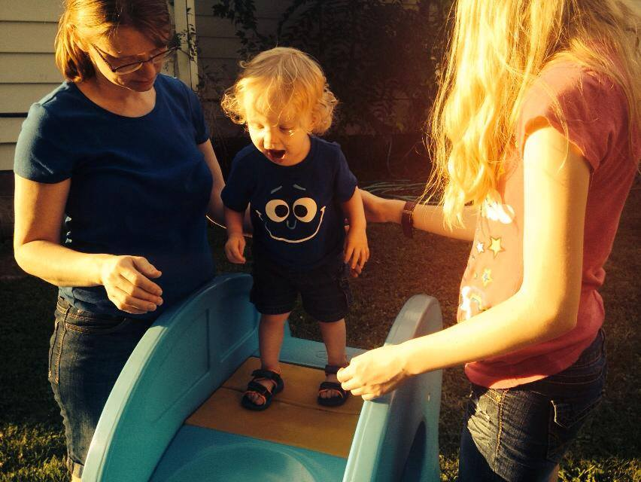


[Edit | Reply | New Entry | Comment ]

