
Savvy Tech
Technology and creative studio, Grenada
WEBSITE PROPOSAL
Taxi, Tours and Auto Rentals Website
A booking-first website for Wayne Radix, Grenada
PREPARED FOR  Wayne Radix  Taxi, Tours and Auto Rentals | PREPARED BY  Savvy Tech  St. George's, Grenada | DATE ISSUED  September 22, 2026 | VALID UNTIL  October 22, 2026

01 SUMMARY

A booking-first website for Wayne Radix
Savvy Tech will design, build and launch a mobile-first website that lets visitors book an airport transfer, reserve an island tour or rent a vehicle from Wayne Radix in a few taps. The site is built to win bookings from tourists, cruise passengers and locals, and to be found on Google when they search.
This proposal sets out what we will deliver, answers the questions raised about labour, maintenance, maps, social media and security, and confirms the full investment, with no hidden costs.

Website build  EC$3,200  One-time, all labour included | Care plan  EC$150  Per month, from launch | Launch  6 weeks  From deposit and content | Live demo  Online now  See section 02

Goals for the website
- Take taxi, airport transfer, tour and rental requests online, day or night.
- Show the fleet, tours and rates clearly, in EC$ and US$.
- Build trust with reviews, photos, licensing details and clear policies.
- Rank on Google for searches such as "Grenada airport taxi" and "car rental Grenada".
- Give every visitor a one-tap route to Wayne on WhatsApp.
- Cut back-and-forth messages by collecting dates, pickup points and guest numbers up front.

02 LIVE DEMO

See the website before you commit
We have built a working demo of the homepage so you can see the look, feel and booking flow on your own phone. It uses Wayne's colours of ocean blue, sand and white, and stock photos of Grenada that will be replaced with Wayne's own vehicles and tours.
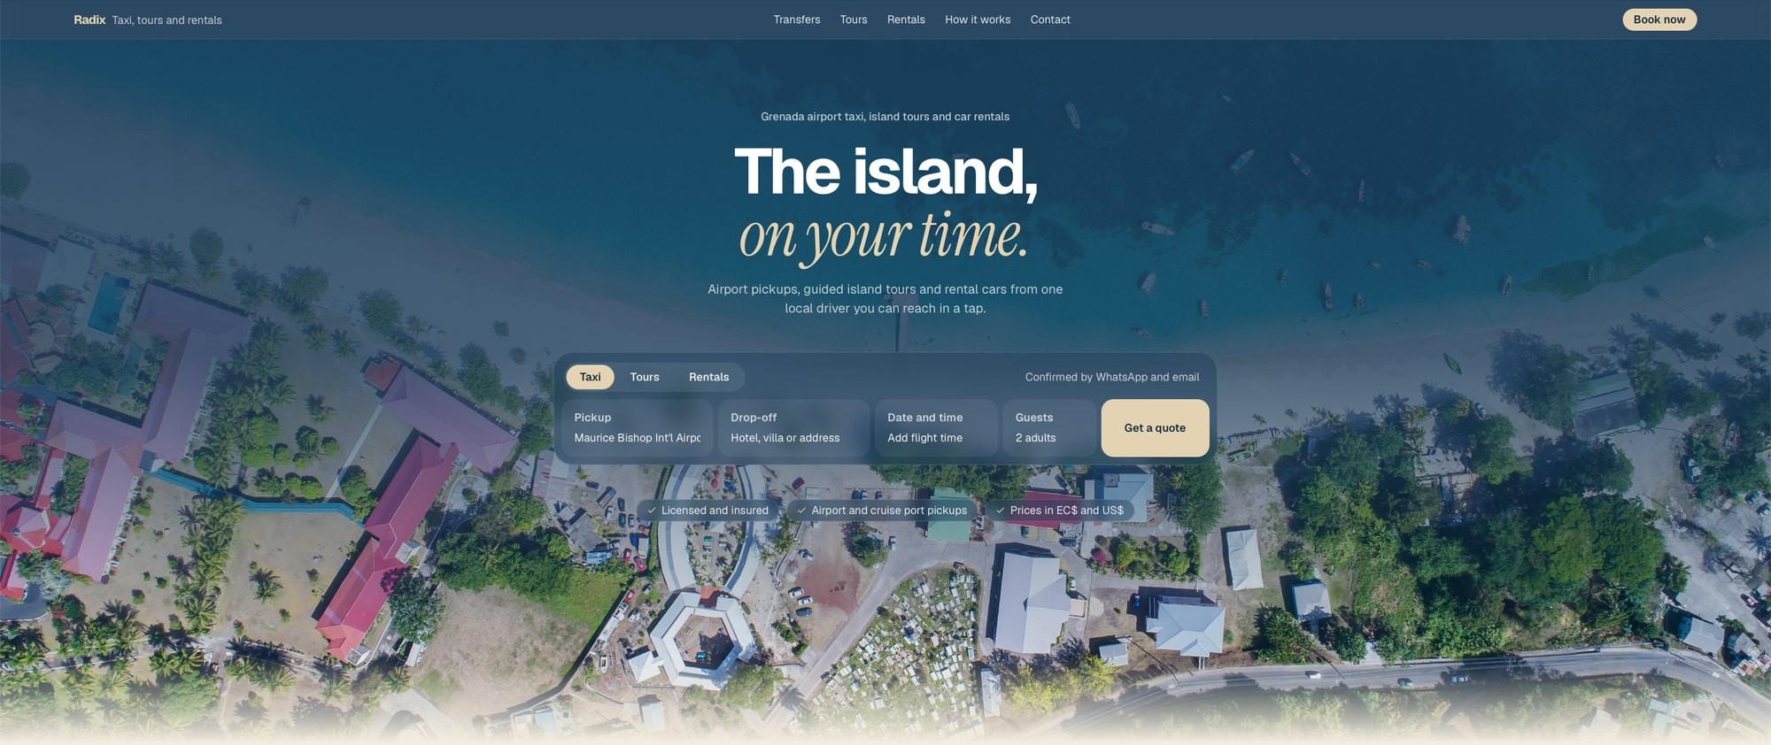
Demo link: https://projects473.github.io/wjr/

What to try in the demo
- Switch between Taxi, Tours and Rentals in the booking panel. Each shows the right fields.
- Filter the fleet by cars, SUVs and vans.
- Press Get a quote. It opens WhatsApp with the booking details already filled in.
- Open it on a phone to see the mobile menu and the Book now bar pinned to the bottom of the screen.

03 SCOPE AND DELIVERABLES

What is included
Everything below is included in the one-time build fee of EC$3,200.

Pages
Page | Purpose
Home | All three services at a glance, quick booking panel, reviews and WhatsApp
Airport and Cruise Transfers | Fixed rates by zone, flight tracking details and booking
Island Tours | Tour list plus a detail page for each tour with itinerary, duration and price
Auto Rentals | Fleet with filters plus a detail page for each vehicle with rates and terms
About Wayne | Story, experience, licensing and insurance
FAQs and Policies | Local driving permit, deposits, cancellations, driving on the left
Contact | WhatsApp, phone, email, Google Map, service area and hours

Features
Feature | What it does
Online booking | One booking flow for taxi, tours and rentals. Every request reaches Wayne instantly by WhatsApp and email.
Availability calendar | Blocks out booked vehicles and tour dates to prevent double bookings.
Fleet and tour manager | Wayne can add vehicles and tours, change rates and swap photos himself, without a developer.
WhatsApp integration | Chat buttons on every page, and booking forms that open WhatsApp with the details pre-filled.
Google Maps and location | Embedded map of Wayne's base and service area, one-tap directions and map links for pickup points.
Social media integration | Links to Facebook, Instagram and TikTok, plus rich link previews when the site is shared on WhatsApp or Facebook.
SEO integration | Keyword-targeted pages, Google business data, sitemap, Search Console setup and Google Business Profile.
Security | HTTPS encryption, spam-protected forms, no card details stored on the site, and backups.
Reviews and trust | Google and TripAdvisor reviews, licence and insurance details beside every booking button.
EC$ and US$ pricing | Rates shown in both currencies for overseas visitors.
Mobile-first and fast | Designed for phones first, with images that load quickly on island mobile data.
Analytics and training | Visitor and booking tracking, plus a handover session so Wayne can manage the site confidently.

Optional add-ons
Not included in the build fee. Available on request and quoted separately before any work begins.
- Online card deposits through a payment gateway such as WiPay or PayPal
- Logo and brand identity design
- Professional photography of vehicles and tours
- Additional languages or pages beyond the scope above

04 YOUR QUESTIONS ANSWERED

Labour, maintenance and integrations

Is labour included in the price?
■ YES, FULLY INCLUDED
The EC$3,200 build fee covers all labour from start to finish: planning, design, development, content setup, integrations, testing, launch and handover training. There are no hourly charges and no surprise invoices.
Two rounds of design revisions are included. Any new work outside the agreed scope will be quoted in writing and approved by Wayne before it starts.

What are the monthly and annual maintenance costs?
■ EC$150 PER MONTH
The care plan is EC$150 per month, which is EC$1,800 per year. It starts on launch day and includes:
- Website hosting and uptime monitoring
- Security updates, SSL certificate renewals and regular backups
- Small content updates such as rates, photos and tour details
- A monthly report on visitors, bookings and top pages
- Priority support by WhatsApp and email
The only other running cost is the domain name (for example, radixgrenada.com), which is registered in Wayne's name and billed yearly at cost.

Does it include Google Maps and location integration?
■ YES, INCLUDED
- An embedded Google Map on the Contact page showing Wayne's base and the areas he serves.
- One-tap "Get directions" links that open Google Maps or Apple Maps on the visitor's phone.
- Pickup locations in the booking form, including the airport, cruise port, hotels and villas.
- Setup of Wayne's Google Business Profile, linked to the website, so he appears on Google Maps searches.

Does it include social media integration?
■ YES, INCLUDED
- Links to Wayne's Facebook, Instagram and TikTok in the header and footer.
- Rich link previews, so when the site is shared on WhatsApp, Facebook or X it shows a photo, title and description.
- WhatsApp chat buttons across the site, with booking details pre-filled.
- An Instagram or Facebook feed on the homepage, if Wayne would like one.

How is the website kept secure?
■ BUILT IN, AND MAINTAINED MONTHLY
- HTTPS encryption on every page, shown by the padlock in the browser.
- Spam protection on all booking and contact forms.
- No card details stored on the website. If online deposits are added, payments are handled by a secure payment gateway.
- Regular backups, security updates and monitoring through the care plan.
- Wayne owns his domain, content and website files, with access handed over at launch.

What does SEO integration include?
■ YES, INCLUDED
- Page titles and descriptions written around searches such as "Grenada airport taxi", "island tours Grenada" and "car rental Grenada".
- Local business data (schema.org) that tells Google about Wayne's services, service area and contact details.
- A sitemap and robots file, with the site submitted to Google Search Console.
- Descriptive photo text, a clean heading structure and fast loading, all of which help rankings.
- Google Business Profile setup, the single biggest factor for appearing in local searches.
These SEO foundations are already built into the demo website.

05 INVESTMENT

Clear, fixed pricing
All prices are in Eastern Caribbean dollars (XCD).
Item | Details | Amount
Website build | Design, development, all features and integrations above, testing, launch and training. All labour included. | EC$3,200 one-time
Care plan | Hosting, security, backups, small updates, monthly report and support | EC$150 per month
Care plan, yearly | 12 months at EC$150 | EC$1,800 per year
First-year total | Build plus 12 months of care | EC$5,000

Payment terms
Milestone | When | Amount
Deposit (50%) | On acceptance, to reserve the start date | EC$1,600
Final payment (50%) | At launch, before the site goes live on Wayne's domain | EC$1,600
Care plan | Monthly from launch. Cancel anytime with 30 days' written notice. | EC$150 / month

Third-party costs, billed at cost
- Domain name registration and yearly renewal, registered in Wayne's name
- Payment gateway transaction fees, only if online deposits are added
- Professional photography, only if requested

06 TIMELINE

Live in six weeks
The timeline starts once the deposit is received and depends on how quickly content and photos arrive.
Week | Phase | Deliverables
Week 1 | Discovery | Kick-off call, services, rates, zones, map locations and social media accounts
Week 2 | Design | Final page designs for approval, building on the live demo
Weeks 3 to 4 | Build | All pages, booking system, fleet and tour manager, maps, social and SEO integration
Week 5 | Content and testing | Photos, copy, security checks, mobile and booking tests, speed checks
Week 6 | Launch | Domain connection, Google Business Profile, Search Console, analytics and handover training

What we need from Wayne
- Business name, logo (if any) and preferred domain name
- Vehicle list with photos, seats and daily and weekly rates
- Taxi rates by zone and airport transfer prices
- Tours with stops, duration, price and pickup times
- Rental terms: deposit, age limit, insurance, cancellations
- Licence and insurance details to display
- Base location and service area for the map
- Social media links, WhatsApp number, email and hours

07 ABOUT SAVVY TECH

Local studio, proven in transport and tourism
Savvy Tech is a technology and creative studio based in St. George's, Grenada, with over 13 years of experience in web design, branding and digital work for tourism, transport and small businesses across the island.
King J's Taxi and Tours  Taxi and tours website with online booking | Pure Grenada  Tourism website and campaign graphics | Maquillage Beauty  Booking-first business website
Ride Right Rental  Brand identity for a vehicle rental business | Island RV Rentals  Brand identity for a rental business | Grenada Transport Commission  Logo design
Full portfolio: ghosten22.github.io/savvy-tech

08 ACCEPTANCE

Next steps
- Review this proposal and the live demo.
- Sign below, or accept by email or WhatsApp.
- Pay the 50% deposit of EC$1,600 to reserve the start date.
- We hold the kick-off call in the first week and launch in six weeks.
By signing, both parties agree to the scope, pricing and payment terms set out in this proposal. Wayne Radix owns the website, its content and the domain once the build fee is paid in full.
CLIENT  Signature  Name: Wayne Radix  Date |  | SAVVY TECH  Signature  Name  Date

Contact
Email ghosten@savvytechllc.net
Phone and WhatsApp +1 (473) 419-8308
Studio St. George's, Grenada

