NCC Helicopter Run Documentation
Objective:
To create and devise own game based on the exemplar, City Emergency. Incorporating all fundamental derivable aspects such as player movement, obstacles, a fuel progress bar, life, buildings, a way to win, and a way to lose, etc...
Pseudocode:
Begin Main Sequence
Initialise Game Status Sequence

Get Keyboard Input
Set Helicopter Position

Get Helicopter Positon

If Helicopter Collision Object
Initialise Game Status Sequence

If Player Lives Equals X
Switch to X Corresponding Screen
End Main Sequence

Begin Game Status Sequence
Set Objects
Set Variables
Set Time
End Game Status Sequence

Structure Chart (Simplified):
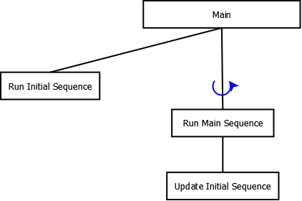

NCC Helicopter Run Documentation

Initial Story Board:
Board Image 01: ‘Program Start’
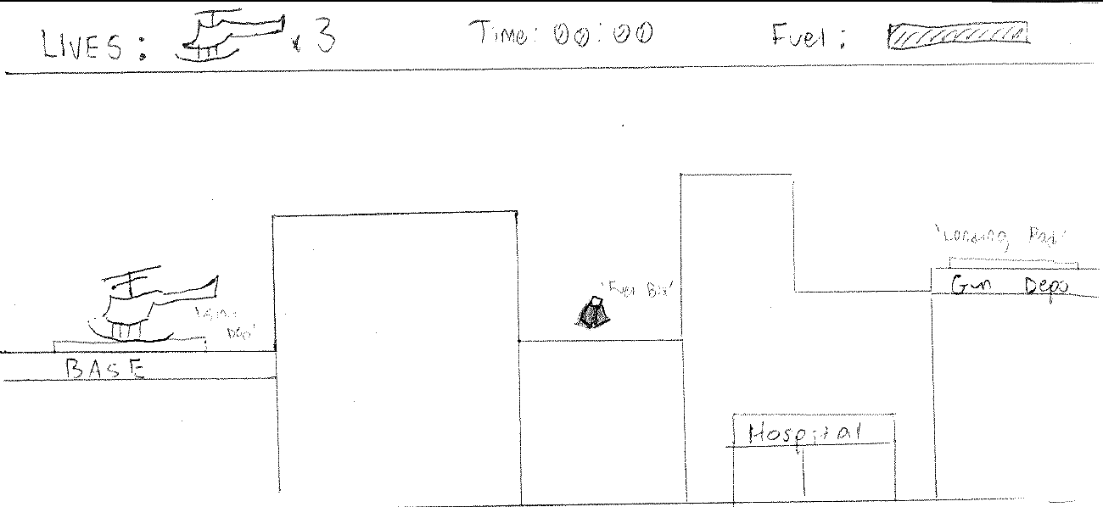

Board Image 02: ‘Player Move’
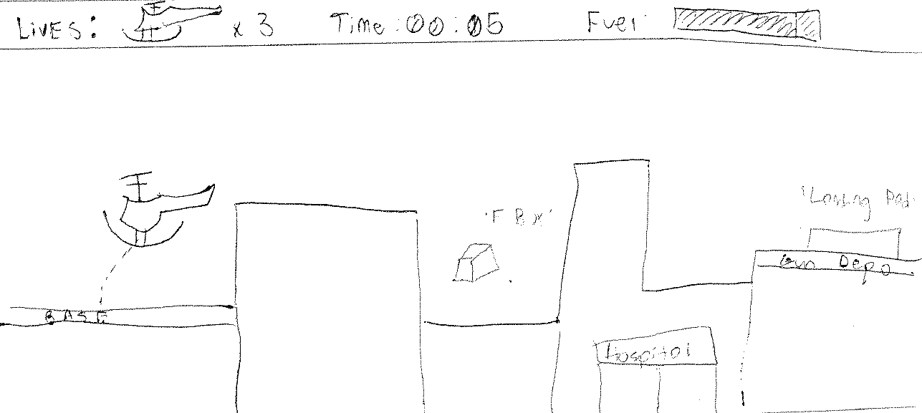

Board Image 03: ‘Player Reach Fuel Box’
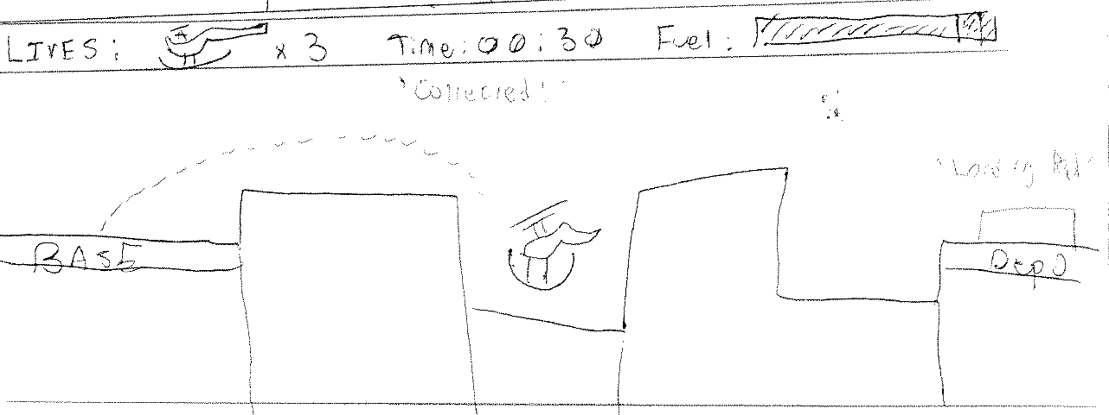

NCC Helicopter Run Documentation
Outcomes:
Introductory and ending screens include the following aspects:
- Buttons
- Text
- Sound

Helicopter game includes the following aspects;
- A timer.
- A fuel progress bar.
- A life system.
- A levelling system.
- A difficulty system, created through dodging randomly moving obstacles.
- User character control.
- An in-game objective i.e. to complete as many levels.
- Game-specific text.
- Background music.
- Sound effects.

Program Screenshots:
