eMovie Menu – The Electronic Food and Drink Calculator:

Objective;
The goal for the program is to be able to complete a food and drink payment based on the ticket number. The central idea is that the order is individualised to a single ticket and would in real-world circumstances be delivered, or pre-brought to the cinema seat. Practically, such a program could be implemented on commonly used devices such as a mobile phone.

Programming-wise, the user should be able to select movie menu items to be purchased based on the food type category. The selection will bring upon a calculation of the total price. Near the end of the order there should be user confirmation towards the purchase. Confirming the order should display the user’s hypothetical ticket account, and a finalised display of bought items.

Mathematical Outcomes;
Random generation of hypothetical matching ticket number. Input ticket numbers 01, 02, 03, and 04 are processed into categories ‘Normal’, ‘3D’, ‘VMAX’, and ‘Gold Class’.
Random generation of hypothetical matching ticket account title.
Random generation of hypothetical matching ticket account surname.
Addition of categorical selection.
Multiplication of categorical selection by categorical amount to receive total categorical price.
Addition of total categorical prices to receive a finalised total amount.
Percentage of discount percentage from finalised total amount.
Rounding of the discount percentage so that the finalised total amount is legitimate currency and not for example 0.05 of a cent.
Subtraction of the discount percentage from the finalised total amount

Program Screenshot 01 – Title Screen;



eMovie Menu – The Electronic Food and Drink Calculator:

Program Screenshot 02 – Displaying Order;

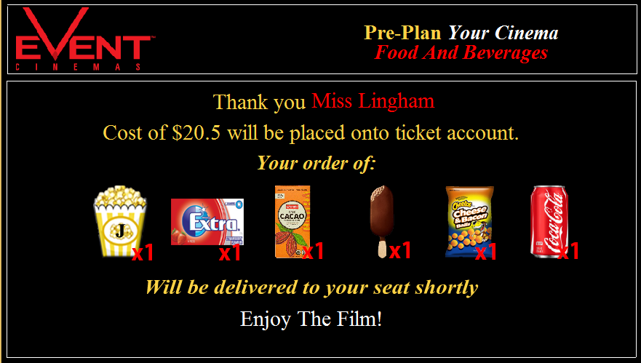

Structure Chart (Simplified);
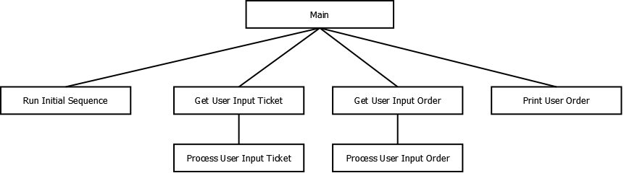

eMovie Menu – The Electronic Food and Drink Calculator:

Pseudocode;
Begin Program
First Frame
Set Initial Program

User Keyboard Action
Go to Frame 2
End User Keyboard Action

User Click Internet Button Action
Open Internet URL
End Click Action

Second Frame
Get Input Ticket Number

User Click Next Action
Generate Hypothetically Matching Ticket Account
If Ticket Type 1-3 Go to Third Frame
If Ticket Type 4 Go to Fifth Frame
End Click Action

Third Frame
User Click Menu Item Action
Highlight Selected Menu Item
Calculate Total Cost Selected Menu Items
Display Total Cost Selected Menu Items
End Click Action

Confirmation Button User Action
Go to Fourth Frame
End Click Action

Fourth Frame
Display Name
Display Ticket Number
Display Order

Fifth Frame
User Click Menu Link Action
Open Link
End Click Action

End Program

