### Age of Empires ECG combat results calculator

#### Developer test cases

###### 2 Cavalry Archer vs 1 Scorpion at range 0

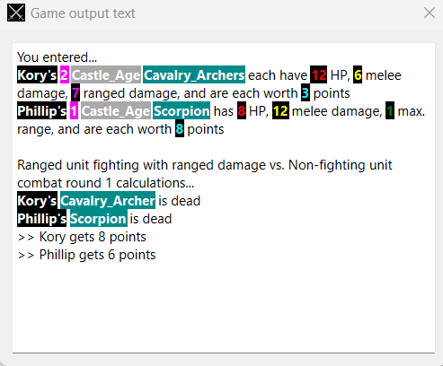

**Verdict:** Expected output

###### 2 archers vs 1 demo ship at range 0

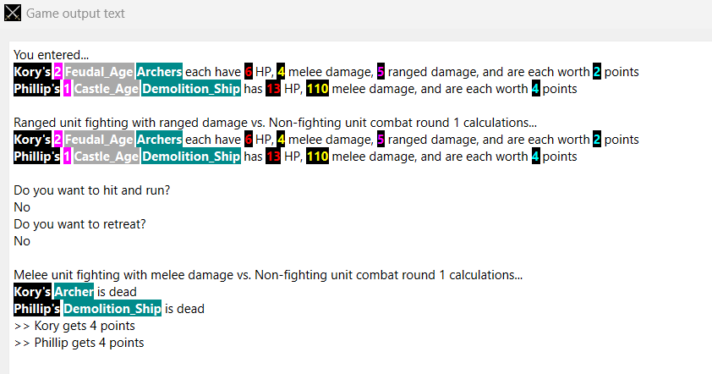

**Verdict:** Expected output

###### 1 Trebuchet vs 1 Scorpion at range 2

**Verdict:** Expected output

###### 1 Trebuchet vs 1 Scorpion at range 10

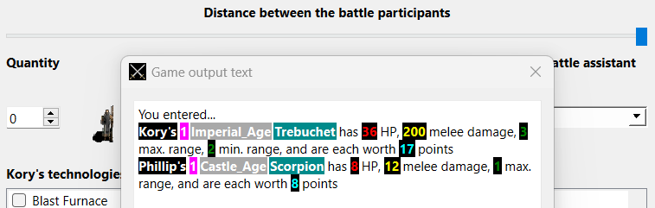

**What’s depicted:** Neither of them attacking

**Verdict:** Expected output