#### UI design

##### Windows shown before user has logged in

###### Welcome window

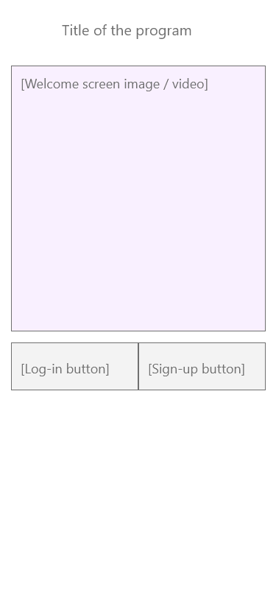

###### Sign-up window

###### Log-in window

##### Windows shown after user has logged in

###### Profile screen

Add share achievements unlocked on this screen

Remove share app from this screen. Move it to settings

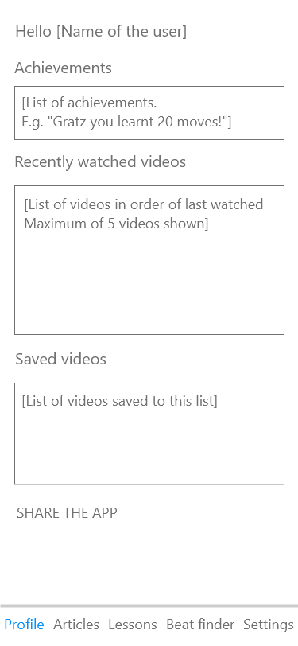

###### Articles screen

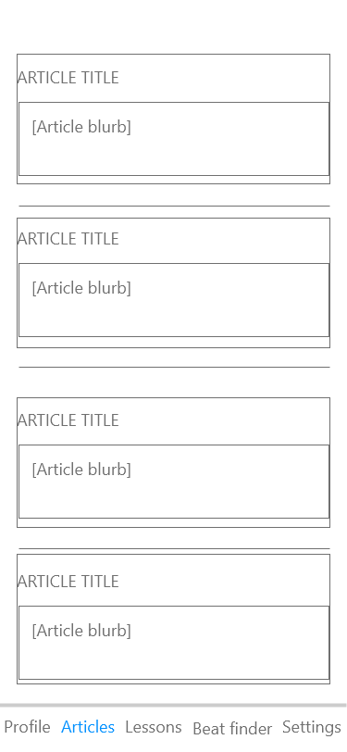

**ARTICLE SELECTED SCREEN**

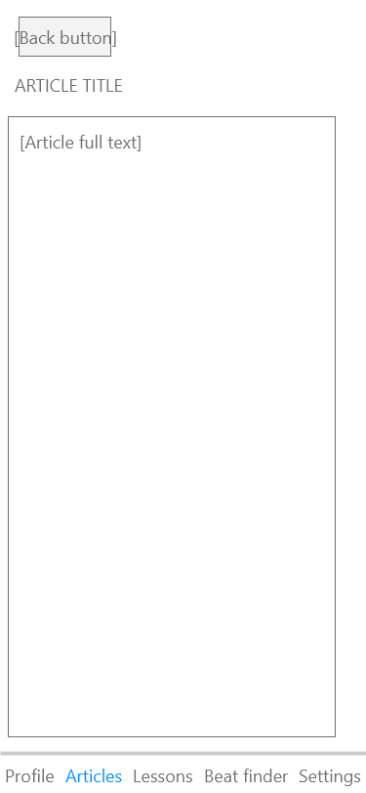

###### Lessons screen

Make it one filters button on LHS

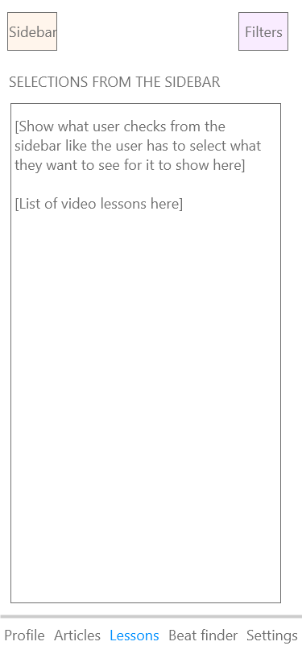

**SIDEBAR COVERS SCREEN**

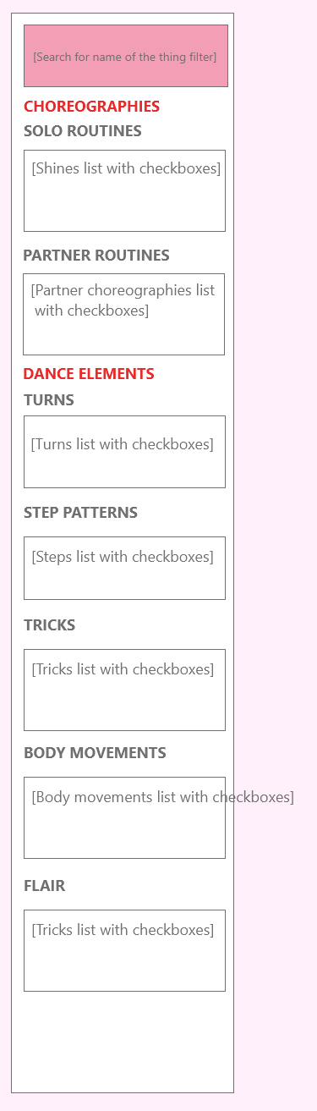

**FILTER COVERS SCREEN**

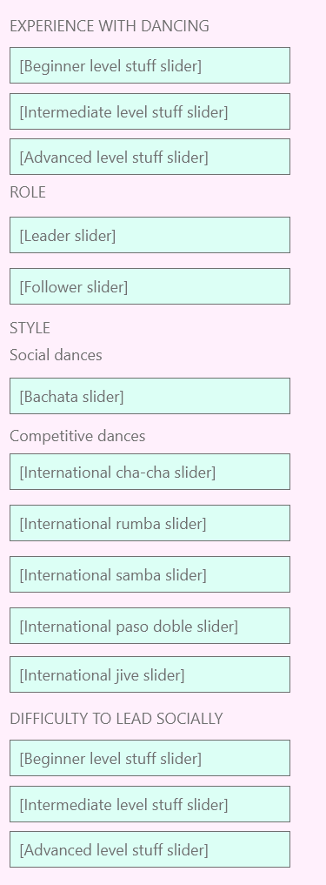

**LESSON CLICKED ON SCREEN**

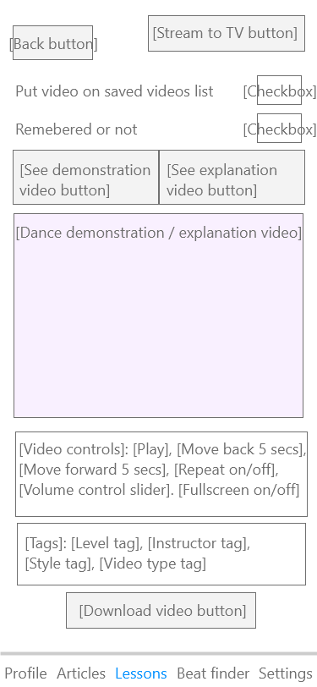

###### Beat finder screen

**FIND THE BEAT SCREEN**

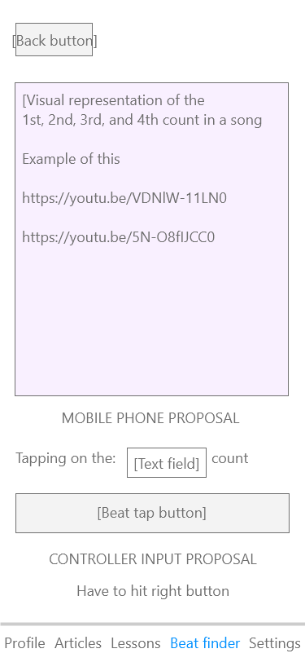

**FIND THE BEAT RESULTS SCREEN**

###### Settings screen

