Data engineering assignment

Kory

2024-03-24

MyDataAnalyzer$returnNumberOfMissingValues()

## [1] 0

MyDataAnalyzer$returnNumberOfRows()

## student_id rows type rows score rows class_id rows   
## 10000 3 400000 501

MyDataAnalyzer$returnMean()

## [1] 49.91072

MyDataAnalyzer$returnMedian()

## [1] 49.91215

MyDataAnalyzer$returnMaximum()

## [1] 99.99974

MyDataAnalyzer$returnMinimum()

## [1] 0.000262781

MyDataAnalyzer$returnMedian()

## [1] 49.91215

MyDataAnalyzer$return1stQuartile()

## 25%   
## 24.9378

MyDataAnalyzer$return3rdQuartile()

## 75%   
## 74.79861

MyDataAnalyzer$returnStandardDeviation()

## [1] 28.8425

MyDataAnalyzer$returnZScore()

## [1] -1.001037

MyDataVisualizer$graphScatterPlot(mongoDBDataset$class_id, mongoDBDataset$score)

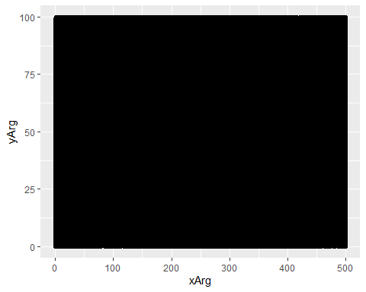

MyDataVisualizer$graphHistogram(mongoDBDataset$score, 6, c(rep("red", 1), rep("orange", 2), rep("lightgreen", 2), rep("darkgreen", 1)), "Where students grades lie", "grade", "grade count")

