Process of making the database

Came up with a design
Worked out:
- What tables I wanted
- What columns I wanted
- What data types to make the columns
- What keys I wanted and how they’d link
- What columns could optionally be filled out

Came up with a creation script
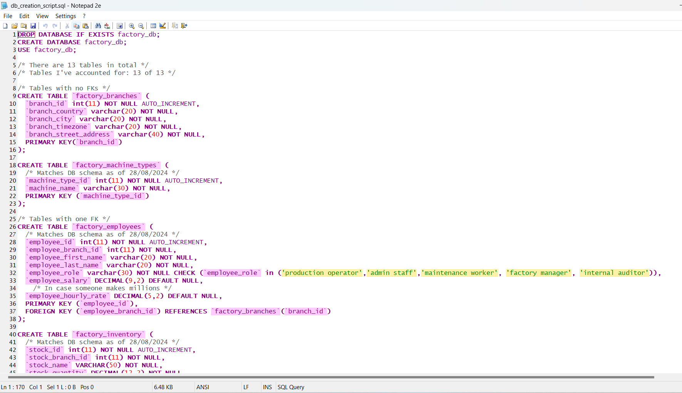

Worked out how to import the factory_logs.csv file into phpmyadmin
- Fixed the timestamps as Mac users (not that I am one), have issues with the data format for the timestamps
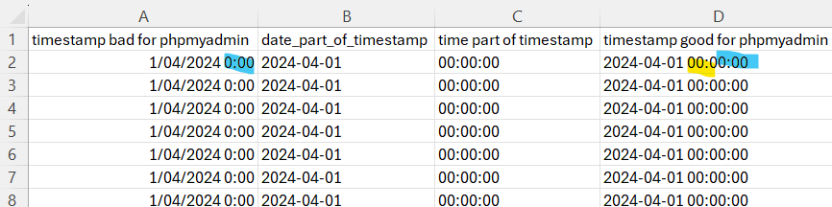
- Modified my.ini file in XAMPP so it could handle the large upload
[mysqldump]
max_allowed_packet=2G
- Modified php.ini file so it could handle the large upload
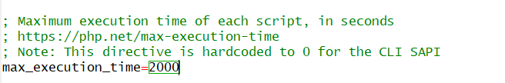
- Created ‘factory_logs’ table in phpMyAdmin
- Need to create table BEFORE importing values into it. This’ll stop it from making dumb decisions
  - Too small varchar
  - Making all timestamps the current time. Proof that it does this
DESCRIBE `factory_logs`;
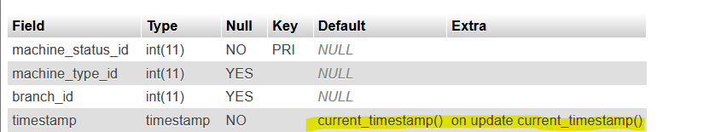

  - Cutting off decimal places

- Import factory_logs_fixed_timestamp.csv into phpMyAdmin for ‘factory_logs’ table
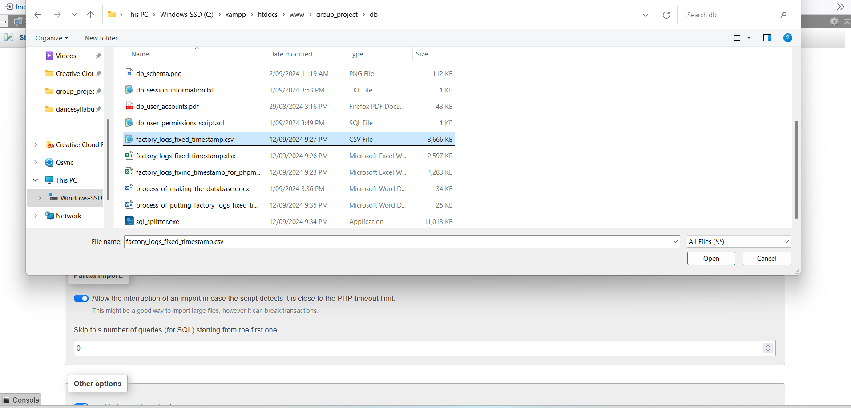

Turn off “Allow the interruption of an import in case the script detects it is close to the PHP timeout limit.”
Turn off “Enable foreign key checks”
Format “CSV”
Columns separated with “,”
Columns enclosed with “”
Columns escaped with “”
Turn on “Do not abort on INSERT error”

- Verify if it imported properly
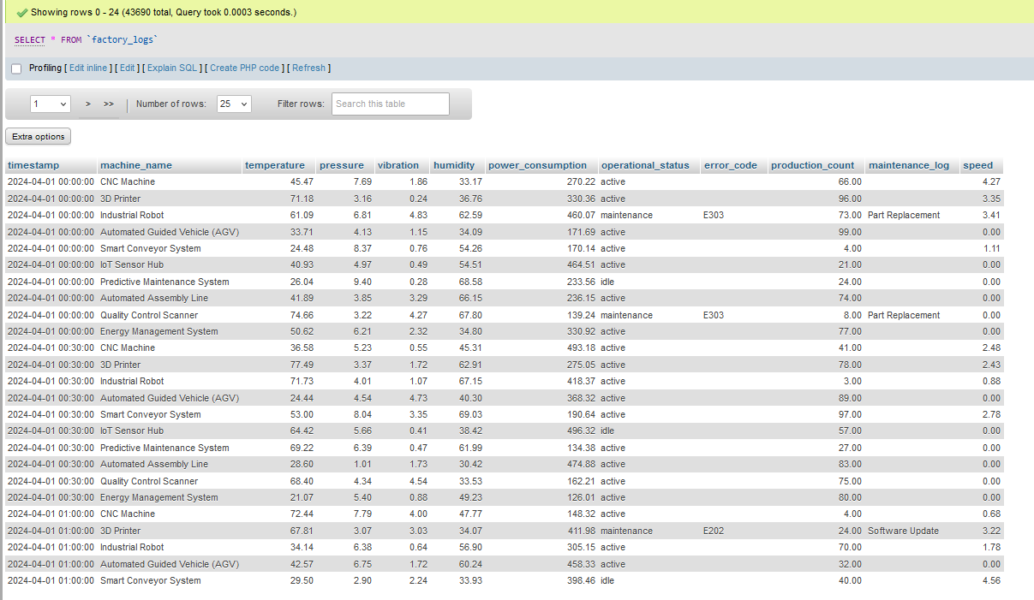

- Put distinct names from this table into ‘factory_machine_types’ table
insert into `factory_machine_types` (`machine_name`)
SELECT DISTINCT
`machine_name`
FROM `factory_logs`

- Adding a column
ALTER TABLE `factory_logs` ADD COLUMN `machine_type_id` INT;

- Replacing the name in a table with its corresponding ID in another table
UPDATE `factory_logs` fl
INNER JOIN `factory_machine_types` fm
ON fm.`machine_name` = fl.`machine_name`
SET fl.`machine_type_id` = fm.`machine_type_id`;

- Dropping a column
ALTER TABLE `factory_logs`
DROP COLUMN `machine_name`;

- Adding a column
ALTER TABLE `factory_logs`
ADD COLUMN `branch_id` INT AFTER `machine_type_id`;

UPDATE `factory_logs`
SET `branch_id` = FLOOR(1 + (RAND() * 3));

- Add auto incrementing column
ALTER TABLE `factory_logs` ADD COLUMN `machine_status_id` INT AUTO_INCREMENT PRIMARY KEY;

- Move ID columns in front of table (run each one separately and in order)
ALTER TABLE `factory_logs` MODIFY COLUMN `branch_id` INT FIRST;

ALTER TABLE `factory_logs` MODIFY COLUMN `machine_type_id` INT FIRST;

ALTER TABLE `factory_logs` MODIFY COLUMN `machine_status_id` INT FIRST;

- Rename table to factory_machines_and_machine_status
RENAME TABLE `factory_logs` TO `factory_machines_and_machine_status`;

- Export table as .SQL file
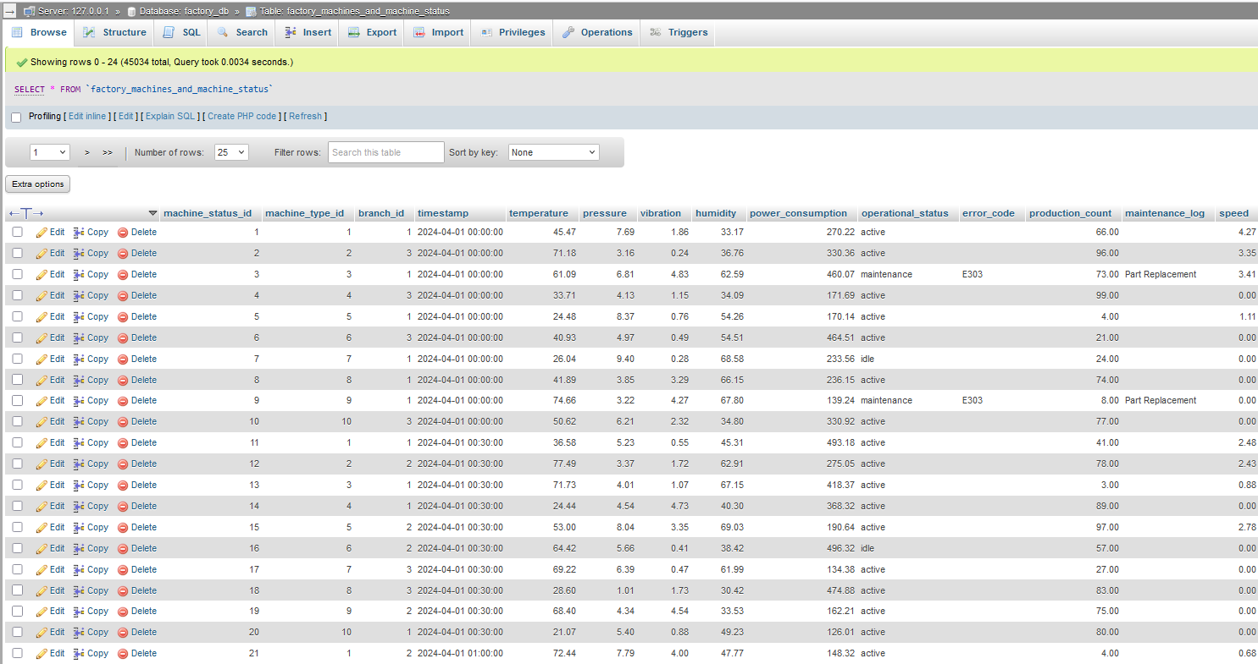

- Download SQL splitter
https://sqlsplitter.com/

- Split this large SQL file
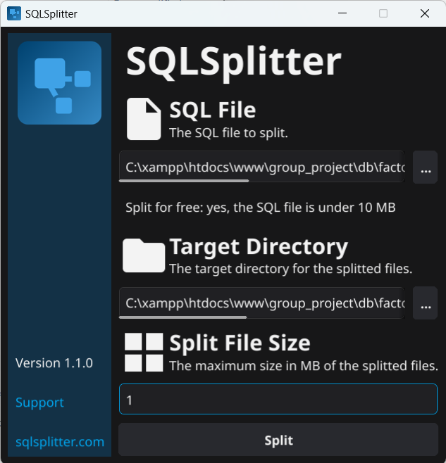

- End up with multiple files
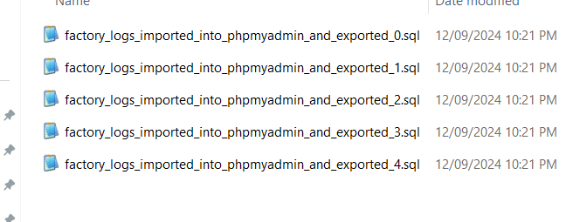

- For our DB creation script for this table. Make these improvements
- Add AUTO_INCREMENT to PK
- Make ID columns NOT NULL
- Make timestamp column NOT NULL
- Add key references

- Transfer insert statements into DB insert values script (now it’s split up so easier for phpMyAdmin)

- Verify that running create table and insert values script makes table we want
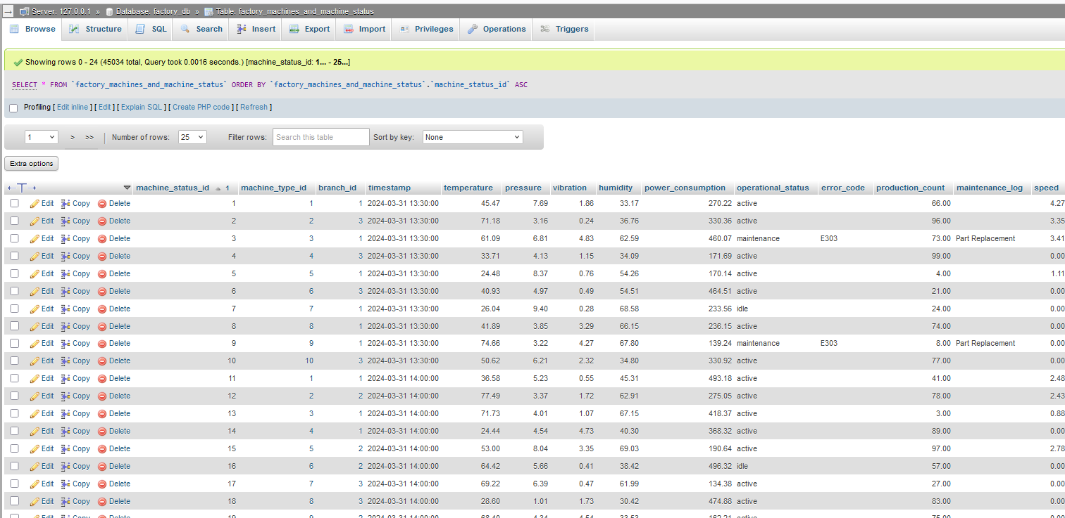

Used ChatGPT to make the mock data based on one’s own specifications
Total tables: 13
Number of tables accounted for: 11 of 13
- The “factory_machines_type” table is based on factory_logs.csv data so don’t need to use make mock data for it
- The “factory_machines_and_machine_status” table is based on factory_logs.csv data so don’t need to make mock data for it
- The “factory_employee_overtime” table I’ve decided to leave blank as can assume overtime hasn’t been worked up until now
- The “factory_shifts” table I’ve filled out oneself as it doesn’t need a lot of data in it

Independent from other tables
☒ TABLE factory_branches
Construct a SQL INSERT INTO statement for factory_branches table. It has columns
- branch_id: A unique non-repeating number starting from 1. Incrementing by 1.
- branch_country: Fixed value, "Australia".
- branch_city: City name from any Australian city.
- branch_timezone: PHP timezone value based on the selected city.
- branch_street_address: A random street address in the outer suburbs of the selected city.

☒ TABLE factory_employees
Construct a SQL INSERT INTO statement for factory_employees table. It has columns
- employee_id: Unique Integer (1 to 60)
- employee_first_name: Factory Worker First Name (Primarily male, some female)
- employee_last_name: Factory Worker Last Name
- employee_email_address: Based on person’s name. Use email providers commonly used in Australia
- employee_role: Values: `production operator`, `factory manager`, `maintenance worker`, `admin staff `, `internal auditor`. Distribution: Majority are `production operator`
- employee_salary: If employee_role is not production operator. Generate a realistic salary based on the role. Have each person of the same employee_role excluding production operators on the same salary in AUD
- employee_hourly_rate: If employee_role is production operator. Generate a realistic hourly rate in AUD based on the role. Have every person of the same production operator employee_role on the same hourly rate in AUD

Doesn’t seem to have listened to me about having women!

Dependent on other tables – 1 other table
☒ TABLE factory_inventory
- Provide factory_branch table values when generating this table

Construct a SQL INSERT INTO statement for factory_inventory table. It has columns
- stock _id: Unique Integer (1 to 100)
- branch_id: Random number corresponding to branch_id from factory_branches table
- stock_name: Name of stock that might appear in a factory environment
- stock_quantity: Random quantity of the stock that’s indicated in the stock_name field. The quantity should be realistic given what might be seen in a factory environment like it has to fit in the building

☒ TABLE factory_jobs
- Provide factory_employee table values when generating this table
- Provie factory_machine_types table values when generating this table
  - Mention these are machines production operators work with

Construct a SQL INSERT INTO statement for factory_jobs table. Provide me with 60 rows. It has columns
- job_id: Integer, unique, values from 61 to 121, in ascending order
- job_employee_id: Integer, unique, values from 61 to 121, in ascending order
- job_assigned_date: Date within September 2024. Can’t be past current date
- job_completed_date: Majority have NULL value. Few have date after or on job_assigned_date. Can’t be past current date
- job_description: Text, describes the job based on the factory_employee_role indicated in the factory_employee table with the employee_id in factory_employees table corresponding to the job_employee_id in the factory_jobs table.
  - For "maintenance worker": Describe the job related to maintenance tasks
  - For "production operator": Describe the job related to manufacturing tasks
  - For "factory manager": Describe the job related to factory management tasks
  - For "admin staff": Describe the job related to administrative/clerical tasks such as but not limited to updating user records and doing the payroll
  - For "internal auditor": Describe the job related to auditing tasks
- For all these roles do not include a prefix
- Be more creative with the descriptions
- No two jobs should have the same description.
- job_status: Text, can be one of 'active', 'postponed', 'cancelled', or 'finished'
- job_task_notes: Text, additional notes about the job
- job_priority: Integer, random value between 1 and 5

Repeat, adjusting values from range

☒ TABLE factory_user_accounts
- Provide factory_employee table values when generating this table

Construct a SQL INSERT INTO statement for factory_user_accounts table. It has columns
- user_account_id: Unique Integer (1 to 60)
- user_employee_id: Unique integer. Corresponds to employee_id from factory_employees in order
- user_username: First four letters of the last name from employee_last_name field from factory_employees + four random digits added to the end (e.g., `smit1234` for Smith)
- user_password: Secure password with Australian themes (e.g., `K@ng@roo1!`, `Veg3m!teRox!`)

☒ TABLE factory_safety_incidents
- Provide factory_employee table values when generating this table

Construct a SQL INSERT INTO statement for factory_safety_incidents table. It has columns
- incident _id: Unique Integer (1 to 10)
- incident_employee_id: Corresponds to random employee_id from factory_employees
- incident_date: Generate random date
- incident_description: Indicate what safety incident occurred
- incident_outcome: Indicate outcome of the safety incident in the incident_description

☒ TABLE factory_employee_time_period_worked
- Provide factory_employee table values when generating this table

Construct a SQL INSERT INTO statement for factory_employee_time_period_worked table. It has columns
- working_time_period _id: Unique Integer (1 to 100)
- working_time_period_employee_id: Random number corresponding to employee_id from factory_employees table. No employee_id should be left out.
- employee_shift_id: Put in 1, 2, or 3. 1 if day shift. 2 if afternoon shift. 3 if night shift. Factor in time period employee worked
- employee_clock_in_date: Put in random dates an employee started working
- employee_clock_in_time: Put in time employee started working based on their shift (day, afternoon, night)
- employee_clock_off_time: Put in time employee stopped working based on reasonable timeframe for an employee to finish their shift by. Base this on the clock_in_time
- employee_clock_off_date: Derive the date the employee clocked off based on the clock_in_date (date started working), clock_in_time (time started working), and clock_off_time (time stopped working).

☒ TABLE factory_employee_grievances
- Provide factory_employee table values when generating this table

Construct a SQL INSERT INTO statement for factory_employee_grievances table. It has columns
- grievance _id: Unique Integer (1 to 10)
- grievance_employee_id: Random number corresponding to employee_id from factory_employees table
- grievance_date: Indicate the date when the issue was raised to or by a manager
- grievance_description: Come up with different people-related issues that an employee might bring up to a manager (e.g. complaints surrounding disrespectful treatment) or that a manager might bring up to an employee (e.g. indicating an employee has attendance problems or that they’re underperforming)
- grievance_action_taken: Indicate what actions were taken to resolve the issue

☒ TABLE factory_employee_messages
- Provide factory_employee table values when generating this table

Construct a SQL INSERT INTO statement for factory_employee_messages table. It has columns
- message_id: Unique Integer (1 to 100)
- sender_employee_id: Random integer corresponding to employee from factory_employees table
- recipient_employee_id: Random integer corresponding to employee from factory_employees table
- conversation_id: Unique Integer (1 to 100)
- message_title: Consider what factory_employee with the sender_employee_id might send recipient_employee_id by looking at the employee_role in the factory_employees table. Come up with a message title
- message_body: Based on message_title come up with an appropriate body for the message
- message_date: Generate a random date

Dependent on other tables – 2 other tables
☒ TABLE factory_employee_breaks_taken
- Provide factory_employee and factory_employee_time_period_worked table values when generating this table

Construct a SQL INSERT INTO statement for factory_employee_breaks_taken table. It has columns
- break_period_id
- break_taker_employee_id
- break_start_date
- break_start_time
- break_finish_time
- break_finish_date
- break_type

Make sure that the break_taker_employee_id corresponds to a working_time_period_employee_id
in the factory_employee_time_period_worked. Each break_taker_employee_id should only appear as many times as the working_time_period_employee_id appears (e..g if working_time_period_employee_id of integer 1 appears once then break_taker_employee_id should also only appear once)

Make sure that break_period_id is a unique integer
Make sure that the break_start_date is based on the employee_clock_in_date from the factory_employee_time_period_worked table.
Make sure that the break_start_time is time when the shift started. This should based on typical break times for the shift types (day, afternoon, night) for the employee's shift

Make sure that the break_type should be either "rest break" or "meal break." Ensure that for each interval between break_start_date and break_finish_date, there is at least one rest break and one meal break, but no more than one of each type within that interval.

Make sure that break_finish_time is calculated based on the break duration. If it’s a rest break, the duration should be approximately 15 minutes. If it’s a meal break, the duration should be approximately 30 minutes.

Make sure that break_finish_date is calculated based on break_start_date, break_start_time, and break_finish_time. Ensure it accurately reflects when the break ended.

Doesn’t seem to have listened to me! Generates first 50 values. Misses some values. Could perhaps be used to show that the employees haven’t been taking adequate breaks in the report that the auditor looks at.

☒ TABLE factory_employee_payments
- Provide factory_employee and factory_employee_time_period_worked table values when generating this table

Construct a SQL INSERT INTO statement for factory_employee_payments table. It has columns
- payment_id: Unique Integer (1 to 100)
- payment_employee_id: Random number corresponding to employee_id from factory_employees table
- payment_date_period_start: Indicate the date the employee pay period starts for. Should be somewhat within the vicinity of the period that the employee indicated by the payment_employee_id worked as indicated in the clock_in_date in the factory_employee_time_period_worked table
- payment_date_period_end: Base on payment_date_period_start. Payment should be fortnightly if employee_id has role of production operator. Should be monthly otherwise.
- payment_amount: Approximate amount to pay employee. If there’s an hourly rate indicated by the employee_id from the factory_employees_table then make amount paid based on the hours worked in the factory_employee_time_period_worked table for dates within this payment_date_period. If there’s a salary indicated in employee_id make payment_amount an approximation based on salary of employee with employee_id and the time period indicated in payment_date_period_start and payment_date_period_end

Used SQL to work out the amount earnt for period for each employee
ChatGPT couldn’t give me reasonable mock-data for the amount each employee earned based on my instructions so had to manually correct this

ChatGPT prompt: "Create an SQL query to calculate employee payment amounts based on hours worked. Use the employee's hourly rate if available; otherwise, calculate it from their annual salary by dividing it by 2080 (the total working hours in a year). The query should join employee data with hours worked data from a separate table."

SELECT
e.employee_id,
e.employee_first_name,
e.employee_last_name,
total_hours,
-- Calculate the hourly rate from salary if hourly rate is NULL
COALESCE(e.employee_hourly_rate, e.employee_salary / 2080) AS calculated_hourly_rate,
-- Calculate the payment
CASE
WHEN total_hours > 40 THEN
(40 * COALESCE(e.employee_hourly_rate, e.employee_salary / 2080)) +
((total_hours - 40) * COALESCE(e.employee_hourly_rate, e.employee_salary / 2080) * 1.5)
ELSE
total_hours * COALESCE(e.employee_hourly_rate, e.employee_salary / 2080)
END AS payment_amount
FROM
factory_employees e
JOIN
(SELECT
ft.working_time_period_employee_id,
SUM(TIMESTAMPDIFF(HOUR,
CONCAT(ft.employee_clock_in_date, ' ', ft.employee_clock_in_time),
CONCAT(ft.employee_clock_off_date, ' ', ft.employee_clock_off_time))) AS total_hours
FROM
factory_employee_time_period_worked ft
GROUP BY
ft.working_time_period_employee_id) AS hours
ON
e.employee_id = hours.working_time_period_employee_id;

Used SQL to edit existing tables
- Hash the user passwords
UPDATE `factory_user_accounts`
SET `user_password` = SHA2(`user_password`, 256);

