Pages 04 to 13 represent the 10 pages of content I was allowed to have and cover what I was asked to discuss (decisions, site map, what code was used and for what). Tried to be brief and to the point as I had limited space to work with. The rest of the pages contain the bibliography, table of contents, table of figures, cover page, and appendix for an ER & UML diagram, GitHub activity log, and website screenshots
Design and development report
Human Factors for Interactive and Web-Based Systems
Presented by Kory Frankee
fran0618

Table of contents
01) Sitemap pp. 04-05
02) Development and UI/UX decisions made pp. 05-10
02.1) Following best practices for the DB p. 05
0.2.1.1) Security measures p. 06
0.2.1.2) Data integrity measures p. 06
0.2.1.3) Usefulness of the data measures p. 06
0.2.1.4) Clarity of the data measures p. 06
0.2.1.5) Usability of the DB scripts measures p. 06
02.2) Following best practices for the website pp. 07-10
0.2.2.1) Security measures p. 07
0.2.2.2) UX measures pp.07-10
0.2.2.3) Stability measures p.10
0.2.2.4) Performance measures p.10
0.2.2.5) Code orderliness measures p.10
0.2.2.6) Server cleanliness measures p. 10
03) What was used to implement the website pp. 11-12
0.3.1) HTML used p. 11
0.3.2) CSS used p. 11
0.3.3) JS used p. 12
0.3.4) PHP used p. 12
04) References p. 13
05) Bibliography pp. 14-17
05.1) Learning resources for programming pp. 14-15
05.2) Learning resources for UI/UX pp. 15-16
05.3) Bad passwords to use data p. 16
05.4) What Visual Studio extensions were used p. 17
05.5) How AI tools were used p. 17
06) Appendix pp. 18-53
A) DB schema (UML and ER diagrams) pp. 18-19
B) Website screenshots pp. 20-51
C) GitHub logs pp. 52-53

Table of figures
Figure 1 Sitemap 4
Figure 2 Container representing the page elements found within all of the pages that share common page elements 4
Figure 3 Container representing the pages of all of the pages that share common page elements 5
Figure 4 What it's like to be colour blind 8
Figure 5 HTML tags wordcloud 11
Figure 6 CSS properties wordcloud 11
Figure 7 JS wordcloud 12
Figure 8 Custom JS wordcloud 12
Figure 9 PHP wordcloud 12
Figure 10 Custom PHP wordcloud 12

Report

01) Sitemap
- Covers what page and page elements there are and how it’s possible to access them
- Covers CRUD operations
- Covers what functionality is built-in to the site
- Covers what users can access based on their roles
- Covers what actions users can perform
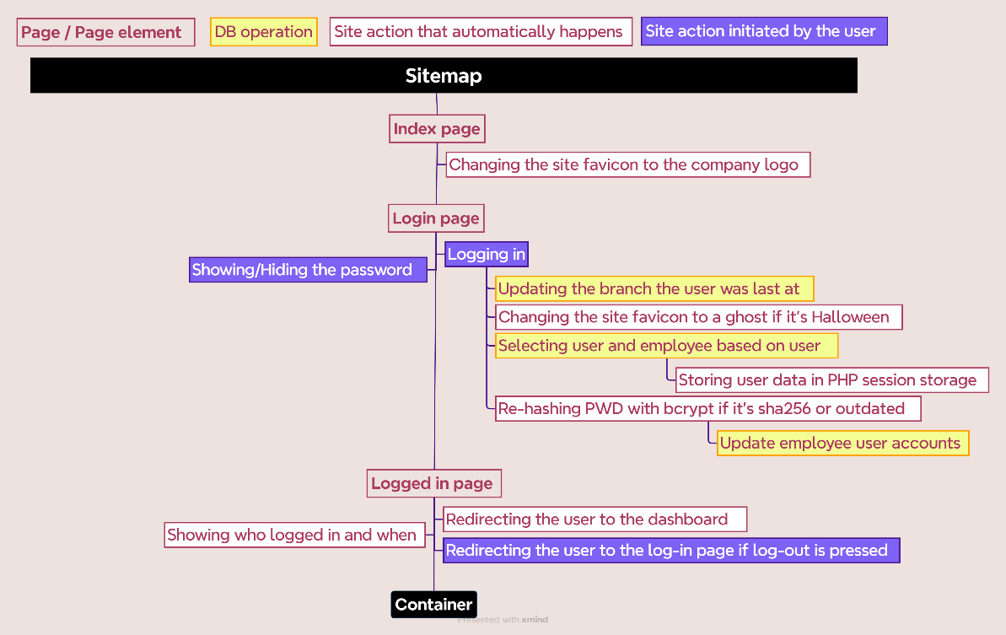
Figure 1 Sitemap

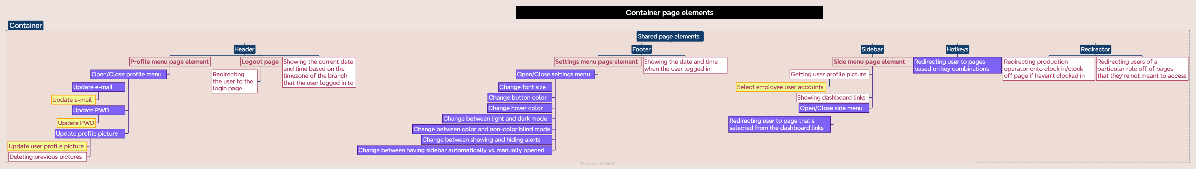
Figure 2 Container representing the page elements found within all of the pages that share common page elements

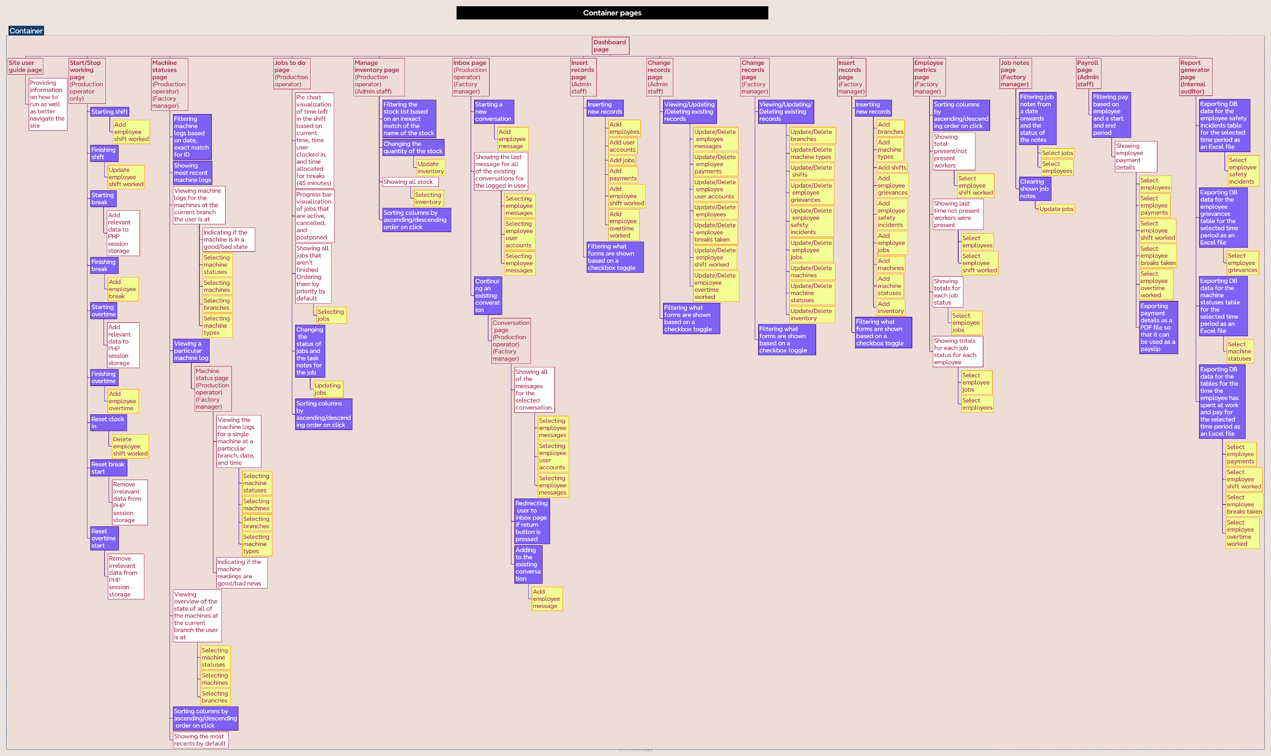
Figure 3 Container representing the pages of all the pages that share common page elements

02) Development and UI/UX decisions made

02.1) Following best practices for the DB

0.2.1.1) Security measures
- Setting a root password.
- Hashing passwords with SHA-256 initially since MySQL supports this.
- Setting a password and appropriate privileges for the user accessing the DB.
- Limiting access to the DB to local users only.

0.2.1.2) Data integrity measures
- Setting constraints.
- Setting unique identifiers.
- Restricting what can be inputted for some fields to prevent improper input.
- Minimizing data duplication.
- Having all records referencing a deleted record disappear.
- Making it so the DB can scale up to handle a lot of data.

0.2.1.3) Usefulness of the data measures
- Collecting data that resembles real-world data
- Using appropriate data types.

0.2.1.4) Clarity of the data measures
- Having clear and descriptive names for the tables and fields within the table.

0.2.1.5) Usability of the DB scripts measures
- Making it so the scripts can be executed with little effort.

02.2) Following best practices for the website

0.2.2.1) Security measures
- Having strong password (PWD) requirements
  - Minimized risk of brute force and dictionary attacks through asking for more complex PWDs. Looked at millions of PWDs from past data breaches and made sure PWDs our users generate wouldn’t match. Also don’t allow the user to set PWDs that exist in a file of known bad PWDs. The problem with data breach data is that the data is of a poor standard (e.g. some of it’s still hashed) and file sizes can be huge (e.g. the “rockyou2024.txt” file size is 145.25 GB). If less strict password requirements were used, I’d advise checking merely for the most probable worst PWDs since you can’t check for every single one since the list of PWDs in past dictionary attacks is gigantean
- Hiding the config file that’s used to connect to the DB from public view with a .htaccess file.
- Setting a high cost factor of 16, making it more computationally expensive to brute force the PWDs at the expense of a slower log-in due to an ~ 3-4 second password hashing process. Figured that this was the absolute highest value that would be reasonable as increases to the cost factor make the time it takes to hash the password grow exponentially so like a cost factor of 20 is ~ 17x slower. The default cost factor value in PHP is 12 but this value should be raised as computers become more powerful
- Using prepared statements to prevent against SQL injection
- Using bcrypt password hashing. If PWD is hashed in sha256 since MySQL supports this, it changes to a bcrypt hash on log-in since that’s a more secure hash due to it having a cost factor and salt
- Validating user input.
- Sanitizing user input.
- Logging the user out if there’s a mismatch between their IP address and browser used to navigate the website from what was saved in session storage
- Prohibiting inappropriate input (e.g. when uploading a profile picture, only images are allowed)
- Setting a maximum session lifetime to minimize risk of unauthorized users accessing the site as well as minimize the time window that attackers would have to hijack the user’s session
- Redirecting users off pages if they are unauthenticated or their role shouldn’t access that page.

0.2.2.2) UX measures
- Asking for confirmation for infrequent actions that could have negative consequences for the user if it were to be performed by mistake (e.g., deleting a record).
- Coming up with pages to develop:
  - Working out what pages are worth adding based on user specifications and my own personal experiences with factory systems from working at places like Stan Bond, Pinz, and Philmac
  - Working out the purpose of each page and the actions users will perform on them.
  - Working out what elements might appear on the pages and where to position them in Figma.
- Factoring in factory environment:
  - Not having SFX
- Following conventions set by other websites:
  - Using familiar terms (e.g. “Back” over “Give ground”)
  - Positioning elements in familiar locations (e.g. logo in the top-left corner)
- Better accommodating inexperienced with tech users:
  - The website is quite basic so even a first-time user of the system could use/figure it out in no time
- Better accommodating tablet users:
  - Having large buttons for easier interaction.
  - Spacing buttons far apart to accommodate touch inaccuracies, preventing accidental selection
- Better accommodating users on a range of devices:
  - Making the website responsive, that page elements are not out of the bounds of the page:
    - Shifting page elements
    - Removing less important page elements from view (e.g. time user logged in)
    - Having scrollbars if the page elements take up more space than the screen can fit in one view.
- Better accommodating users with poor vision/Making the site more readable:
  - Making important information stand out:
    - Larger font sizes
    - Greater font weights
  - Offering a dark/light mode so users can pick what setting is easier on the eyes for them
  - Aligning text either to the left or the centre based on what seemed more readable
  - Distinguishing buttons close to one another by having a different colour for them. This is so a button isn’t accidentally pressed if the user isn’t careful (e.g. the delete button has a red background)
  - Using consistent fonts, colours, and layouts across pages
  - Having balance like symmetry (e.g. having as much on the LHS as what’s on the RHS)
  - Offering customizable font sizes
  - Making page elements more compact so can see more in one view of the screen
  - Minimizing visual clutter:
    - Having users choose what’s shown instead of overwhelming them with too much on the screen.
    - Not having superfluous or unexpected elements on the page in the first place
  - Adding distance between page elements. The more distance, the less the elements are related
  - Having a large font size by default.
  - Putting like content with like content for a logical structure that’s easier to read
  - Using “Roboto Regular”, a sans-serif font for most text and “Courier New”, a monospaced font for number due to their high legibility
  - Utilizing contrasting colours (e.g. black on white or white on black)
  - Offering a change button and hover effect colour setting so users can pick what colours suit them
  - Implementing a red-green colour blind mode setting:
    - Converts Green to Blue
    - Converts Red to Black
    - Keeps Yellow as Yellow (since the problem is identifying Red/Green, not Yellow)
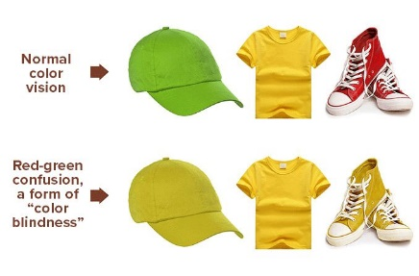
Figure 4 What it's like to be colour blind (Bailey 2000)
- Better accommodating hurried or impatient users or users that want to do tasks quicker:
  - Minimizing the use of animations and CSS transitions
  - Minimizing the number of actions needed to go where the user wants (e.g. through hotkeys)
  - Auto-filling known information, not even prompting user for it
  - Offering buttons that perform convenient actions (e.g. show most recent logs)
  - Making it so filters left blank aren’t applied to reduce user choices and increase task efficiency.
    - E.g. If a start date is specified but an end date is not specified then it filters the records by date from the start date to now instead of the user having to put in the current date as the end date
  - Placing buttons for related actions together so it takes less time to move between them
  - Performing actions by default, saving a click (e.g. starting with show most recent logs shown)
  - Making the filters more forgiving (e.g. If searching for an item, don’t have to match casing)
  - Exporting data into suitable formats for their use case (e.g., PDF for payslips, Excel for reports).
  - Making it so users don’t have to know the PK ID number when inserting records (it’s automatically put in) or the FK ID number when inserting or managing records through a dropdown list. Still showing the ID in the dropdown in case there’s a desire to search for it or in case two records have the same name but different IDs (e.g. two employees with the same first and last name)
- Making what is shown clearer for users:
  - Indicating if something is bad or good news through colour.
  - Using meaningful labels/headings/titles
  - Indicating when an element is selected or hovered over through colour.
  - Indicating the total records and what record the user is looking at when changing records
- Making users aware of what’s possible:
  - Telling users what actions can be performed on screen.
- Making it so users can see the information that’s most relevant to them:
  - Highlighting key information
  - Making it so filters can be applied to narrow down what’s shown to what’s relevant.
  - Making it so it’s possible to reorganize the information based on user preferences (e.g., sorting table columns by ascending/descending order).
- Making the site easier to navigate:
  - Making it so users could navigate the site with a dashboard page that serves as a portal to all other pages and a sidebar on each page.
  - Making it so users don’t have to dig too deep to find all the links
  - Having no broken links
- Making what will happen clearer for users:
  - Providing users with information about what’s happening behind the scenes:
    - Having alerts to indicate successful or failed actions
  - Describing actions from the user’s perspective
  - Minimizing unnecessary text
  - Using proper spelling and grammar
  - Using unambiguous and consistent language for UI elements.
  - Ensuring UI elements function as expected.
  - Telling users what to do in response to error messages
- Providing a more streamlined experience:
  - Displaying updated content without having to refresh the page.
  - Redirecting users onto a page if that’s the natural place for them to end up.
- Personalizing the experience for users:
  - Referring to users by their name or "you."
  - Showing user profile pictures and relevant time zones.
  - Customizing the experience the user has based on their job role (where appropriate).
- Special seasonal customization:
  - Switching to a ghost website icon if it’s Halloween instead of the default company website icon.

0.2.2.3) Stability measures
- Catching (with line and file indicated, as well as a custom error message if desired) and fixing errors

0.2.2.4) Performance measures
- Making it so the website is fast loading (except for a slower login process for security purposes):
  - Not having a lot of the assets on the page to load
- Freeing up resources.
- Displaying content dynamically from the DB to reduce redundant HTML.

0.2.2.5) Code orderliness measures
- Separating CSS/JS/PHP from HTML into its own separate file where possible.
- Making use of functions to repeat series of instructions for new cases.
- Making pages have different views for different users to reduce redundant code.
- Making use of named parameters.

0.2.2.6) Server cleanliness measures
- Made use of the MySQL long blob data type for storing message attachments (.pdf, .xls .xlsx, and .txt files). Having message attachments associated with messages in the DB is preferable to storing the message attachments on the server itself as having it in the DB makes cleanup operations easier
  - E.g. When an employee leaves, if they’re deleted from the factory employees table then all messages sent to them (and in effect, message attachments) are also cleaned up, making the DB smaller
- Making use of storage on the actual server for profile pictures. Base filename on employee’s username (that’s unique) so you don’t delete the wrong file or have two pictures shared by the same employee as well as their first name and last name (so it’s easier to know what picture is associated with who). When a user uploads a new profile picture (say, a .png) this overwrites any existing images of the same filename and file extension. I automatically delete any filenames with other extensions (say, a .jpg)
  - E.g. When employee leaves, it’s easy to know what to remove as there’s only one picture vs. potentially hundreds of message attachments to one employee and because of the filenames, it’s super obvious what to manually or use a script to remove, not that a picture takes up a lot of space

03) What was used to implement the website

03.1) HTML used

Documented HTML used wordcloud
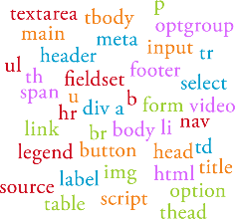
Figure 5 HTML tags wordcloud
Used for page structure, layout, and content

03.2) CSS used

Custom CSS used wordcloud
All I used that’s custom CSS is one’s own CSS variables

Documented CSS used wordcloud
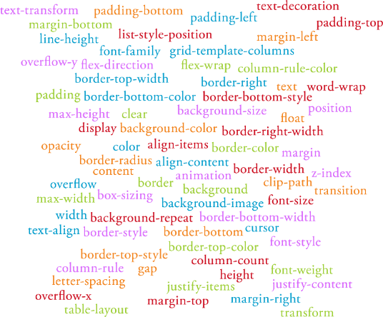
Figure 6 CSS properties wordcloud
Used for controlling the layout, appearance, and behavior of page elements as well as for responsive design

03.3) JS used
Documented JS used wordcloud | Custom JS used wordcloud
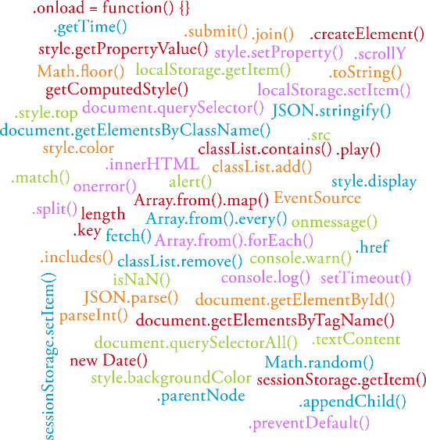  Figure 7 JS wordcloud | 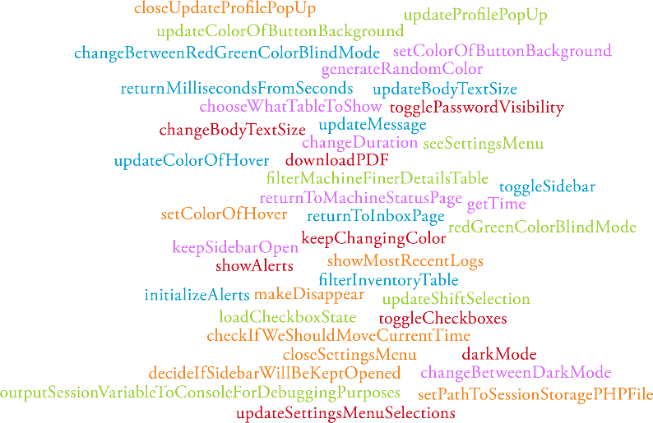  Figure 8 Custom JS wordcloud
Used for DOM manipulation, event handling, data processing, and interactivity | Used for handling interactions with the UI, controlling the visibility and layout of page elements, filtering and displaying data

03.4) PHP used
Documented PHP used wordcloud | Custom PHP used wordcloud
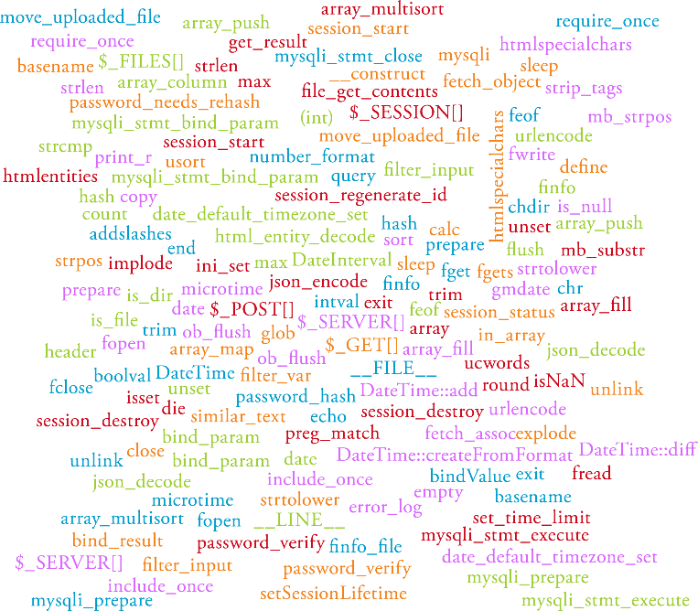  Figure 9 PHP wordcloud | 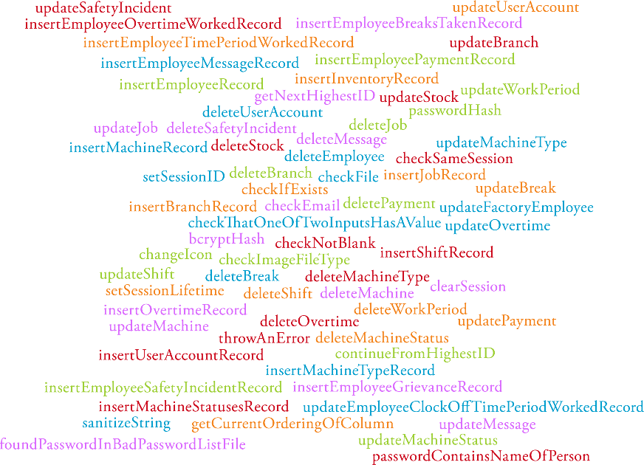  Figure 10 Custom PHP wordcloud
Used for DB interactions, security, file handling, session handling, and data manipulation | Used for validating input, managing DB records, handling user sessions, and implementing security measures like password hashing or seeing if a password exists in a text file of bad passwords to use

04) References

Code
Switch
- W3Schools n.d.. “How To Create a Toggle Switch”. W3Schools, viewed 2024, <w3schools.com/howto/howto_css_switch.asp>.

Notched corners
- Kavinda, S 2024, “How to create fancy corners with CSS”, LogRocket Blog, viewed 6 2024, <blog.logrocket.com/create-fancy-corners-css/>.

Pie chart
- Scarpitta, C 2021, “Build a simple Pie Chart with HTML and CSS”, DEV Community, viewed 2024, <dev.to/cscarpitta/build-a-simple-pie-chart-with-html-and-css-32dn>.

Sidebar
- Codingtotime 2024. “Responsive sidebar toggle”. CodingToTime, viewed 2024, <codingtotime.com/article/responsive-sidebar-toggle-code-with-boxicons-css>.

PDF maker
- Plathey, O 2019, “FPDF PHP class”, FPDF, viewed 2024, <fpdf.org/>.

Date validation
- GeeksforGeeks, 2024. “How to check a date is valid or not using JavaScript”, GeeksForGeeks, viewed 2024, <https://www.geeksforgeeks.org/how-to-check-a-date-is-valid-or-not-using-javascript/>

Assets
Logo
- Stan Bond Adelaide. 2024. “Stan Bond | Blinds, Curtains, Shutters, Crimsafe Security | Adelaide”. Stan Bond, Viewed 2024, <stanbondsa.com.au/>

Induction video
- WorkSafe 2020, “WorkSafe induction video”, YouTube, viewed 2024 <youtu.be/zKaMtbiQ9Io>

05) Bibliography

05.1) Learning resources for programming
Workshops
- Wilkinson, B 2024, “PHP workshop on Wednesday 21 August 2024”, Flinders University, viewed 2024.
- Wilkinson, B 2024, “PHP workshop on Wednesday 28 August 2024”, Flinders University, viewed 2024.

Language documentation
- Php.net 2019, “PHP: Documentation”. PHP, viewed 2024, <www.php.net/manual/en/>.
  - Helped with understanding how I could use PHP (e.g. how I could use finfo_buffer)
- Mozilla 2019, “CSS: Cascading Style Sheets”. MDN Web Docs. Viewed 2024, <https://developer.mozilla.org/en-US/docs/Web/CSS>

Answers to specific questions I had
- Apache.org 2018. “MIME types”, Apache Software Foundation Subversion Server, viewed 2024, <svn.apache.org/repos/asf/httpd/httpd/trunk/docs/conf/mime.types>
- CodexWorld.2023, “Export data to Excel in PHP”, CodexWorld, viewed 2024, <codexworld.com/export-data-to-excel-in-php/>
- Joaquín Fernández 2015, “mysqli_stmt::send_long_data - PHP Manual”. Joaquinfernandez.net, viewed 2024, <php.joaquinfernandez.net/pt/mysqli/mysqli_stmt/send-long-data/mysqli-stmt.html>
- odd_duck 2024, “PHP - Move a file into a different folder on the server”, Stack Overflow, viewed 2024, <stackoverflow.com/questions/19139434/php-move-a-file-into-a-different-folder-on-the-server>
- RaGE 2008, “Can I change the checkbox size using CSS?” Stack Overflow, viewed 2024, <stackoverflow.com/questions/306924/can-i-change-the-checkbox-size-using-css>
- rvandoni 2024, “When and why I should use session_regenerate_id()?” Stack Overflow, viewed 2024, <stackoverflow.com/questions/22965067/when-and-why-i-should-use-session-regenerate-id>
- Singhai, V 2024, “Tips to export PHP data to XLS file”, Knowband, viewed 2024, <knowband.com/blog/tips/export-php-data-xls-file/>
- Stack Overflow 2019, “html - What does enctype=‘multipart/form-data’ mean?” Stack Overflow, viewed 2024, <stackoverflow.com/questions/4526273/what-does-enctype-multipart-form-data-mean>
- Susaki, H 2021, “How to represent optional attributes in an ER diagram?” Stack Overflow, viewed 2024, <stackoverflow.com/questions/64732357/how-to-represent-optional-attributes-in-an-er-diagram>.
- Tucker, T 2024, “Overriding Browser’s Keyboard Shortcuts”, Stack Overflow, viewed 2024, <stackoverflow.com/questions/3680919/overriding-browsers-keyboard-shortcuts>
- user310291 2024, “Does MySQL support historical date (like 1200)?” Stack Overflow, viewed 2024, <stackoverflow.com/questions/2487543/does-mysql-support-historical-date-like-1200>
- YashArora 2024, “Is there a way to interpolate CSS variables with url()?”, Stack Overflow, viewed 2024, <stackoverflow.com/questions/42330075/is-there-a-way-to-interpolate-css-variables-with-url>
- Zuga.net 2024, “HTML - Heading elements h1, h2, h3, h4, h5 and h6”. Zuga.net, viewed 2024, <zuga.net/articles/html-heading-elements>

Books
- Barefoot, D 2017, “JavaScript and jQuery: The Missing Manual”. 3rd ed. Sebastopol, CA: O'Reilly Media, viewed 2024
- Duckett, J 2011, “HTML & CSS: Design and Build Websites”. 1st ed. Chichester: Wiley, viewed 2024
- Groner, L 2018, “Learning JavaScript Data Structures and Algorithms”. 2nd ed. Birmingham: Packt Publishing, viewed 2024
- Lockhart, J 2017, “Modern PHP: New Features and Good Practices”. 1st ed. New York, NY: O'Reilly Media.
- McFarland, T 2014, “PHP, MySQL, JavaScript, and HTML5 All-in-One for Dummies”. 1st ed. Hoboken, NJ: Wiley, viewed 2024
- Nixon, R. 2018, “Learning PHP, MySQL, JavaScript, CSS, and HTML5”. 4th ed. New York, NY: O'Reilly Media, viewed 2024

05.2) Learning resources for UI/UX
Books
- Cooper, A., 2010. “Seductive interaction design: creating playful, fun, and effective user experiences (Voices that matter)”. New York: New Riders.
- Johnson, J., 2000, “GUI Bloopers: Don'ts and Do's for Software Developers and Web Designers”. San Francisco, CA: Morgan Kaufmann Publishers, viewed 2024
- Yablonski, J 2019, “Laws of UX: Using Psychology to Design Better Products & Services”, 1st edn. New York: O'Reilly Media, viewed 2024

Lecture notes
Wilkinson, B., 2024. “Lectures for Human Factors for Interactive and Web-Based Systems”, Flinders University, viewed 2024.

Webpages
- Atelier Studios, 2019, “Web design principles”, viewed 2024, <atelierstudios.com/web-design-principles/>
- Babich, N 2020, “12 Top Web Design Principles That Every Beginner Should Know”, Mockplus, viewed 2024, <mockplus.com/blog/post/web-design-principles>
- Bailey, G. 2000, “Color Blindness Explained”, All About Vision, viewed 2024, <allaboutvision.com/conditions/colordeficiency.htm>
- Bajpal, B 2019. “13 effective website design principles”, Dilate, viewed 2024, <dilate.com.au/blog/13-effective-website-design-principles-2019/>
- Corre-Tanzon, J 2024, “50+ web design principles”, Optimind Technology Solutions, viewed 2024, <myoptimind.com/web-design-principles/>
- Dauntless Agency, 2024, “10 fundamental web design principles”, Dauntless, viewed 2024, <https://wearedauntless.com/creativity/10-fundamental-web-design-principles/>
- Huang, H., 2016. “Cognitive behavioural therapy in web-based interventions: A review”, BMC Psychiatry, viewed 2024, <ncbi.nlm.nih.gov/pmc/articles/PMC4974011/>
- Issacharoff, D 2024. “Principles of website design”, Elementor Blog, viewed 2024, <elementor.com/blog/principles-of-website-design/>
- Juviler, J 2024, “6 guidelines for exceptional website design and usability”, HubSpot, viewed 2024, <blog.hubspot.com/blog/tabid/6307/bid/30557/6-guidelines-for-exceptional-website-design-and-usability.aspx>
- Kaldate, A 2024. “Good website design”, Wpastra, viewed 2024, <wpastra.com/guides-and-tutorials/good-website-design/>.
- McAshan, T 2020, “10 principles of good web design”, Glide Design, viewed 2024, <glidedesign.com/blog/10-principles-of-good-web-design/>
- Reddit 2021. “What is the best modern font for websites?” Reddit, viewed 2024, <reddit.com/r/web_design/comments/qai0w7/what_is_the_best_modern_font_for_websites/>

05.3) Bad passwords to use data
- berzerk0 2019, “Probable Wordlists”, GitHub, viewed 2024, <https://github.com/berzerk0/Probable-Wordlists>.
- Miessler, D 2023, “SecLists: Security's collection of passwords, dictionaries, and more”, GitHub, viewed 2024, <https://github.com/danielmiessler/SecLists>
- P4wnSolo 2023, “Breach Torrents”, viewed 2024 GitHub, <https://github.com/p4wnsolo/breach-torrents/tree/main>. From here, it’s possible to access the “Collection #01 data breach” magnet:?xt=urn:btih:b39c603c7e18db8262067c5926e7d5ea5d20e12e&dn=Collection%201.
- Weakpass 2024, “All-in-one wordlists”, Weakpass, viewed 2024, <https://weakpass.com/wordlists/all_in_one.txt#download>.

05.4) What Visual Studio extensions were used
- Displaying PDF files in Visual Studio Code {vscode-pdf by tomoki1207}
- Identifying programming mistakes {PHP by DEVSENSE}
- Identifying spelling mistakes {Code spell checker by Street Side Software}
- Not needing to refresh page {Live Server by Ritwick Dey}
- Removing comments {Comment remover by DaniDan Dev}
- Removing empty lines {Remove empty lines by Alexander}

05.5) How AI tools were used
- Correcting formatting
- Helping me understand and fix errors
- Helping me do two repetitive and tedious tasks:
  - Generating mock data for the DB (e.g. coming up with first and last name combinations):
    - Discussed this in the "process_of_making_the_database.docx" file
    - DB schema, DB creation script, and DB mock-data specifications is still one’s own
  - Copying + Pasting code that I’d written for one form for another form for the insert_records.php and manage_records.php pages (e.g. making sure that each form has the same buttons). I made further manual changes, corrections, and improvements once each form shared the same structure.
- Helping me write the logic for a few lines of code that I found challenging (so I’m not taking credit for this):
  - Working out the time calculations with different date and time formats for the pie chart. Even with AI helping me get it to work, it still took countless attempts. From this experience, I learnt quite a lot about debugging CSS, PHP, and JS code as well as about how one event stream updating seems to stop the other one from updating. I also learnt more about working with dates and times.
[[This section of code that I used AI logic for I've indicated with comments in the lots_of_times.php file]]
  - Working out this long regular expression '/^(?=.*[A-Za-z])(?=.*[a-z])(?=.*[A-Z])(?=.*\d)(?=.*[!()*+,\-.\:;?[\]_])(?!.*[<>^`{}~=\'"\\;$@])(?=.{20,256})(?!^\s)(?!\s$).*$/'
[[This small section of code that I used AI logic for I've indicated with comments in the updating_profile.php file]]

Have indicated where I used AI help with the logic of the code in these two places with /* START of use of AI logic **/ and /* END of use of AI logic **/ tags. I've provided what prompt I used too

06) Appendix

A - DB schemas (UML and ER diagrams)

UML diagram
- Shows the tables and their purpose (what each table is designed to store is framed as a question within each table)
- Shows fields of each table and their constraints
- Shows the relationships between the tables
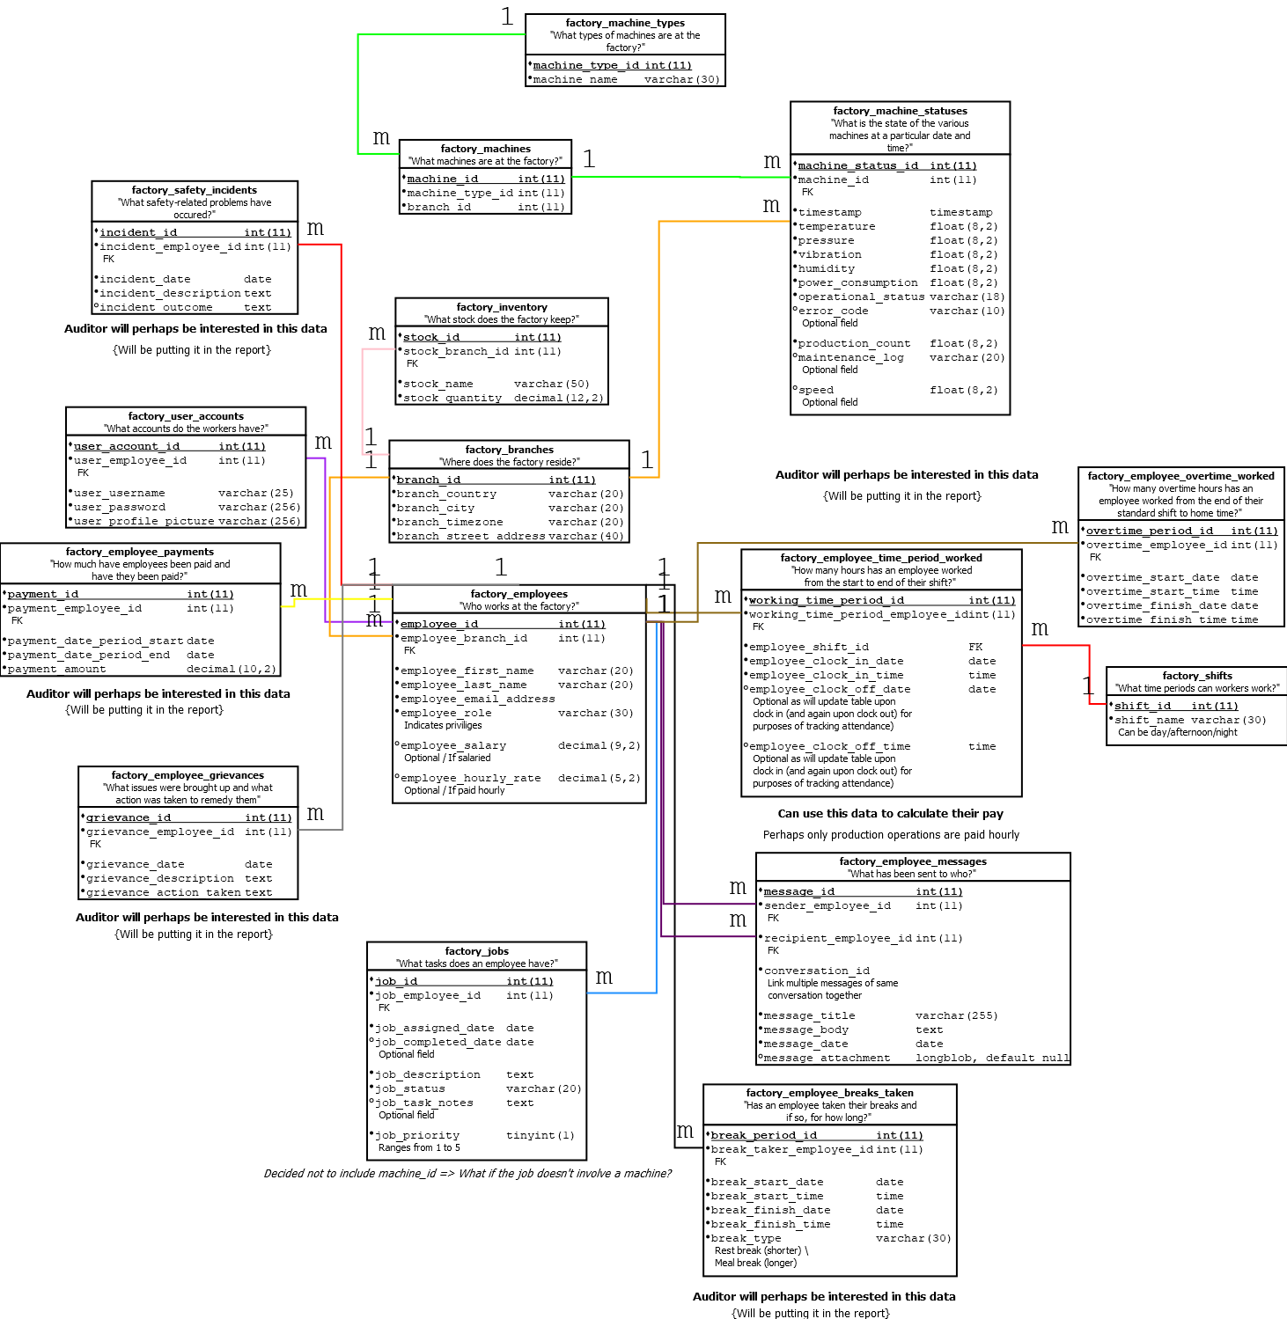

ER diagram
- Ovals represent attributes
  - Bolded text: Primary key
  - Underlined text: Key
  - Dotted line between an attribute and table: Optional attribute
- Rectangles represent tables
- Diamonds describe relationships between two tables
- Lines represent relationships (how attributes relate to tables and how tables relate to other tables)
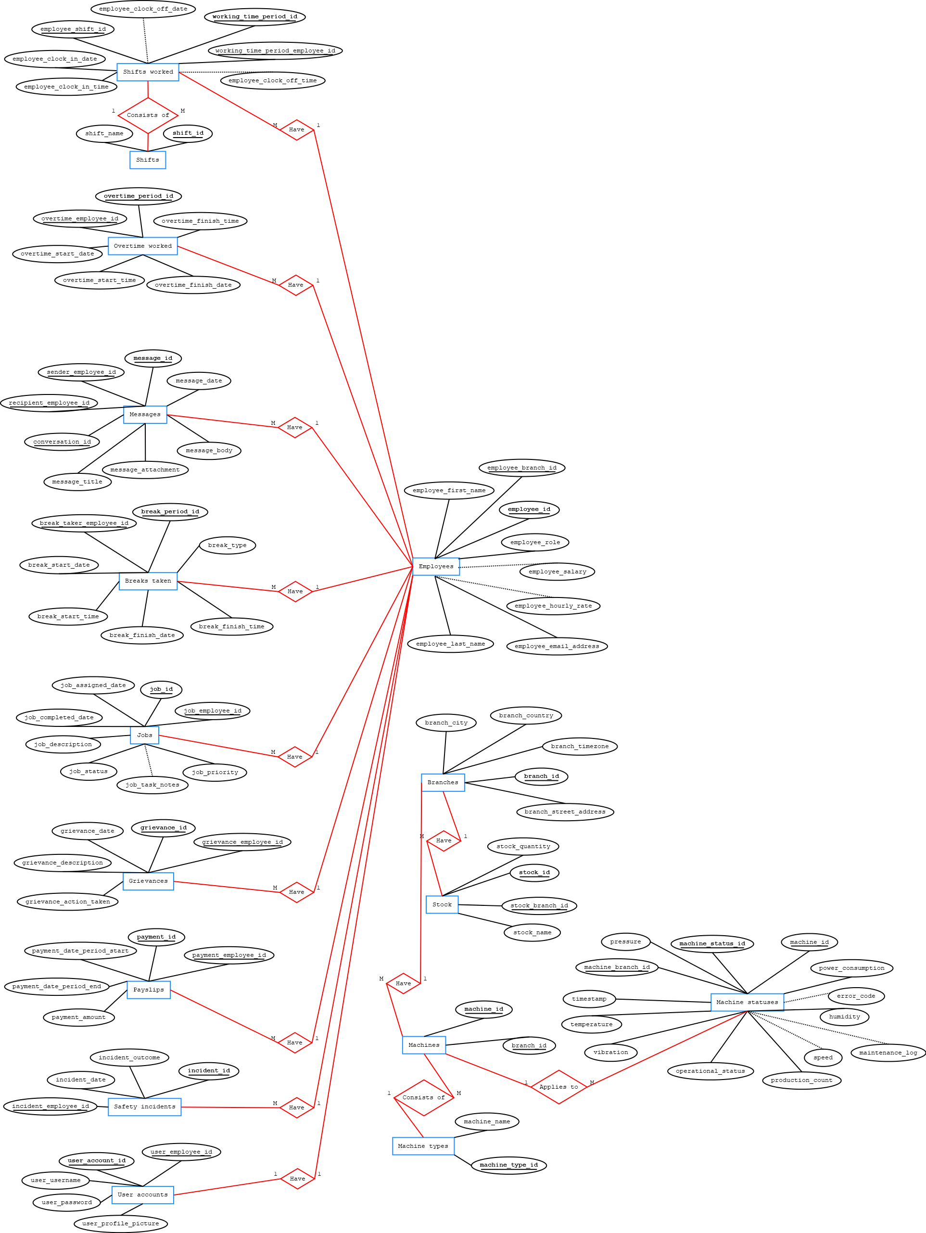

B – Website screenshots

Dashboard page

Production operator dashboard
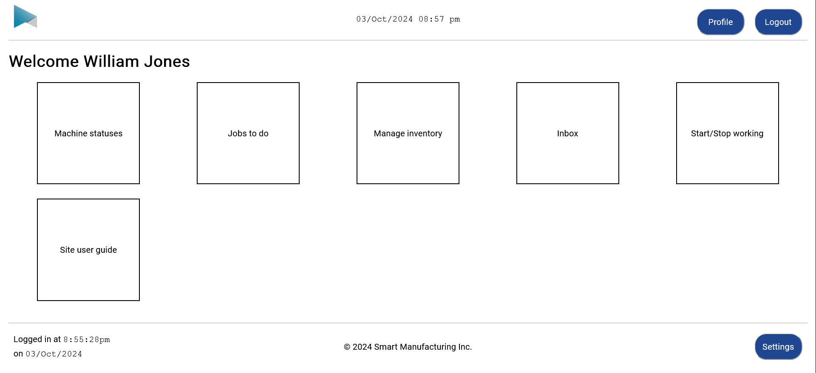

Factory manager dashboard
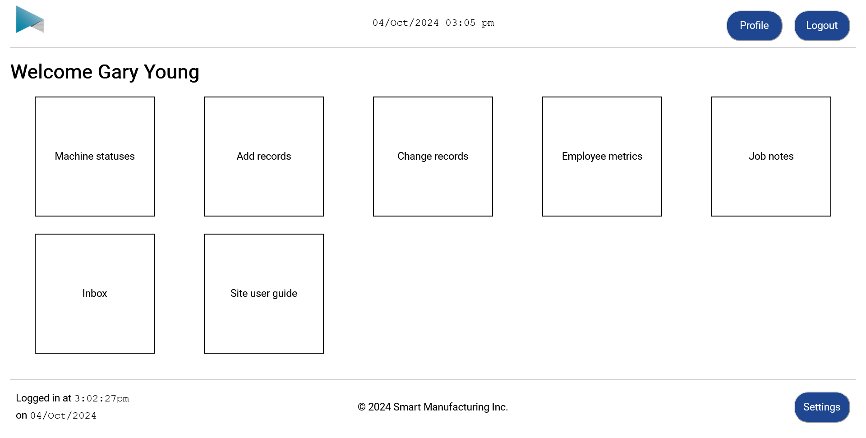

Internal auditor dashboard
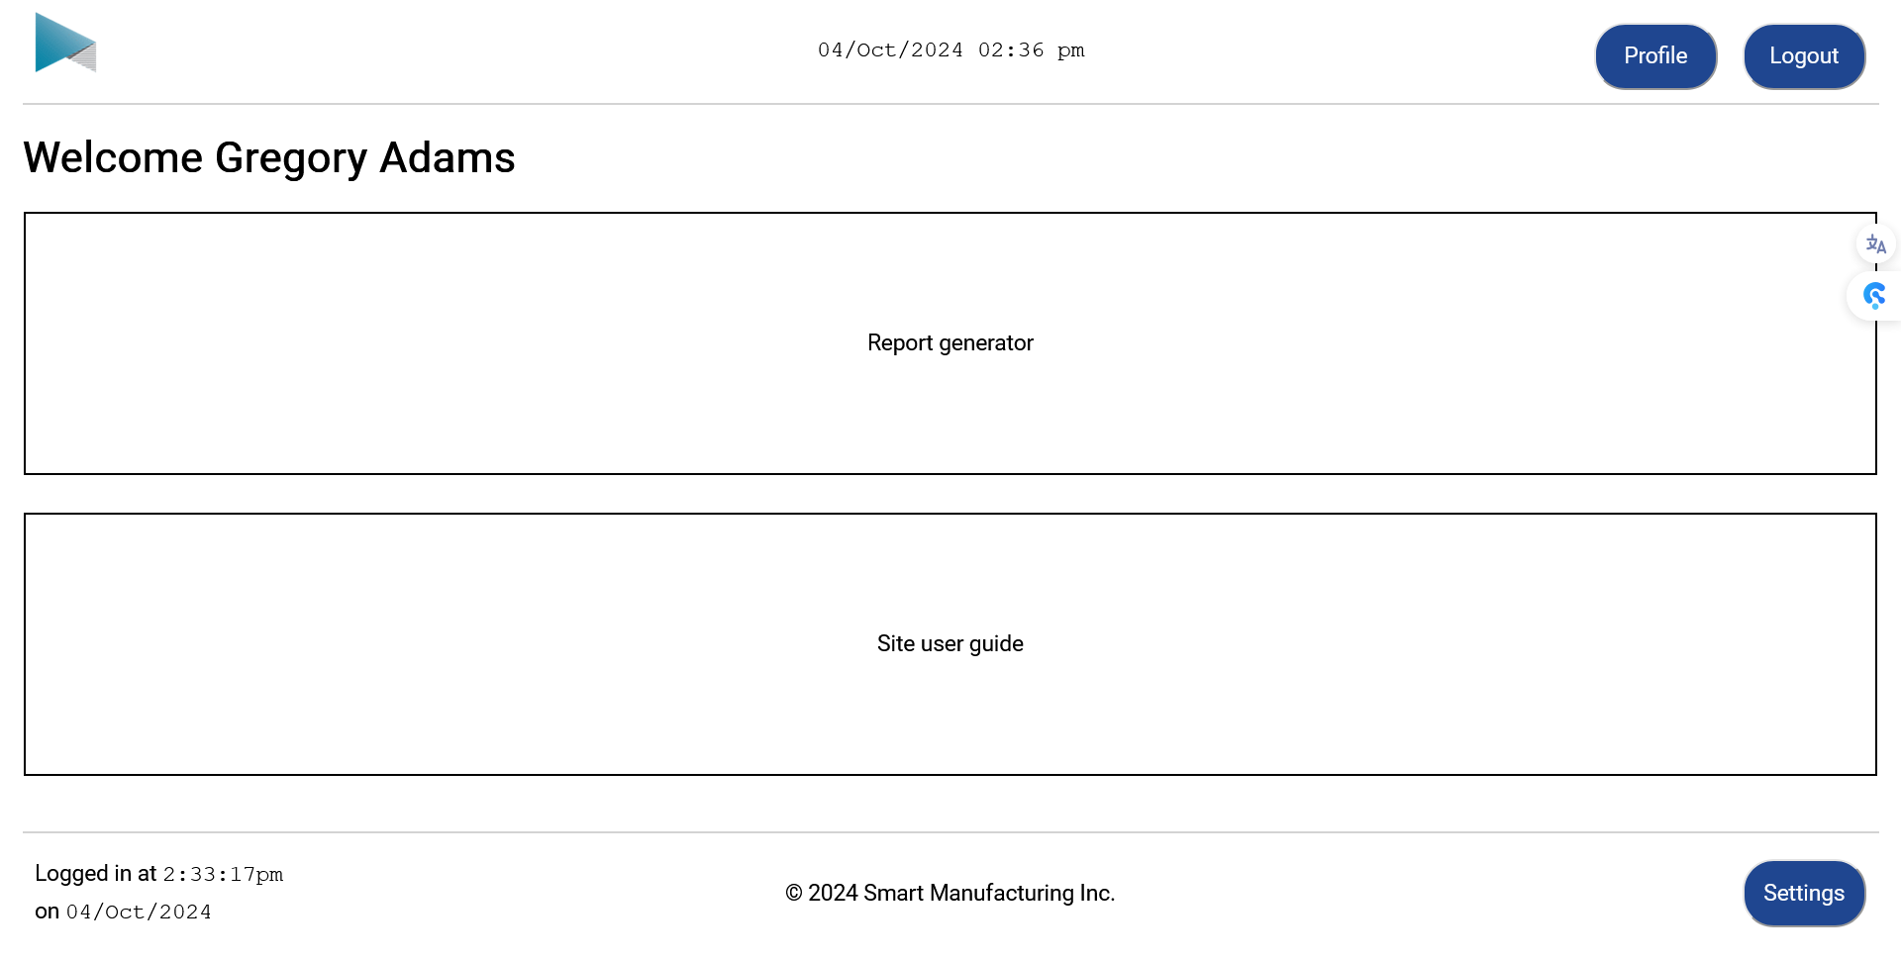

Admin staff dashboard
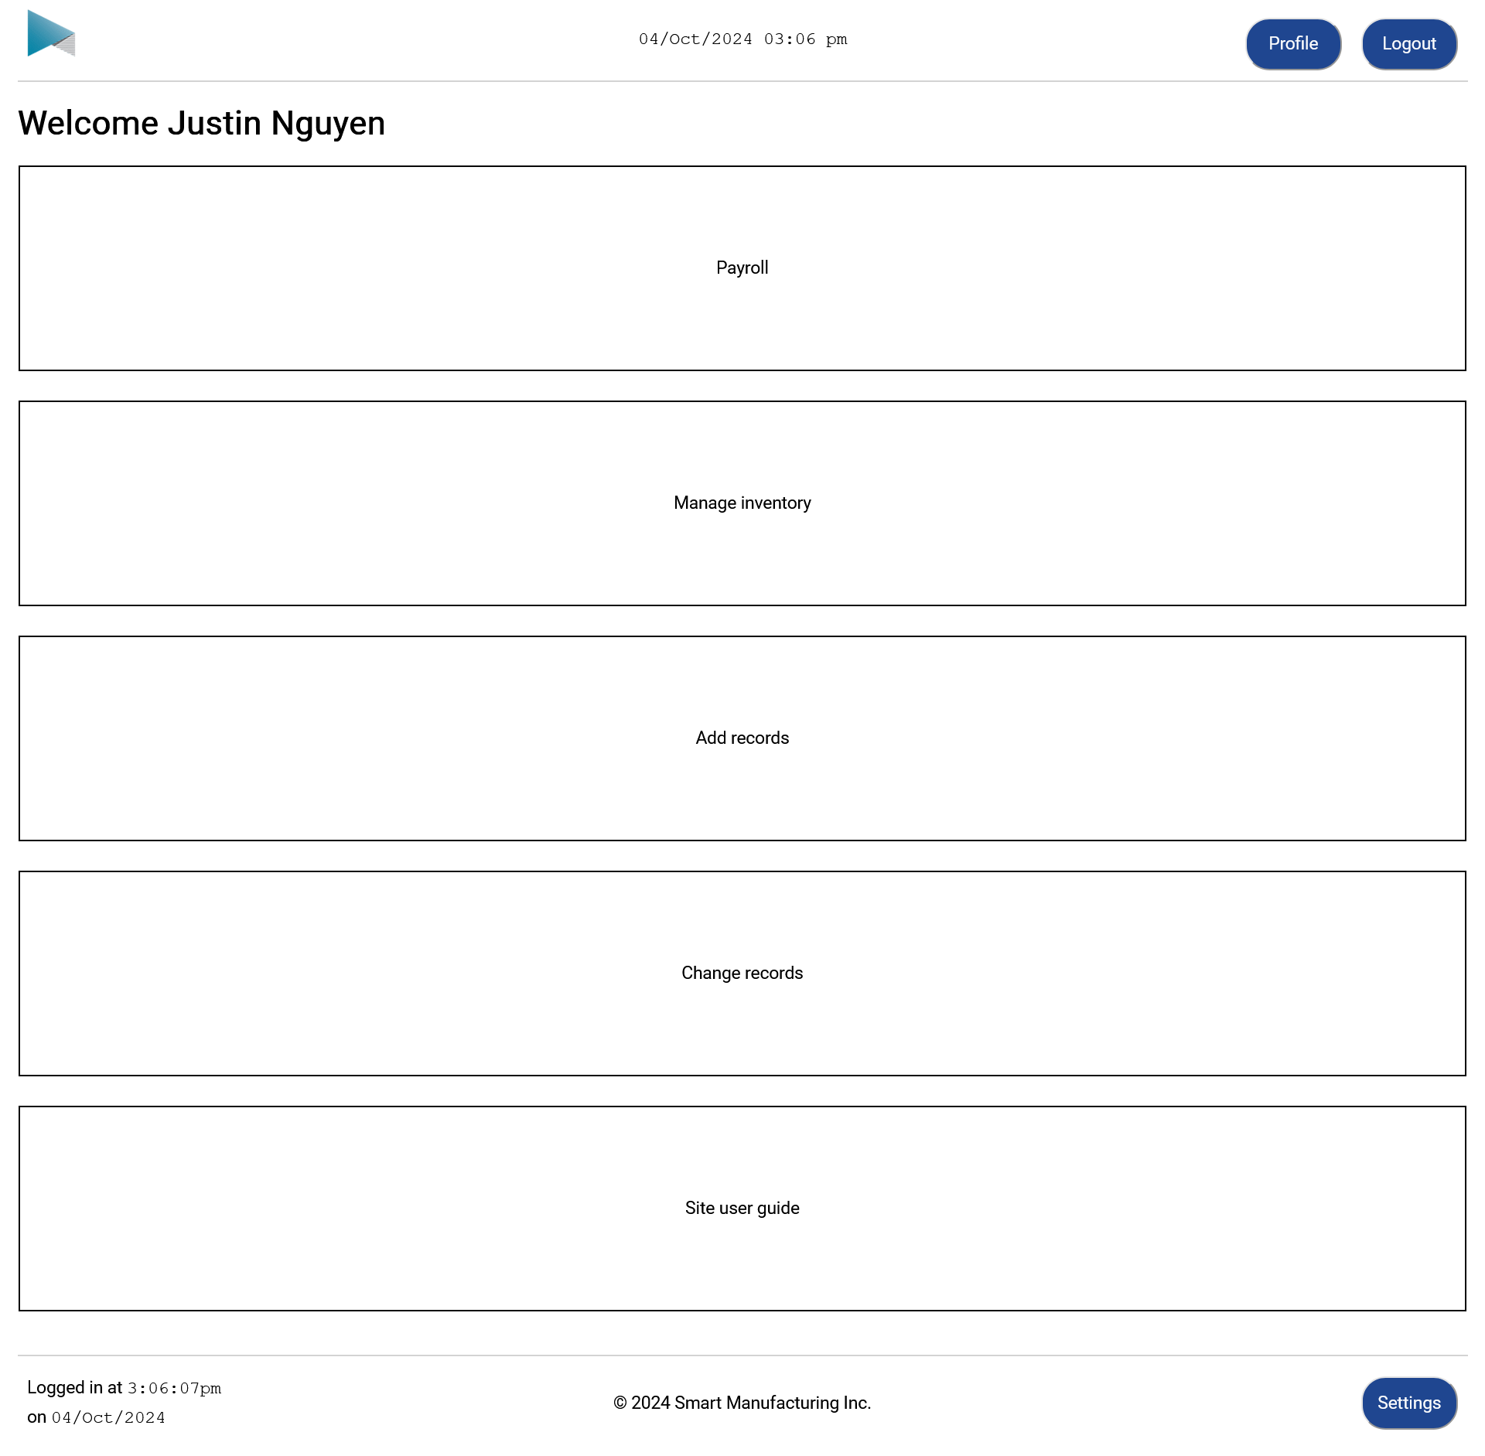

Settings menu

The menu
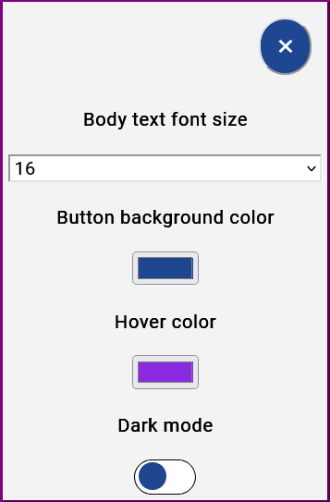
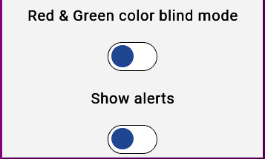


The effects the options have
- Body text font size – Changes font size
- Button background colour – Changes button colours (and UI elements intended to match the button colour) for all pages
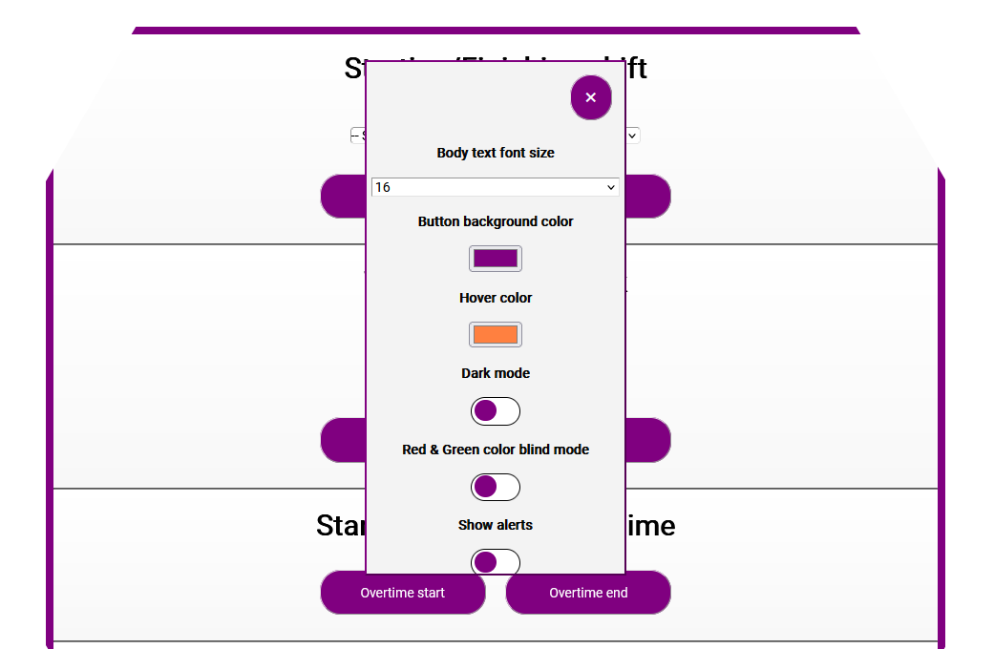
- Button hover colour – Changes hover colour

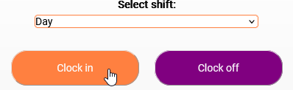
- Show alerts – Indicate if user is to receive information that the action performed worked or didn’t work via a message with a banner atop each page where the user is performing actions
- Keep sidebar open – Make it so sidebar is opened by default and so user doesn’t have to click to open it

- Dark mode – Makes background darker and ensures UI elements are still readable
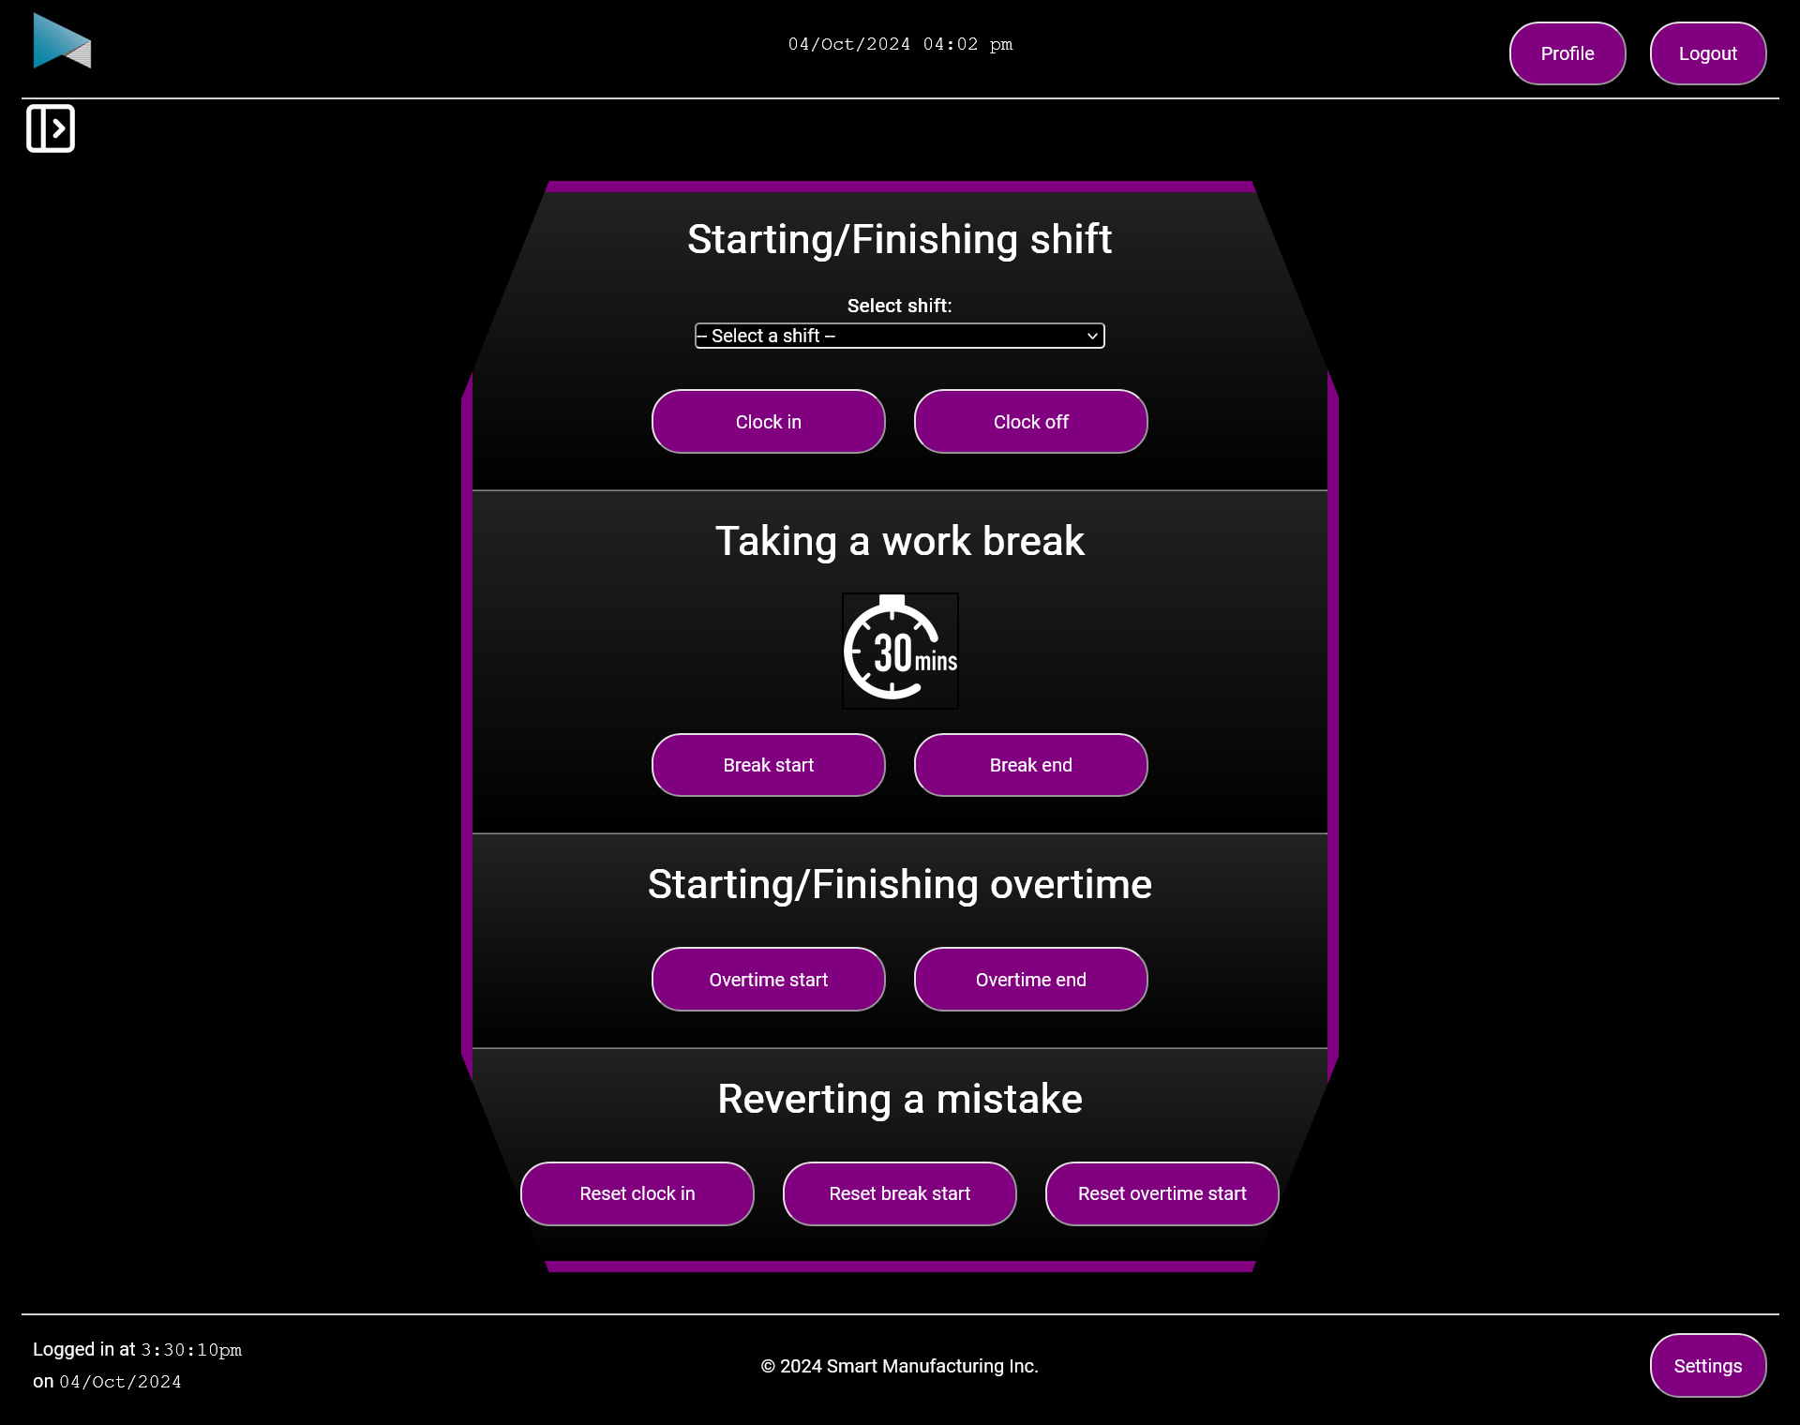

- Red/Green colour blind mode – Makes it so colour blind people can still perceive bad/good news
  - Blue -> Green (good news)
  - Grey -> Red (bad news)
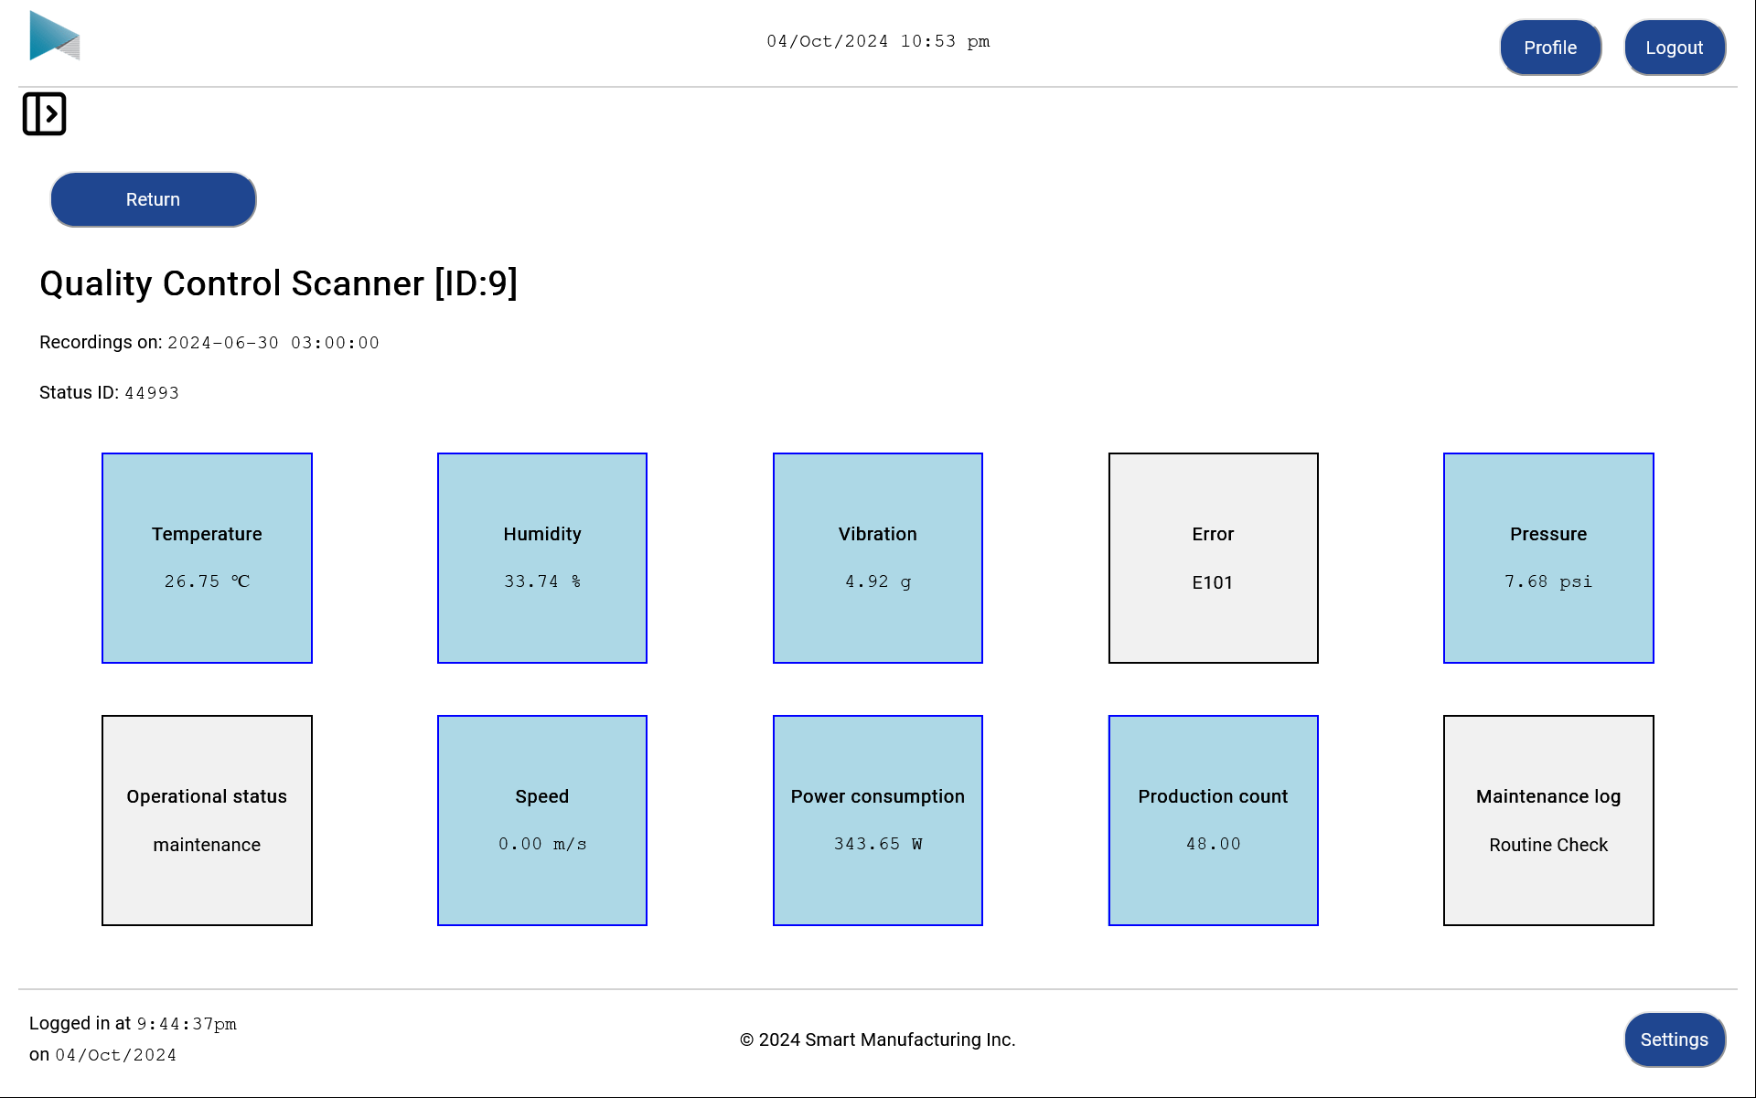

Sidemenu – Opened
- Shifts page elements to right to accommodate it
- Upon scrolling down, follows top of page
- When scrolled up, appears under header


Profile menu
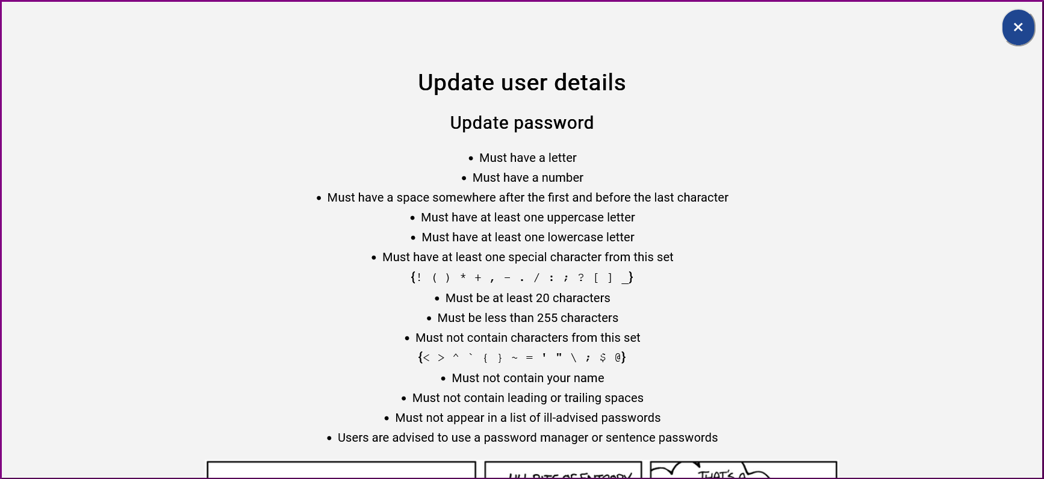
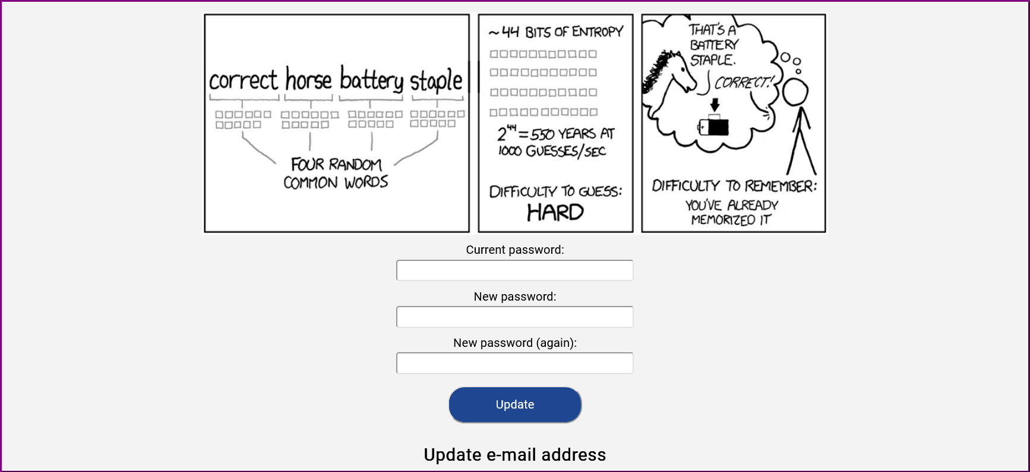


Start stop working page
Production operator
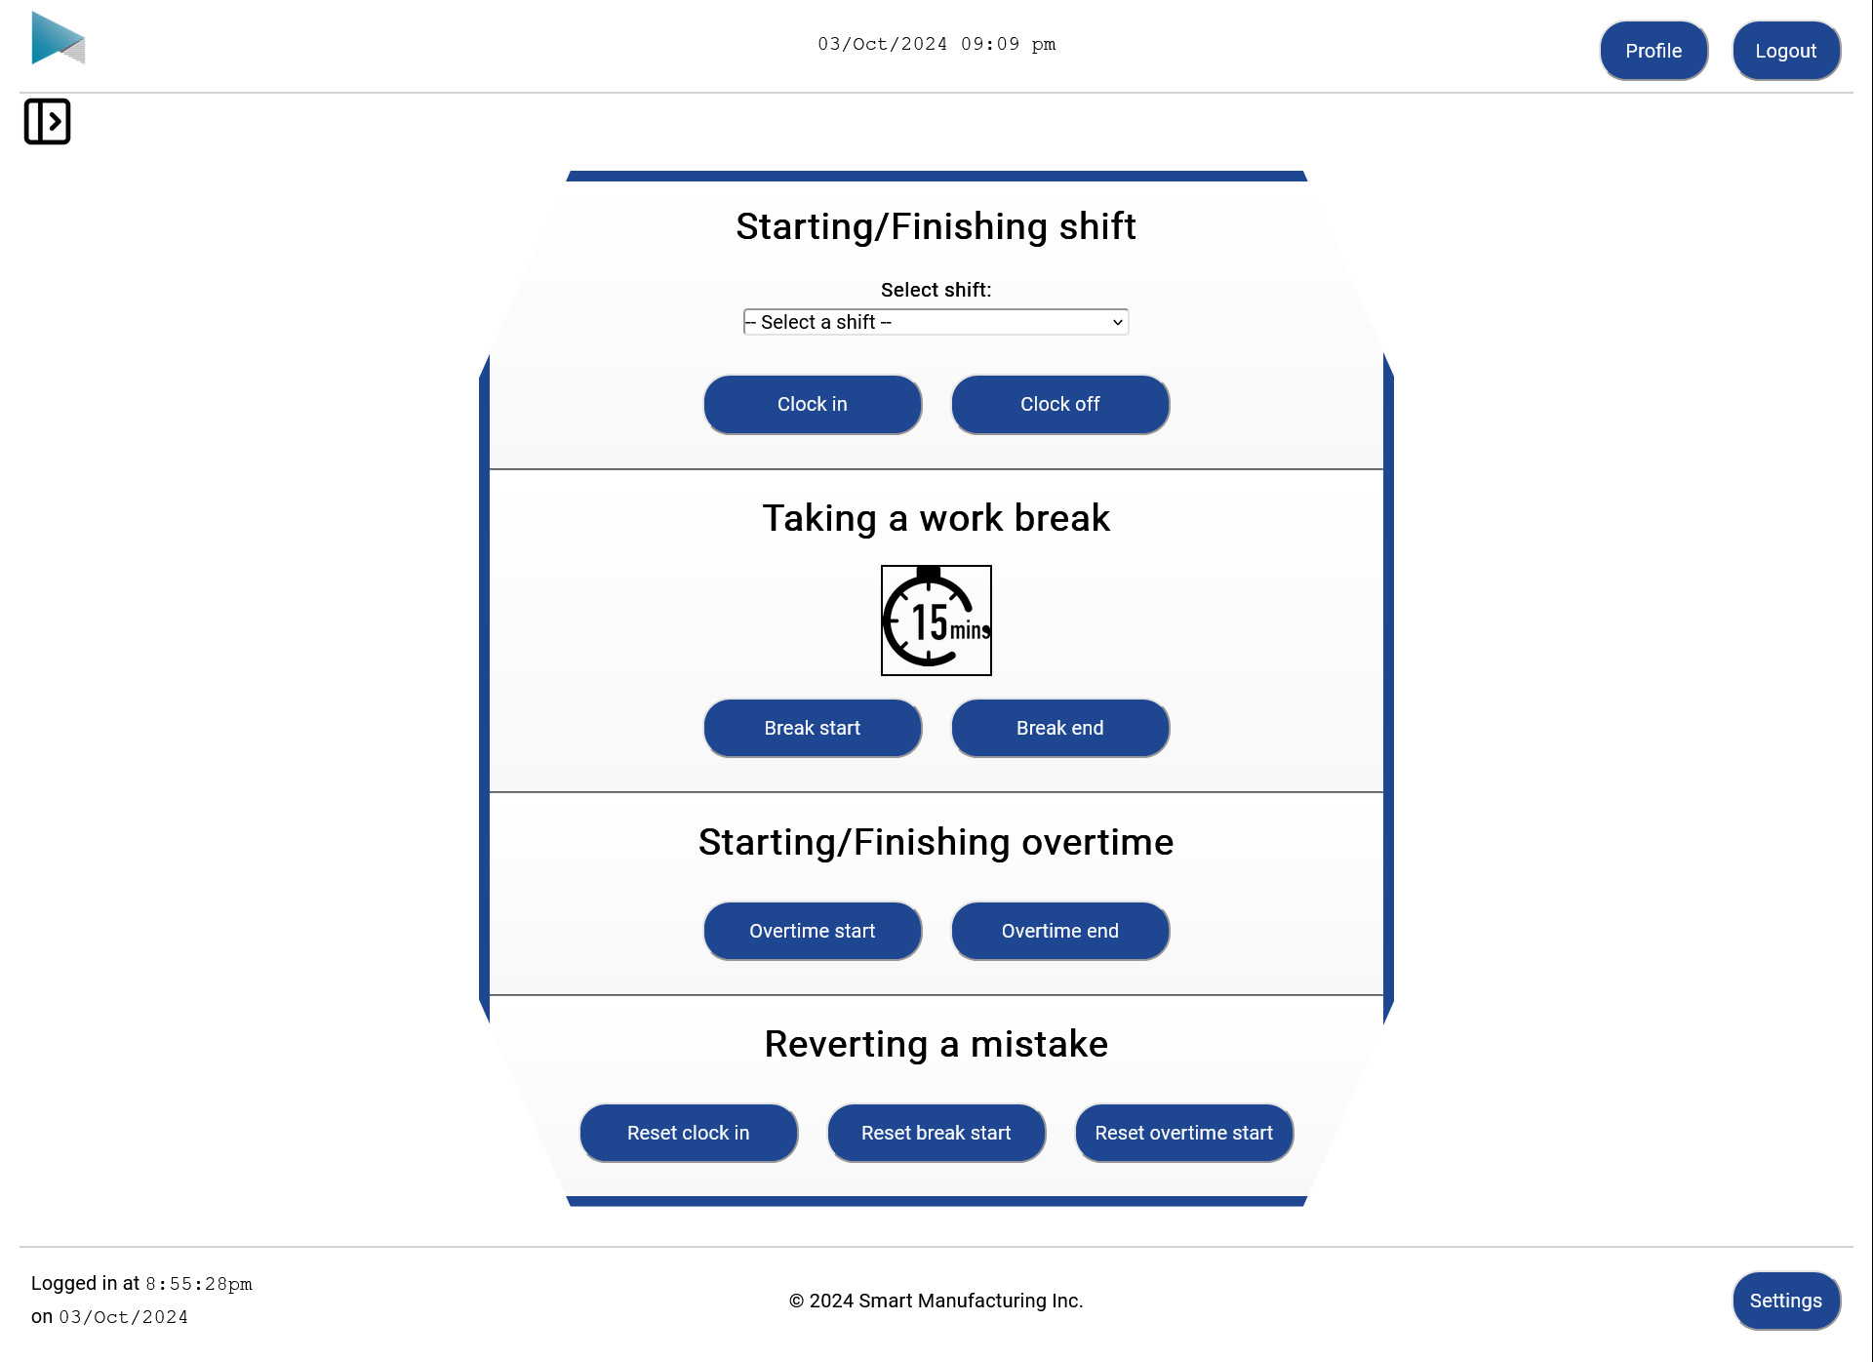

Login page
All roles
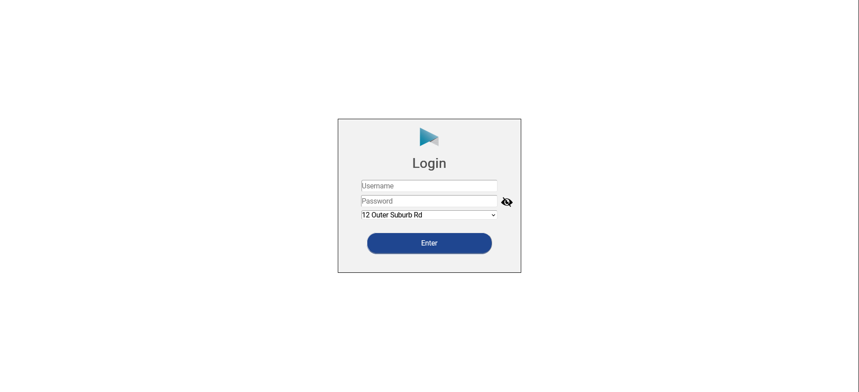

Logged in page
- Transition page. See it for a few seconds upon logging in before being redirected to the dashboard
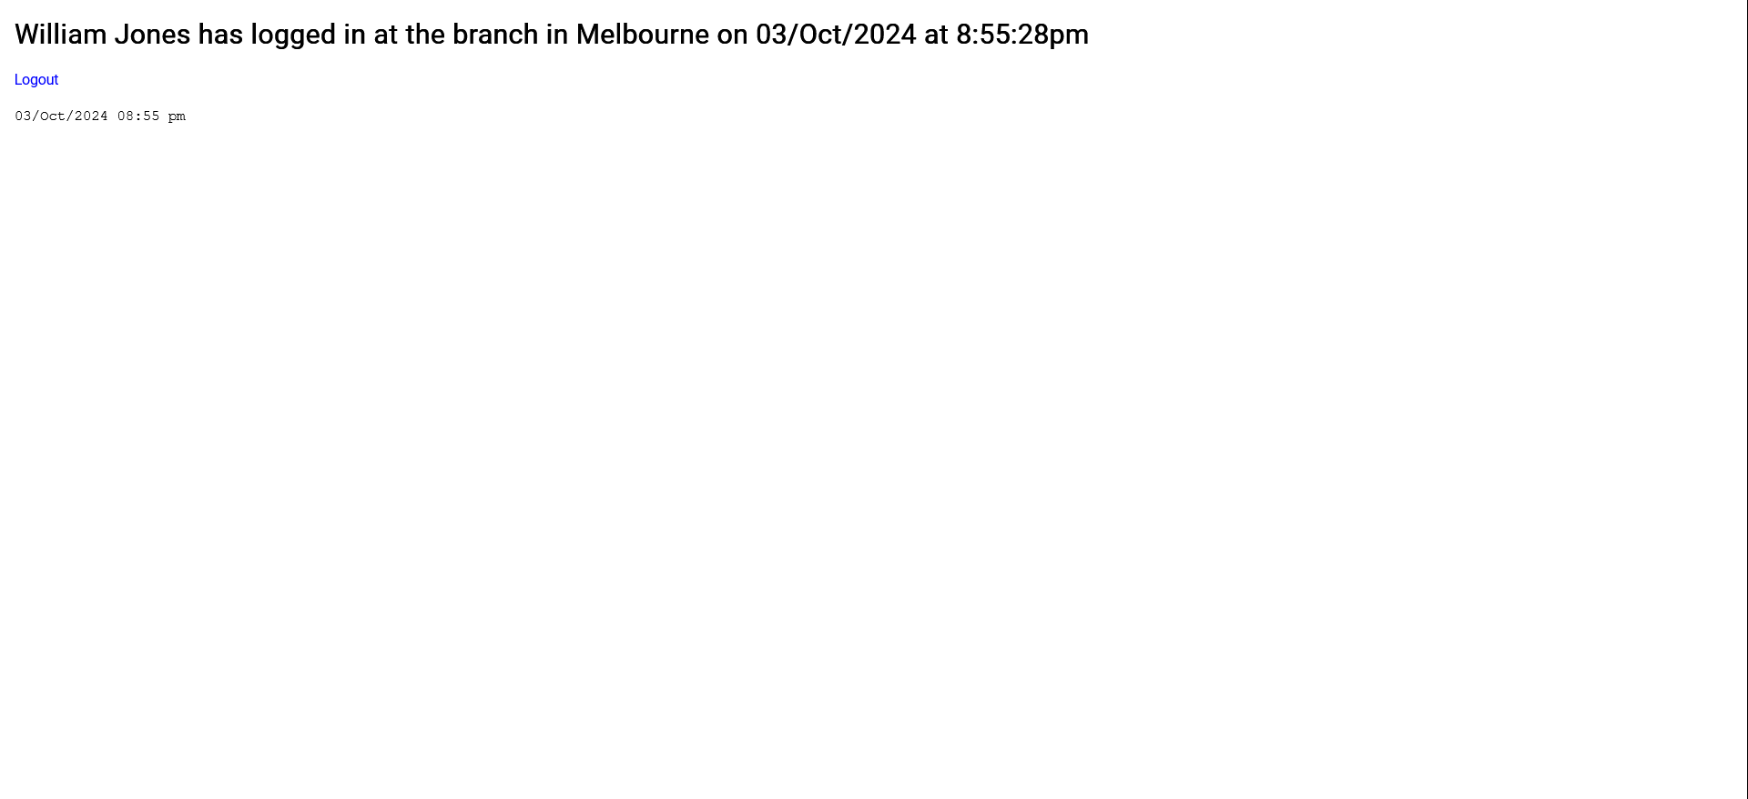

Site user guide page
All roles.
- Hotkeys differ based on what pages the employee has access to
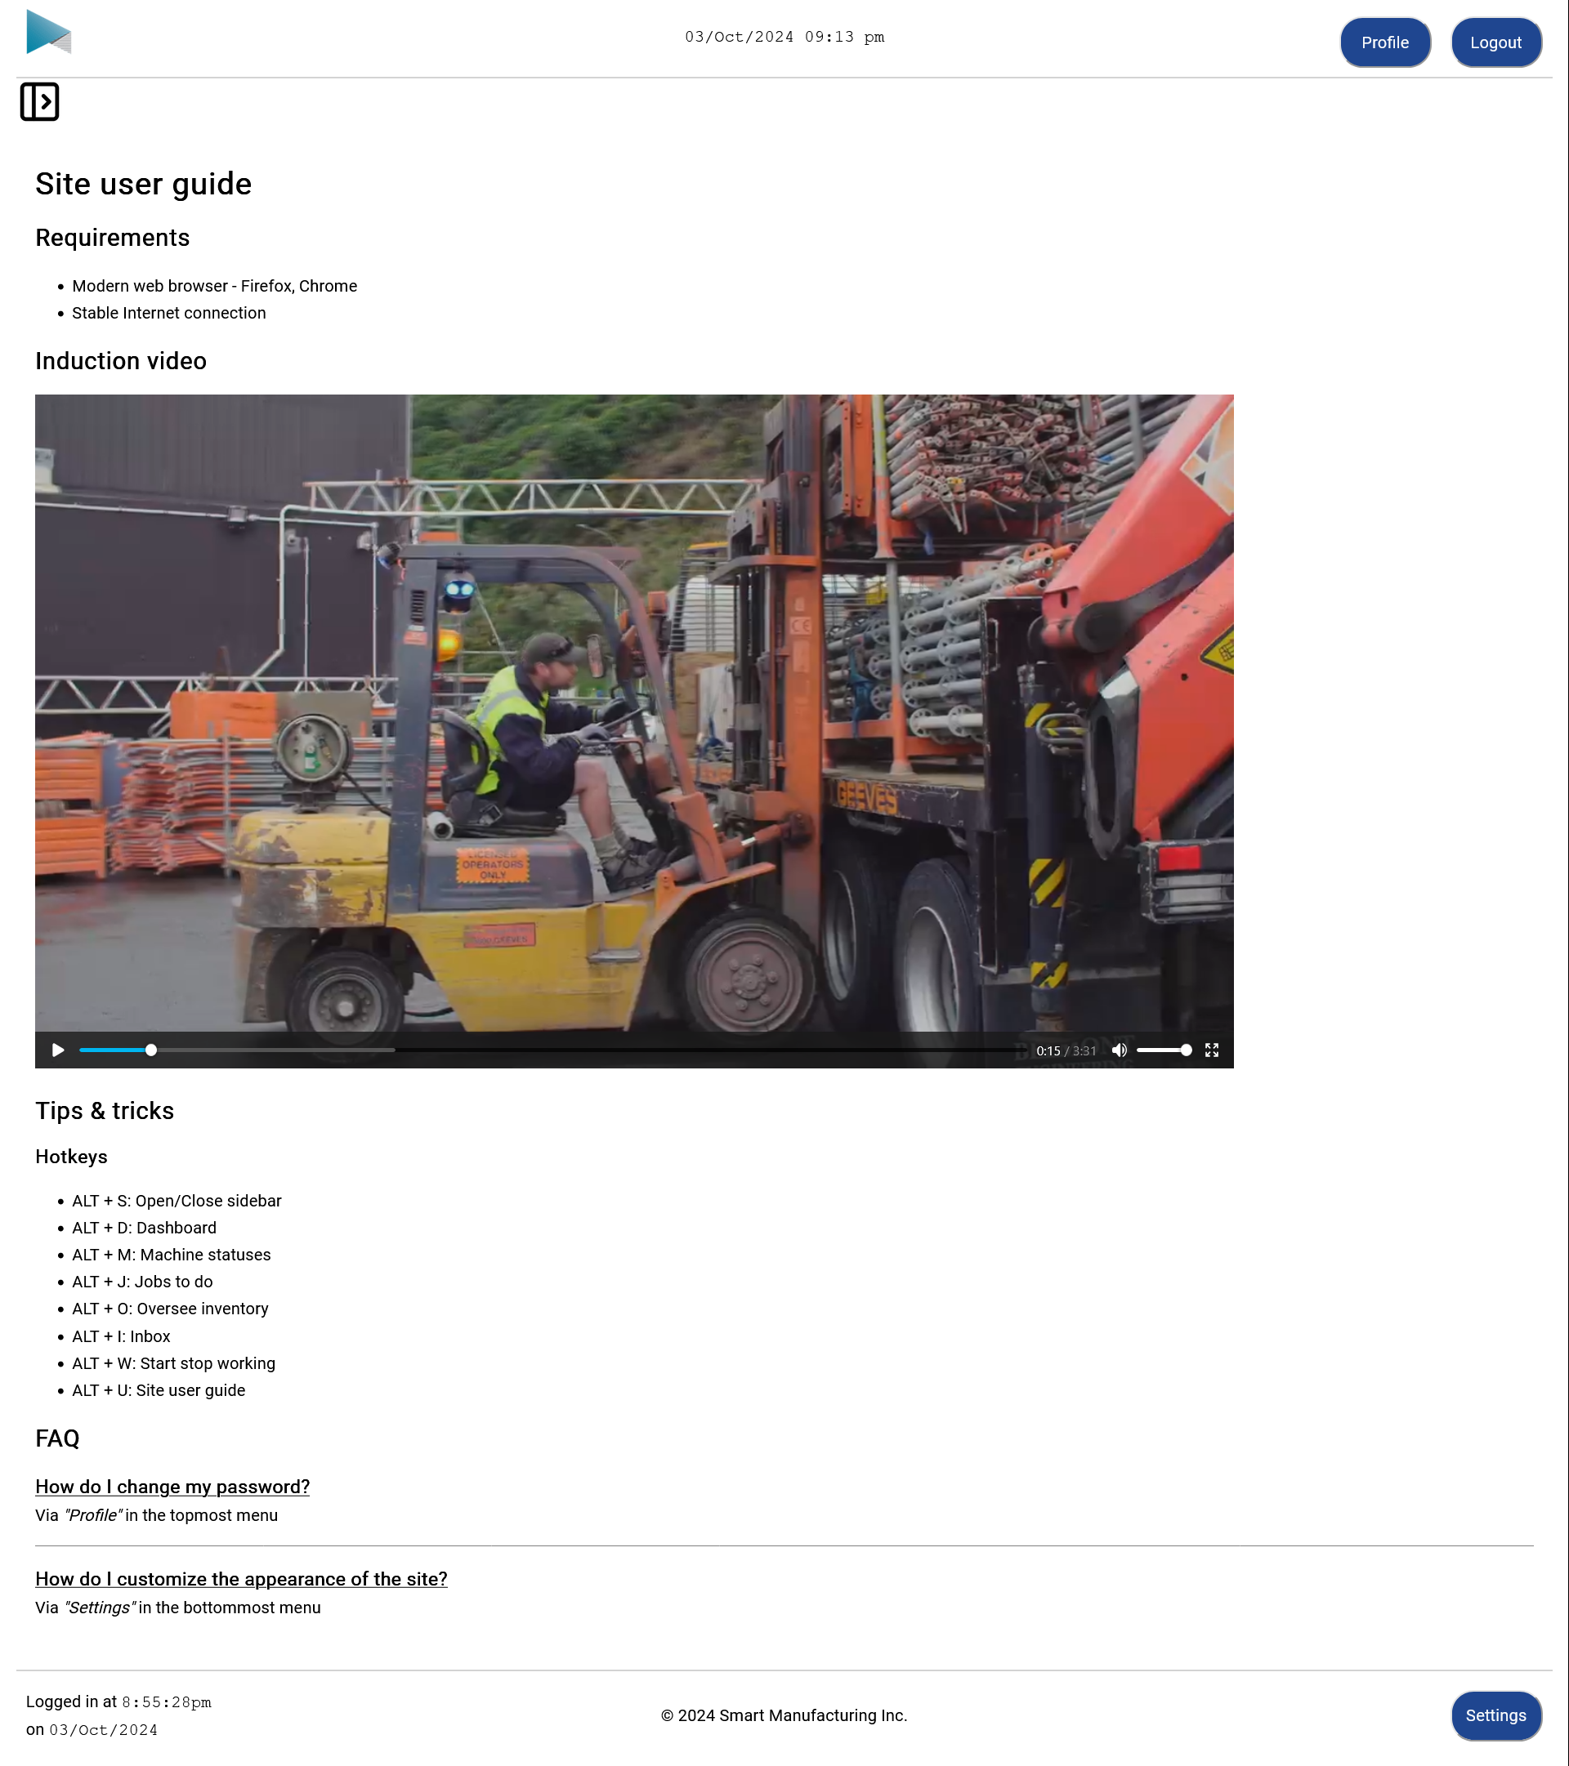

Report generator page
Internal auditor
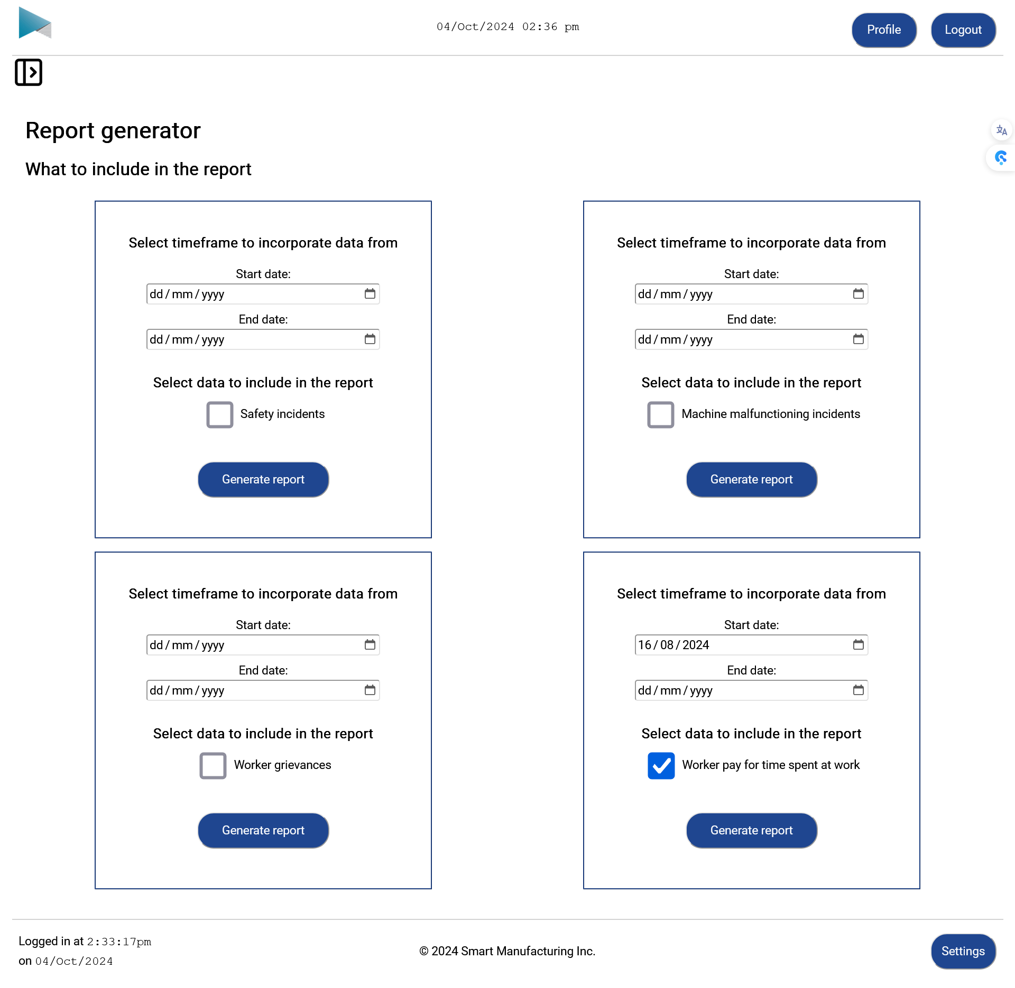

Downloaded report
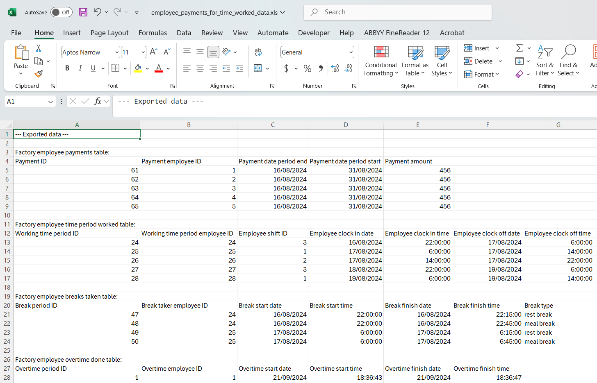
(Cut off some of the data to conserve space)

Payroll page
Admin staff
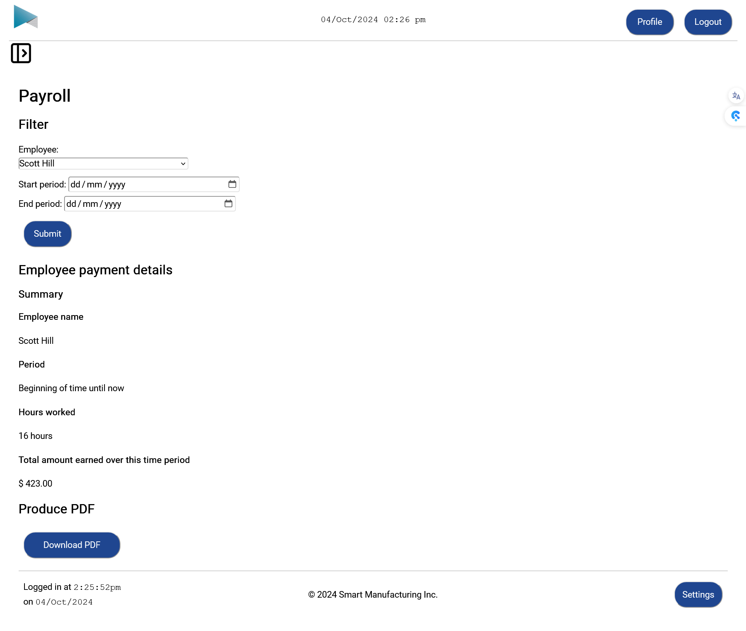

Downloaded payslip
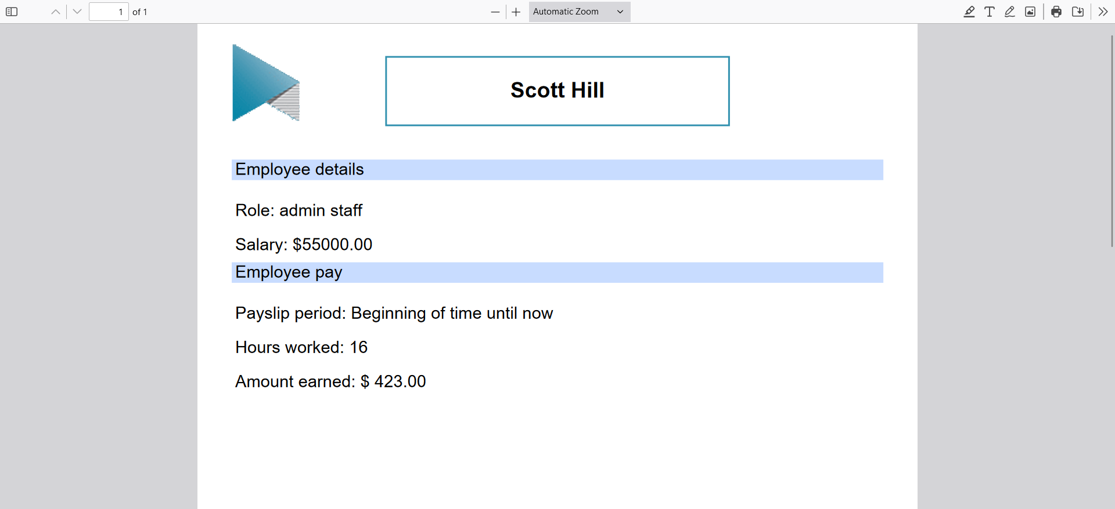

Insert records page

Admin staff
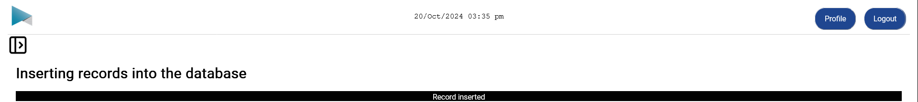
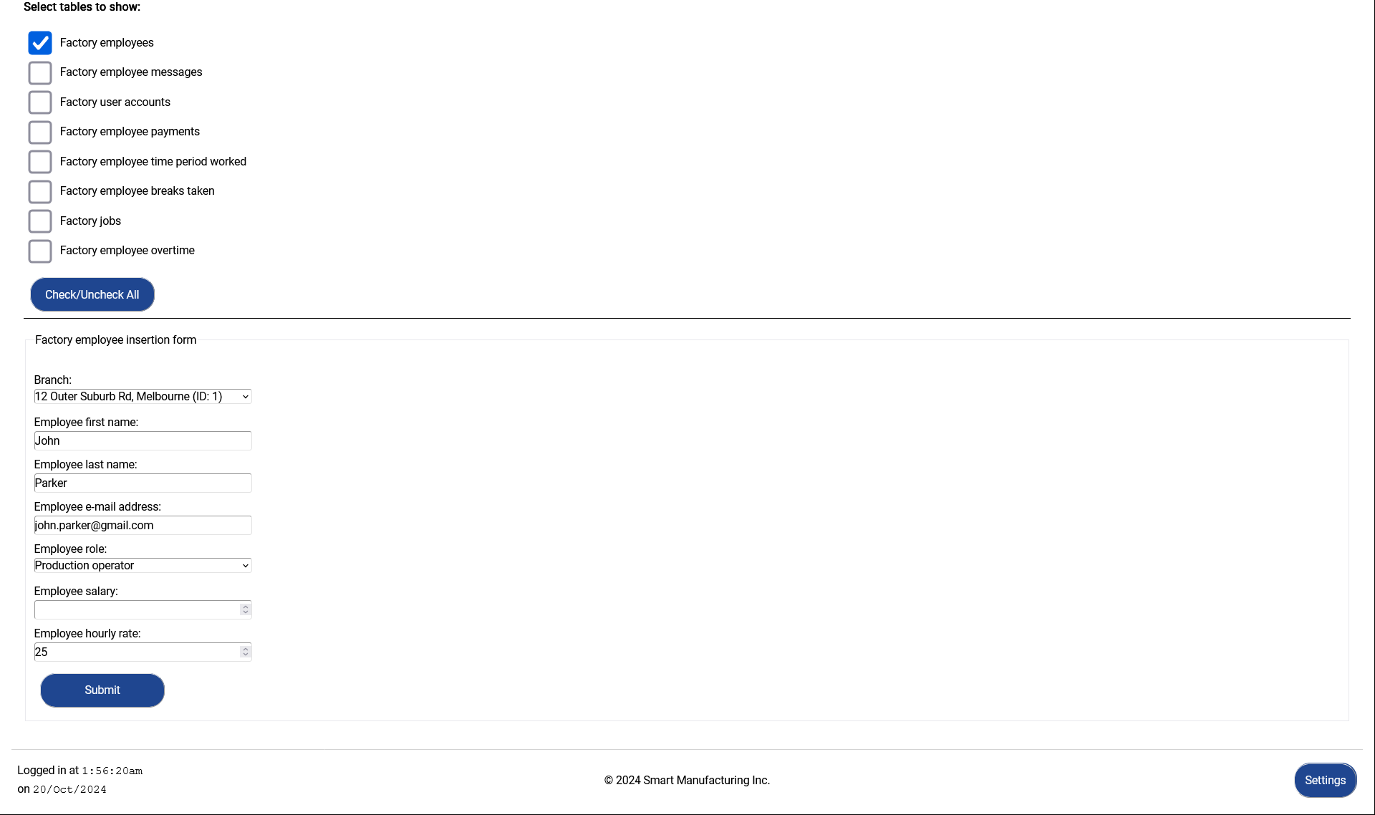
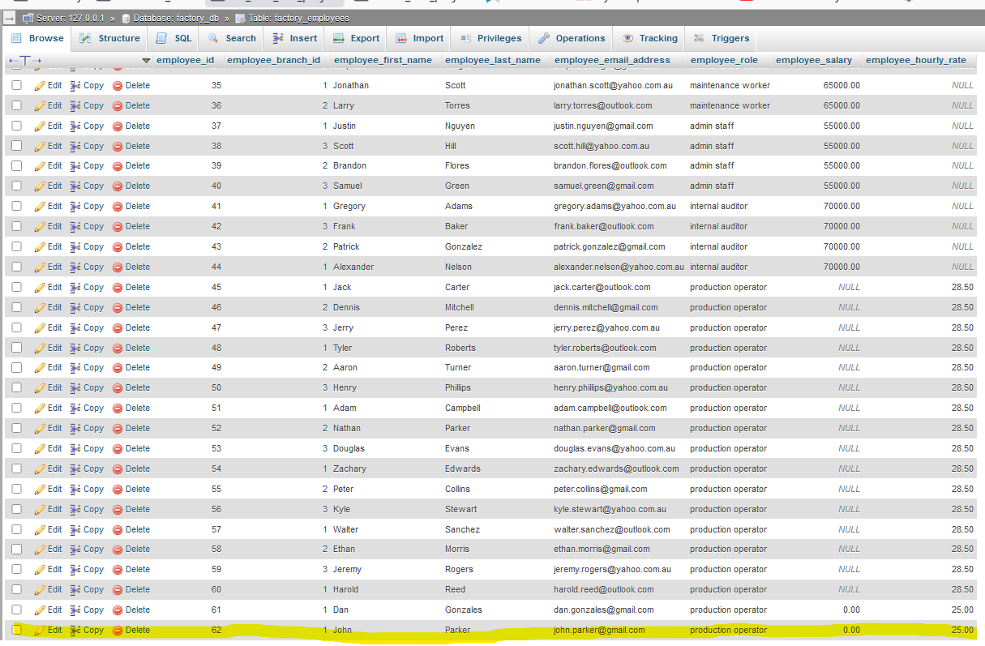

Factory manager
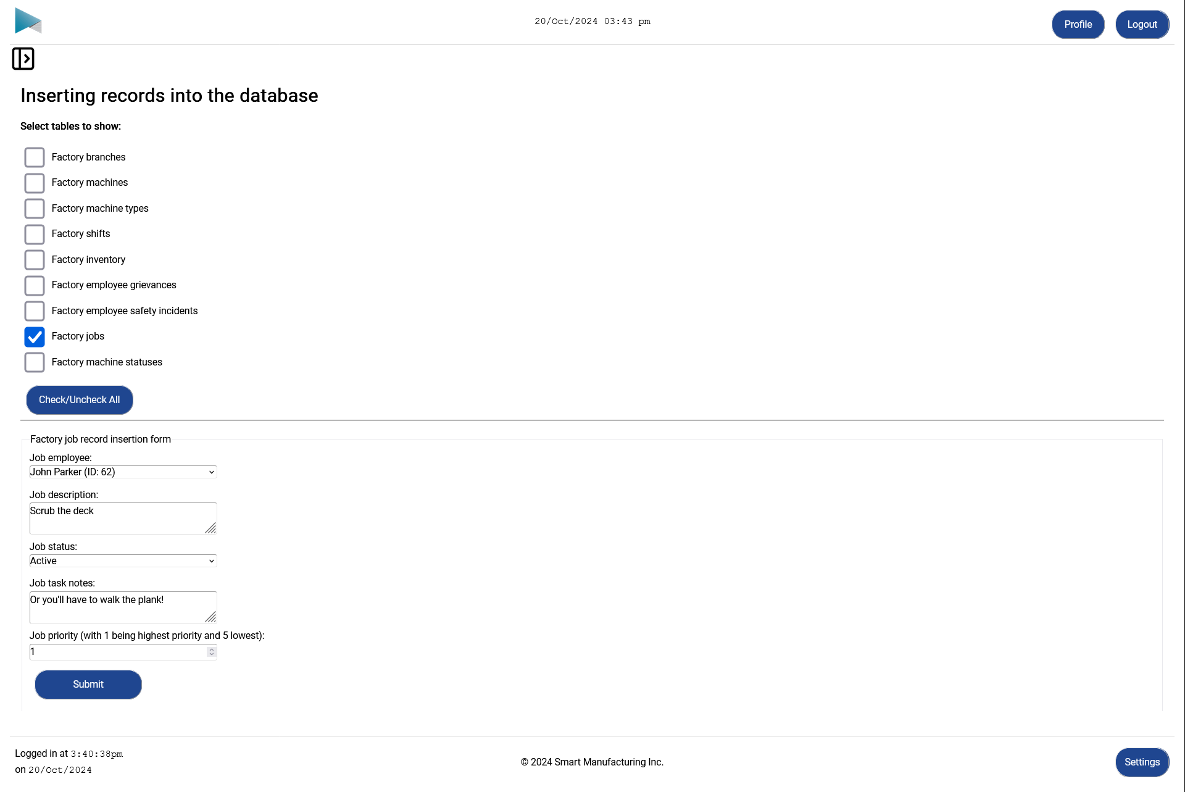
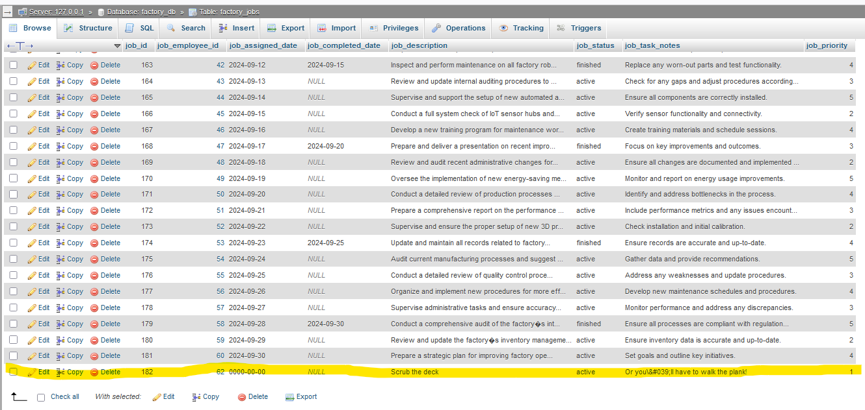

Manage records page

Admin staff
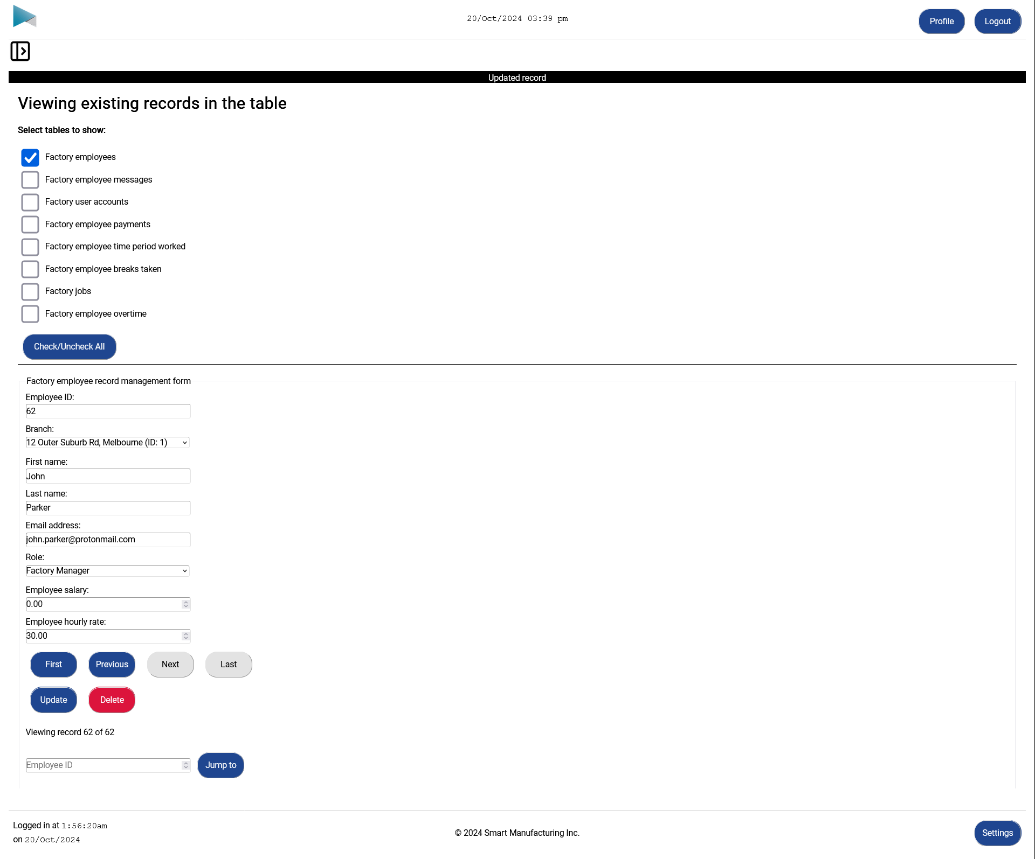
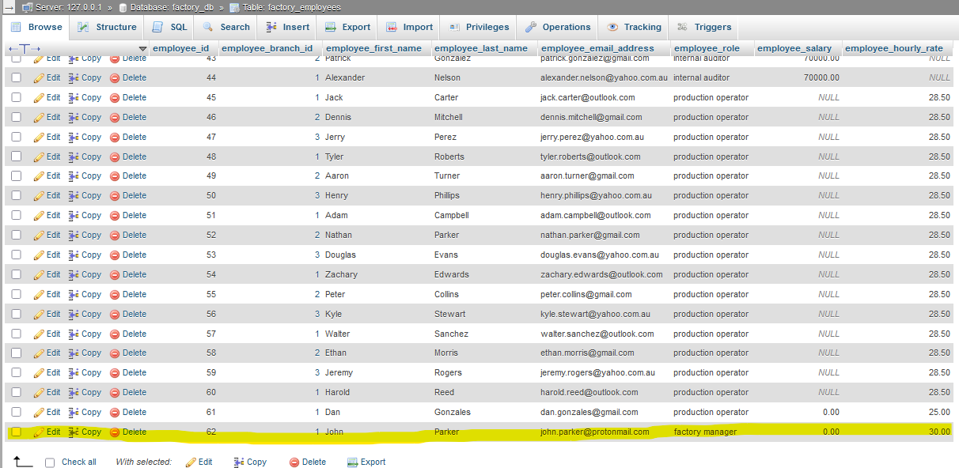

Factory manager
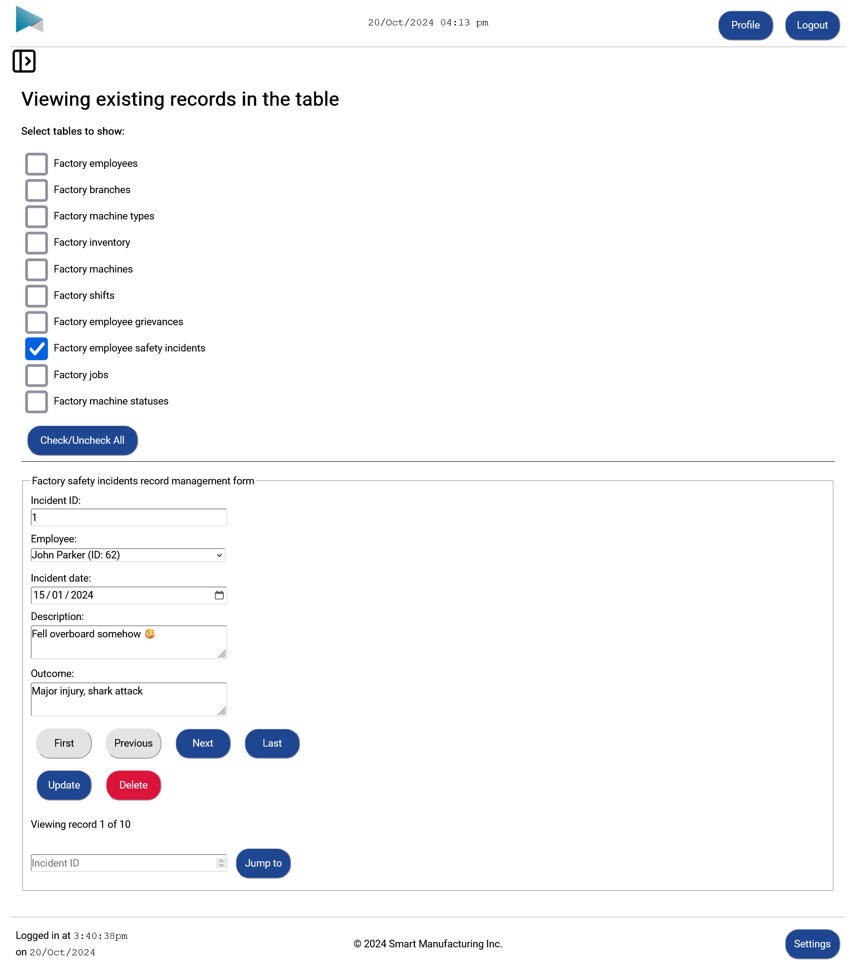
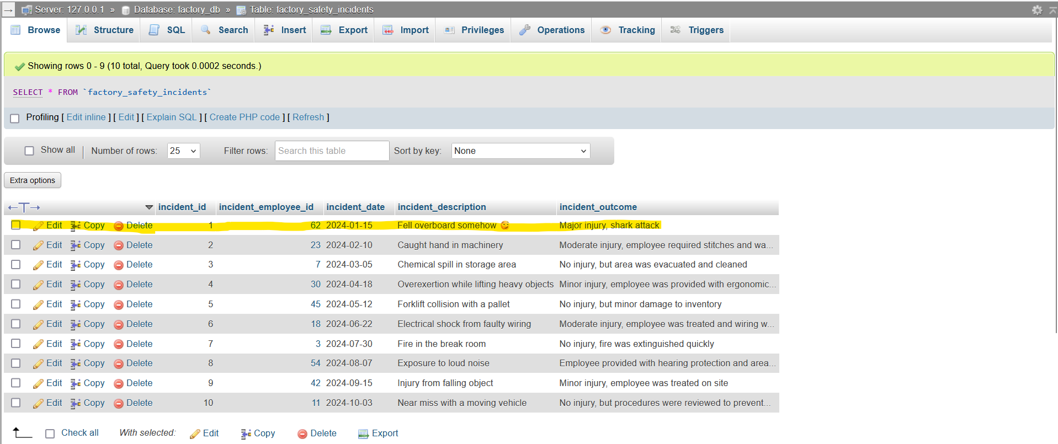

Oversee inventory page

Production operator / Admin staff
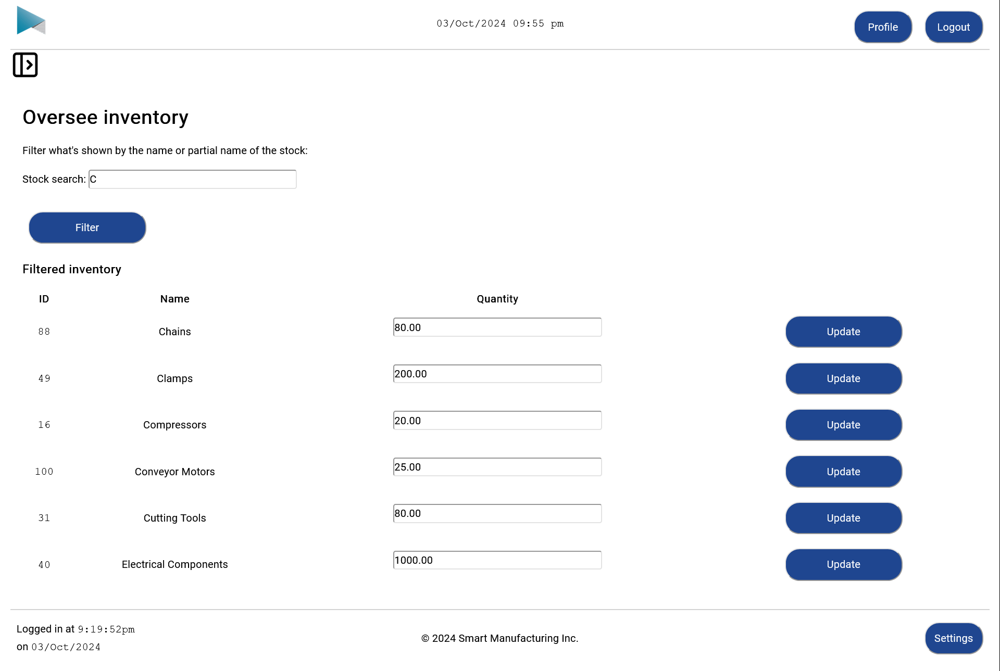

Machine statuses page

Production operator / Factory manager
Recent logs for machines at the current branch shown by default (on page load). Can also see an overview of the machine statuses for these machines
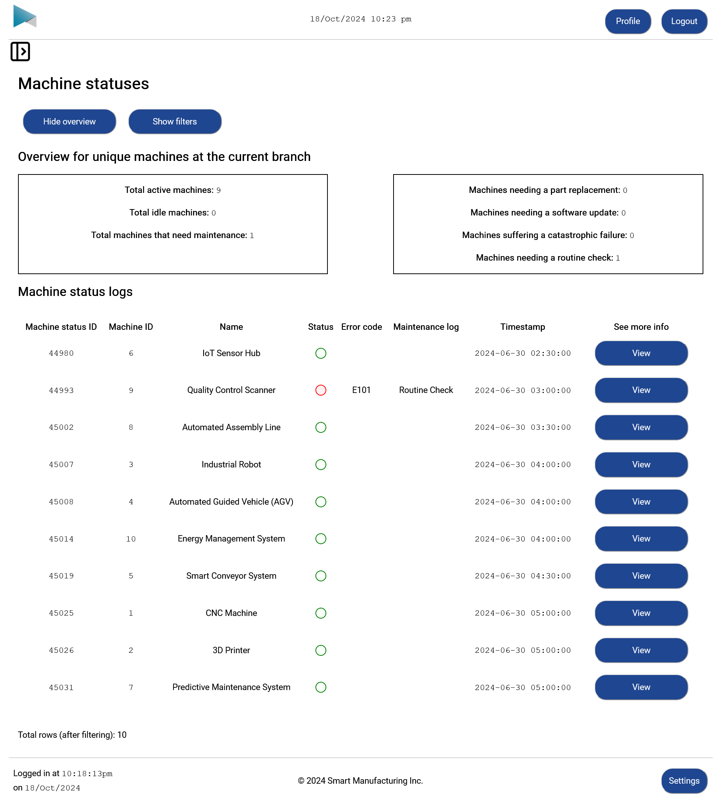
Can also filter for a particular result
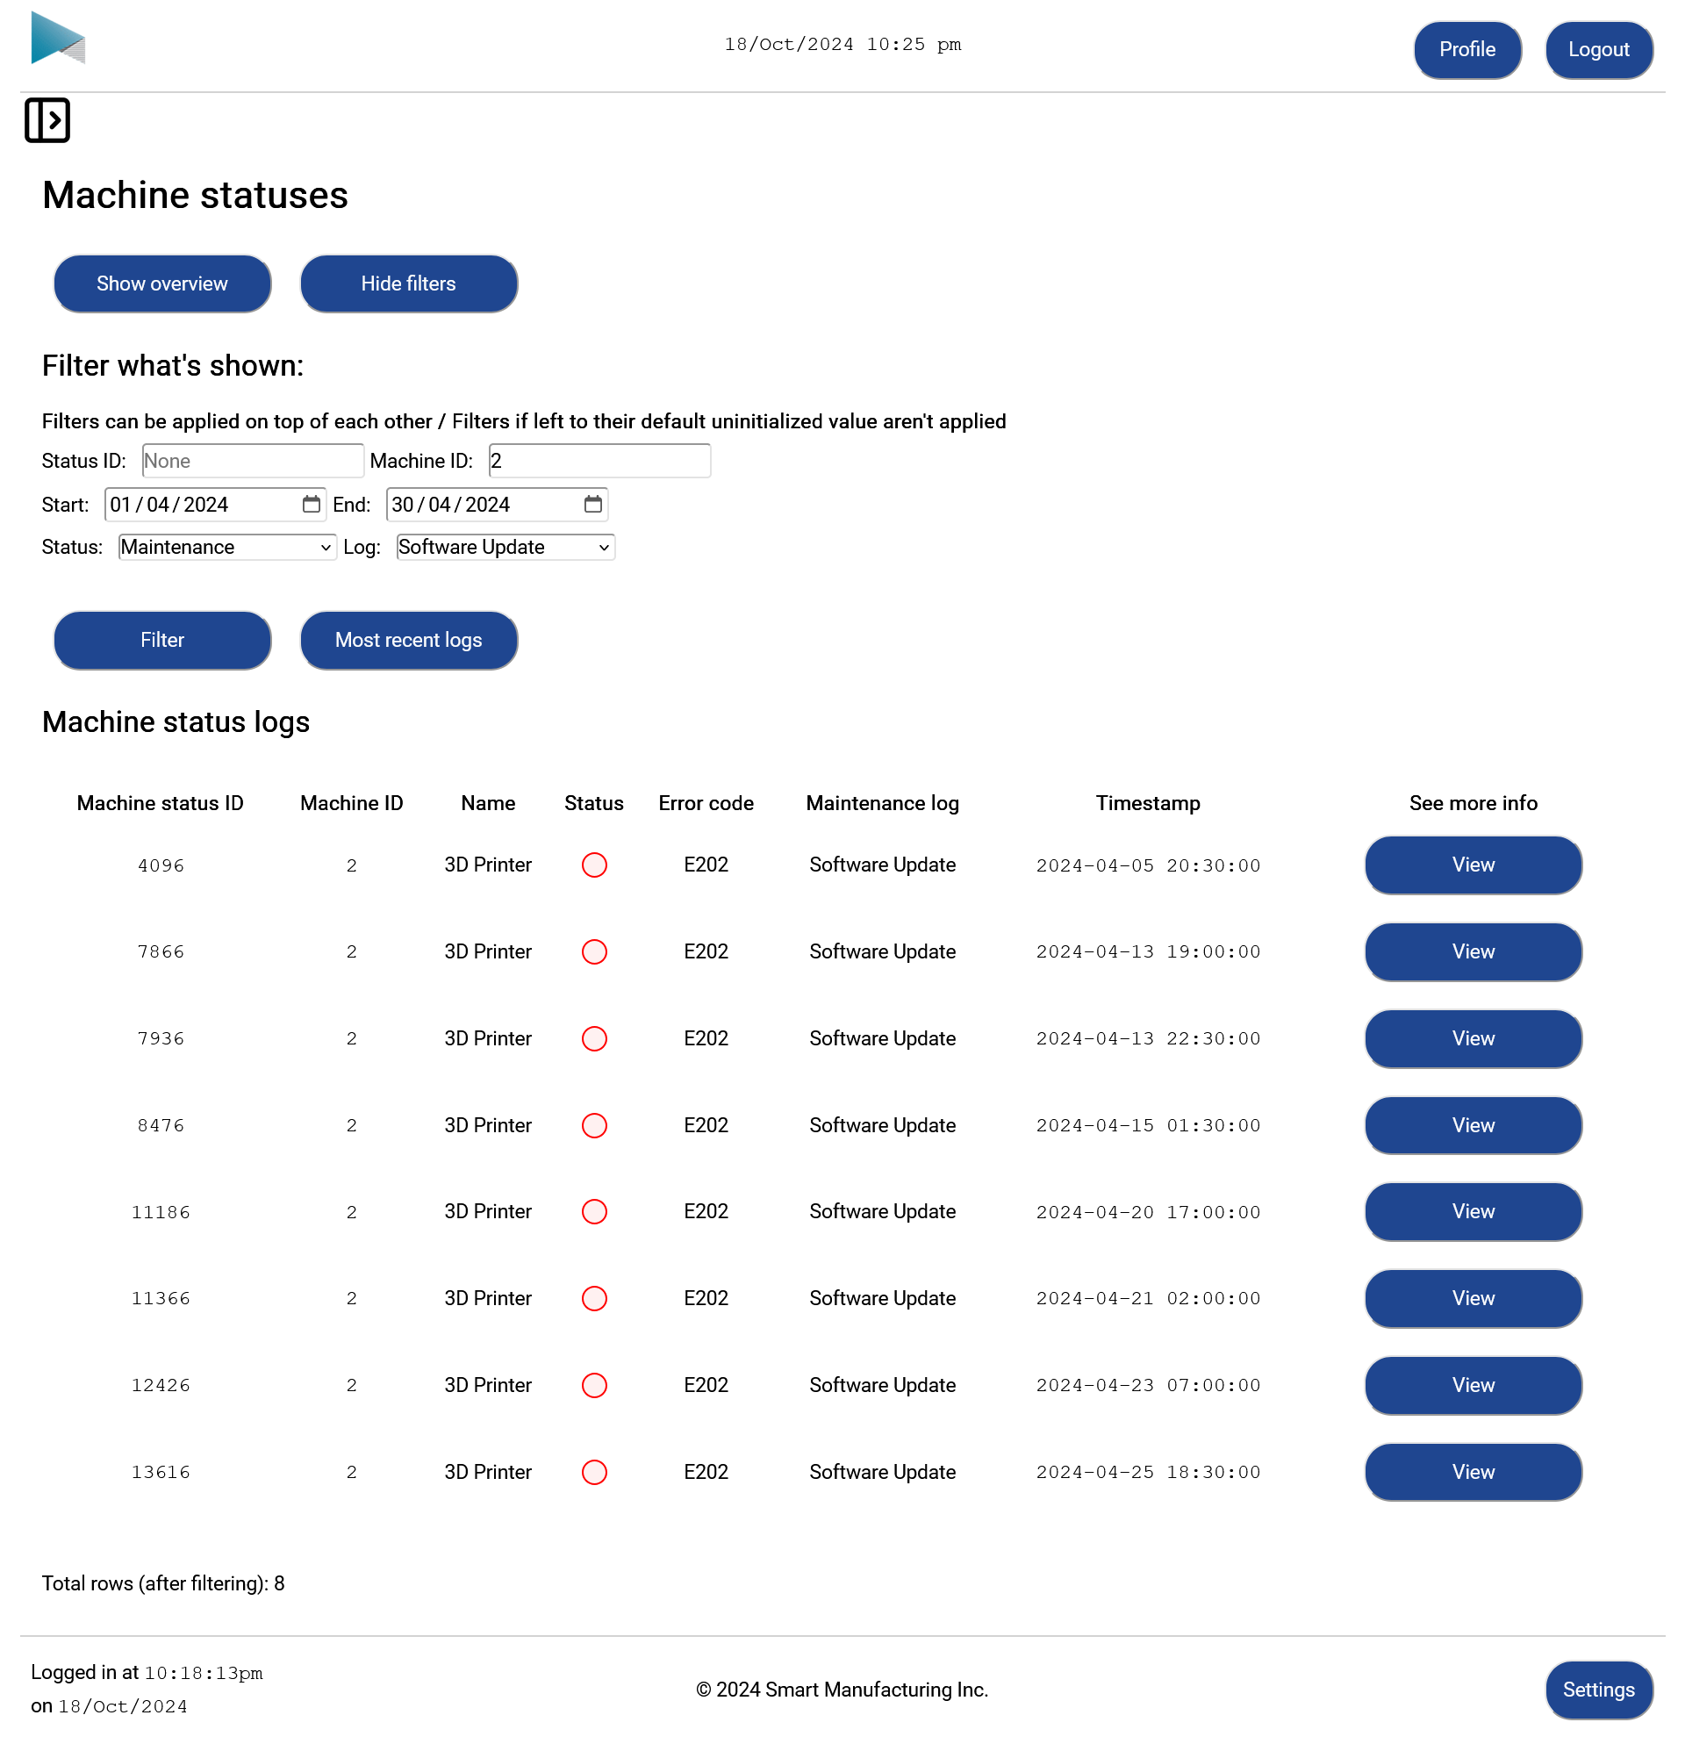

Individual machine status page

Production operator / Factory manager
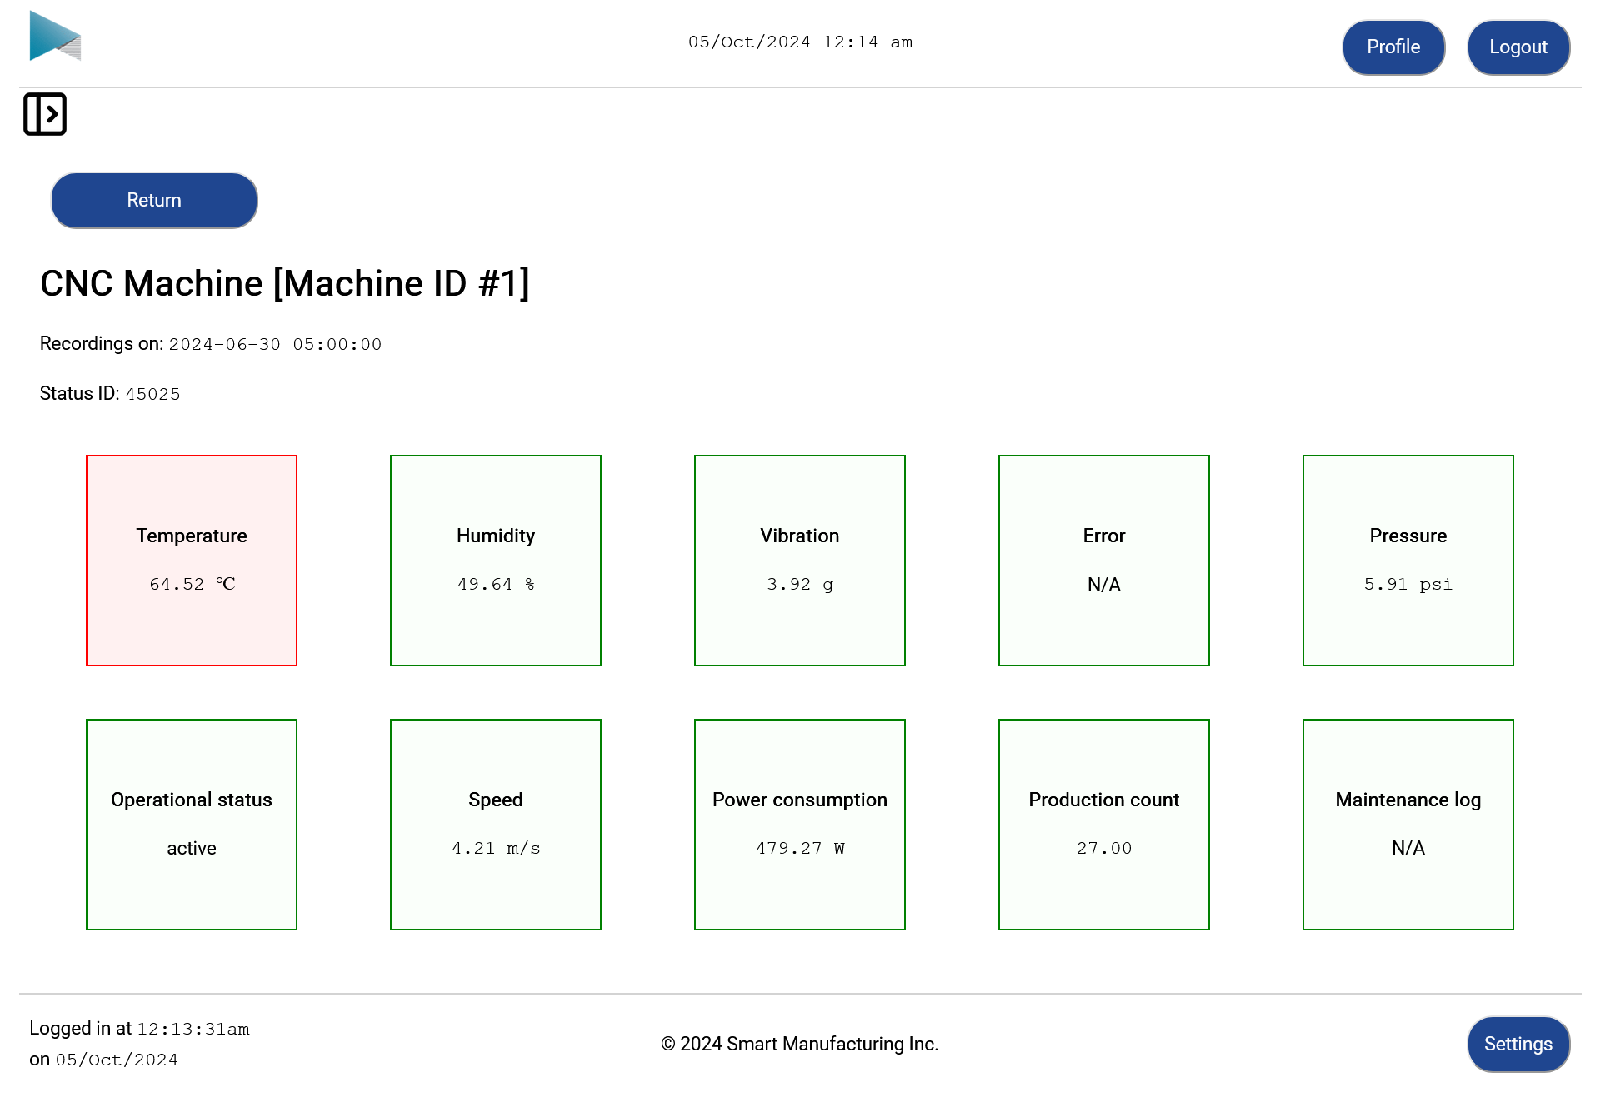

Jobs to do page

Production operator
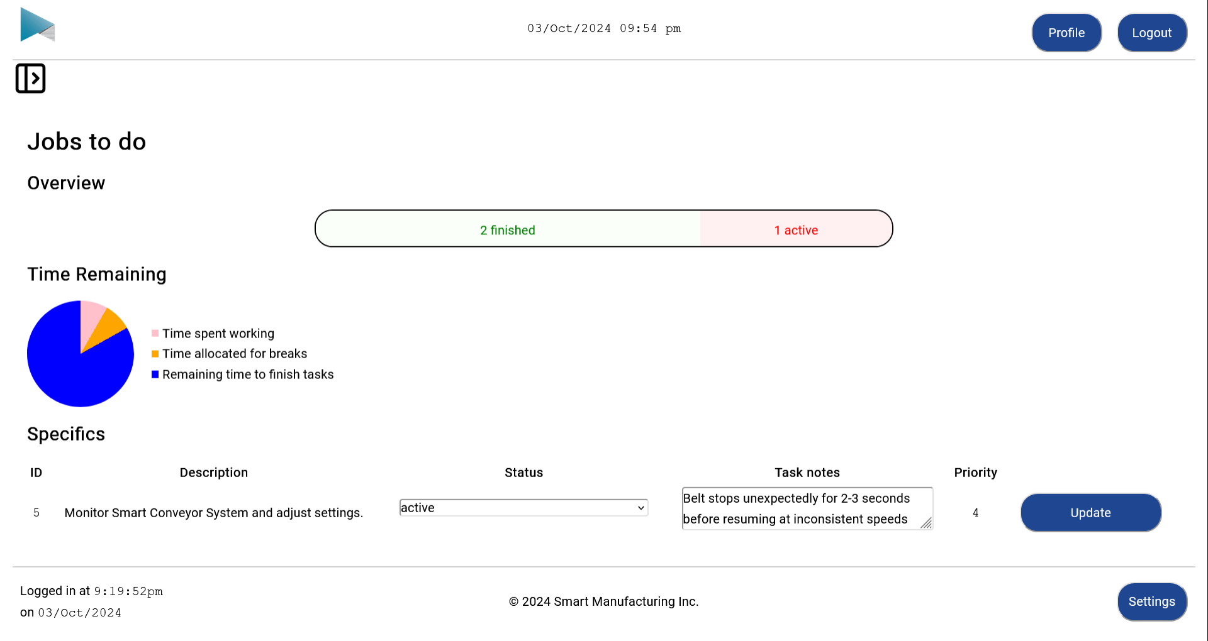

Job notes page

Factory manager
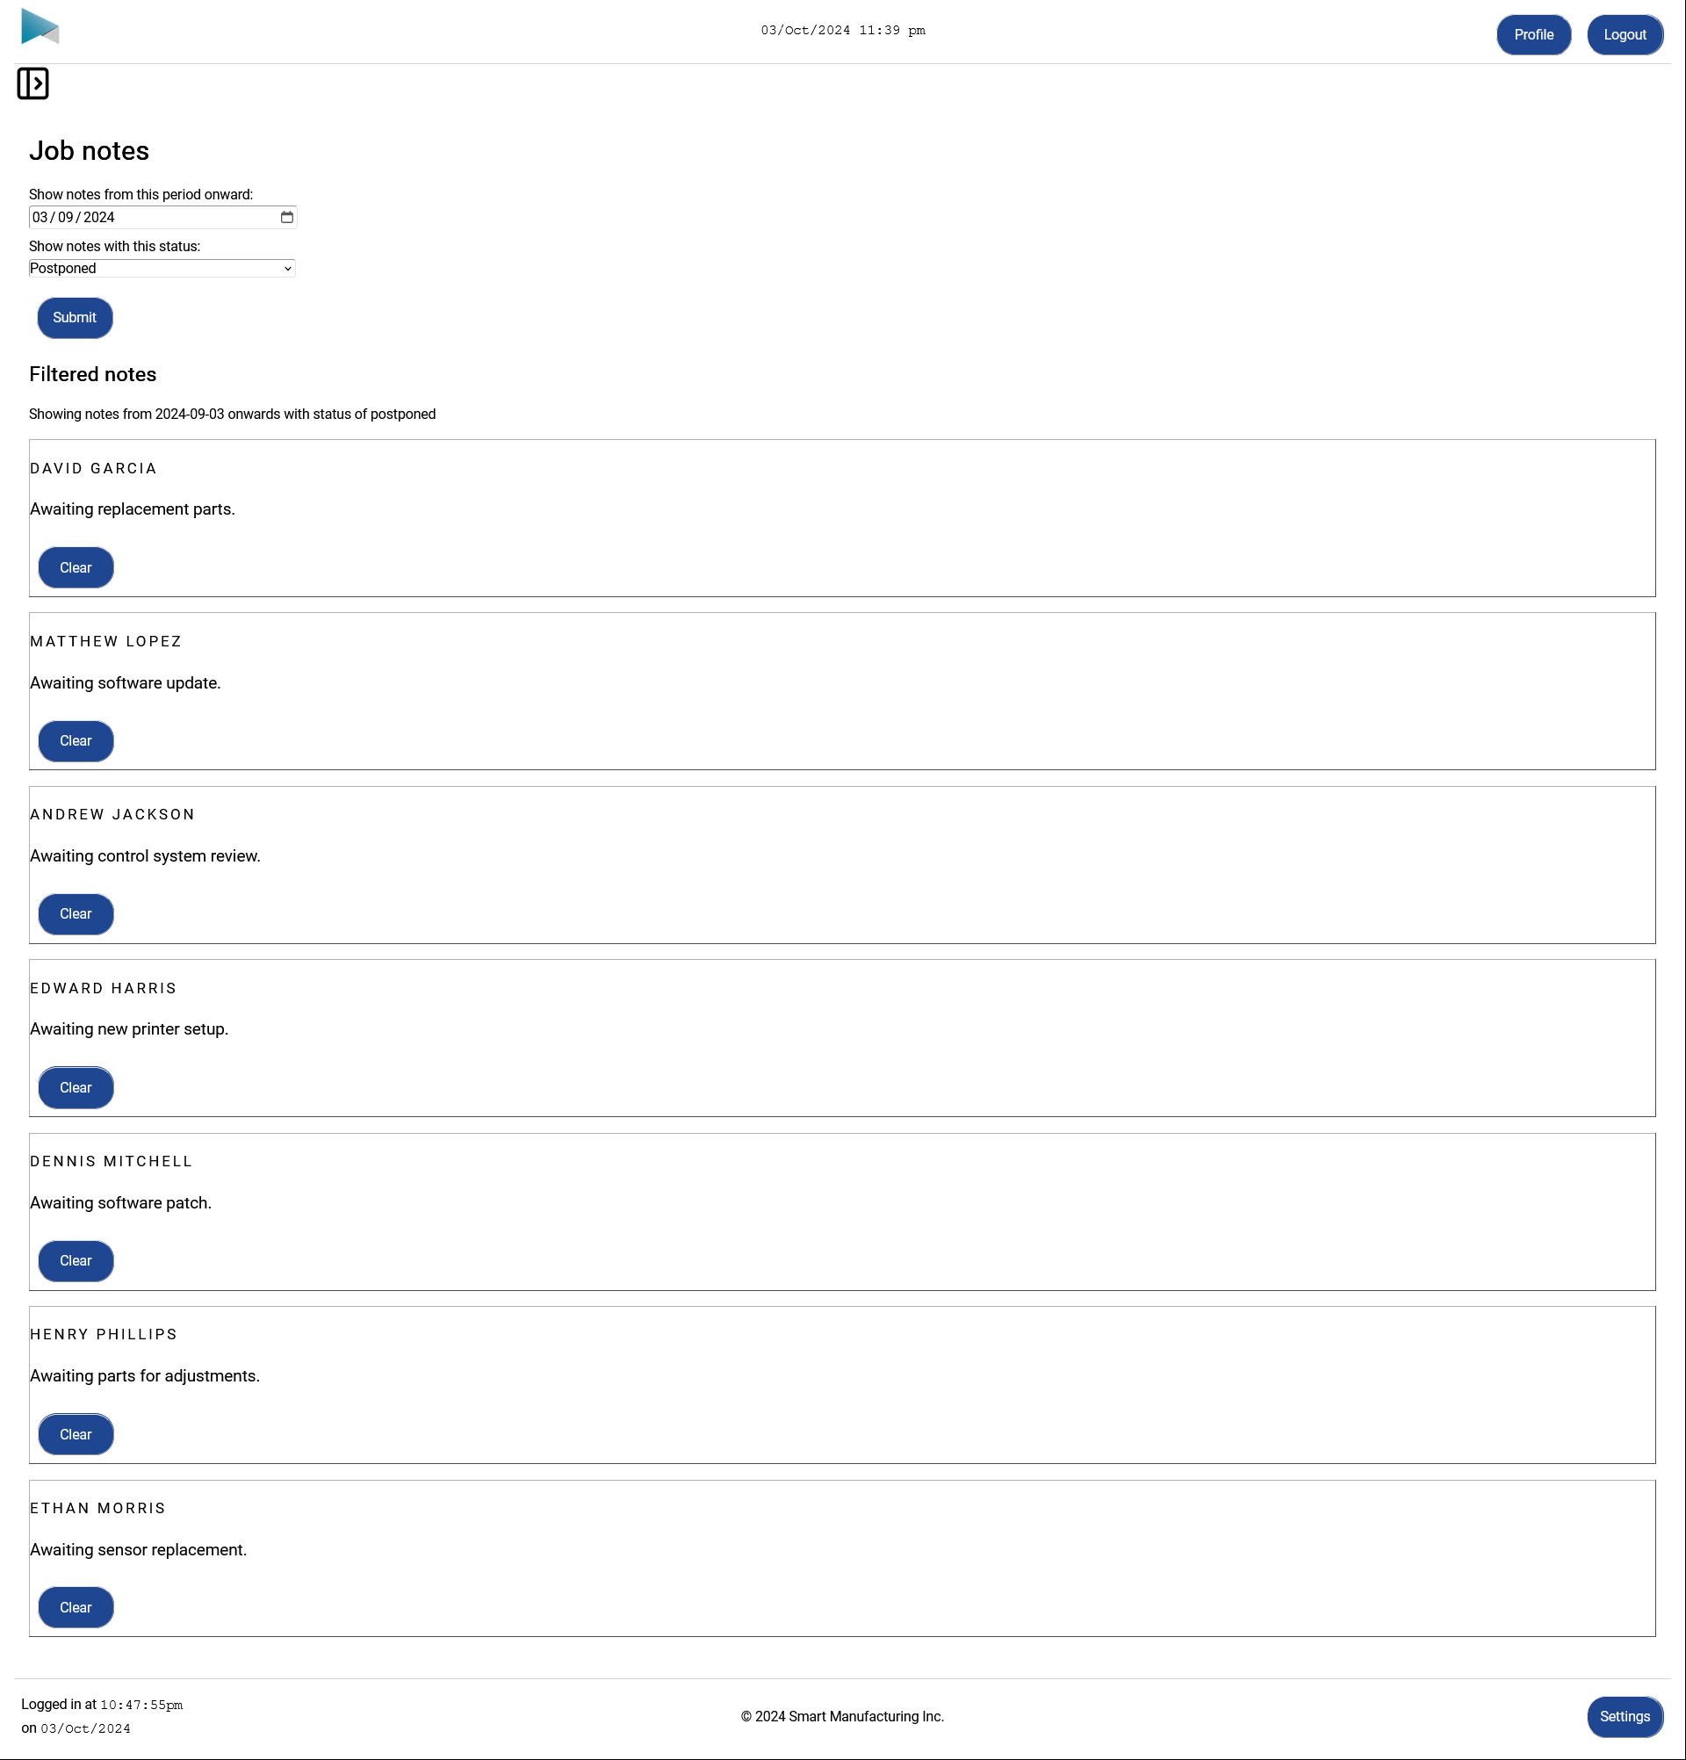

Factory floor attendance and productivity page

Factory manager
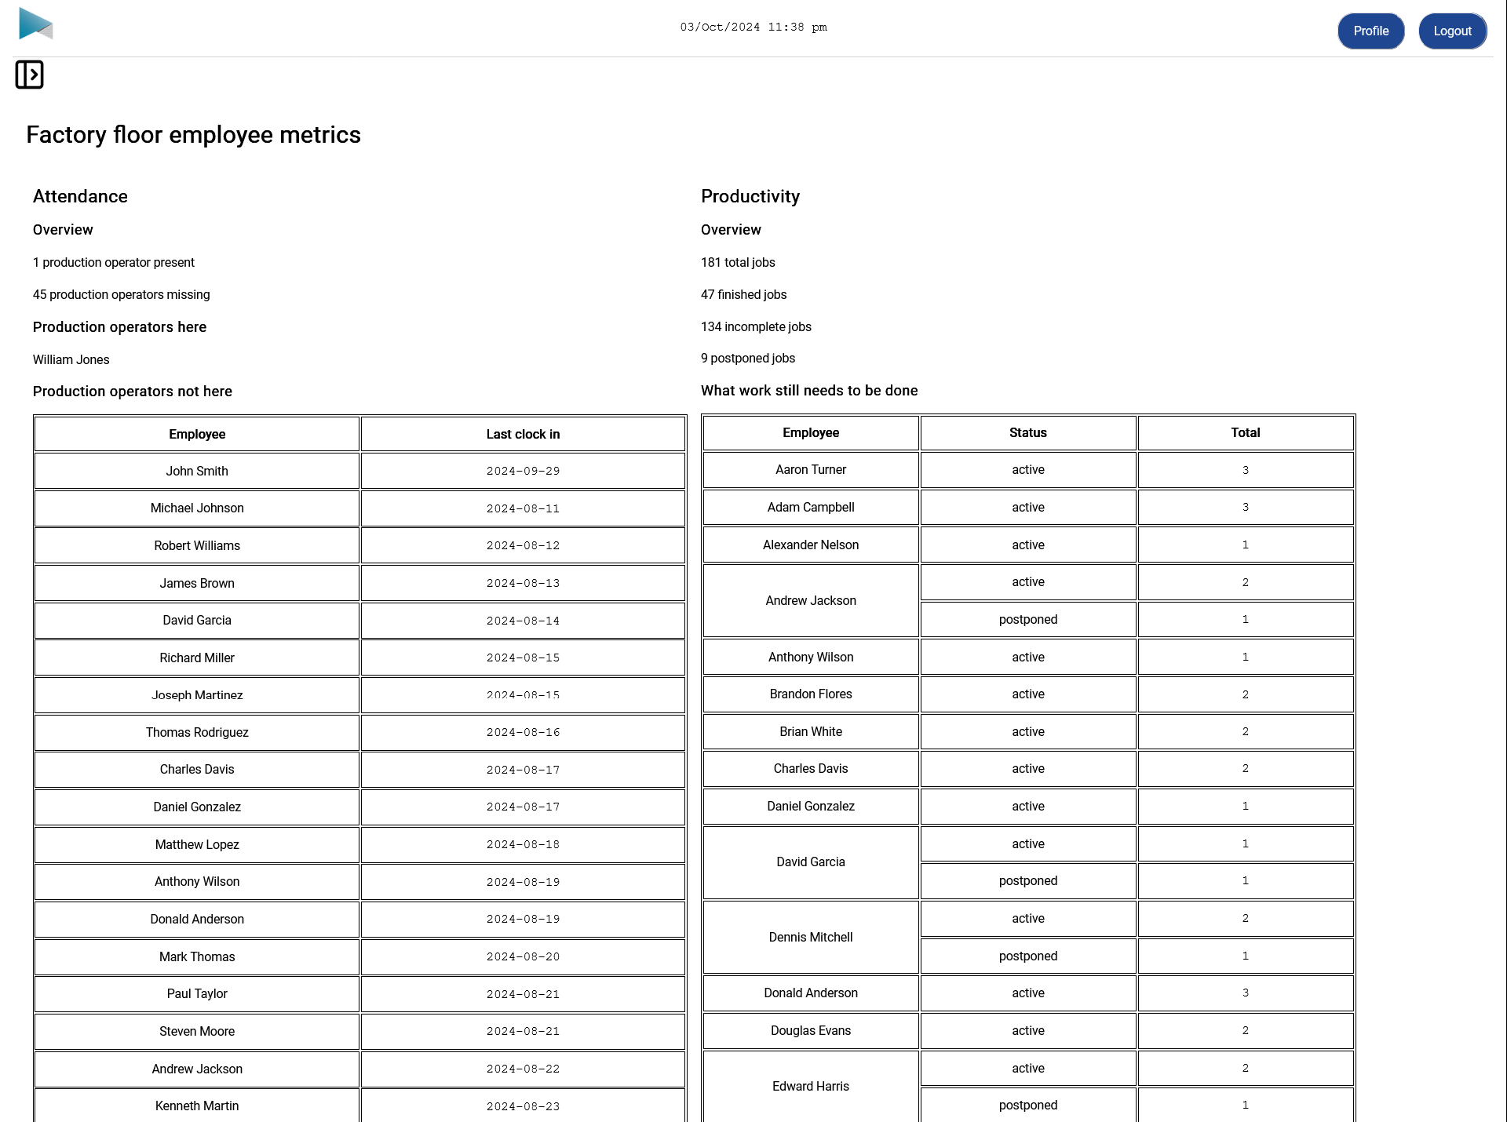
(Cut off some of the page in the screenshot to conserve space)

Inbox page

Production operator / Factory manager roles
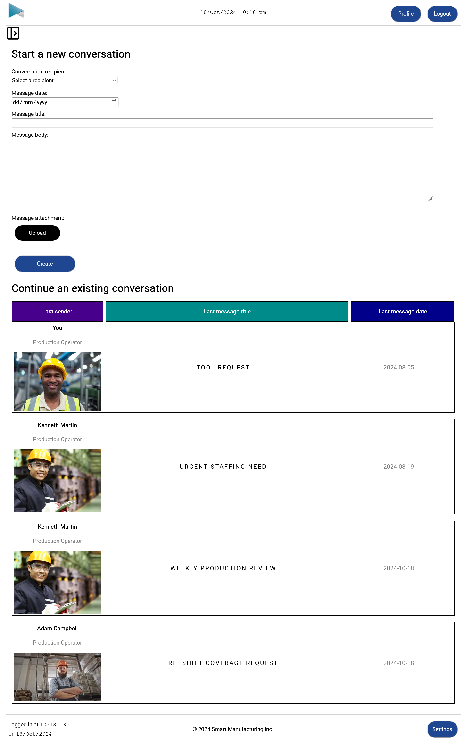

Conversation page

Production operator / Factory manager roles
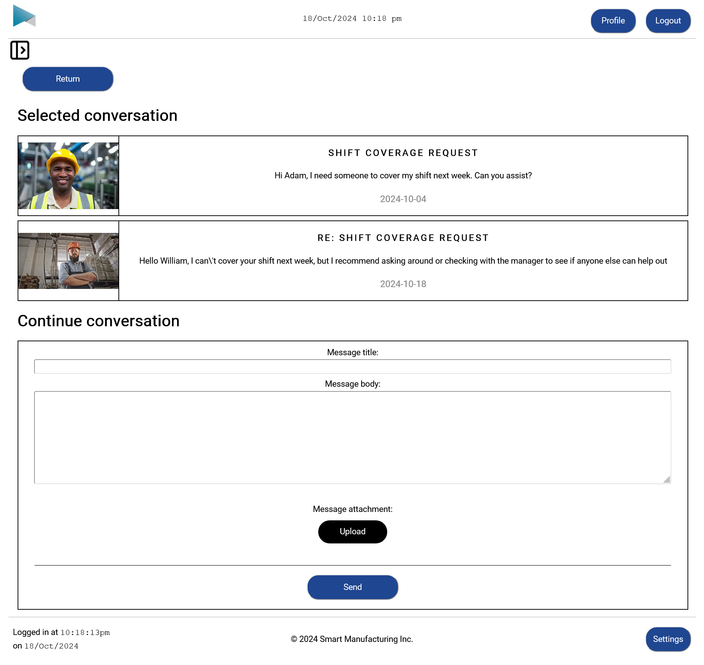

Error found page
Me (Shouldn’t be seen by any employees of the system)
- This page serves two purposes
  - Seeing how “broken” I can make a “website is broken” webpage, trying to break as many web design principles as possible
    - Autoplay multimedia (even though browsers attempt to stop this, I found a workaround) of a bat dancing to a Silence of the Lambs song
    - Expanding and shrinking text animation
    - Rotating video animation
    - Randomly changing colours for the text and page background with poor contrast between them
(Could have taken this idea a lot further but it’s already psychologically torturous enough)
  - Telling me what line and file the problem is in with the option to have custom error messages so I know what must be debugged
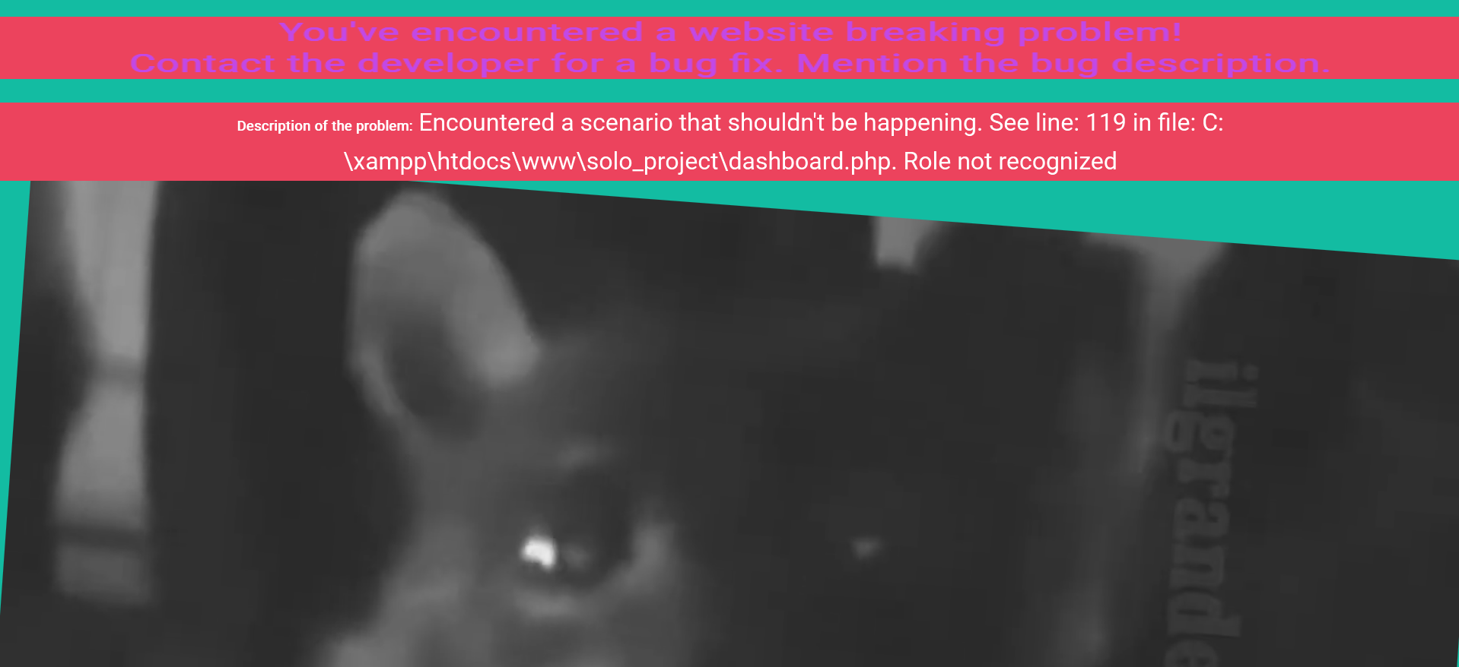

In this case, the problem was that I had a _ instead of a space for one’s switch statement so the user with the ‘maintenance worker’ role wasn’t recognized
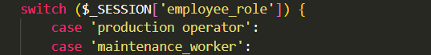

C -GitHub logs
All one’s own commits from when the assignment was first handed out to when it was due
