UX evaluation report
Human Factors for Interactive and Web-Based Systems
Kory Frankee
fran0618
Table of contents
01) Introduction 2
02) Evaluation methodology 3
03) KLM/GOMS 4
04) Results 14
04) Recommendations 16
05) Conclusion 17
06) Appendices 18

01) Introduction

Goals of a UX evaluation
- Working out if the product appeals to the target audience enough for them to want to use it
- Involving users in the process of deciding what direction the software solution should take

How these goals are met through UX evaluations
From conducting them, it’s possible to:
- Make user requirements more accurate via getting input from users on their:
  - Ideas
  - Goals
  - Needs
  - Paint points
  - Problems
  - Preferred approach to tackling tasks
  - Preferred solution to the problem at hand
  - Wants
- See if those responsible for UI/UX should be responsible for this based on their:
  - Applied knowledge about UI/UX
  - Adherence to best practices
  - Reasons for making the decisions made
  - Understanding of what the intended audience is looking for
- Improve the UX. Some of the measures used to judge UX:
  - The less time it takes for users to complete tasks, the better the UX is
  - The less confused users are about what to do, the better the UX is
  - The less mistakes users are making, the better the UX is
  - The less users need support from a support representative, the better the UX is
  - The fewer problems users have because of using the software solution, the better the UX is
  - The more users that can finish started tasks, the better the UX is
  - The higher the average revenue per user, the better off the business will be and UX has a bearing on whether users will perform the actions that business wants them to
  - The more users spend productively engage with the software solution, the better the UX is
  - The more users that like how the UI looks, the better the UX is
  - The more satisfied users are with the software, the better the UX is
  - The more users find value in the software, the better the UX is
  - The more users leave positive reviews and recommendations, the better the UX is

02) Evaluation methodology
Participants
- Gabrielle
- Xavier

Scripts provided
Script 01:
- Role: Maintenance operator
- Task: Investigating past machine malfunctioning incidents and state of a current machine

Script 02:
- Role: Admin staff
- Task: Adding a new employee and account for this employee

Client-side software
- An OS
- An Internet browser like Chrome or Mozilla Firefox
- Web server software like XAMPP if running a local server

Hardware
Computers that could be used:
- A desktop PC
- A laptop
- A tablet
- A mobile phone

Peripherals that could be used:
- Mouse
- Keyboard

Materials
- Two scripts w/:
  - Tasks for participants to perform
  - Questions to understand the user better that’re provided before all tasks have been done
  - System usability scale (SUS) provided after all tasks have been done
  - Single ease question (SEQ) provided after each task
- Pen
- Paper if recording one’s own notes

Scripts can be found in the appendix

03) KLM/GOMS
Needed 2 set of tasks for KLM/GOMS different to what the 2 UX evaluation participants encounter

The rules
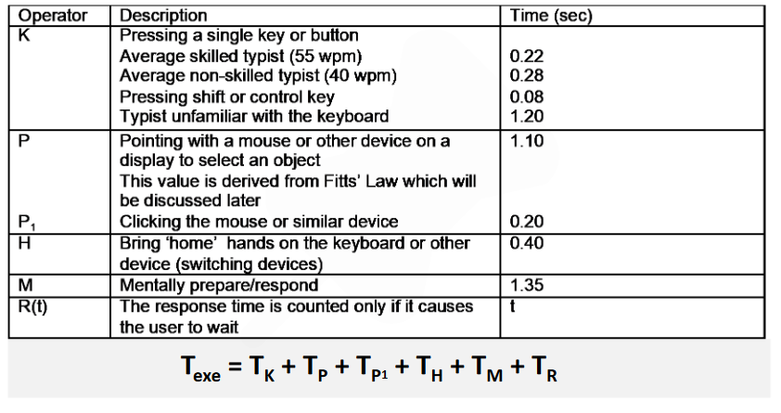
Decided to use the non-skilled typist time for K for consistency

- Insert a M in front of each K and P, more or less
- If a string of MKs belongs to a cognitive unit, delete all Ms except the first
  - Hello: “MKMKMKMKMK” → “MKKKKK”
  - 4564.23: “MKMKMKMKMKMKMK” → “MKKKKKKK”
- If K is a redundant terminator, then delete M in front of it
  - [enter] [enter]: MKMK → MKK
- If K terminates a constant string (command name), delete the M in front of it
  - cd [enter]: MKKMK → MKKK
- If K terminates a variable string (parameter), keep the M in front of it
  - cd class [enter] MKKMKKKKKMK

First set of tasks

GOMs w/ KLM

Goal
Updating the number of saws from 20 to 19 as one went missing

Goal in a picture
Want to go from this
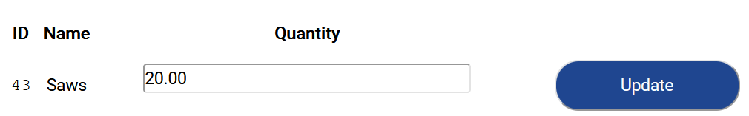

To this
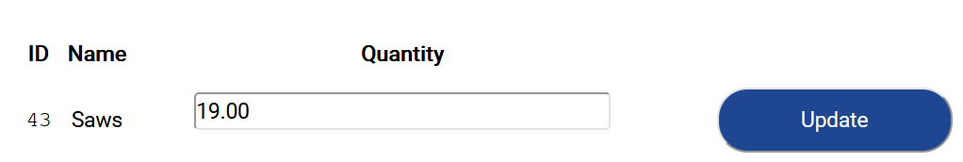

Process of achieving the goal
Options to choose between:
- Scrolling down to where saws are in the list
- Using the CTRL + F hotkey. Brought to the ‘Saws’ entry by typing in “Sa”
- Selecting the stock search field, putting in “Sa”, and pressing the ‘Filter button’. It’ll find “Saws” since it works for inexact matches

No matter the scenario, end up having to:
- Select the ‘Quantity’ field
- Put in the number ‘19’
- Press the ‘Update’ button

Operators (a sequence of actions)
Scenario 1) Scroll to find
Mentally prepare / respond – M
Move hand to the mouse - H
Scrolling down once – PP_1
Number of scrolls needed varies depending on the user’s scroll settings. For me it’s one scroll
MHPP_1

Scenario 2) Search to find
Mentally prepare / respond – M
Move hands to keyboard - H
Pressing ‘CTRL + F’ – 2K
Mentally prepare / respond - M
Typing ‘Sa’ – K[Shift]KK
MHKKMK[Shift]KK

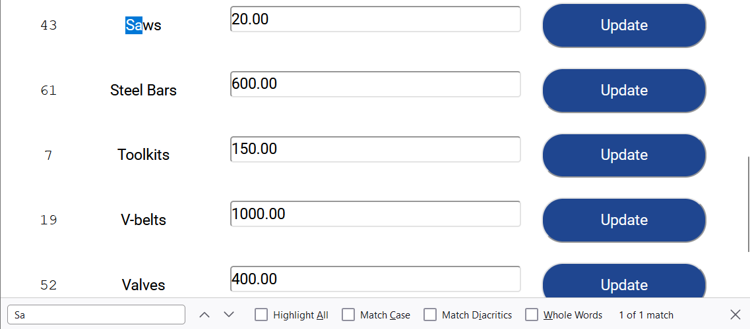

Scenario 3) Filter to find
Mentally prepare / respond – M
Move hands to the mouse – H
Moving pointer to select field - P
Selecting ‘Search’ field– P_1
Mentally prepare / respond – M
Move hands to the keyboard - H
Typing ‘Sa’ – K[Shift]KK
Mentally prepare / respond – M
Moving hands to the mouse – H
Moving pointer to the ‘Filter’ button - P
Pressing ‘Filter’ button– P_1
MHPP_1MHKKMHPP_1

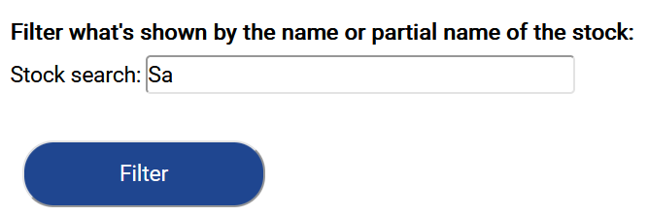

Scenario 4) Sort name by descending order to find
Mentally prepare / respond – M
Move hands to the mouse – H
Moving pointer to ‘Name’ field - P
Selecting ‘Name’ field– P_1
MHPP_1

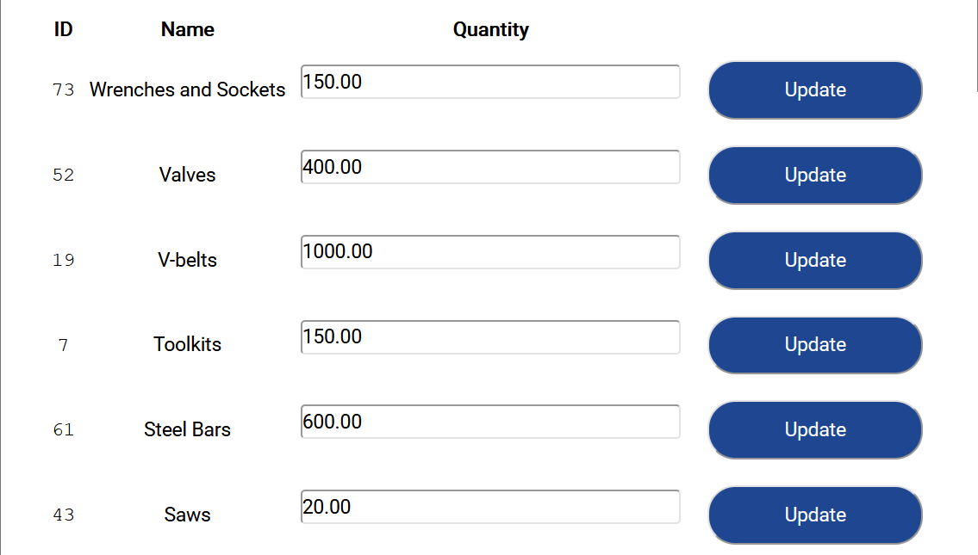

All scenarios) Updating stock
Mentally prepare / respond – M
Moving hands to the mouse – H
Moving pointer to the ‘Quantity’ field - P
Selecting ‘Quantity’ field – P_1
Mentally prepare / respond – M
Moving hands to the keyboard - H
Typing ‘19’ – 2K
Mentally prepare / respond – M
Moving hands to the mouse – H
Moving pointer to the ‘Update’ button - P
Pressing ‘Update’ button – P_1
MHPP_1MHKKMHPP_1

3 strings we end up with:
Scenario 1 MHPMHPP_1MHKKMHPP_1
Scenario 2 MHKKMK[Shift]KKMHPP_1MHKKMHPP_1
Scenario 3 MHPP_1MHK[Shift]KKMHPP_1MHPP_1MHKKMHPP_1
Scenario 4 MHPP_1MHPP_1MHKKMHPP_1

Selection rules – Decision process for choosing one method over another
- First method is best if
  - The list isn’t too long. The shorter the list, the less inefficient it is to scroll down to find ‘Saws’
  - The exact position of ‘Saws’ in the list is known since that will help with knowing how much to scroll
- Second method is ideal if
  - The list is long
  - The user knows keyboard shortcuts and is using a keyboard
- Third method is ideal if
  - The list is long
  - The user isn’t sure what to do. There’s an option to search for inexact matches presented to them
- Fourth method is ideal if:
  - What the user is looking for skews towards the first few or last few letters of the alphabet
- Want to perform the task in as little time as possible, no matter the method

Estimated response times
 | Scenario 1  MMMM  HHHH  PPP  KK  P_1P_1P_1 | Scenario 2  HHHH  PP  P_1P_1  MMMMM  KKKKKK  K[Shift] | Scenario 3  MMMMMM  HHHHHH  PPPP  P_1P_1P_1P_1  K[Shift]  KKKK | Scenario 4:  MMMM  KK  HHHH  PPP  P_1P_1P_1
M  (1.35) | 4  (5.4 seconds) | 5  (6.75 seconds) | 6  (8.1 seconds) | 4  (5.4 seconds)
H  (0.40) | 4  (1.6 seconds) | 4  (1.6 seconds) | 6  (2.4 seconds) | 4  (1.6 seconds)
P  (1.10) | 3  (3.3 seconds) | 2  (2.2 seconds) | 4  (4.4 seconds) | 3  (3.3 seconds)
K[Shift]  (0.08) | 0  (0 seconds) | 1  (0.08 seconds) | 1  (0.08 seconds) | 0  (0 seconds)
K  (0.28) | 2  (0.56 seconds) | 6  (1.68 seconds) | 4  (1.12 seconds) | 2  (0.56 seconds)
P_1  (0.20) | 3  (0.6 seconds) | 2  (0.4 seconds) | 4  (0.8 seconds) | 3  (0.6 seconds)
Total time | 11.46 seconds | 12.71 seconds | 16.18 seconds | 11.46 seconds

Second set of tasks

GOMs w/ KLM

Goal
Let’s assume that the manager recently added a record into the factory employee grievances table from the “add records” page, detailing a grievance John Smith had. Now, he has the goal of updating the information recorded about this grievance from the “change records” page given newfound information.

Goal in a picture
Want to go from this
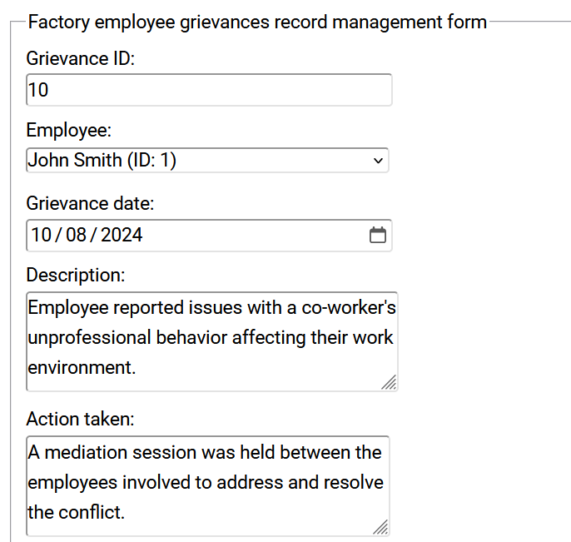

To this:
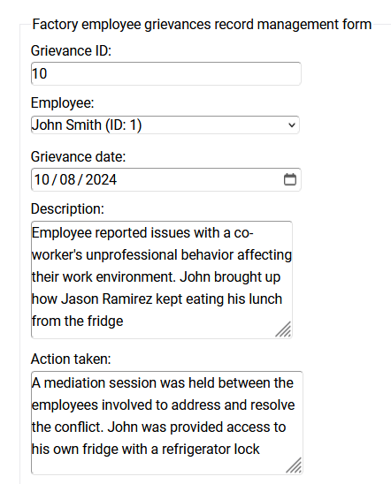

Process of achieving the goal
Options to choose between:
- Pressing the ‘Last’ button
Manager knows it’s the last record since it was last one he put in
- Pressing the ‘Next’ button 10 times
- Jumping to the record:
  - Selecting the ‘Grievance ID’ field.
  - Putting in the number ‘10’.
  - Pressing the ‘Jump to’ button
Manager knows it’s the 10th record since there’s text at the bottom that indicates what record he is looking at and the total records, which is stated to be 10. So, it’s clear that the 10th record is the last record

No matter the scenario, end up having to:
- Click and drag the bottom right corner of the ‘Description’ field to expand the field
- Select the ‘Description field
- Add the following text
“[space] John brought up how Jason Ramirez kept eating his lunch from the fridge”
- Click and drag the bottom right corner of the ‘Action taken field’ to expand the field
- Select the ‘Action taken’ field
- Add the following text
“[space] John was provided access to his own fridge with a refrigerator lock”
- Press the ‘Update’ button

Operators (a sequence of actions)
Scenario 1) Pressing the ‘Last’ button
Mentally prepare / respond – M
Moving hands to the mouse – H
Moving pointer to the ‘Last’ button – P
Pressing ‘Last’ button – P_1
MHPP_1

Scenario 2) Pressing the ‘Next’ button 10 times
Mentally prepare / respond – M
Moving hands to the mouse – H
Moving pointer to the ‘Next’ button - P
Pressing ‘Next’ button 10 times – {10P_1}
MHP{10P_1}

Scenario 3) Jumping to the record
Mentally prepare / respond – M
Moving hands to the mouse – H
Moving pointer to the ‘Grievance ID’ field - P
Selecting ‘Grievance ID’ field – P_1
Mentally prepare / respond – M
Moving hands to the keyboard - H
Typing ‘10’ – KK
Mentally prepare / respond – M
Moving hands to the mouse – H
Moving pointer to the ‘Jump to’ button - P
Pressing ‘Jump to’ button – P_1
MHPP_1MHKKMHPP_1

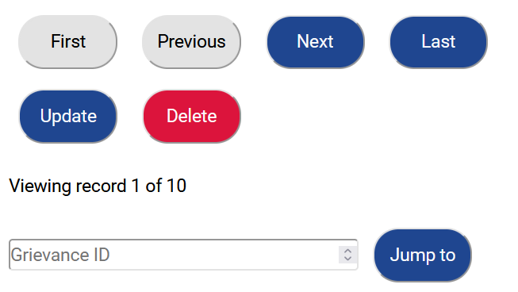

All scenarios) Updating the description
Mentally prepare / respond – M
Moving hands to the mouse – H
Moving pointer to the bottom right-hand corner of the ‘Description field’ - P
Moving pointer downward to expand it – P
Moving pointer to within the field – P
Clicking towards the end of the field – P_1
Mentally prepare / respond – M
Moving hands to the keyboard – H
Type in our message – {Total of 3K[Shift] and 72K}
- It has 72 characters. Of these 72 characters, 3 characters require pressing SHIFT
Mentally prepare / respond – M
Moving hands to the mouse – H
Moving pointer to the bottom right-hand corner of the ‘Action taken field’ - P
Moving pointer downward to expand it – P
Moving pointer to within the field – P
Clicking towards the end of the field – P_1
Mentally prepare / respond – M
Type in our message – {Total of K[Shift] and 68K}
- It has 68 characters. Of these 68 characters, the first one requires pressing SHIFT
Mentally prepare / respond – M
Moving hands to the mouse – H
Moving pointer to the ‘Update’ button - P
Pressing ‘Update’ button – P_1
MHPPPP_1MH{Total of 3K[Shift] and 72K}MHPPP_1M{Total of K[Shift] and 68K}MHPP_1

3 strings we end up with:
Scenario 1 MHPP_1MHPPPP_1MH{Total of 3K[Shift] and 72K}MHPPP_1M{Total of K[Shift] and 68K}MHPP_1
Scenario 2 MHP{10P_1}MHPPPP_1MH{Total of 3K[Shift] and 72K}MHPPP_1M{Total of K[Shift] and 68K}MHPP_1
Scenario 3 MHPP_1MHKKMHPP_1MHP{10P_1}MHPPPP_1MH{Total of 3K[Shift] and 72K}MHPPP_1M{Total of K[Shift] and 68K}MHPP_1

Selection rules – Decision process for choosing one method over another
- First method of using the ‘Last’ button is best if
  - The element that we’re looking for is the last record in the DB table or close to it
- Second method of using the ‘Next’ button is ideal if
  - The element that we’re looking for the second record in the DB table or close to it
- Third method of ‘Jumping to a record’ is ideal if
  - We know what record in the DB we’re looking for
  - The element that we’re looking for isn’t close to the last or second record in the DB table. Suppose for example that we were interested in the 500 hundredth record in a table of 1,000 records.

Estimated response times
 | Scenario 1  M  H  P  P_1 | Scenario 2  M  H  P  10P_1 | Scenario 3  MMM  HHH  PP  P_1P_1  KK
Across all scenarios
MMMMM, HHHH, PPPPPP, P_1P_1P_1 , {Total of 4K[Shift]} , {Total of 140K}
M  (1.35) | 6  (8.1 seconds) | 6  (8.1 seconds) | 8  (10.8 seconds)
H  (0.40) | 5  (2 seconds) | 5  (2 seconds) | 8  (3.2 seconds)
P  (1.10) | 7  (7.7 seconds) | 7  (7.7 seconds) | 8  (8.8 seconds)
K[Shift]  (0.08) | 4  (0.32 seconds) | 4  (0.32 seconds) | 4  (0.32 seconds)
K  (0.28) | 140  (39.2 seconds) | 140  (39.2 seconds) | 140  (39.2 seconds)
P_1  (0.20) | 4  (0.8 seconds) | 13  (2.6 seconds) | 5  (1 second)
Total time | 58.12 seconds | 59.92 seconds | 63.88 seconds

04) Results

04.1) SES score findings
Task | Gabrielle SES score | Xavier SES score | Calculations | Average SES score
Logging in | 7 | 7 | (7+7)/2 | 7
Clocking in | 7 | 7 | (7+7)/2 | 7
Filtering machine logs | 5 | 5 | (5+5)/2 | 5
Sending messages | 6 | 6 | (6+6)/2 | 6
Inserting records | 7 | 5 | (7+5)/2 | 6
Logging out | 7 | 7 | (7+7)/2 | 7

Average SES score across all the averages = (7+7+5+6+6+7)/6 = 6.33 out of 10

04.2) SUS score findings
Process is:
- If question ordering is odd, subtract one from response value
- If question ordering is even, subtract response value from five
- Times total number by 2.5
- Average SUS scores by totalling them and dividing by the number of participants

Getting the SUS scores from the data from our two participants
Question number | Gabrielle score | Calculation | Xavier score | Calculation
01 | 4 | 4 – 1 = 3 | 4 | 4 – 1 = 3
02 | 3 | 5 – 3 = 2 | 3 | 5 – 3 = 2
03 | 5 | 5 – 1 = 4 | 4 | 4 – 1 = 3
04 | 1 | 5 – 1 = 4 | 1 | 5 – 1 = 4
05 | 5 | 5 – 1 = 4 | 4 | 4 – 1 = 3
06 | 2 | 5 – 2 = 3 | 1 | 5 – 1 = 4
07 | 3 | 3 – 1 = 2 | 4 | 4 – 1 = 3
08 | 2 | 5 – 2 = 3 | 2 | 5 – 2 = 3
09 | 4 | 4 – 1 = 3 | 5 | 5 – 1 = 4
10 | 2 | 5 – 2 = 3 | 2 | 5 – 2 = 3
 | Total score: | 31 | Total score: | 32
 | X2.5: | 77.5 | X2.5: | 80
 | Average score
 | (77.5 + 80) / 2 = 78.75

Putting this average score in form of a university grade
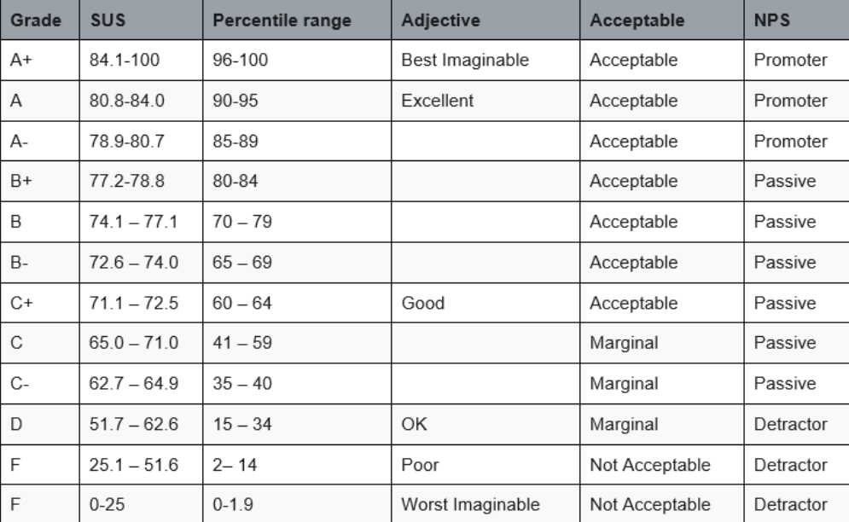
Can see that an average score of 78.75 is a B+ with a percentile range of 80-84 and in the acceptable band

0.4.2) Predictive model findings

Estimates for time it takes to update stock count for ‘Saws’
Scenario | Time estimate
- Scroll + Change | 11.46 seconds
- Search + Change | 12.71 seconds
- Filter + Change | 16.18 seconds
- Sort + Change | 11.46 seconds

Estimates for time it takes to update details for last employee grievance
Scenario | Time estimate
- Last button + Change | 58.12 seconds
- Next button (10x) + Change | 59.92 seconds
- Jump to record button + Change | 63.88 seconds

- Found that the KLM model times didn’t reflect the time it took to complete the tasks in the real-world
- Found that the KLM model provided an inaccurate estimate of what tasks would take longer relative to other tasks in some cases (e.g. for the second scenario, it’s faster to jump to a record then press the next button 10 times but the model suggests that this would take ~~ 4 seconds longer). One factor for pressing the ‘Next’ button being so slow if the record is not near the start is because after each time the button is clicked, the server must refresh the page because the logic is in PHP. So, we’ve found that as the KLM model isn’t based on a particular language like PHP, it isn’t aware of additional time that this language might introduce in completing tasks. AJAX would be faster than PHP, for example.
- Found that using the KLM model can indicate if a task is a large ordeal (e.g. making a complex 3D model) since if it’s a large ordeal then there’ll be a strong desire to resist having to create the string for it (i.e. it might take thousands of letters). If a task is appearing to be more of an ordeal that what it should be then this indicates that changes ought to be made to reduce the number of actions required

04) Recommendations

What recommendations were taken on board

Feedback from the UX evaluation session
- Having different colours for buttons or making more important buttons bigger so it doesn’t blend in with or be confused with other buttons that are close it when rushing the process
- Reducing the odds of misclicks
- Reducing how confused users are
- Not having to know FK IDs when inserting/updating records
- Making the workflow more efficient
- Reducing how much users must remember
- Reducing the need to scroll down to see what’s of interest to the user for the machine statuses page
- Making the workflow more efficient

What suggestions should be taken on board if further development was to occur on this website

Feedback from the UX evaluation session
- Decreasing how long it takes to pull the data from the database in case of there being a lot of records
- Reducing page loading times
- Separating more of the data into different menus so that what’s shown is less overwhelming
- Showing what’s relevant to the user, nothing more

One’s own thoughts
- Better balancing security with performance through reducing cost factor from 16 to 14
- Reducing login page loading time
- Developing induction videos for each job role
- Reducing the time first-time users spend to become comfortable with the system
- Eliminating need to refresh page where possible
- Reduce page loading times
- Reducing the need to scroll down to see what’s of interest to the user for the manage records table through automatically travelling to form user last looked at if form navigation buttons are pressed
- Making the workflow more efficient
- Filtering without having to click a button to do so for text-based filters
- Making the workflow more efficient
- Introducing a find and replace feature for changing lots of DB records at once
- Making the workflow more efficient
- Making it so can see lots of records for users at once and navigate between pages of records for the manage records page instead of seeing a single record at a time
- Making the workflow more efficient
- Adding a way to insert lots of new records via importing data from an Excel file
- Making the workflow more efficient
- Showing each level of hierarchy leading to the current page
- Making it easier to navigate the website
- Making where the user is relative to where the user came from clearer
- Introducing new pages based on what’s of interest to the target audience. The manager, for example, might want a noticeboard page where messages can be sent to all employees or events can be created. The production operator might, for example, want to see a calendar that shows what days they’re scheduled in for and for what timeframe as well as when breaks are happening (e.g. for Xmas)
- Meeting more user requirements
- Using radio buttons for forms instead of dropdown lists in cases where there’s few options
- Making the workflow more efficient
- Arranging items in categories for dropdown lists if these lists become large (e.g. folders containing employees belonging to a particular job role and can toggle them open/closed). Also adding a way to search for the name of a particular item from this list with a search field
- Making the workflow more efficient
- Adding more complex editor to format text (e.g. being able to make text bold or change font size) when sending messages to others
- Making the UI prettier
- Adding a password strength meter but perhaps allowing less secure passwords compared to the ultra-secure passwords users must have now
- Encouraging but not forcing desired behaviour
- Optimizing the site based on what tasks are performed most frequently
- Making the workflow more efficient
- Introducing new features based on what’s of interest to the target audience. There could be an interest in being able to have requests for time-off approved or rejected from the system. There may be a desire to show which employees were the most well-performing over a period. There might also, for example, be a desire to make it so a conversation could have more than two participants.
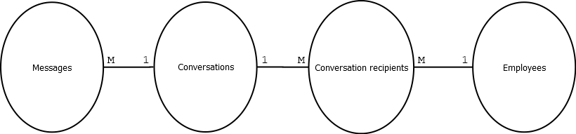
- Meeting more user requirements
- Providing an alternative log-in mechanism (e.g. facial recognition logging in)
- Making the workflow more efficient

05) Conclusion
From the UX evaluation process, we had users use our software solution and showed how their experiences and perception could be used to make targeted improvements to the system. We explored how as UI/UX designers and/or software developers, we don’t want to unnecessarily overcomplicate the process by which users accomplish their goals. The solution developed received a score of 78.75 out of 100 (a B+). After multiple rounds of testing the system with a diverse range of users from our target audience and acting on what was learnt from this, it’s anticipated that the system would score better.

06) Appendices

A) Pre-evaluation tasks questionnaire
What is your name?

What is your age?

What is your gender?

What is your occupation?

What device are you using to perform the tasks?

What browser are you using to perform the tasks?

How comfortable are you navigating most websites, generally speaking?

Have you used similar systems before? If so, for how long?

B) Scripts

Script 01
Investigating the times the machine with an ID of 1 needed maintenance in April 2024 and reporting to the manager that it’s at risk of needing maintenance again if action is not taken

Starting at the URL of the webpage …

Logging in….
- Log-in as Eric King, the ‘maintenance worker’
- Put in username => king7865
- Put in password => B!lbyM@rch!
- Leave branch as it is => 12 Outer Suburb Rd
- Select log-in

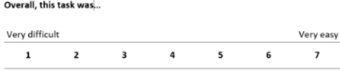

Clocking in upon being redirected to the dashboard…
- Select ‘Start/Stop working’
- Select ‘Day’ for shift selector
- Select ‘Clock in’

Seeing reasons the machine with an ID of 1 has suffered a catastrophic failure…
- Select sidebar toggle in top-left hand corner
- Select ‘Machine statuses’
- Scroll down to ‘Timestamp’ column under ‘Filtered machine status logs’
- Select ‘Timestamp’ column to put the logs in descending order
- Scroll up to ‘Filters that can be applied’
- Put in the filters
The filters
- Apply filter for ‘Filter what’s shown by machine ID’:
  - Put in a machine ID => 1
- Apply filter for ‘Filter what’s shown by time period’:
  - Put in a start date => 01/04/2024
  - Put in an end date => 30/04/2024
- Apply filter for ‘Filter what’s shown by status’
  - Put in a status => Maintenance
- Apply filter for ‘Filter what’s shown by maintenance log’:
  - Put in a reason for it needing maintenance => Catastrophic failure
- Select ‘Filter’
See the total times this machine has suffered a catastrophic failure via the ‘total rows (after filtering)’ shown at the bottom of the table
- Select ‘View’ for the first (i.e. most recent instance) in the list with the timestamp of ‘2024-04-30 02:30:00’ and machine status ID ‘15695’
See what is highlighted in red as a potential cause of the failure
- Select ‘Return’
- Select ‘Filter’
- Select ‘View’ for the timestamp ‘2024-04-09 07:00:00’ with machine status ID ‘5705’
See what is highlighted in red as a potential cause of the failure
- Select ‘Return’
- Select ‘Most recent logs’
- Select ‘View’ for the machine with an ID of 1
See what is highlighted in red as a potential reason it might change from operational status of ‘active’ to ‘maintenance’

Communicate findings to the manager…
- Select ‘Inbox’
- For ‘Conversation recipient’, select ‘Nicholas Allen’ under ‘Factory managers’
- For message date, put in the current date
- For message title, put in ‘Potential risk of machine failure’
- For message body, put in

Hello Nicholas,
I noticed that the temperature for the machine with an ID of 1 is high.
This might be worth looking into as I found that there were previous incidents where it suffered a catastrophic failure where a high temperature was the cause for this

- Select ‘Create’

End session…
- Select ‘Logout’ at the top right hand corner

Script 02
Entering new employee into the DB

Starting at the URL of the webpage …

Logging in….
- Log-in as Justin Nguyen, the ‘admin staff’
- Put in username => nguy6342
- Put in password => D1dgeridooR@ge!
- Put in branch => 34 Coastal Lane, Gos
- Select log-in

Inserting records into the DB upon being redirected to the dashboard…
- Select ‘Add records’
- Toggle ‘Factory employees’
- Put in the details of the new employee
New employee details
Branch ID: 1
First name: Dan
Last name: Gonzales
E-mail address: dan.gonzales@gmail.com
Employee role: Production operator
Employee salary: [Leave it blank]
Employee hourly rate: 25
- Select submit
- Untoggle ‘Factory employees’
- Toggle ‘Factory user accounts’
New employee user account details
Employee ID: 61
User username: gonz4284
User password: flyingGorilla
User profile picture: N/A

End session…
- Select ‘Logout’ at the top right hand corner

B) Post-evaluation tasks questionnaire
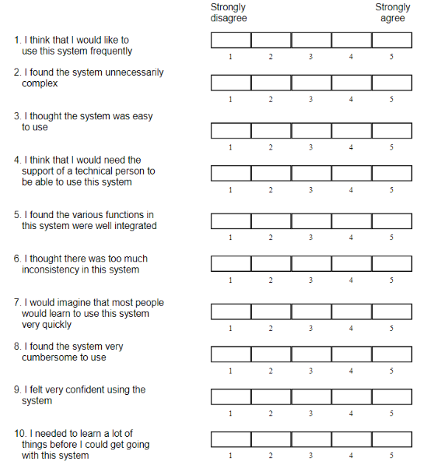

What would you change about the system if anything?

C) Responses

Pre-evaluation tasks questionnaire

Participant – Gabrielle:
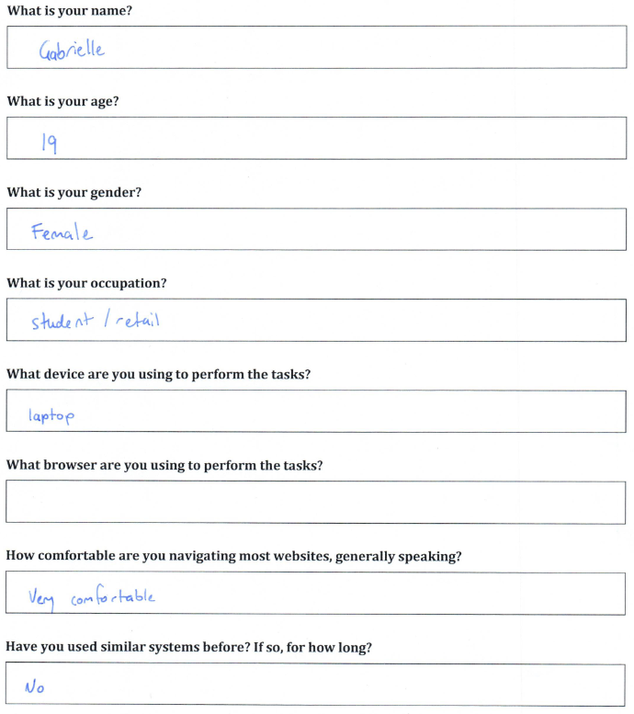

Participant – Xavier:
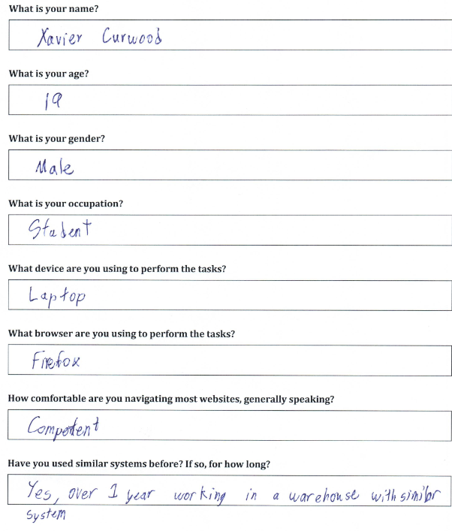

SES from script

Participant – Gabrielle:
Logging in….
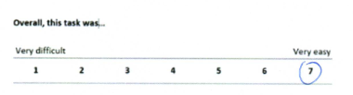

Clocking in….
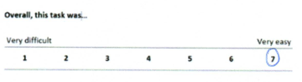

Seeing reasons the machine with an ID of 1 has suffered a catastrophic failure ….
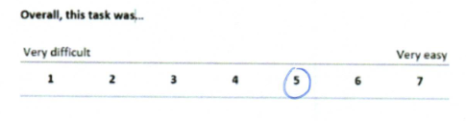

Communicating findings to the manager …
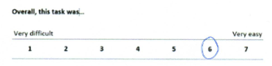

Inserting records into the DB ….
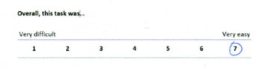

Logging out …
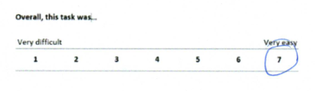

Participant – Xavier:
Logging in …
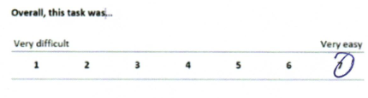

Clocking in …
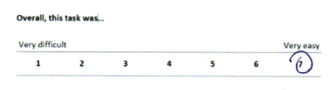

Seeing reasons the machine with an ID of 1 has suffered a catastrophic failure …
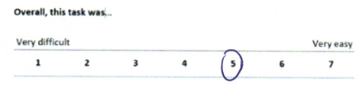

Communicating findings to the manager …
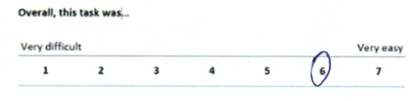

Inserting records into the DB…
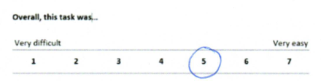

Logging off …
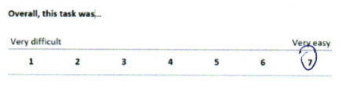

Post-evaluation tasks questionnaire

Participant – Gabrielle:
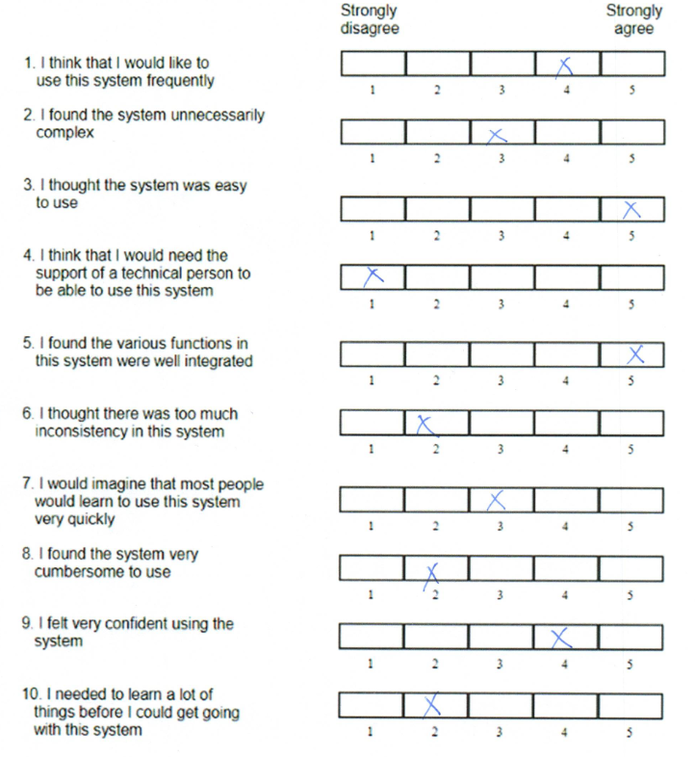

Her feedback:
- Maybe add menus for some functions as the amount of content on one page was a bit overwhelming
- Feel like log-in and machine statuses page could be faster to load

Participant – Xavier:
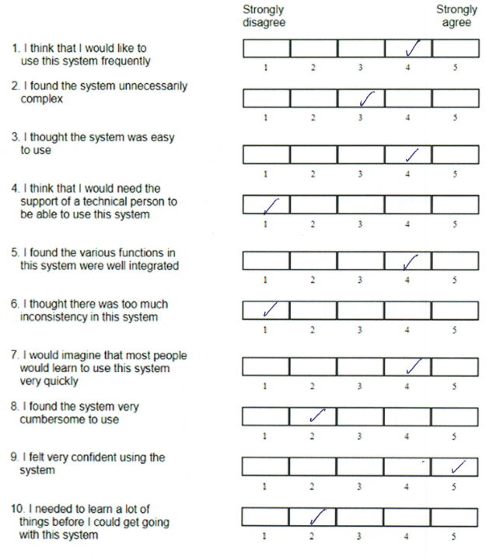

His feedback:
- Almost pressed the upload button instead of the send message button – Make it more distinct (did this)
- Make the machine statuses page more compact to reduce scrolling (did this)
- The text input fields could be a dropdown list for the FK IDs (e.g. it’d be better to choose the name of the employee from a list instead of having to put in the ID of that employee) (did this)

