Project Velvet
System Blueprint
How the whole platform works, for both the agency and the client. Welcome Tomorrow · 21 July 2026

1. What Velvet is, and why we're building it
Today we run every client in Notion. It works as a shared notepad, but it can't do the things an agency our size now needs: it doesn't hold live campaign data, it can't keep each client's data walled off from the next, it has no real automation, and it can't show a client a clean, service-specific dashboard. We have outgrown it.
Velvet is one platform with two sides. The agency side runs the whole business — every client, every department, every piece of work, in one place. The client side gives each client their own private space to see the work we're doing, the performance we're driving, and the calls, documents and plans that belong to them — and nothing that belongs to anyone else. It is the same system, shown two ways depending on who logs in.
Where the idea comes from. SEODesk — a personal project Cosmas built — already proved the core of this: a task-and-client manager for an SEO agency, with a Search Console dashboard, an Ahrefs audit view, and Claude-generated client reports. It's what the team saw and said “let's build something bigger.” Velvet is that bigger thing, built fresh from scratch. Nothing from SEODesk is connected or carried over as-is; it's a reference for what's possible and a proof that the foundation works.
A note on the reference we're borrowing from. A tool called AdSynth shows almost exactly the working style we want for our team's day-to-day: live dashboards, an AI that surfaces the next best action, and a per-client “brand memory.” We are not connecting to AdSynth — we are reproducing that feel and those features inside Velvet, in our own visual language.
One thing to be clear about: nothing is connected yet. We are starting from zero — every account, integration and data source in this document is something we will set up as we build, not something already in place.

2. The two sides at a glance
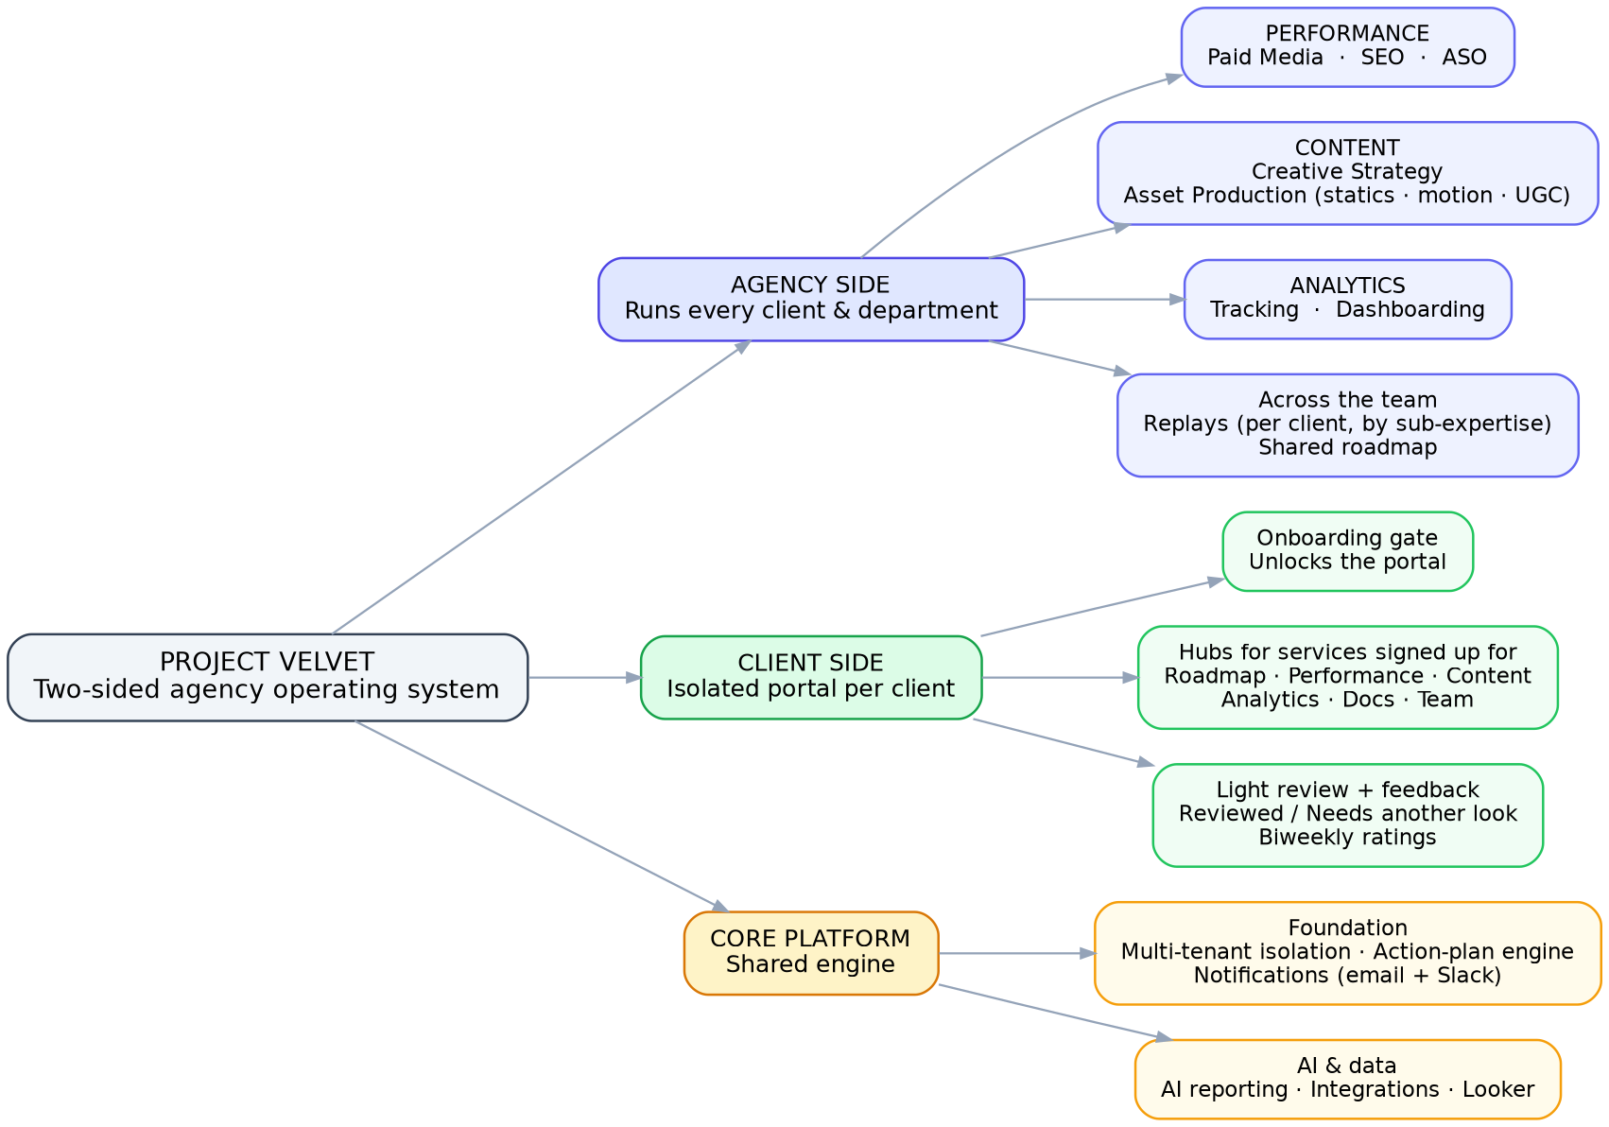
Figure 1 — the agency side, the client side, and the shared core they both run on.
The rest of this document walks through each side in detail: first how a Welcome Tomorrow team member works (section 6), then exactly what a client sees and does (section 7).

3. Three departments, each with its own services
Verified with Brian: we organise around three departments, and each department contains several services (sub-expertises). Every service has its own live dashboard inside the platform — not just tasks. A client only sees the services they are signed up for.
Department | Services (sub-expertises) | Each service's live dashboard shows
Performance | Paid Media, SEO, ASO | Paid: all-channel spend, conversions, ROAS/CPA, pacing vs targets. SEO: clicks, impressions, top pages & queries. ASO: rankings, store conversion, installs.
Content | Creative Strategy, Asset Production (statics, motion design, UGC) | Creative performance: compare creatives side by side, spend and installs per creative, engagement, plus AI learnings.
Analytics | Tracking, Dashboarding | Looker dashboards over GA4 + the app measurement partner, tracking health/QA, and the audience segments that feed retargeting.

4. Roles and who sees what
Which side you see is automatic. A Welcome Tomorrow login lands on the agency side; a client login lands on their own side. Nobody chooses a side.
We're deliberately keeping roles simple rather than rigid tiers:
- Super Admin (us, the owners) — sees everything, manages users and billing.
- Team member — works within their service/expertise (e.g. a paid-media specialist) across the clients they're assigned to; sees their service's work and dashboards.
- Client Lead (a per-client hat, not a separate rank) — for each client, one team member is flagged as the lead. They see across every department for that client and can pull reports on the whole account. This is how a client's lead generates a quick cross-service report without needing a special role.
- On the client side: a client project lead (adds their own team, gives feedback, reviews work) and client team members.
Assigning work is open — anyone can assign a task to anyone (including a client assigning one back to us). Creating and managing user accounts stays with Super Admin and Client Leads. Everything a person can see is still scoped: a team member sees their service; the Client Lead sees across their client; Super Admin sees all.

5. Keeping every client separate (the non-negotiable)
Because every client lives in the same system, the one failure we cannot allow is a client seeing another client's data. Velvet enforces this in the database itself, so the separation holds even if something in the interface has a bug. Every record belongs to exactly one client workspace. This is the first thing we build and the thing we test hardest. (AdSynth uses the same “one workspace per client” isolation model, which is good validation of the approach.)

6. The agency side — how a Welcome Tomorrow team member works

6.1 Onboarding a client and setting up their workspace
When a client signs, a Client Lead creates their workspace. This sets up the client's private space, records which services they've bought, connects their accounts (their Google, Meta, GA4, app stores, etc.), and uploads their brand materials. It also auto-creates that client's document library and their space in reporting. From this moment the client can be invited to their own side to begin onboarding.

6.2 The Customer Action Plan — how work is organised
Instead of tasks bouncing between separate inboxes, each client has a Customer Action Plan — the shared, living plan of what we're doing for them, grouped by service. Every piece of work is an item in that plan and moves through a small, clear set of states. A team member's personal “my work” view is simply their own items pulled out of the plans they're on, with running counts (in progress, delivered, complete) so each person can see their own throughput and use it for reporting.
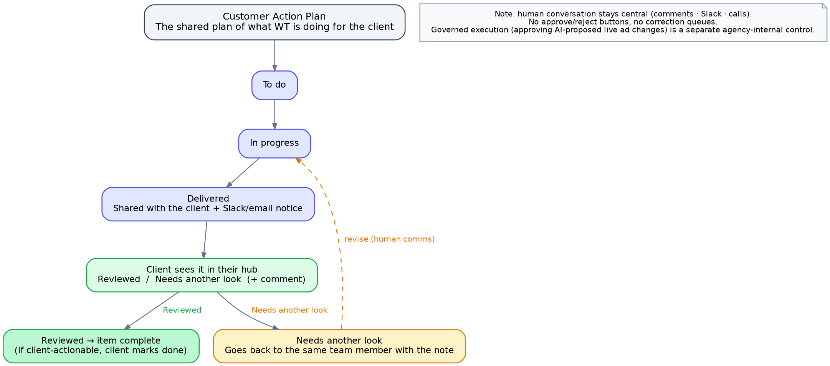
Figure 2 — the life of a work item, from the action plan to client review. Deliberately light: human conversation stays central.
The review step is intentionally simple. When we deliver something, the client sees it in their hub with two options — Reviewed or Needs another look — and a comment box. There are no rigid approve/reject buttons and no “correction queue.” If they need a change, the item goes back to the same team member with the client's note, and the real back-and-forth happens like it does today: comments, Slack, a call. The tool coordinates the work; it doesn't turn our client relationships into a sign-off machine.
The same action plan is also shown as a shared roadmap — what's planned, in progress and delivered, who owns each item, and timelines — and this roadmap is visible on both sides: our team works from it here, and the client sees the same roadmap in their own portal.

6.3 A team member's workspace
When a team member opens a client, they get a focused workspace for their service that brings together four things:
- Their action-plan items for that client and service — what to do, in progress, delivered, and complete.
- Live dashboards for their service (detailed in 6.4) — real numbers they can filter, not static reports.
- A signals feed — an AI-generated, prioritised list of “next best actions” for that client (e.g. “spend is pacing 20% over on Google — review budgets”), each with an urgency and confidence score, a short “why this matters,” and quick actions (act, mark done, snooze, dismiss). This is the platform working between our questions, catching things the day they happen instead of at the weekly check-in.
- The client's Brand / Knowledge Hub — the client's briefs, SOPs and strategy docs (see section 8), so everything the team member produces is already in that client's context.

6.4 The live dashboards, by service
Every service shows its own live, filterable dashboard. This is the core of the day-to-day tooling:
- Paid Media — an all-channel rollup across Google, Meta, TikTok and LinkedIn plus GA4 (web) and AppsFlyer (app): spend, conversions, ROAS, CPA, CPL trend, wasted-spend flags, and pacing against the monthly budget and KPI targets set per channel.
- SEO — a Search Console dashboard (the kind SEODesk proved out): clicks, impressions, top pages, top queries, all filterable, with GA4 alongside.
- ASO — App Store Connect and Google Play Console: keyword rankings, store conversion rates, installs.
- Creative / Asset Production — Atria and Adshore connected together to compare creatives side by side: spend per creative, installs per creative (from the app measurement partner), engagement, plus AI bullet learnings on what's working.
- UGC — the same creative-performance view, sliced by a strict naming convention (creator name, ad type — static / UGC / motion) that Isaac is rolling out, so we can read performance straight off the ad names.
- Analytics — this department is the dashboards: Looker Studio over GA4 and the app measurement partner, plus tracking health/QA, feeding the audience segments and reports the Paid Media team reuses for retargeting.

6.5 Governed execution (an internal control, not client sign-off)
Where the platform's AI proposes an actual change to a live ad account — a bid, a budget, a negative keyword — that change waits for a Welcome Tomorrow team member to approve it before it goes live, with a log of what changed. This is an internal safety control on our own ad operations. It is separate from, and must not be confused with, the light client review above: the client is never put behind an approval queue.

6.6 The Client Lead's view: health, reports and documents
On top of the service workspaces, a Client Lead has an account-wide view of their client:
- Client health — the lead marks each client Healthy, To Watch, or At Risk, with a reason (performance trend, or a sense that confidence is slipping).
- Reports & documents library — every deliverable we send a client is automatically filed here under that client and service (an SEO audit lands under their SEO documents), so the whole account's history is one click away. Team members see their own service's documents; the Client Lead sees all services for their client; Super Admin sees everything.
- Cross-service reporting — the lead can pull a report across every service for the account, drawing on the same live data behind the dashboards.

6.7 Replays — the team's call library
Every call we have with a client is captured by our notetaker and kept here as an internal team resource — recording, recap and action items, all searchable. Replays live on the agency side, at department level: anyone in a department can open Replays, pick any client that department serves, and see that client's calls grouped by sub-expertise — so an SEO team member opens the SEO replays for a client and sees exactly those. This keeps the whole department in sync on what was discussed, even for calls they weren't on. Replays are internal; clients don't see them in their portal.

7. The client side — what a client sees and does

7.1 First login: the onboarding gate
A newly invited client lands on an onboarding flow modelled on Scalezia's: a short, stepped checklist (company presentation, business map, offer, and so on), each step with a time estimate and a clear “start” button. Until onboarding is finished the rest of the portal stays locked — clicking Dashboard simply takes them back to onboarding. Once it's marked complete, their dashboard and hubs open up. (The exact questions come from the COO.)

7.2 The dashboard and hubs — only what they signed up for
After onboarding, the client sees a dashboard and a menu of hubs limited to the services they actually bought. A client on Performance and Analytics sees those; they never see hubs for services they aren't on. The hubs:
- Performance / Content / Analytics dashboards — the same live numbers our team works from, presented cleanly: their campaigns, their SEO and app performance, their creative results, their analytics — all their own data, refreshed automatically.
- Roadmap — their Customer Action Plan, shown as a shared roadmap: what's planned, in progress and delivered, who owns each item (them or us), and timelines.
- Documentation — every doc, deck and report we've shipped them, organised and easy to find.
- Team — who's who: the Welcome Tomorrow people on their account, and their own team, with decision-makers marked.
For Content clients specifically, the creative hub also lists the UGC creators we've proposed, with each creator's full profile — including pricing and payment method, since the client pays creators directly.

7.3 Reviewing what we deliver
When we deliver an item, it appears in the client's relevant hub with a link to the work and two simple options: Reviewed or Needs another look, plus a comment box where they can add notes, files or screenshots. “Reviewed” closes the item (and if it's something for them to action, they can mark it done once they've done it). “Needs another look” sends it back to the team member who made it, with their note attached. That's the whole mechanism — light on purpose, with the real conversation happening between people.

7.4 Biweekly feedback
Every two weeks the client's project lead fills in a short feedback form: they rate us out of 10 on each service they're signed up for, and they rate themselves on the same scale. Rating both sides is deliberate — it shows, for example, when we're delivering strongly (high score for us) but the work isn't being actioned on their end (low self-score), which explains stalled results honestly. All of this flows into the Client Lead's health view on the agency side.

8. The Brand / Knowledge Hub and the AI layer
Each client has a Brand / Knowledge Hub. We upload their briefs, SOPs and strategy docs once — or point it at a Drive folder, or CC a dedicated address on client emails — and Velvet builds a living brand profile: their voice, goals, audience and USPs, kept current automatically. From then on, everything the AI produces for that client is already in their context, and the whole team can search the client's own documents on demand. It also remembers past decisions across sessions, so context doesn't leave when a team member does.
On top of that memory, the AI layer does four jobs: it writes client reports from the connected data (the same Claude-generated reporting SEODesk already demonstrated, expanded across services); it turns any dashboard into short bullet insights on demand; it runs the signals feed on a schedule, scanning accounts for spikes and drops; and — for live ad-account changes only — it proposes actions that wait for a human to approve them.

9. Tooling and integrations, by service (V1)
Service | Connections for the first version
SEO | Google Search Console + GA4 (Ahrefs optional, later)
Paid Media | Google, Meta, TikTok, LinkedIn + GA4 (web) + AppsFlyer (app). No Reddit, Bing or Search Console here.
ASO | App Store Connect + Google Play Console (AppTweak later)
Creative / Asset Production | Atria + Adshore (connected together); optionally Google & Meta
UGC | Per-ad performance via the naming convention (same measurement as Creative)
Analytics | App measurement partner (AppsFlyer/Adjust) + GA4, with Looker Studio as the visualization layer
None of these are connected today — they're all to build. SEODesk showed the pattern works: each integration runs as a small server-side function holding its keys safely, exactly as its Search Console, Ahrefs and Claude connections did. Two of these need platform approval before they can go live (a weeks-long process, outside our control, so we should start it early): Meta and Google Ads, and later TikTok and LinkedIn. We do not need a separate data warehouse to start — the dashboards read from each platform's own data, with Looker Studio for visuals.

10. Notifications
Notifications go out by email and Slack — either a direct message to the person's Slack (matched to their email) or a shared channel set up for that specific client. They fire when work is assigned, delivered, reviewed or sent back, and when biweekly feedback is due.

11. What the system stores (plain-English data model)
- Client workspace — the tenant: name, contacts, services signed up for, connected accounts, brand profile, onboarding status, health.
- User — name, email, role, service/expertise, the clients they're on, Slack handle, and (per client) whether they're the Client Lead.
- Action Plan & Plan Item — the client's plan and each work item: service, owner, state, deliverable links, comments.
- Deliverable / Document — a shipped file, auto-filed under client and service.
- Brand Profile & Knowledge doc — the uploaded materials and the living profile built from them.
- Signal — an AI next-best-action in the feed: urgency, confidence, status.
- Connection — a client's linked account (Google, Meta, GA4, App Store, etc.).
- Replay — a call: recording, recap, action items, topic tags.
- Creator — a UGC creator profile (niche, contact, pricing, payment, socials, samples).
- Health status & Feedback rating — the lead's health call and the client's biweekly ratings.
- Notification — event, recipient, channel.

12. How we'll build it (stack)
This is not a guess — it's the same foundation SEODesk already runs on, so it's proven ground. Chosen so a small team can build safely with AI-assisted coding, and so the client-separation requirement is enforced by the database rather than by code we have to get perfect:
- Supabase (hosted Postgres) for the database, logins and file storage — SEODesk already uses it, and its row-level security is what enforces the per-client separation at the database level.
- GitHub + Vercel for hosting and the serverless functions that hold integration keys — again, exactly how SEODesk is hosted.
- Claude (Anthropic) for the AI layer, as SEODesk already does for reports; Looker Studio embedded for dashboards.
- Next.js (React) for the application. This is the one real step up from SEODesk: SEODesk is a single HTML file, which is fine for a small tool, but Velvet is far larger and two-sided, so it needs a proper app framework. The data, auth, hosting and AI layers stay the same as what already works.

13. Build order (by dependency)
- Foundation — logins, the five roles, automatic side detection, and the client-separation layer, tested first.
- The Customer Action Plan — items, states, the light Reviewed / Needs-another-look flow, assignment, notifications.
- The client workspace setup and onboarding gate.
- The two sides — agency service workspaces and the isolated client portal.
- Live dashboards per service, then the signals feed.
- The Brand / Knowledge Hub and AI reporting.
- Reports & documents library, health and biweekly feedback.

14. Still to confirm
- The exact onboarding questions and what triggers onboarding (from the COO).
- Which notetaker we use, and whether it gives us recordings/transcripts by link or API (sets how deep Replays search can go).
- The go-ahead to start the Meta / Google / TikTok / LinkedIn platform approvals early, since they take weeks.
15. The service section in detail (SEO as the model)
This section expands how a single service works, top to bottom, using SEO as the worked example. Every service section (Paid Media, ASO, Content, Analytics) follows the same pattern: the same data shown two ways, an internal working view for the Welcome Tomorrow team member, and a report-only view for the client. SEO is the first one we build, so it sets the template.
15.1 What the team member sees (internal)
When a team member opens the app, their dashboard is a personal 'my work' landing: running counts (in progress, awaiting client, back to me, done this month), an AI attention feed, their work items across clients, and quick links to their clients. The agency assistant (15.4) is docked at the top.
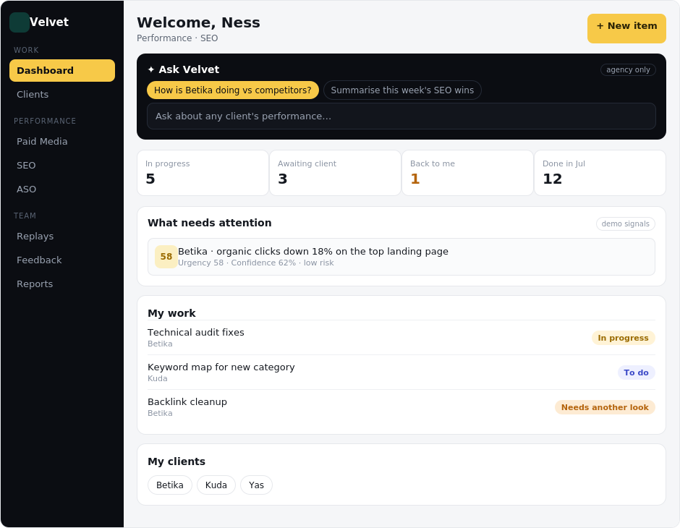
Figure 3 — the team member's dashboard landing, with the agency-only assistant docked at the top.
Opening a client gives a workspace scoped to that person's service. A team member sees only their service for that client — an SEO specialist opens Betika and sees the SEO view; they do not see that client's Paid Media or Analytics. It brings together the service's live dashboard, the LLM visibility block, top 5 queries and pages, the competitor comparison, that person's own tasks for the client, and the client's brand documents.
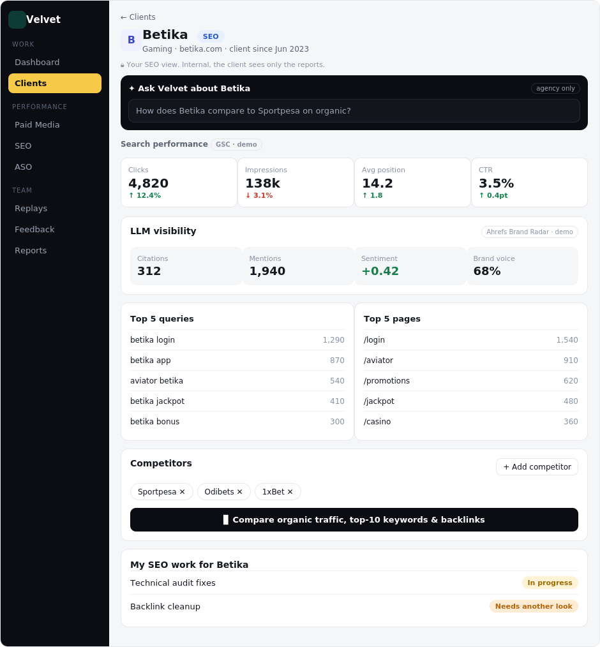
Figure 4 — the agency SEO view of a client (Betika). Internal: the client never sees the tasks, signals, or notes.
15.2 LLM visibility (on every service)
Every service section carries an LLM visibility block: how AI answers and assistants see the client — citations, mentions, a sentiment score, and a brand-voice score. This is not SEO-only; it belongs on Paid Media, ASO, Content and Analytics too. The data comes from Ahrefs' Brand Radar, which is already connected.
15.3 Competitors and the comparison
On the SEO section the team adds competitors manually, and they appear on the dashboard. Below the list, a Compare button opens a side-by-side of the client and each competitor on organic traffic, top-10 keyword rankings, and backlinks. All three map directly to Ahrefs.
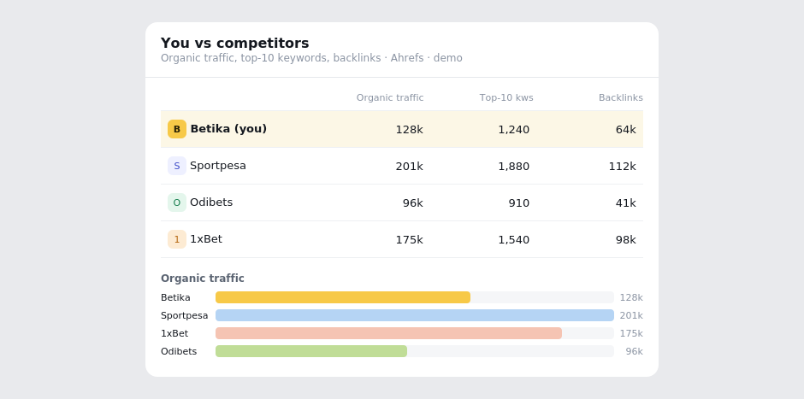
Figure 5 — the Compare panel: the client (highlighted) against each competitor on traffic, top-10 keywords, and backlinks.
15.4 Ask Velvet — the agency AI assistant (agency only)
A chat assistant lets a team member ask how a client is performing, including against competitors, in plain language. It appears in two places on the agency side: the dashboard landing and inside each client's view. It is never shown on the client side. This is the heavier, paid AI surface, most useful once each client's live data and brand context are connected; until then it answers from demo context.
15.5 The client's view: reports only
The client's own SEO section shows only the reports and data, pulled from Google Search Console and Ahrefs: the metrics, the LLM visibility block, top 5 queries and pages, and the competitor comparison. It deliberately shows no internal tasks, no signals, no assistant, and no team notes. Each service also carries a Send task button so the client can send work to the team.
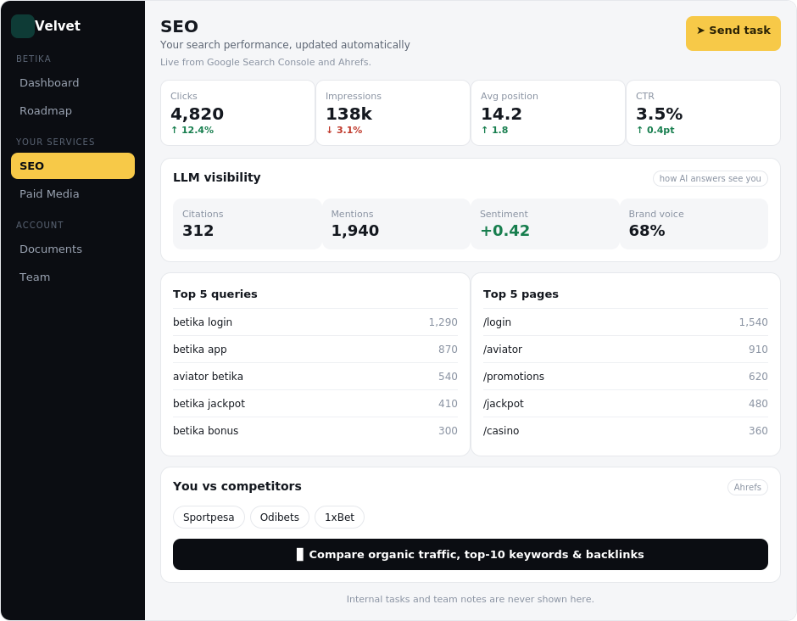
Figure 6 — the client's own SEO view: reports and data only, with a per-service Send task button.
15.6 Send task (client side) — fields to confirm
Each service on the client side has a Send task button. The exact fields the client fills are still to be defined (COO input), and will start from the blueprint's light action-plan model and the SEODesk samples already on file.
15.7 Where the data comes from
• Ahrefs (connected) — organic traffic, keyword rankings, backlinks, and the LLM visibility block (via Brand Radar).
• Google Search Console — clicks, impressions, average position, CTR, top queries and pages.
• Claude (Anthropic) — the Ask Velvet assistant.
Per the demo-first rule, all of the above is built on demo data first, then swapped to live sources service by service.
Appendix — What the Velvet hub does today
This appendix shows the Velvet hub as it stands now, with a figure for every service in every department: what an agency team member (and super admin) sees when they open a client, and what that client sees on their own side.
SEO is live on real data, pulling from Ahrefs and Google Search Console. Every other service is built and shown here on demonstration data, clearly labelled, while we connect each underlying source in turn (the ad platforms, the app stores, GA4 and BigQuery, and the creative tools). The layouts, roles, and client and team views are final; only the live data connections remain.
How the hub is organised
Velvet is two-sided. The agency side runs every client and department in one place; the client side is a private portal where each client sees only their own work. Work is grouped into three departments — Performance (Paid Media, SEO, ASO), Content (Creative Strategy, Asset Production, UGC), and Analytics (Tracking, Dashboarding) — eight services in total. Running across all of them are shared tools: Ask Velvet (an assistant that answers and summarises, agency only), a task action-plan per client, a documents library, and a branded onboarding intake.
The shared experience
Figure: The team member's home — their tasks, clients and priorities on login.
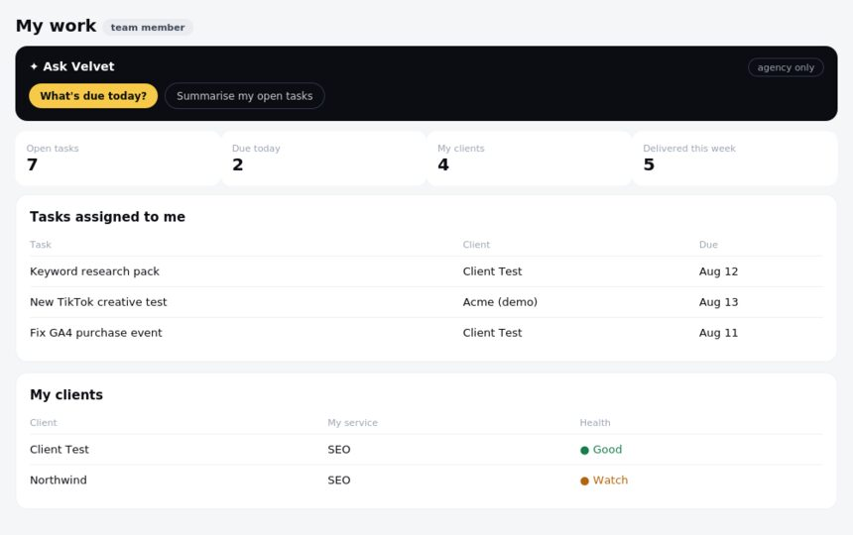
Figure: The super admin's overview — every client, department and health at a glance.
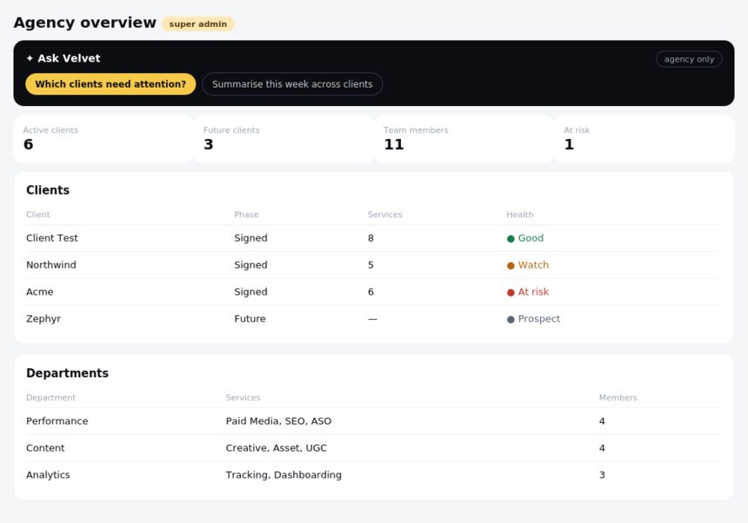
Figure: The client portal home — the client's services, tasks and documents.
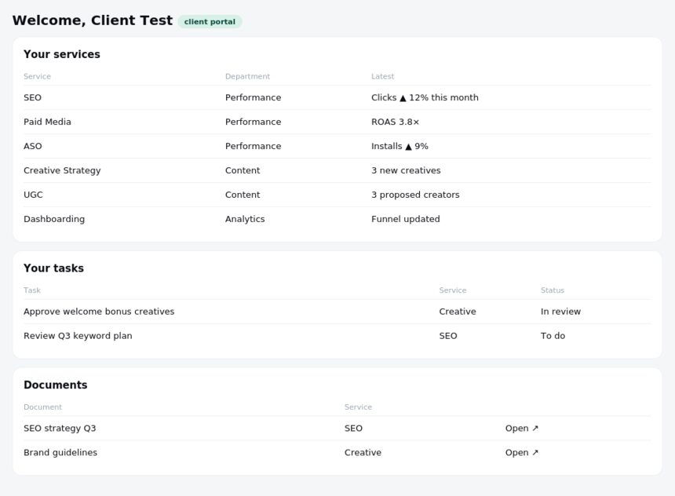
Figure: The branded onboarding intake — a step-by-step, fully required client intake.
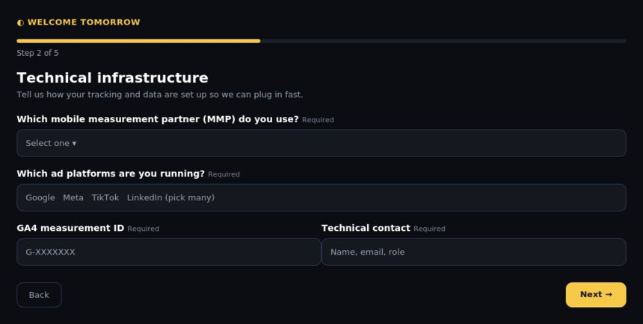
Figure: The onboarding questions editor — edit the intake and target all future onboards or one specific client.
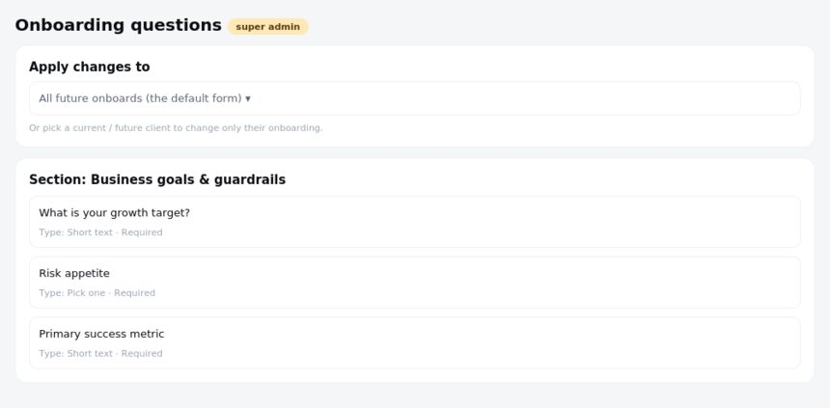
Figure: Settings — team, connections, and downloadable onboarding answers.
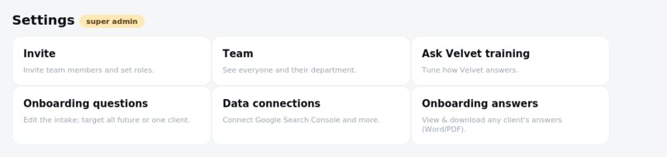
Performance department
Paid Media, SEO and ASO. SEO is live; Paid Media and ASO are on demo data pending their source connections.
SEO
Live on Ahrefs and Google Search Console. Search performance, organic traffic, top queries and pages, and competitors.
Figure: SEO — what the team sees (agency and super admin).
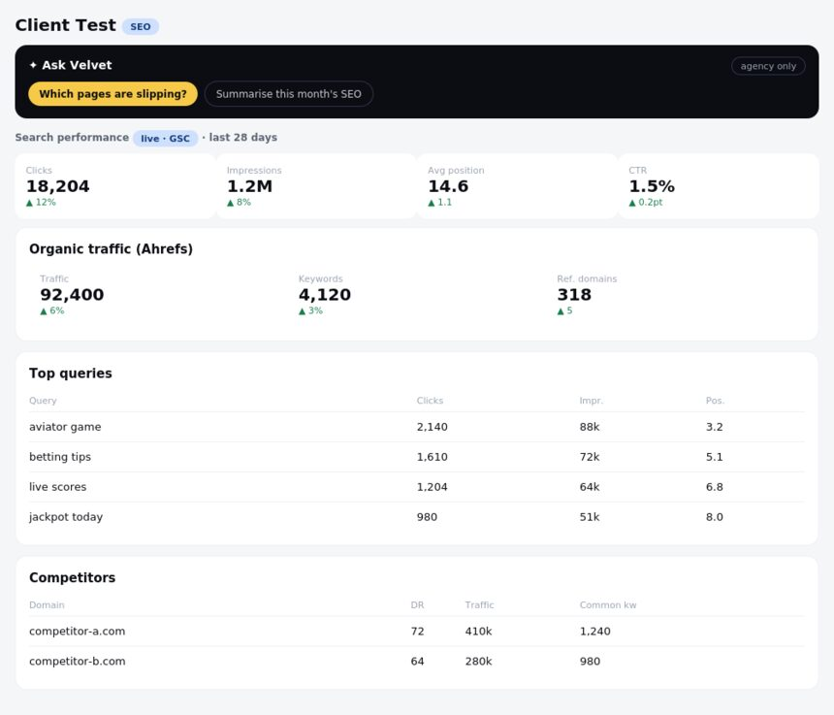
Figure: SEO — what the client sees.
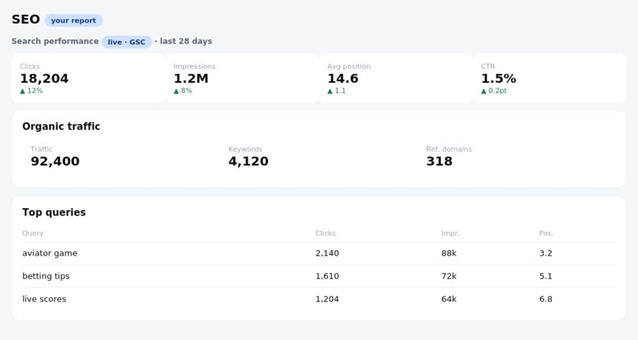
Paid Media
Demo, pending Google Ads, Meta, TikTok and LinkedIn. All-channel spend, ROAS, CPA, conversions, budget pacing and wasted spend, current campaigns, channel breakdown and trend.
Figure: Paid Media — what the team sees (agency and super admin).
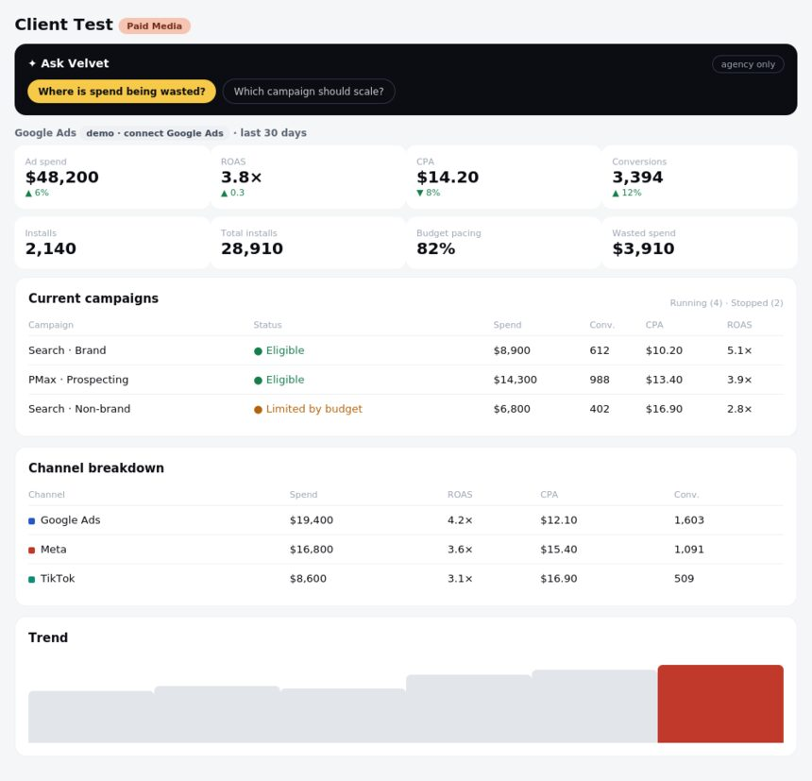
Figure: Paid Media — what the client sees.
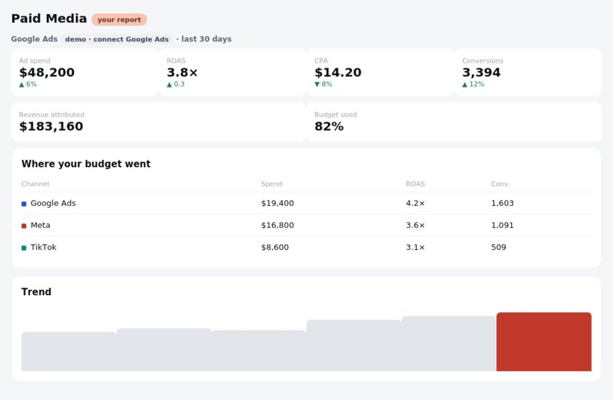
ASO
Demo, pending App Store Connect and Google Play (AppTweak later). Installs, store conversion, keyword rankings, platform split and competitor apps.
Figure: ASO — what the team sees (agency and super admin).
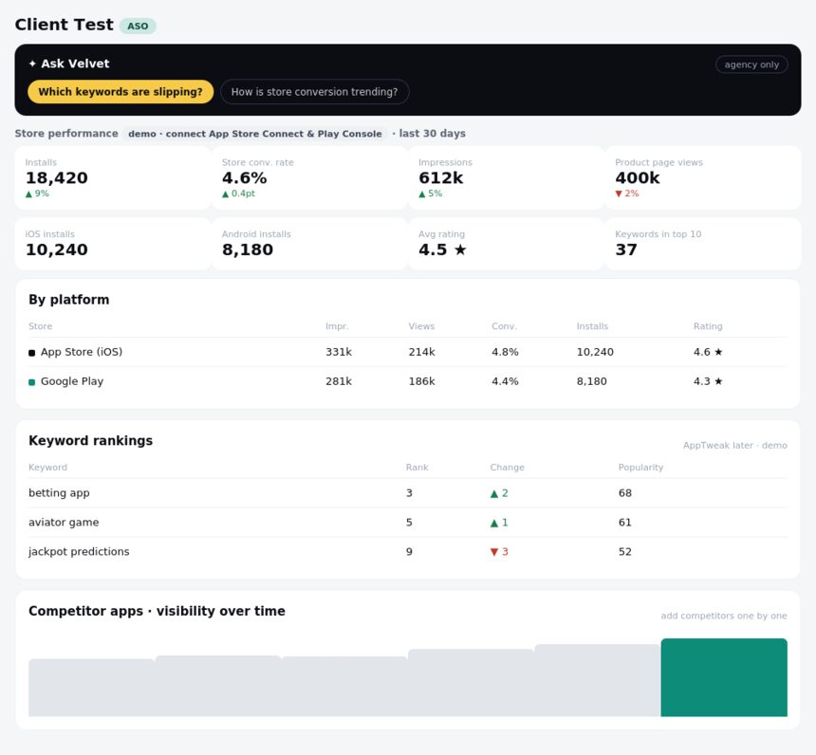
Figure: ASO — what the client sees.
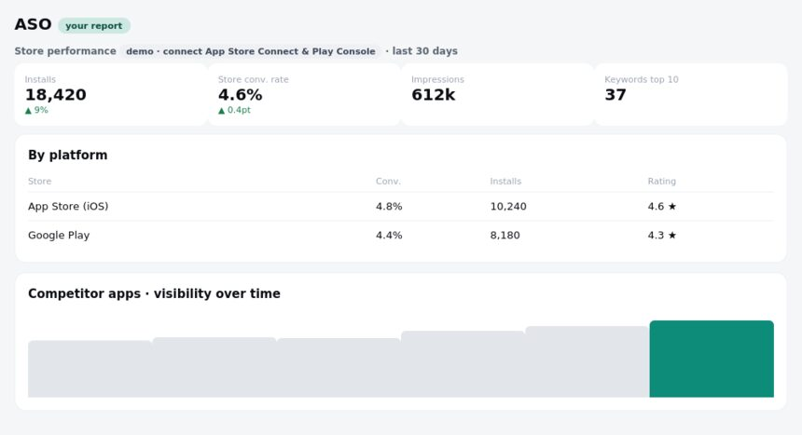
Content department
Creative Strategy, Asset Production and UGC. All on demo data pending the creative sources (Atria and Adshore, with installs from the app measurement partner).
Creative Strategy
Demo. Compare creatives side by side with a gallery of cards and a comparison table, an ad-type filter, and AI learnings.
Figure: Creative Strategy — what the team sees (agency and super admin).
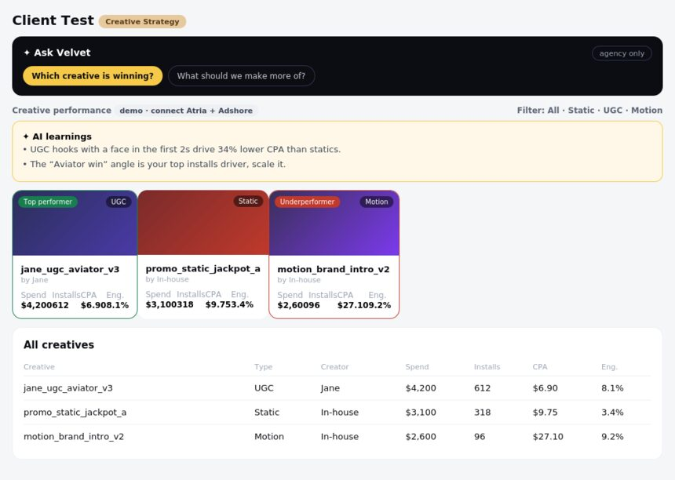
Figure: Creative Strategy — what the client sees.
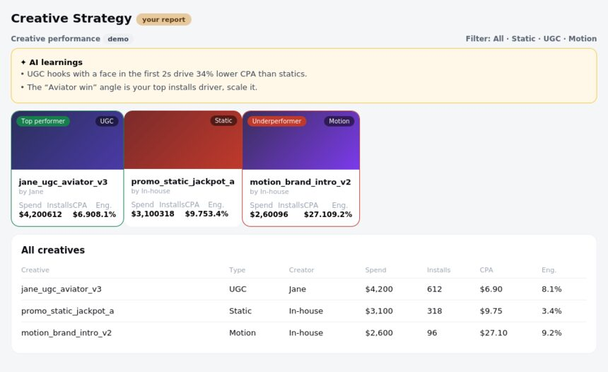
Asset Production
Demo. A production pipeline — what's requested, in production, in review and delivered — with owners, due dates and a delivered library.
Figure: Asset Production — what the team sees (agency and super admin).
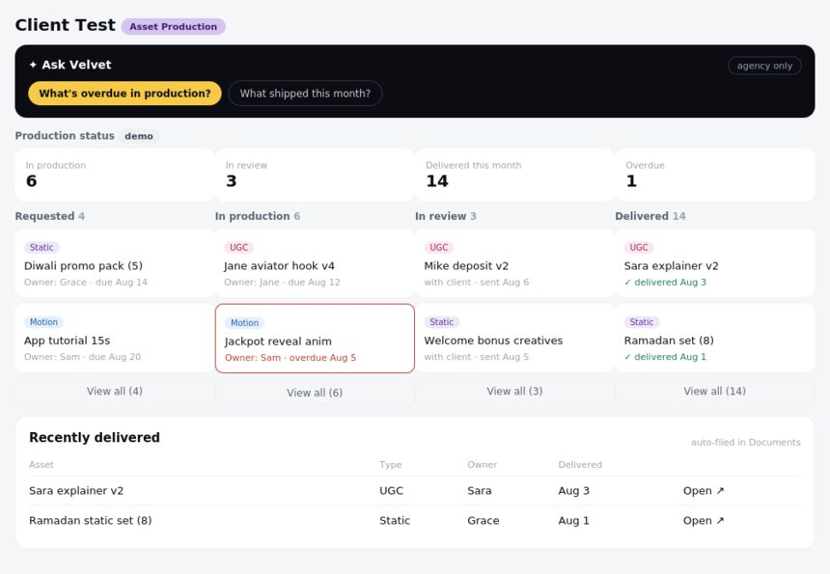
Figure: Asset Production — what the client sees.
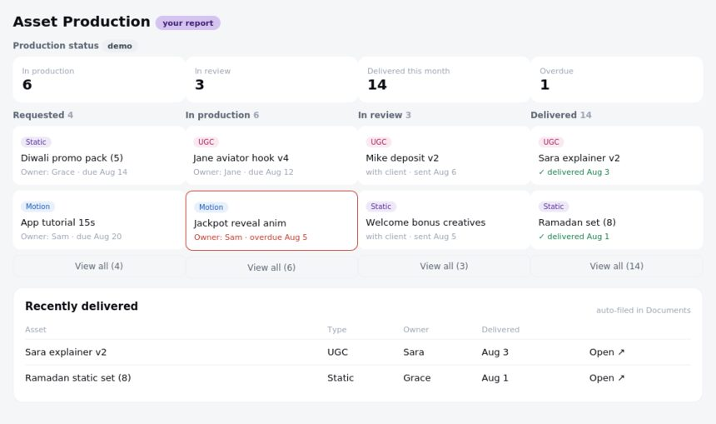
UGC
Demo. A creator roster with full profiles and pricing/payment (the client pays creators directly), plus per-ad performance by creator and AI learnings.
Figure: UGC — what the team sees (agency and super admin).
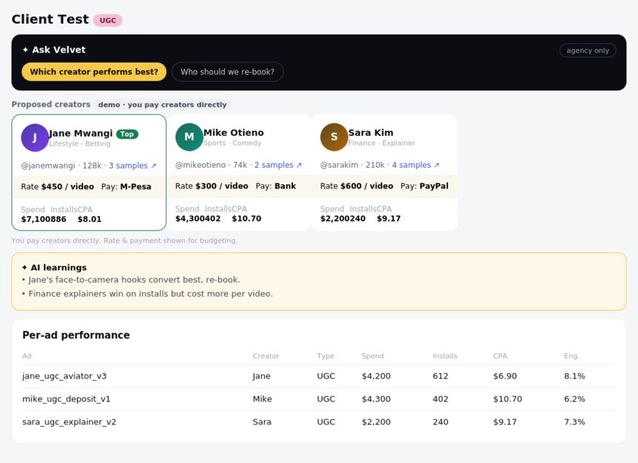
Figure: UGC — what the client sees.
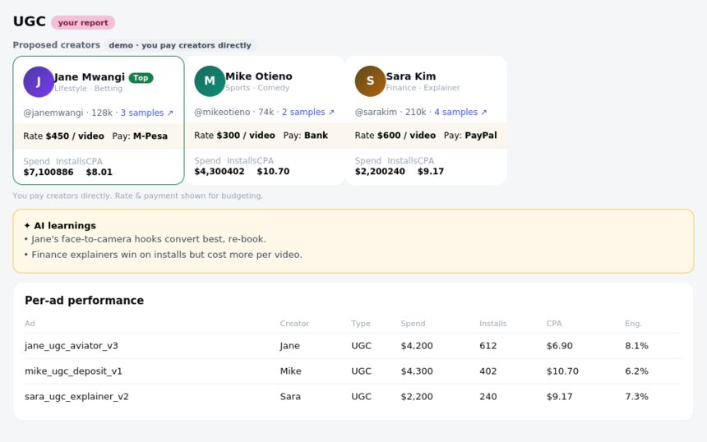
Analytics department
Tracking and Dashboarding. On demo data pending GA4, BigQuery and the app measurement partner.
Tracking
Demo. A health board — what's connected, pending or broken, which events are firing, setup health and recent changes — rather than a performance report.
Figure: Tracking — what the team sees (agency and super admin).
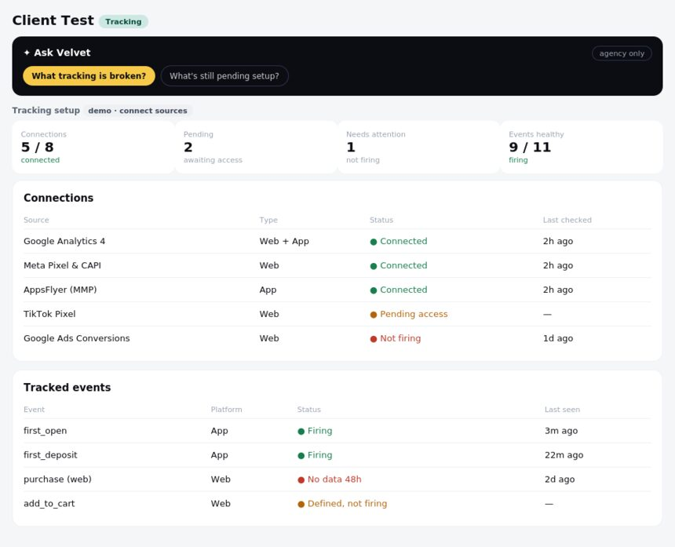
Figure: Tracking — what the client sees.
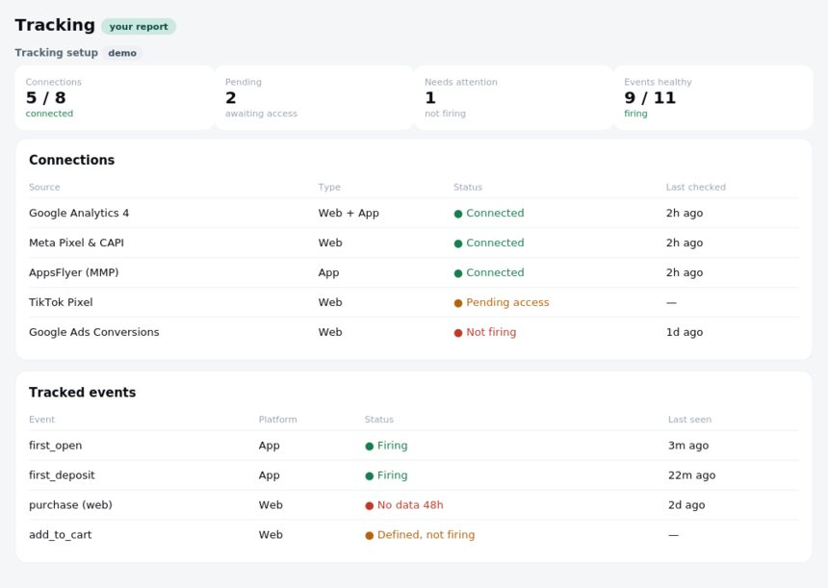
Dashboarding
Demo. A curated performance view (KPIs, install-to-deposit funnel, sources, events for app and web) with a Looker embed tab to show the data team's exact report.
Figure: Dashboarding — what the team sees (agency and super admin).
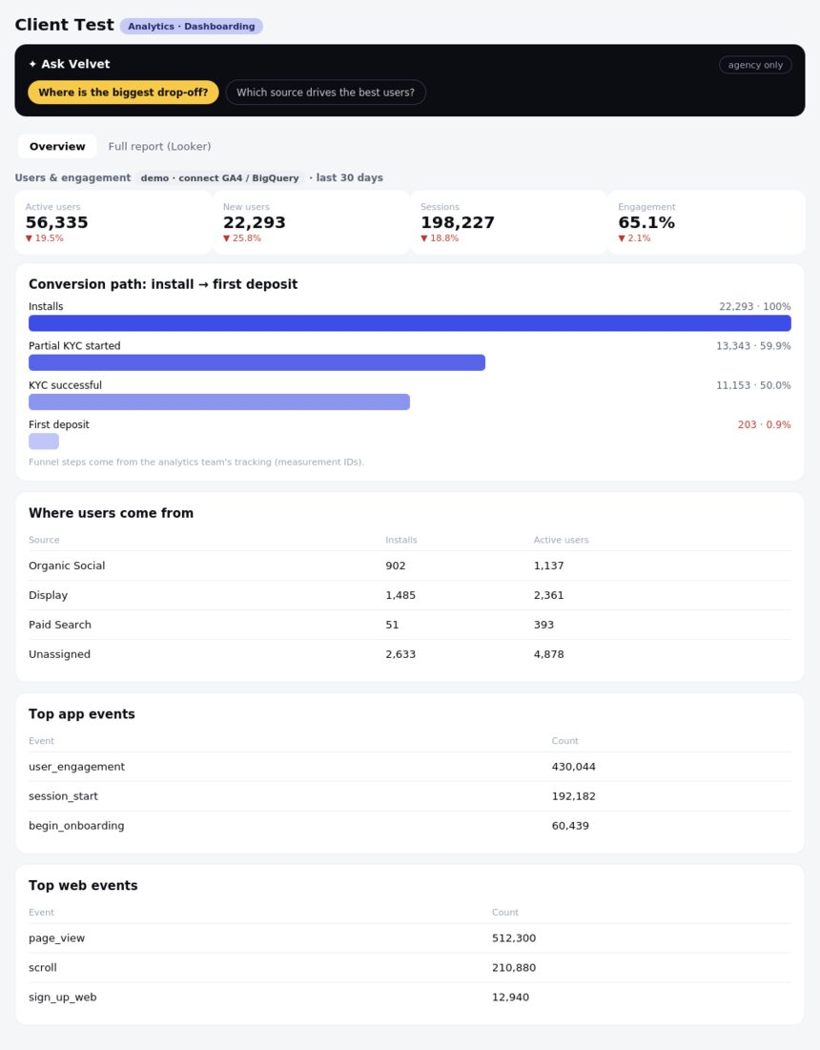
Figure: Dashboarding — what the client sees.
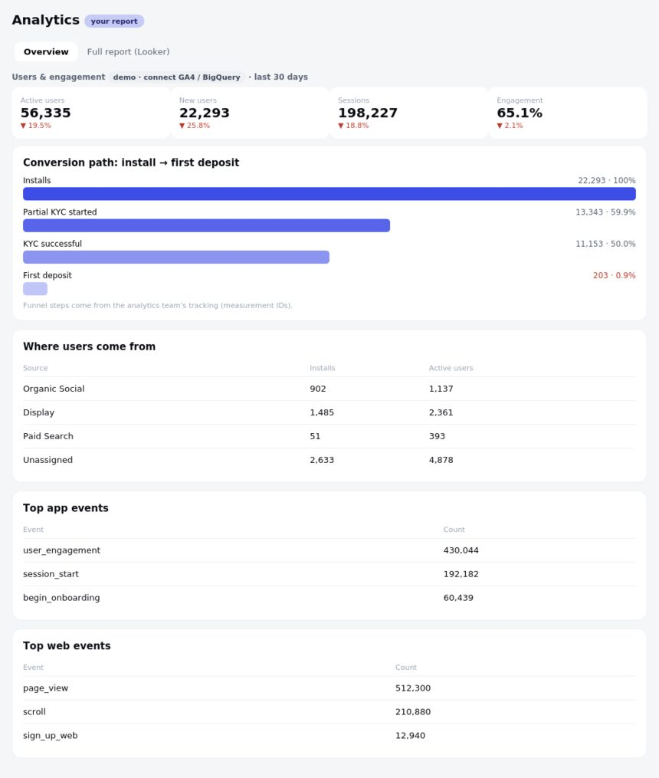
A note on demo versus live
Everything labelled demo shows the final layout on sample data. As each source connects — each is its own secure connection, built the way Google Search Console already is — the demo for that service is replaced by the client's real numbers, and nothing is presented as real until it is. The team and client views, roles, tasks, documents and onboarding are already working across the hub.

