Adding members to project

Prerequisites 1

Guide 1

Accepting the assignment 1

Creating intelij project

Setup intellij for git.

## Prerequisites

* Github account.

## Guide

### Accepting the assignment

click on this link: <https://classroom.github.com/a/GtYaT_76>

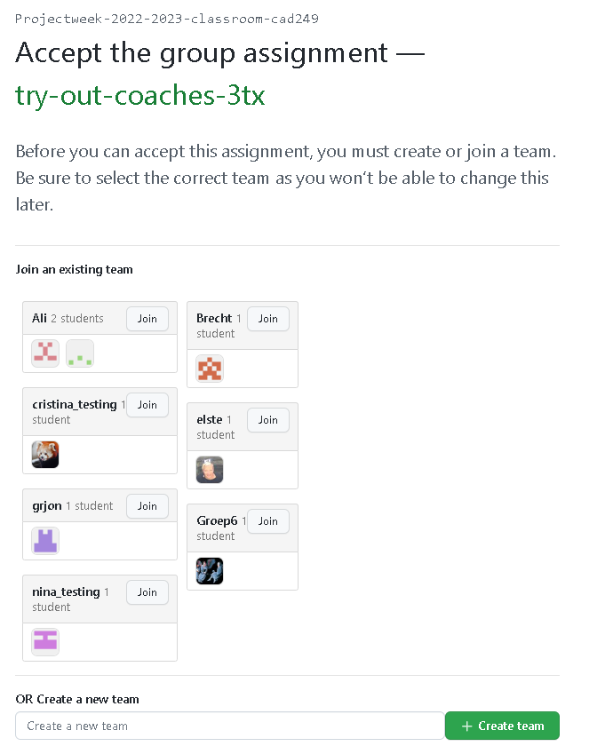

Create a team if you are the first one to accept this assigment.  
If you are not the first one join the right team by clicking join.

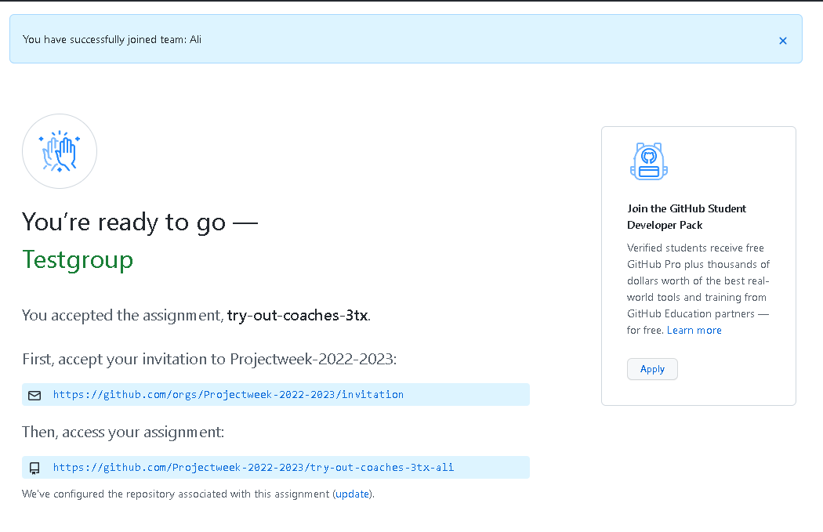

Follow the given steps on the screen.

With these steps you just made a git repository.

Next 1 person on the team needs to create an intellij project following these naming convention.

* groupId: be.ucll.ip.web3
* artefactId: groepsnaam
* name: groepsnaam

In the root of the project (where the .git folder is located) create a .gitignore file with the following contents. (If you don’t know what this means make sure to ask your projectcoach!)

*.iml  
  
.idea/  
  
target/  
  
out/

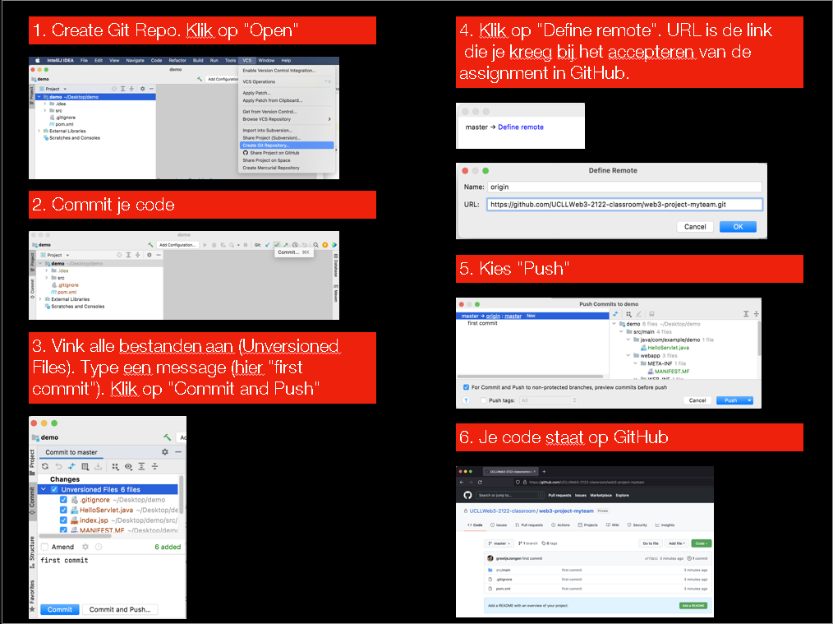Now we need to push this empty project to github.

Acceptance Criteria

* Every team member can pull and push from/to github
* Every team member can run the empty project.