Start-up Project

Start-up Project 1

Prerequisites 1

Guide 1

Importing Project 1

Tomcat Configuration 3

## Prerequisites

* Recent version of IntelliJ
* Project Repository on Gitlab (cfr Spike 01)
* Tomcat 9 installed
* Java >=8 installed

## Guide

### Importing Project

To start this spike, you first have to clone the repository of the project.

You can clone it with your favourite Git-tool, or import it from Git directly by IntelliJ:

Open IntelliJ and choose “Get from Version Control”.



Fill out URL (link to your project on GitHub Classroom) and Directory on your laptop.

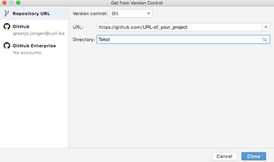

Alternatively, you can open Git Bash or any other Git-tool and clone the repository specified in the Prerequisites.

Once the project is cloned, open IntelliJ. IntelliJ asks for a project. Choose “Open or Import”( new version of intellij just have open). Go to the folder where you have cloned the repository and select it.

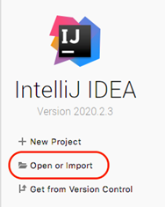

Sometimes, it is necessary to add Framework Support (Right Click on project name, select “Java EE Web Project” and/or “Maven Project”).

Sometimes, it is necessary to mark the src-folder as “Sources Root”.

Run the Maven Build.

### Tomcat Configuration

Click on « Add configurations » and click on the plus sign in the top left of the window.

Then scroll down and choose Tomcat server -> Local.



You will see an error at the bottom of the configuration window. Click on fix and choose the

“template:war exploded” one. After this, go to the deployment tab, you should be able to see an entry like in the

picture below. The next part is optional, but recommended. Change the application context to a single slash “ / ”.

When you change it to a single slash, it will be available from :

localhost :8080

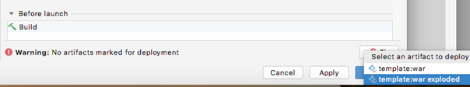

Now, everything is configured. Click on apply, and run this configuration.

At this point, you are not able to visit your website in the browser because you didn’t configure connection with the database. The server gives error

connecting to database ...url:jdbc:postgresql://databanken.ucll.be:62223/webontwerp

connection troubles:

FATAL: SASL authentication failed

Acceptance Criteria

* Every team member can compile project on his computer.
* The server shows error message as described above.