Bootstrap

In Webontwikkeling 1, you learned how to write CSS files. This year you might want to try Bootstrap instead. Bootstrap is a framework for HTML and CSS, with optional JavaScript extensions. Its goal is to help you quickly build responsive mobile-first web projects. The latest version is Bootstrap 4.4, which saw major changes in order to improve speed and stability.

**Set Up**

You can install Firefox Developer Edition to use its Responsive Design Mode and grid tools:

<https://www.mozilla.org/firefox/developer/>

Before you can utilize Bootstrap, you have to include it in your web page. You can either download the CSS and JavaScript files, or paste a link to freely provided BootstrapCDN. Advanced users can also compile Bootstrap themselves, optimized to their needs.

The Bootstrap Getting Started Guide provides links to either download or include Bootstrap: <https://getbootstrap.com/docs/4.5/getting-started/introduction/>

**Important:** to be able to use the JavaScript plugins in Bootstrap, you have to include jQuery (if it isn’t included yet).

**Try it out!**

You can use the “Starter template” on the Introduction page to get along, or you can opt for one of the other templates instead.

W3schools provides a tutorial for Bootstrap, as well as countless snippets that you can easily integrate into your projects: <https://www.w3schools.com/bootstrap4/bootstrap_get_started.asp>

TutorialsPoint also offers a Bootstrap tutorial: <https://www.tutorialspoint.com/bootstrap4/index.htm>

**Important:** When googling for Bootstrap code snippets, make sure they are for the correct Bootstrap version!

**Responsive tables**

Since we will be writing a web application both for mobile and desktop, responsive tables deserve extra attention.

Fortunately, Bootstrap 4 has you covered! The documentation offers two types of examples:

<https://getbootstrap.com/docs/4.5/content/tables/#responsive-tables>

However, the solution of bootstrap consists only of a horizontal scrollbar. In a following spike you explore another solution.

**Acceptance criteria**

Take a look at the Bootstrap Grid system for the width of the elements: <https://getbootstrap.com/docs/4.5/layout/grid/>

Create a responsive demo page on your GitHub Classroom, using Bootstrap, containing

* header + main > (article + aside) + footer structure
* a responsive table in the article
* desktop lay-out: width of article is 2/3, width of aside is 1/3
* mobile lay-out: width of both is 100%

Index.jsp - responsive columns

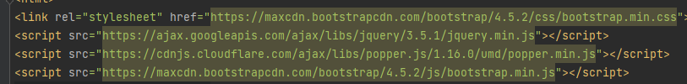

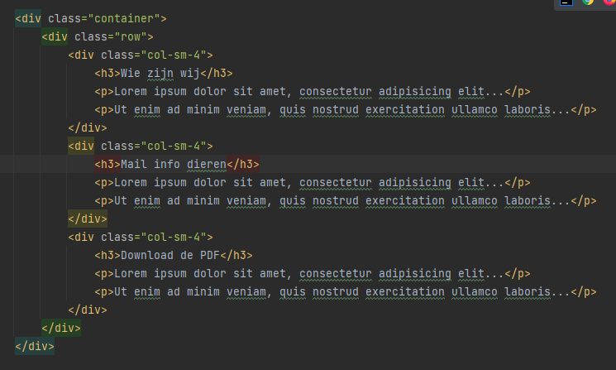



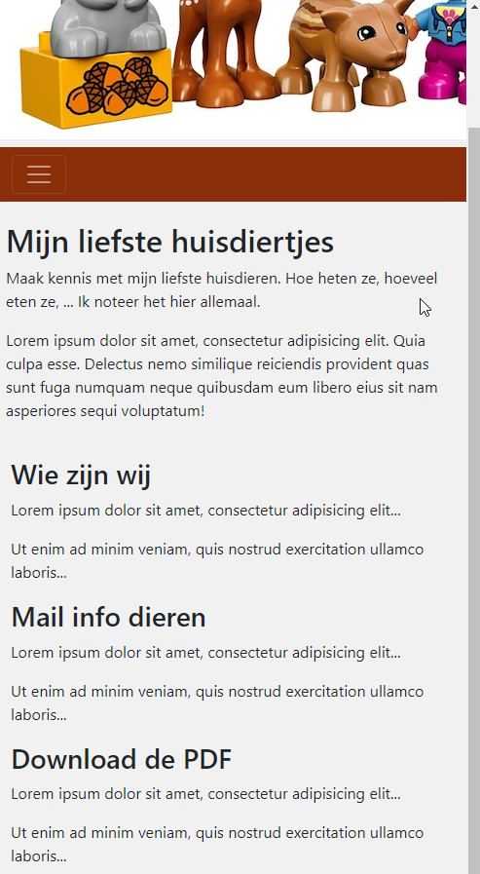

Header.jsp - responsive navbar

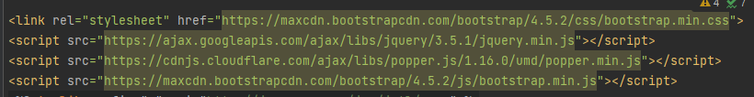

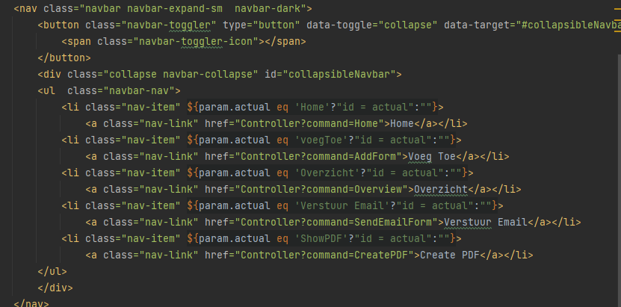

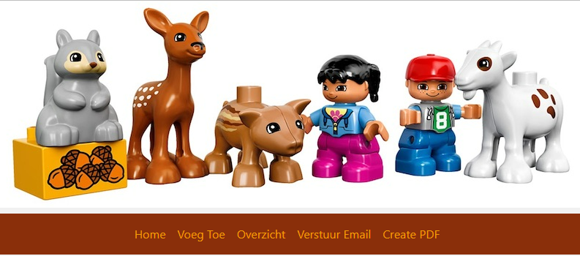

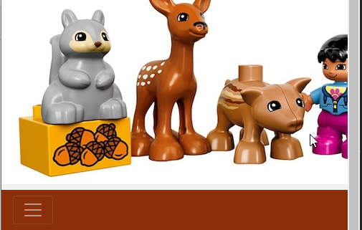

Overview.jsp - responsive table



