Writing to pdf

To be able to write text / images / tables to a pdf.

## Requirements

* Have access to your GitLab repository. (Complete previous spikes)
* Have a working servlet project
* iText 7 Core is a PDF library to program PDF documents in Java.

Add the following dependencies to pom.xml

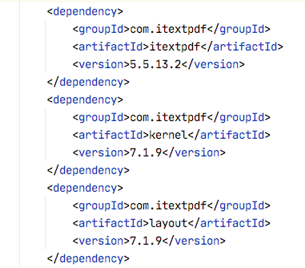

* Using iText core 7: <https://itextpdf.com/en/products/itext-7/itext-7-core>
* Creating a table <https://www.tutorialspoint.com/itext/itext_adding_table.htm>

**Warnings**  
1. Be aware of correct packages you import. There are itext.kernel and itext.text imports that could result in issues if they are used in the same class. We will be using itext.text...

2. When managing servlets, be aware of path of documents. Use   
**request.getServletContext().getRealpath(“path”)** to map relative path on path of tomcat-server. Keep in mind this wil always result in **target/app/path**

## Write to pdf:

Create a class with main method

We’ll first need to create a PDF and open it.

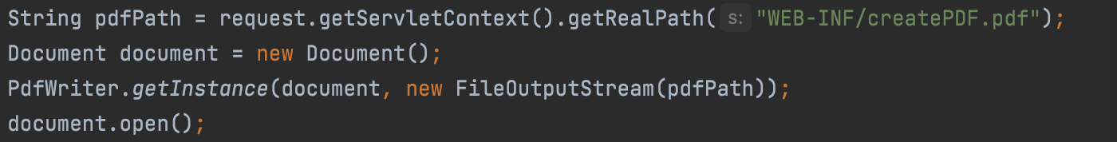

Lets begin with adding methods to the class:

Add meta data: Allows you to set file properties

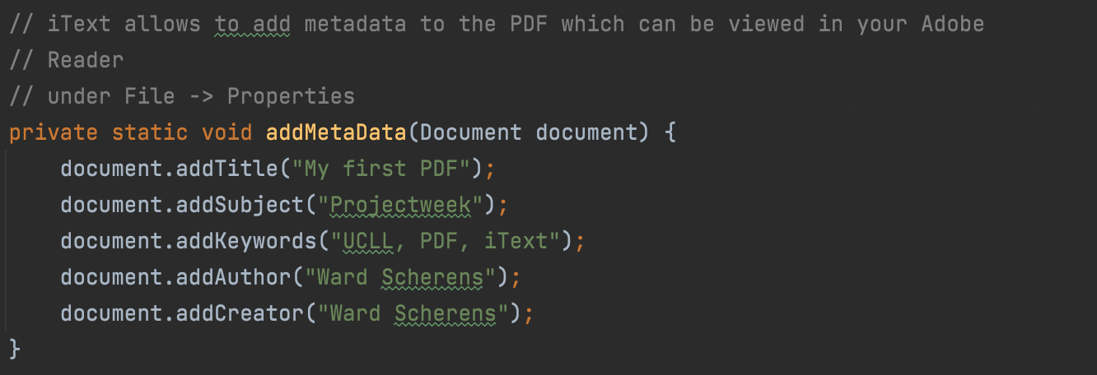

Add Title to the page.

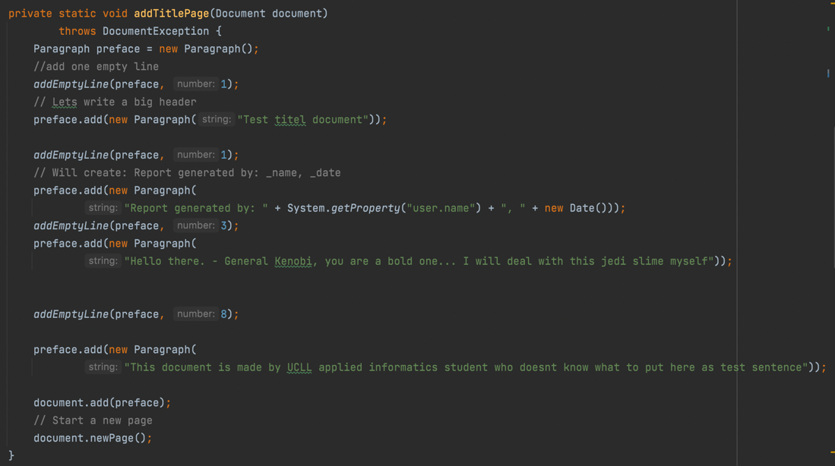

Add content.

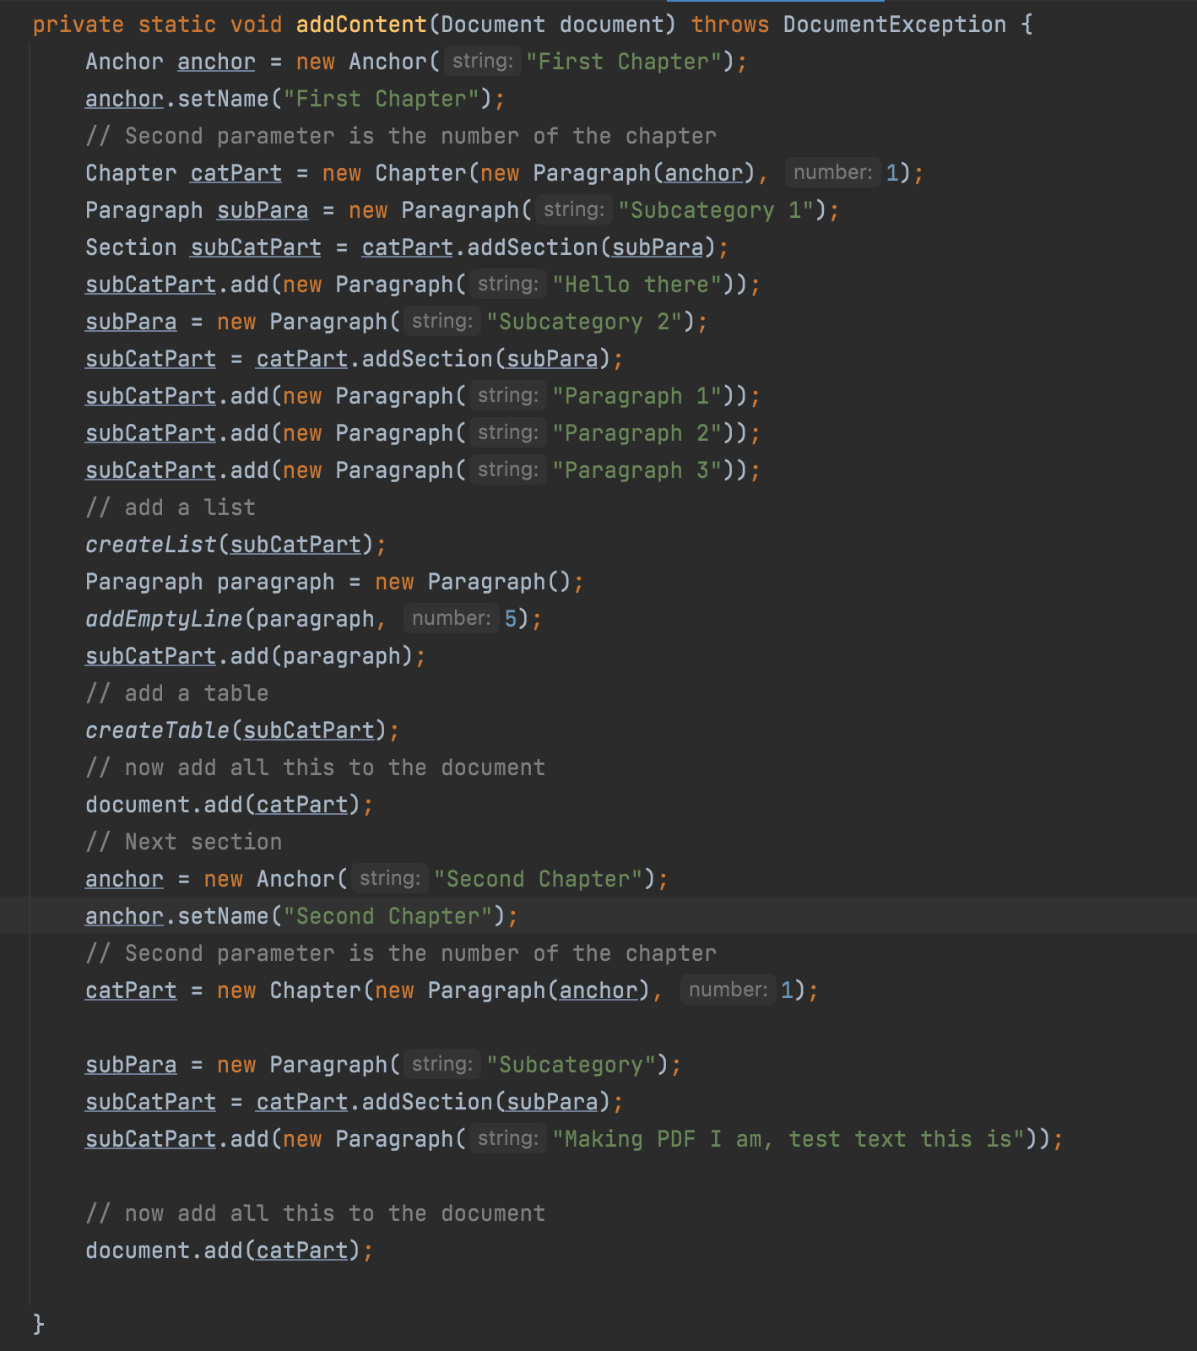

Add a method for adding a table in pdf

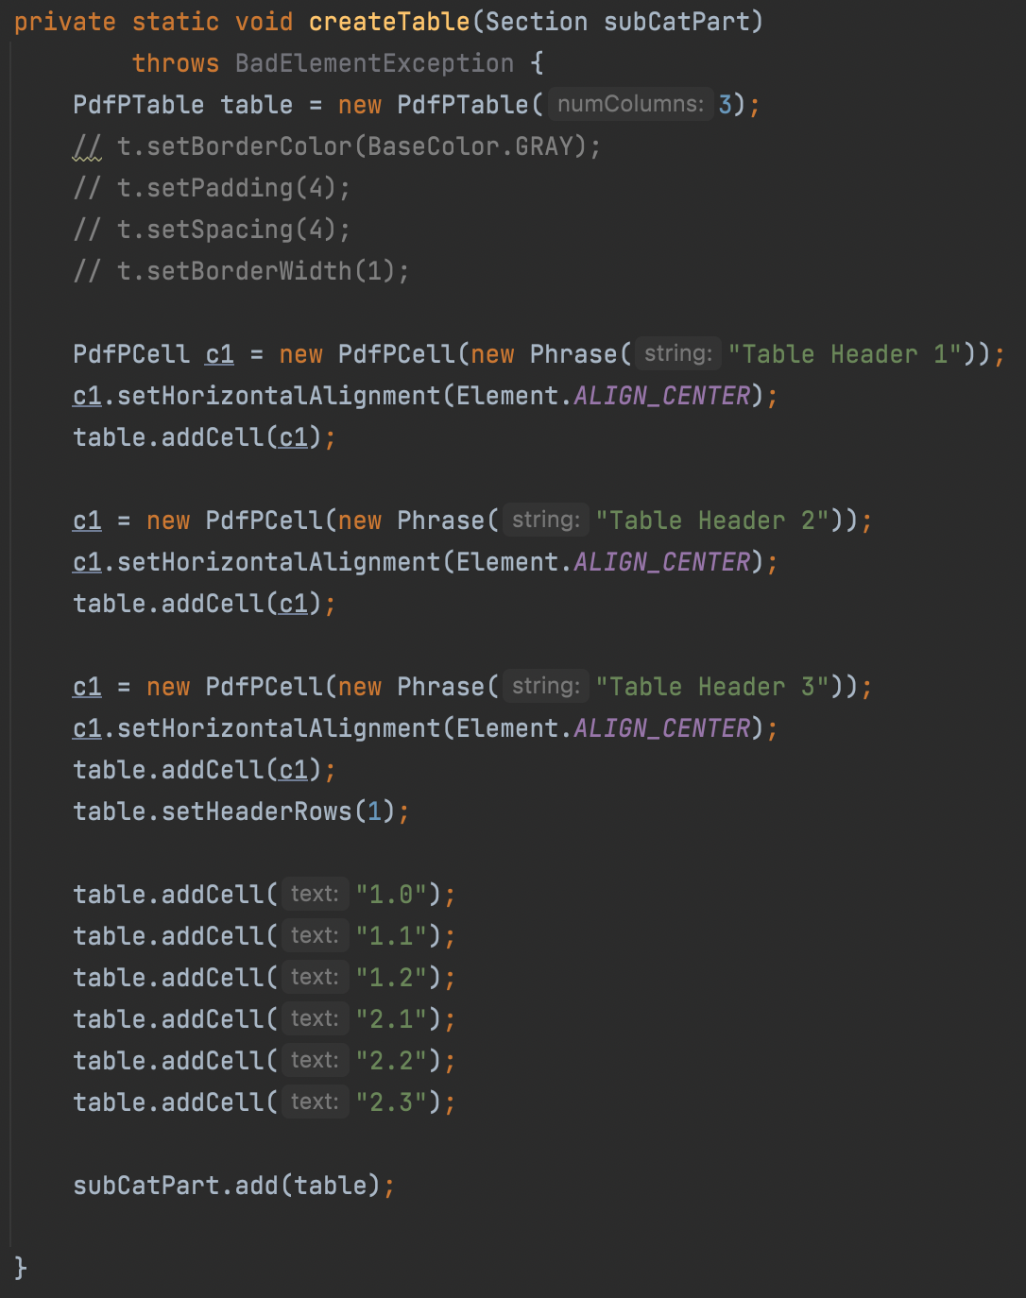

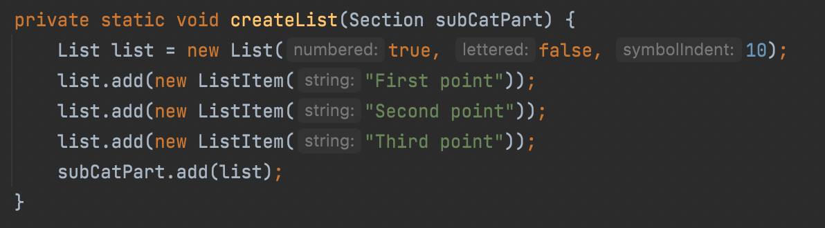

Method to add empty lines in your pdf

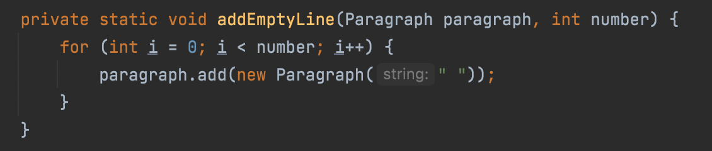

Method to add images, keep in mind you will need to specify where/ in what map the image is

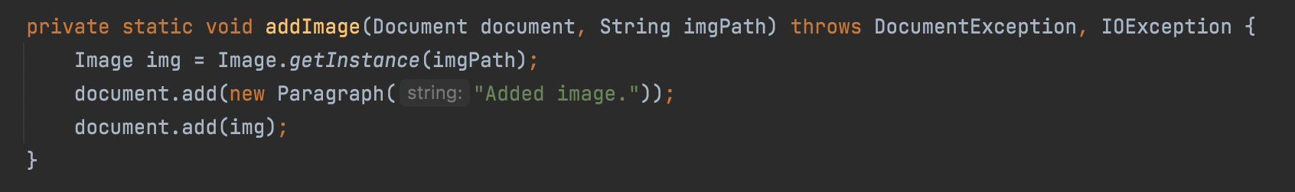



At the end your request handler should look like this.

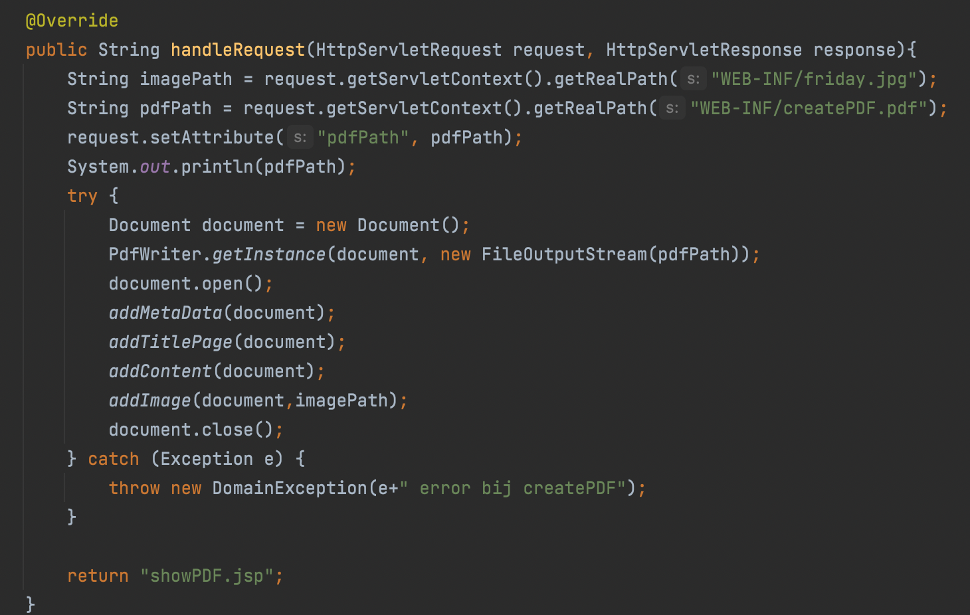

You should create the pdf in the folder target/app/WEB-INF.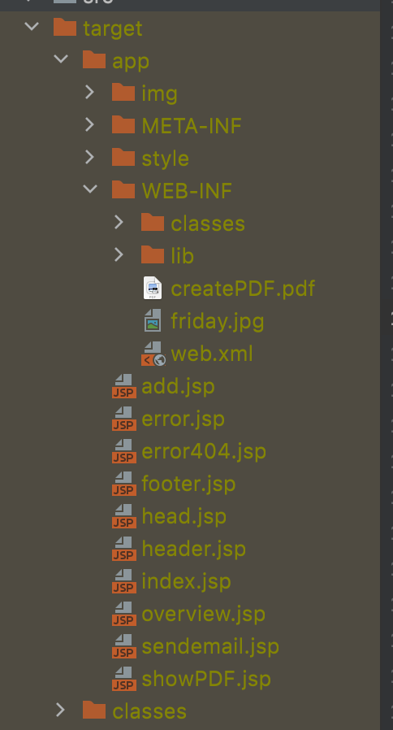

containing link to the created pdf:

what's needed:

* A new servlet (path of File object can't be absolute) TIP: stackoverflow is your BFF
* An a-tag containing jsp tags with the pagecontext request's contextpath

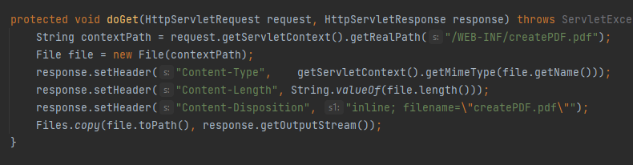



Source :

<https://www.vogella.com/tutorials/JavaPDF/article.html>

<https://www.concretepage.com/itext/add-image-in-pdf-using-itext-in-java>

## Acceptance Criteria

* Main method that creates pdf (tekst + image)
* Web project (Maven): Clicking on link as <http://localhost:8080/project_ucll_war_exploded/Controller?command=CreatePDF> results in pdf and webpage as

