TPS40200 test report

* Input 8 .. 16.0V, 12V nominal
* Output 6.0V @ 1.0A
* Switching Frequency of 220 kHz

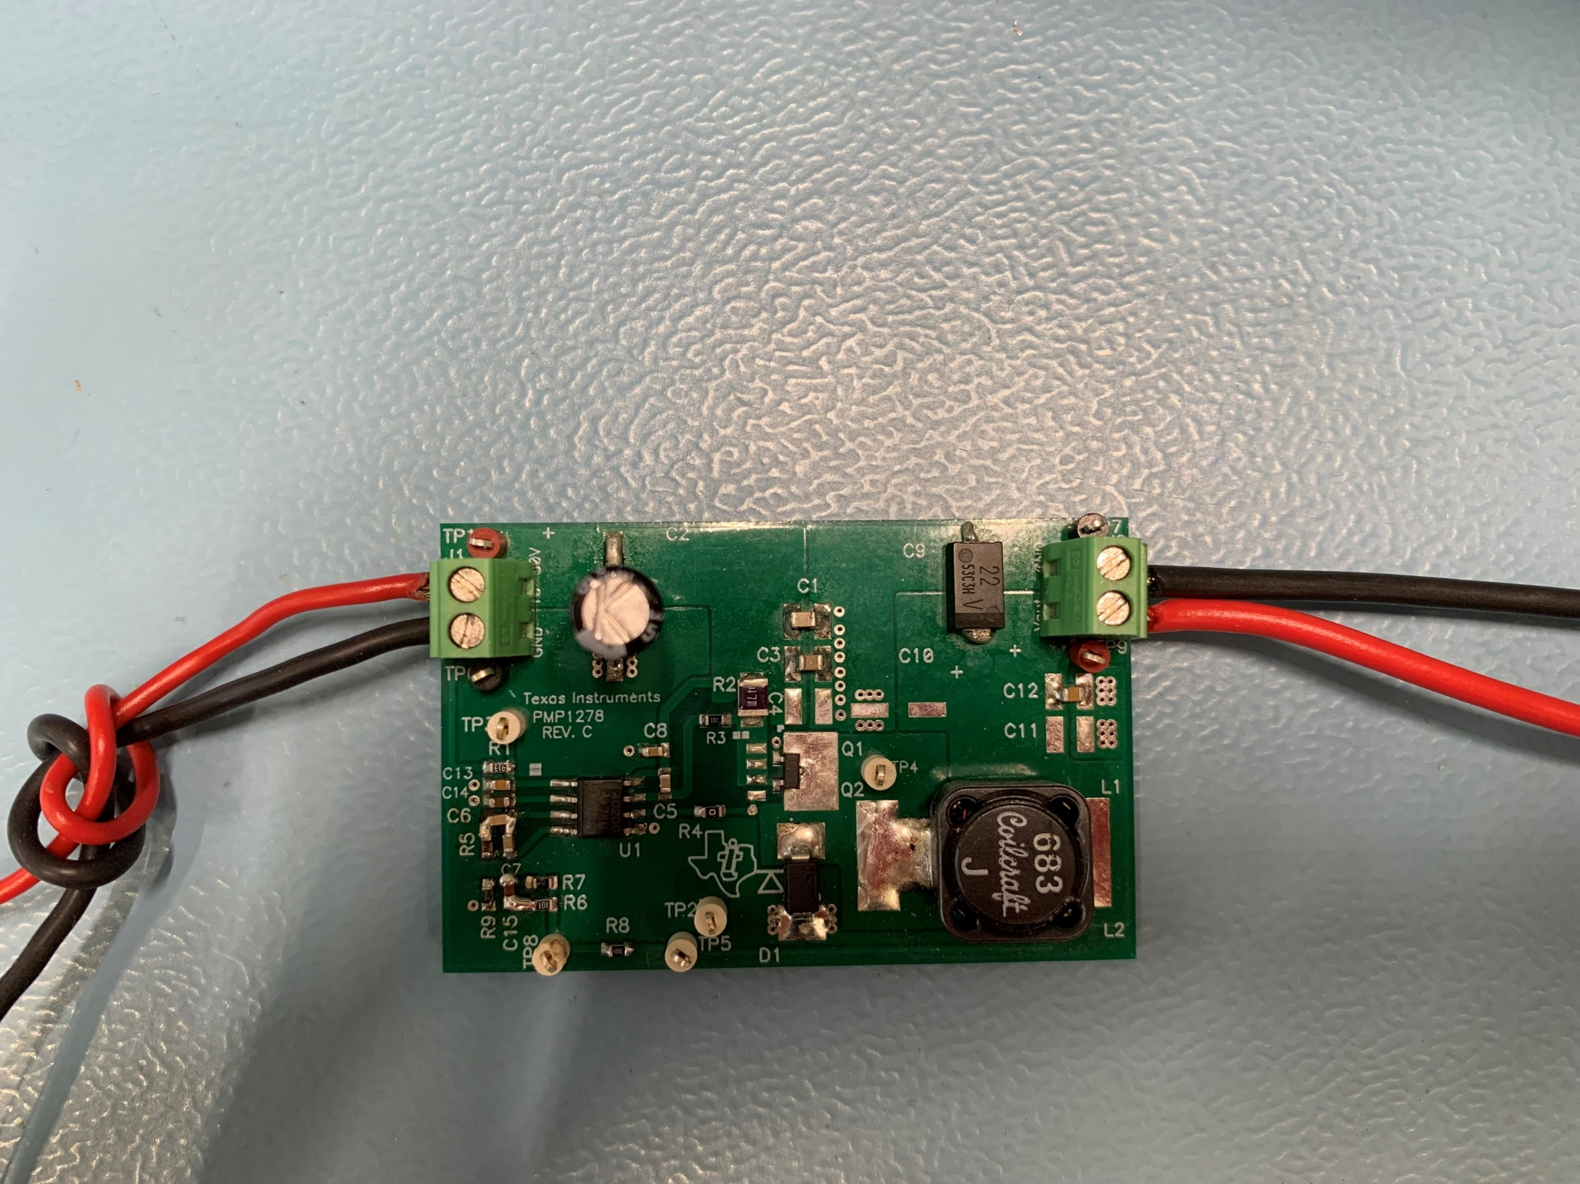

1. Startup

The startup waveform at 12.0V input voltage and no load on the output is shown in Figure 1.

Channel C1 **12.0V Input Voltage**  
5V/div, 4ms/div

Channel C2 **6V Output Voltage**  
5V/div, 4ms/div

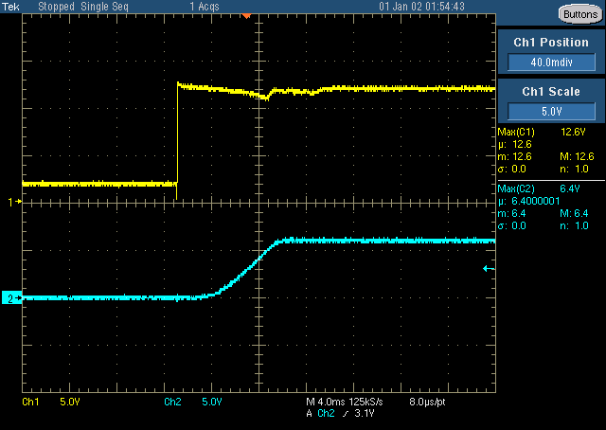

Figure 1

1. Shutdown

The shutdown waveform at 12.0V input voltage and 0.1A load on the output is shown in Figure 2.

Channel C1 **12.0V Input Voltage**  
5V/div, 40ms/div

Channel C2 **6.0V Output Voltage**  
5V/div, 40ms/div

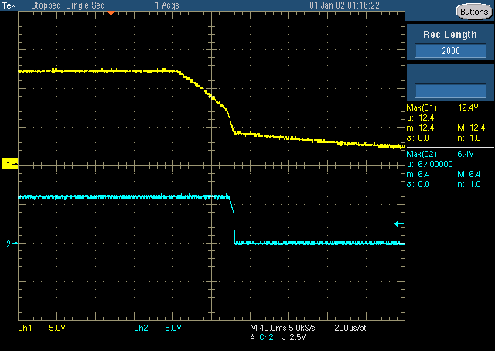

Figure 2

1. Efficiency

The efficiency at different input voltages is shown is Figure 3

Figure 3

1. Transient Response

The response to a load step at 12.0V input voltage is shown in Figure 4

Channel C3 **Output Current**, Load Step 0.5A to 1.0A  
500mA/div, 200us/div

Channel C4 **Output Voltage**, -88mV undershoot (1.47%), 105mV overshoot (1.75%)  
100mV/div, 200us/div, AC coupled

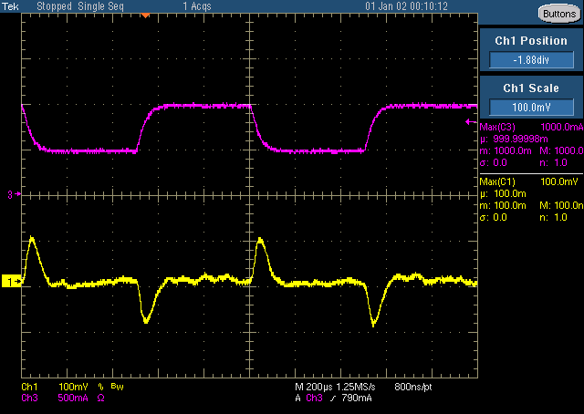

Figure 4

1. Input Ripple

The input ripple voltage at 8/12/16 input voltage & 1A load is shown in Figure 9/10/11.

Channel C1 **Input Voltage ripple @ 8V Input**, 104mV peak-peak  
100mV/div, 2us/div

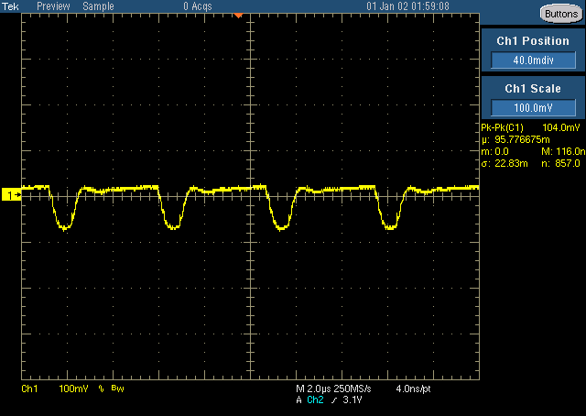

Figure 9

Channel C1 **Input Voltage ripple @ 12V Input**, 112mV peak-peak  
100mV/div, 2us/div

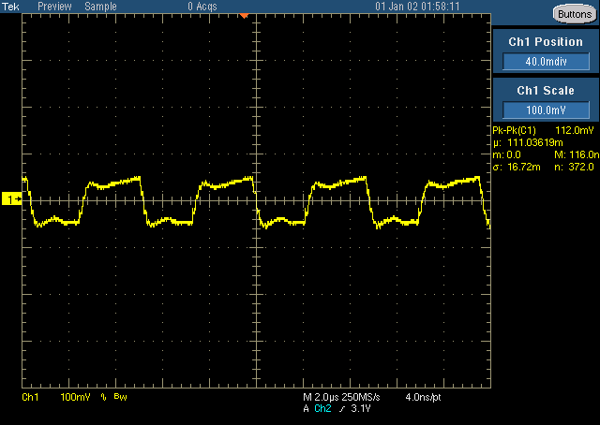

Figure 10

Channel C1 **Input Voltage ripple @ 16V Input**, 112mV peak-peak  
100mV/div, 2us/div

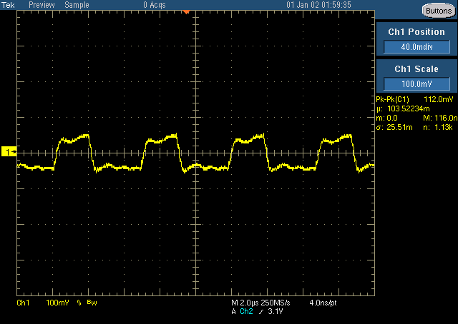

Figure 11

1. Output Ripple

The output ripple voltage at 8/12/16 input voltage & 1.0A load is shown in 12/13/14.

Channel C1 **Output Voltage ripple @ 8V input**, 37mV peak-peak  
20mV/div, us/div, AC coupled

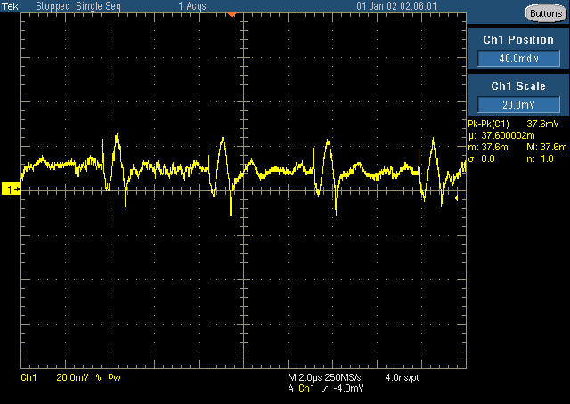

Figure 12

Channel C1 **Output Voltage ripple @ 12V input**, 40mV peak-peak  
20mV/div, 400ns/div, AC coupled

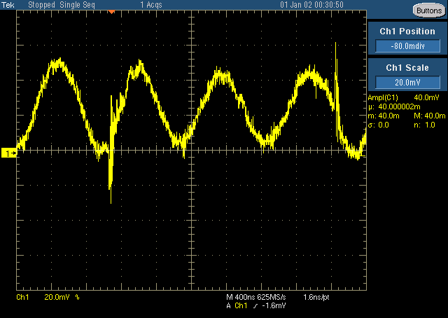

Figure 13

Channel C1 **Output Voltage ripple @ 16V input**, 55mV peak-peak  
20mV/div, 400ns/div, AC coupled

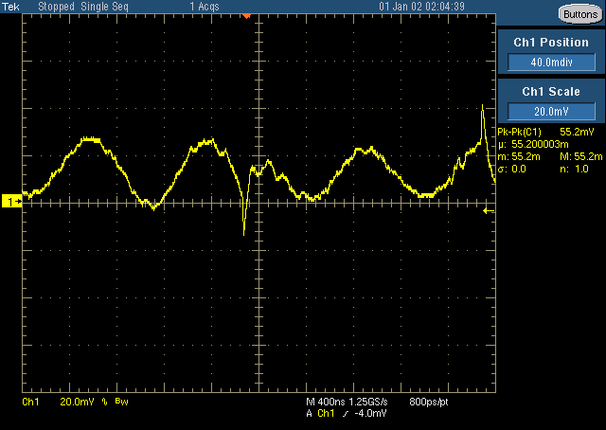

Figure 14

1. Buck Switching Node

The drain-source voltage of the Buck FET at 16.0V input voltage and 0.1A load on the output is shown in Figure 15.

Channel C1 **Drain-Source Voltage**,   
5V/div, 2us/div

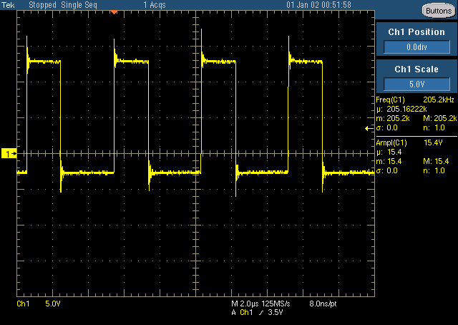

Figure 15

1. Frequency Responses

The frequency responses at 8/12/16V inputs & 1A load is shown in Figure 6,7,8.

8.0V Input 16.86 kHz crossover frequency, 61.07 deg Phase Margin, -1.18 slope

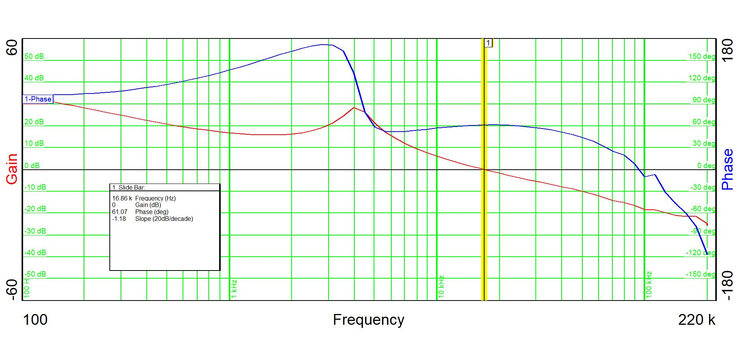

Figure 6

12.0V Input 16.03 kHz crossover frequency, 60.42 deg Phase Margin, -1.19 slope

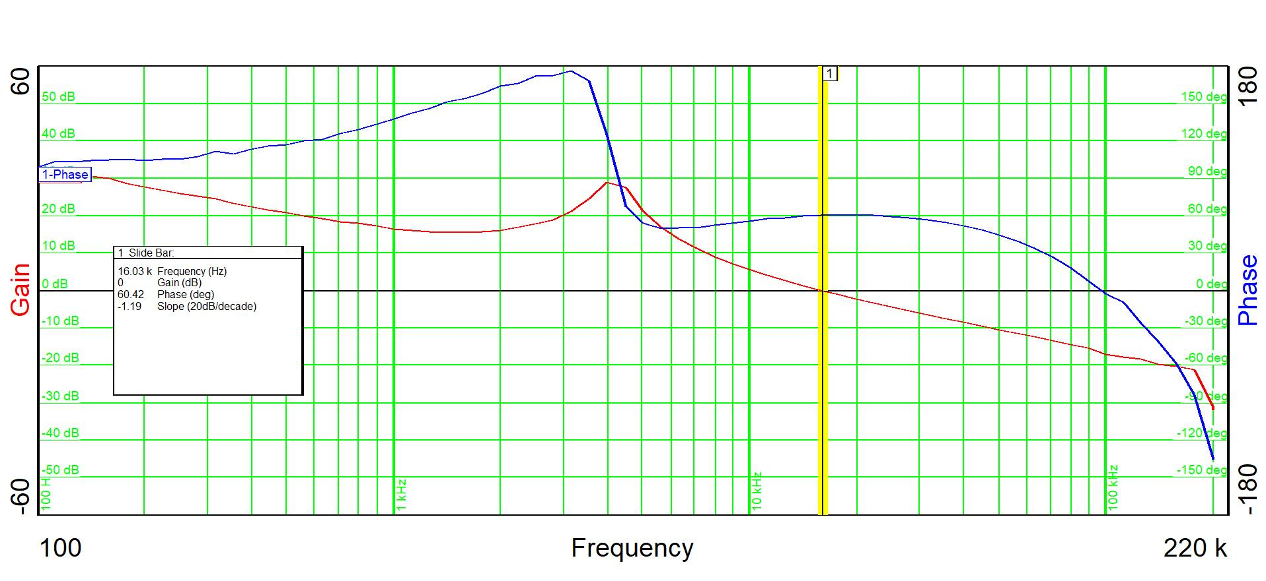**Figure 7**

16.0V Input 15.64 kHz crossover frequency, 60.19 deg Phase Margin, -1.19 slope

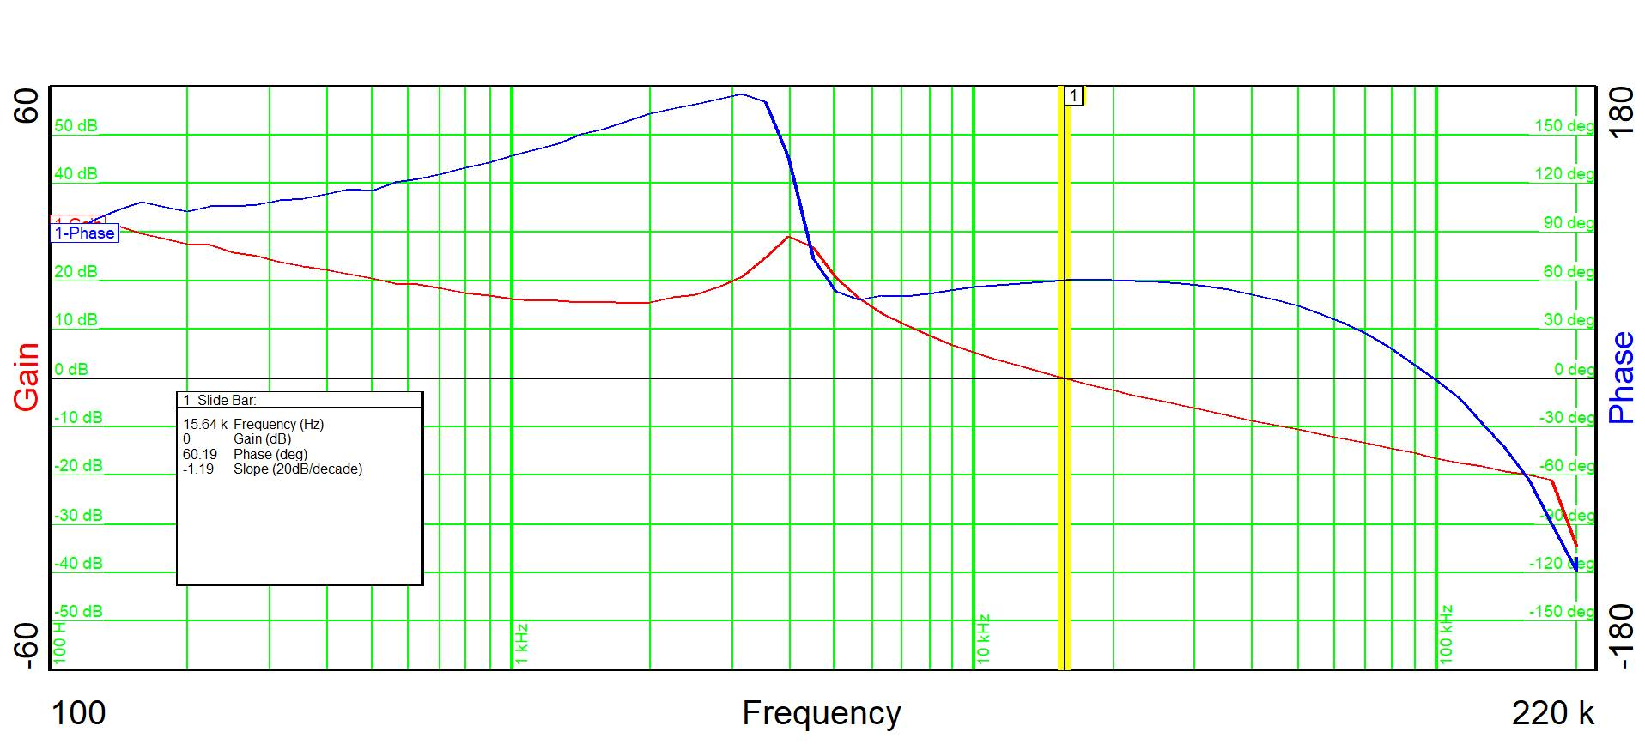

Figure 8