TPS40200 test report
- Input 8 .. 16.0V, 12V nominal
- Output 6.0V @ 1.0A
- Switching Frequency of 220 kHz
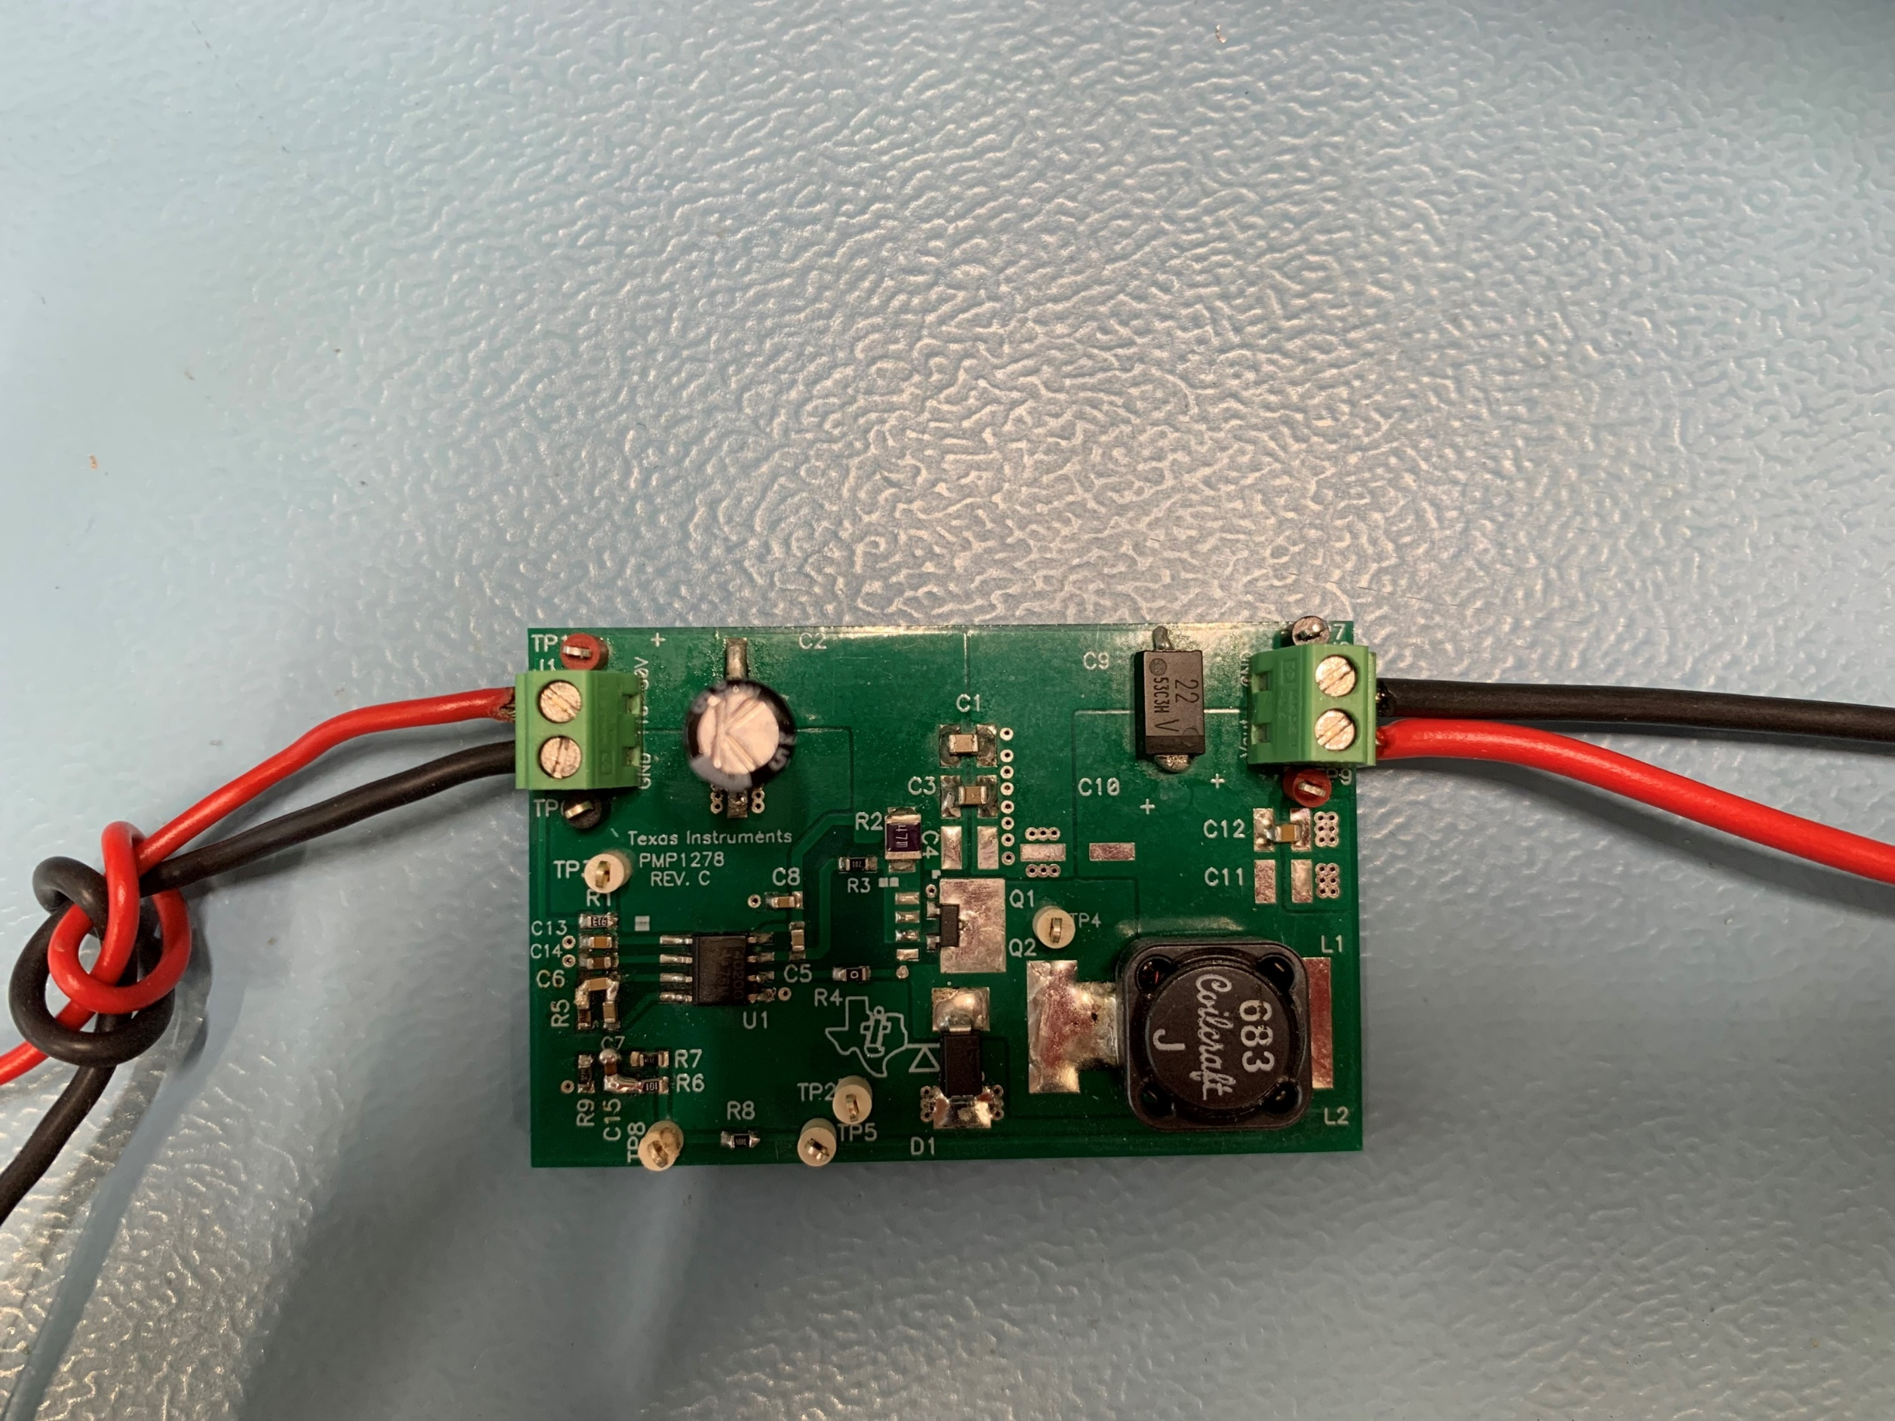

- Startup
The startup waveform at 12.0V input voltage and no load on the output is shown in Figure 1.
Channel C1 12.0V Input Voltage
5V/div, 4ms/div
Channel C2 6V Output Voltage
5V/div, 4ms/div
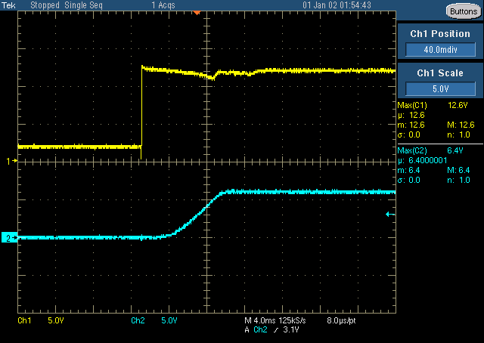
Figure 1

- Shutdown
The shutdown waveform at 12.0V input voltage and 0.1A load on the output is shown in Figure 2.
Channel C1 12.0V Input Voltage
5V/div, 40ms/div
Channel C2 6.0V Output Voltage
5V/div, 40ms/div
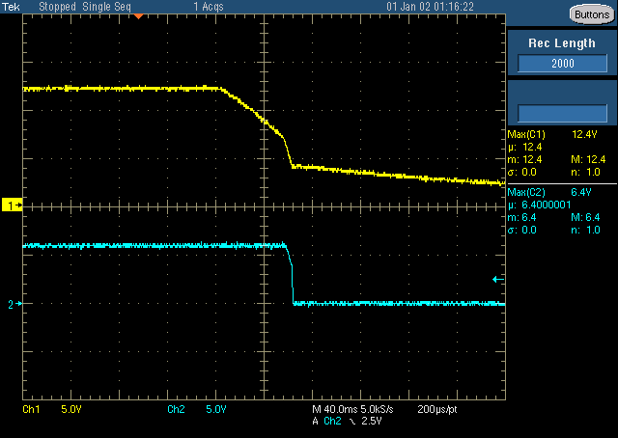
Figure 2

- Efficiency
The efficiency at different input voltages is shown is Figure 3

Figure 3
- Transient Response
The response to a load step at 12.0V input voltage is shown in Figure 4
Channel C3 Output Current, Load Step 0.5A to 1.0A
500mA/div, 200us/div
Channel C4 Output Voltage, -88mV undershoot (1.47%), 105mV overshoot (1.75%)
100mV/div, 200us/div, AC coupled
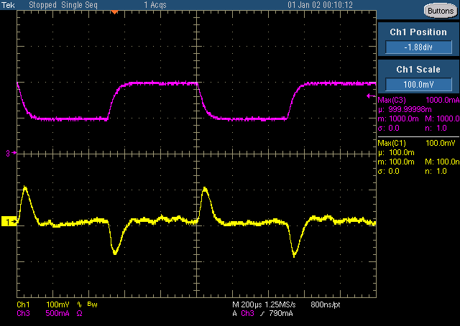
Figure 4

- Input Ripple
The input ripple voltage at 8/12/16 input voltage & 1A load is shown in Figure 9/10/11.
Channel C1 Input Voltage ripple @ 8V Input, 104mV peak-peak
100mV/div, 2us/div
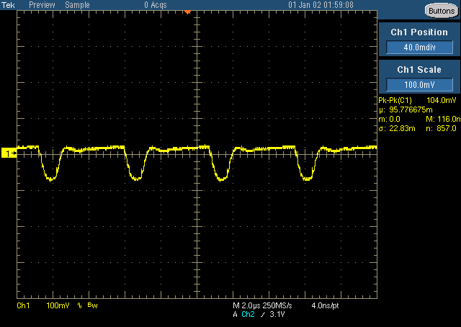
Figure 9
Channel C1 Input Voltage ripple @ 12V Input, 112mV peak-peak
100mV/div, 2us/div
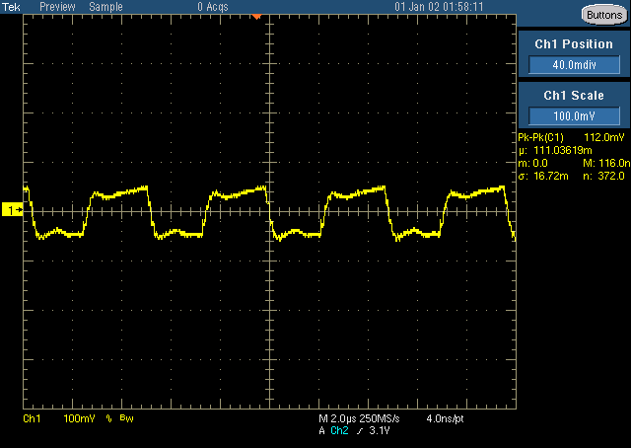
Figure 10

Channel C1 Input Voltage ripple @ 16V Input, 112mV peak-peak
100mV/div, 2us/div
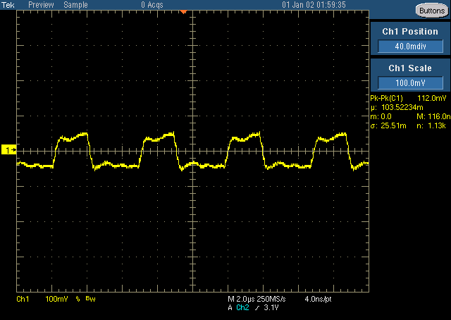
Figure 11

- Output Ripple
The output ripple voltage at 8/12/16 input voltage & 1.0A load is shown in 12/13/14.
Channel C1 Output Voltage ripple @ 8V input, 37mV peak-peak
20mV/div, us/div, AC coupled
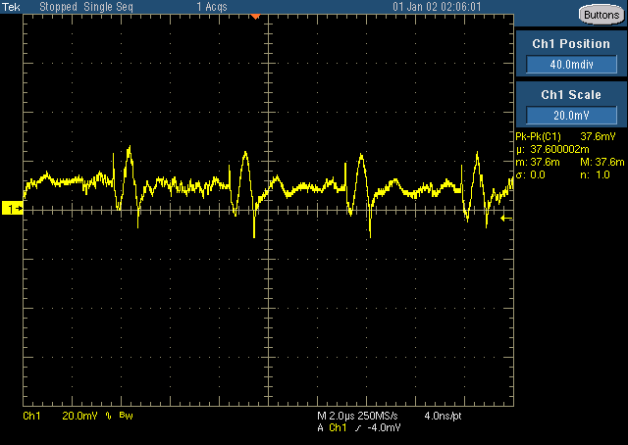
Figure 12
Channel C1 Output Voltage ripple @ 12V input, 40mV peak-peak
20mV/div, 400ns/div, AC coupled
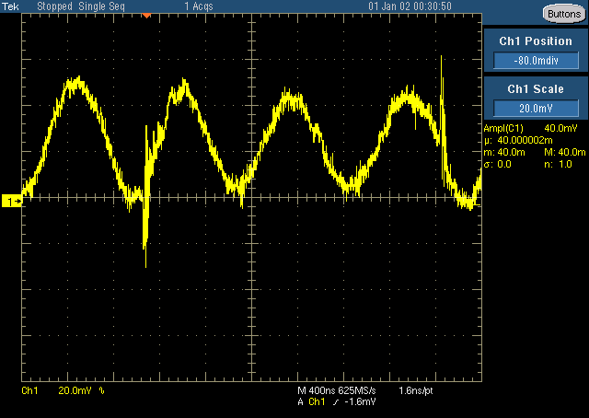
Figure 13

Channel C1 Output Voltage ripple @ 16V input, 55mV peak-peak
20mV/div, 400ns/div, AC coupled

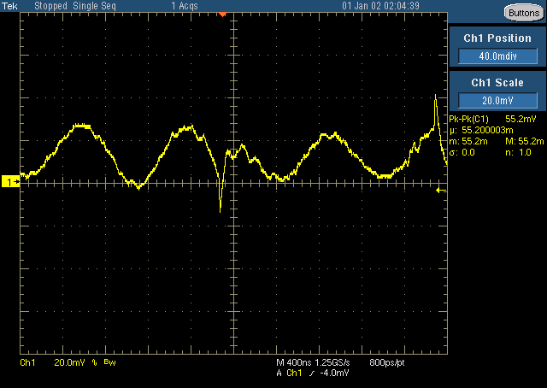
Figure 14
- Buck Switching Node
The drain-source voltage of the Buck FET at 16.0V input voltage and 0.1A load on the output is shown in Figure 15.
Channel C1 Drain-Source Voltage,
5V/div, 2us/div
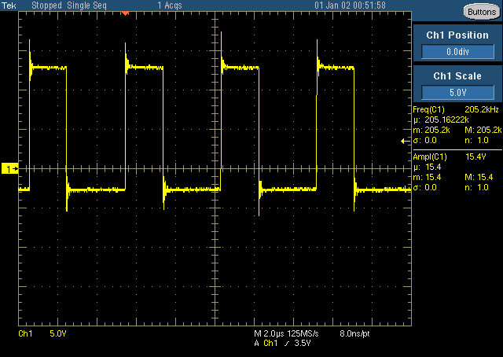
Figure 15

- Frequency Responses
The frequency responses at 8/12/16V inputs & 1A load is shown in Figure 6,7,8.
8.0V Input 16.86 kHz crossover frequency, 61.07 deg Phase Margin, -1.18 slope
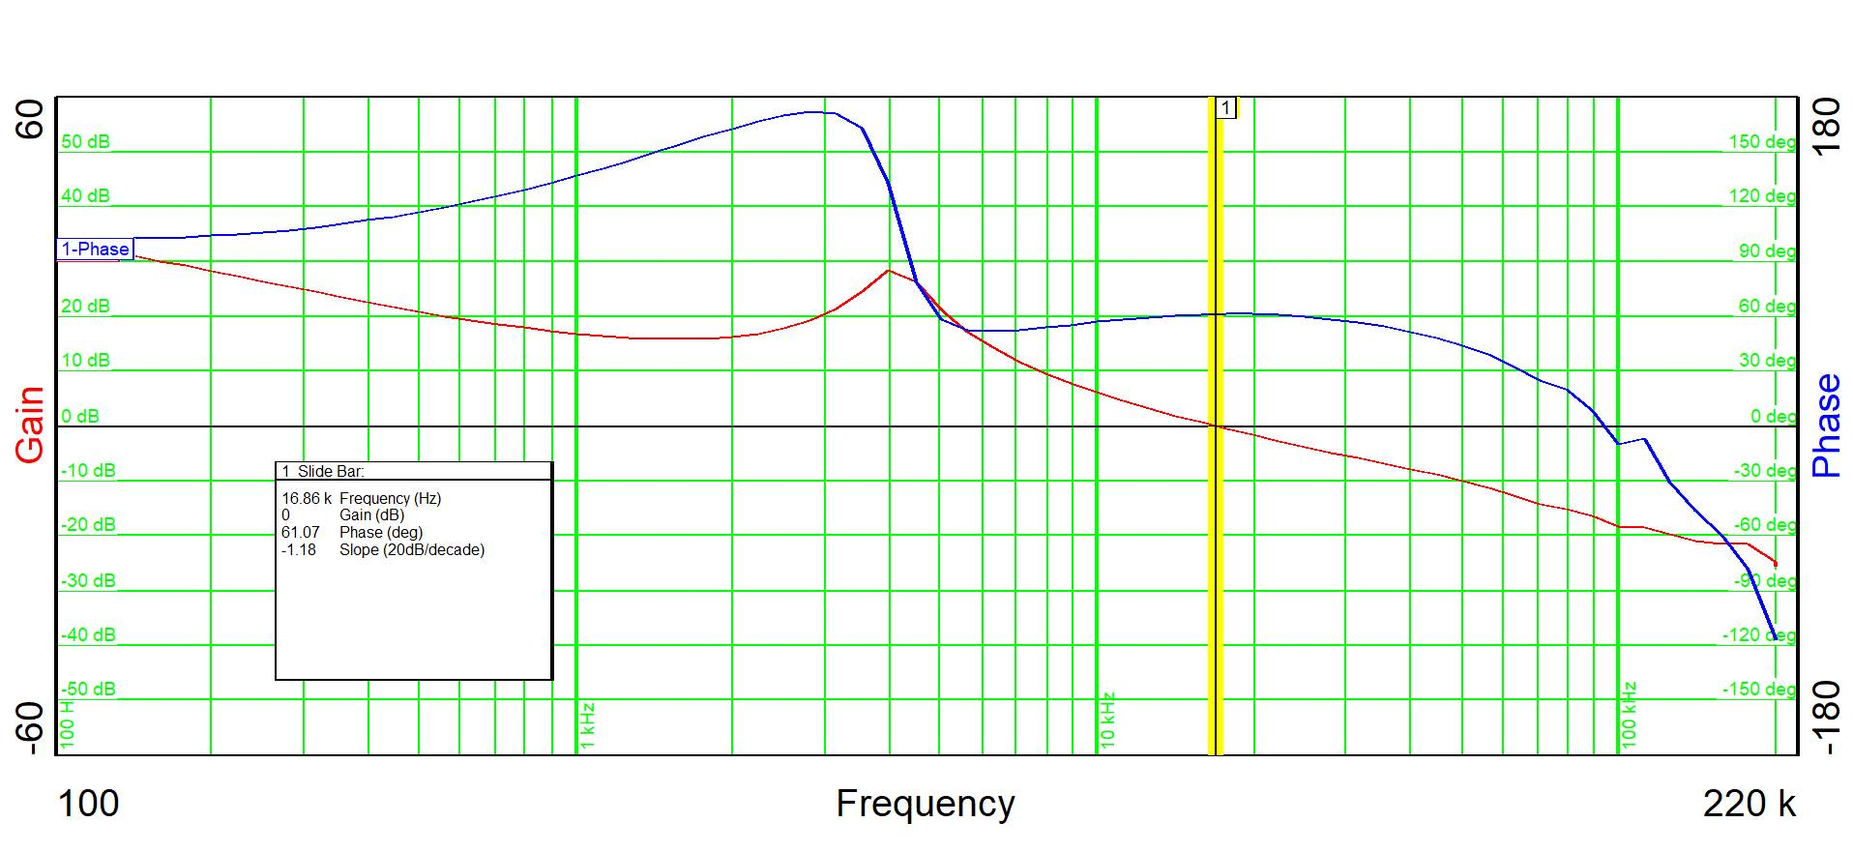
Figure 6

12.0V Input 16.03 kHz crossover frequency, 60.42 deg Phase Margin, -1.19 slope
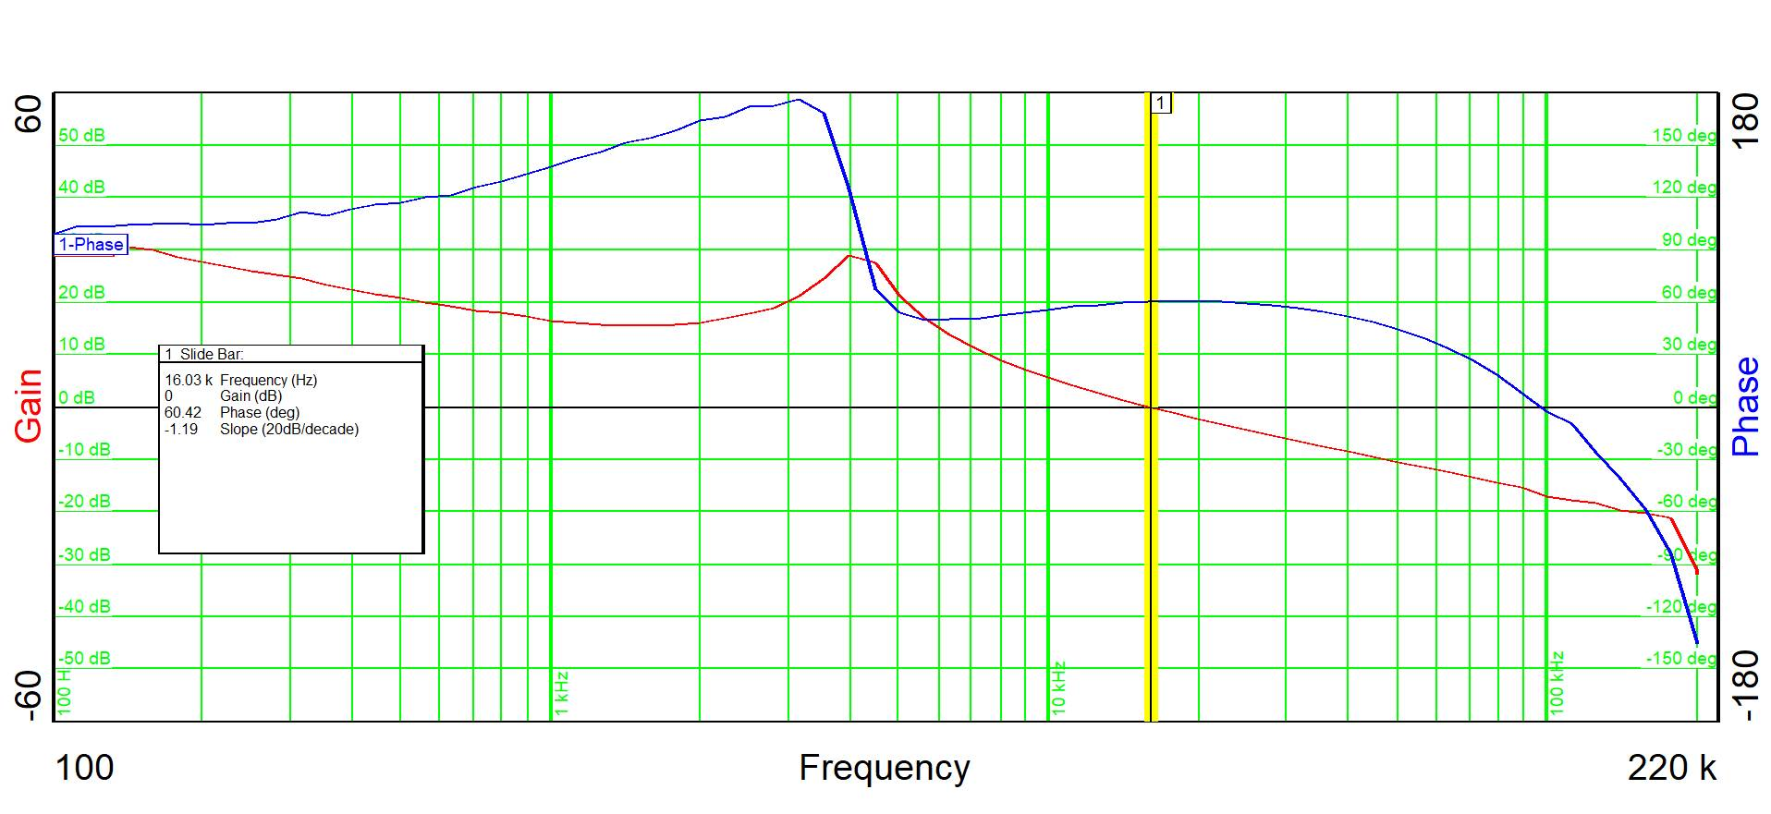Figure 7

16.0V Input 15.64 kHz crossover frequency, 60.19 deg Phase Margin, -1.19 slope
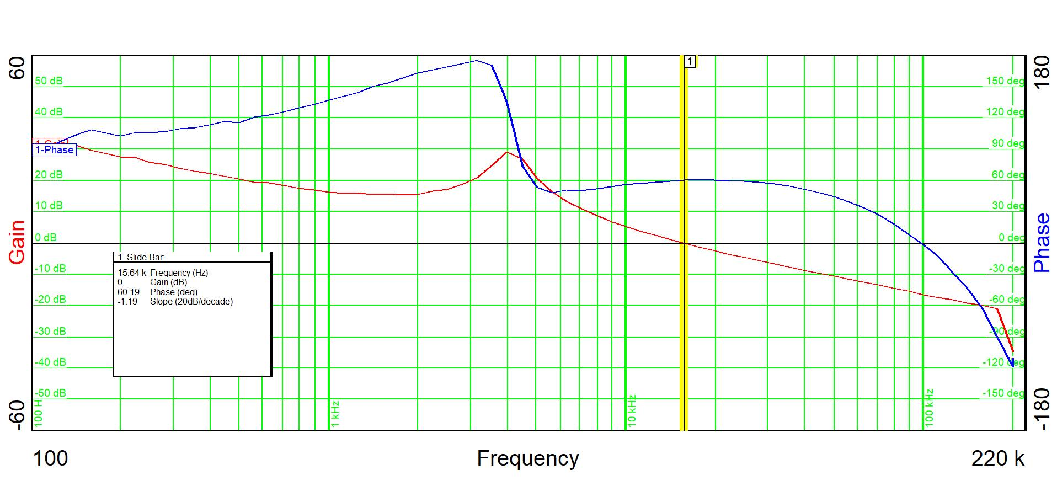
Figure 8

