One time setup:
- Create a MS Dos batch file with the name ‘DueProgrammer.bat’ and save it in Arduino installation path. To do this, open any text editor (Notepad) and type the following code
mode %1:1200,n,8,1,p
"C:\Program Files (x86)\Arduino\hardware\tools\bossac.exe" --port=%1 -i -e -w -v -b %2 -R
Explanation:
mode : A Dos command to switch serial port mode. This is required for enter into programming mode.
–port : COM port used for programming. %1 is the argument passed to the batch file
-i : displays1 the device information during programming
-e : erase the entire flash content on the device
-w : write given file to the flash. File name is passed as an argument to the batch file (%2)
-v : verify after writing
-b : boot from flash
-R : reset CPU
Save this file with the name DueProgrammer.bat and save it in Arduino installation path (for example: C:\Program Files (x86)\Arduino\DueProgrammer.bat)
bossac.exe : BOSSA is a microcontroller flash programming software for Atmel’s SAM microcontrollers. The name, BOSSA, is an acronym for Basic Open Source SAM-BA Application. Software’s homepage can be found here.

- Open Atmel Studio and click on Tools > External Tools. We will add this batch file as an external tool and tell Atmel Studio to pass required arguments to this batch file.

- Click Add to add a new external tool, and provide following information:
Title:
Due Programmer
Command:
C:\Program Files (x86)\Arduino\DueProgrammer.bat
Note: If you are using a different path, provide the same.
Arguments:
COM3 $(TargetDir)$(TargetName).bin
NOTE: COM3 is used as an example, you need to provide correct port. To find out exact COM port of the due board, plug-in micro USB connector to the “NATIVE USB -> SAM3X” connector of the due board, and insert the other end of the USB cable in any of the free USB ports on your computer. Check Device Manager for the COM port number.
TIP: If you connect your same Arduino Due board to the same USB port of your computer, the COM port number will always be the same !
Initial Directory:
$(TargetDir)
Select the check box ‘Use Output Window‘
You can refer to the screenshot below:
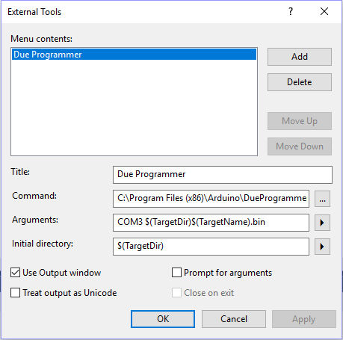Adding Due Programmer

- Click OK, and then click YES to save changes you have made.
Now you will find the new external programmer tool listed as “Due Programmer” under the Tools menu.
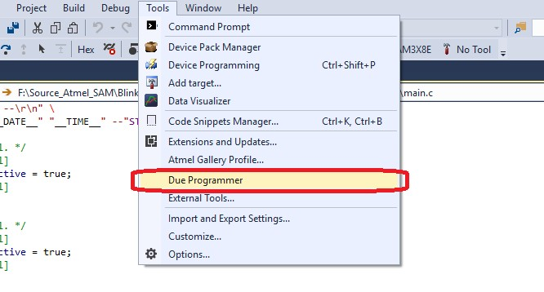Adding Arduino Due Programmer to Atmel Studio 7

