

**Auto Mata Assignment :2**

**Name: Daniyal Khalid**

**BSCS-4**

**1612113**

**Question No.1**

**Convert the following NFA to DFA**

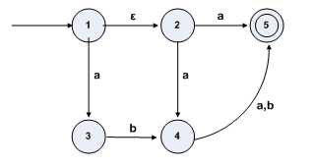

Ans.

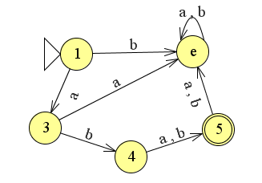

**Question No.2**

**Convert the following NFA to DFA.**

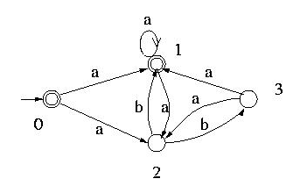

**Ans:**

**.** 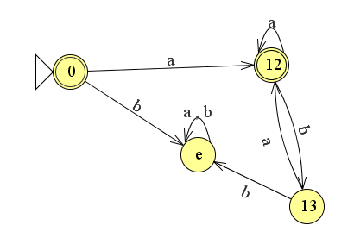

**Question No.3**

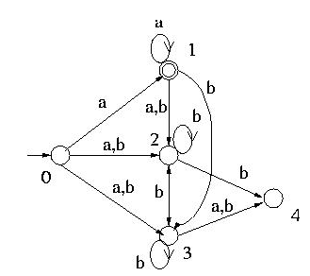

**Ans.** 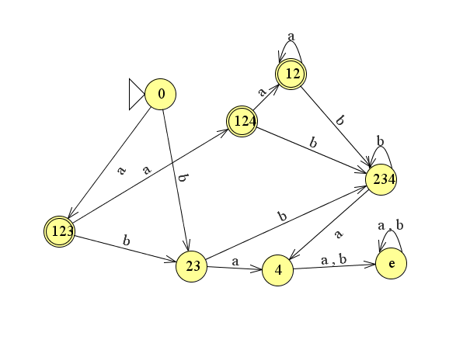

**Question No.4**

**Convert Epsilon NFA to NFA**

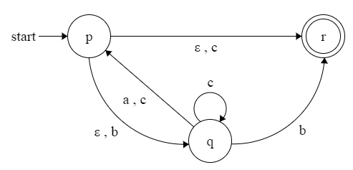

Ans

