RESEARCH TISSUE SAMPLING PROTOCOL
Oral Cavity SCC Resection — Tumor, Distance and Margin Samples for qRT-PCR
For the operating surgeon and reporting pathologist · HNSCC qRT-PCR study · Ethics approval ref: ____________
Why these samples: Comparing tumor with normal-looking mucosa at increasing distances shows how far molecular changes extend beyond the visible tumor (field cancerization), and whether changes at the margin predict local recurrence. The opposite cheek and healthy volunteers give the least-exposed baseline.

Priority rule: Diagnostic pathology always comes first. Research sampling must never compromise margin assessment, staging or frozen-section reporting. If a margin is close or the specimen is small, skip N1 / N2 — the pathologist has the final say.
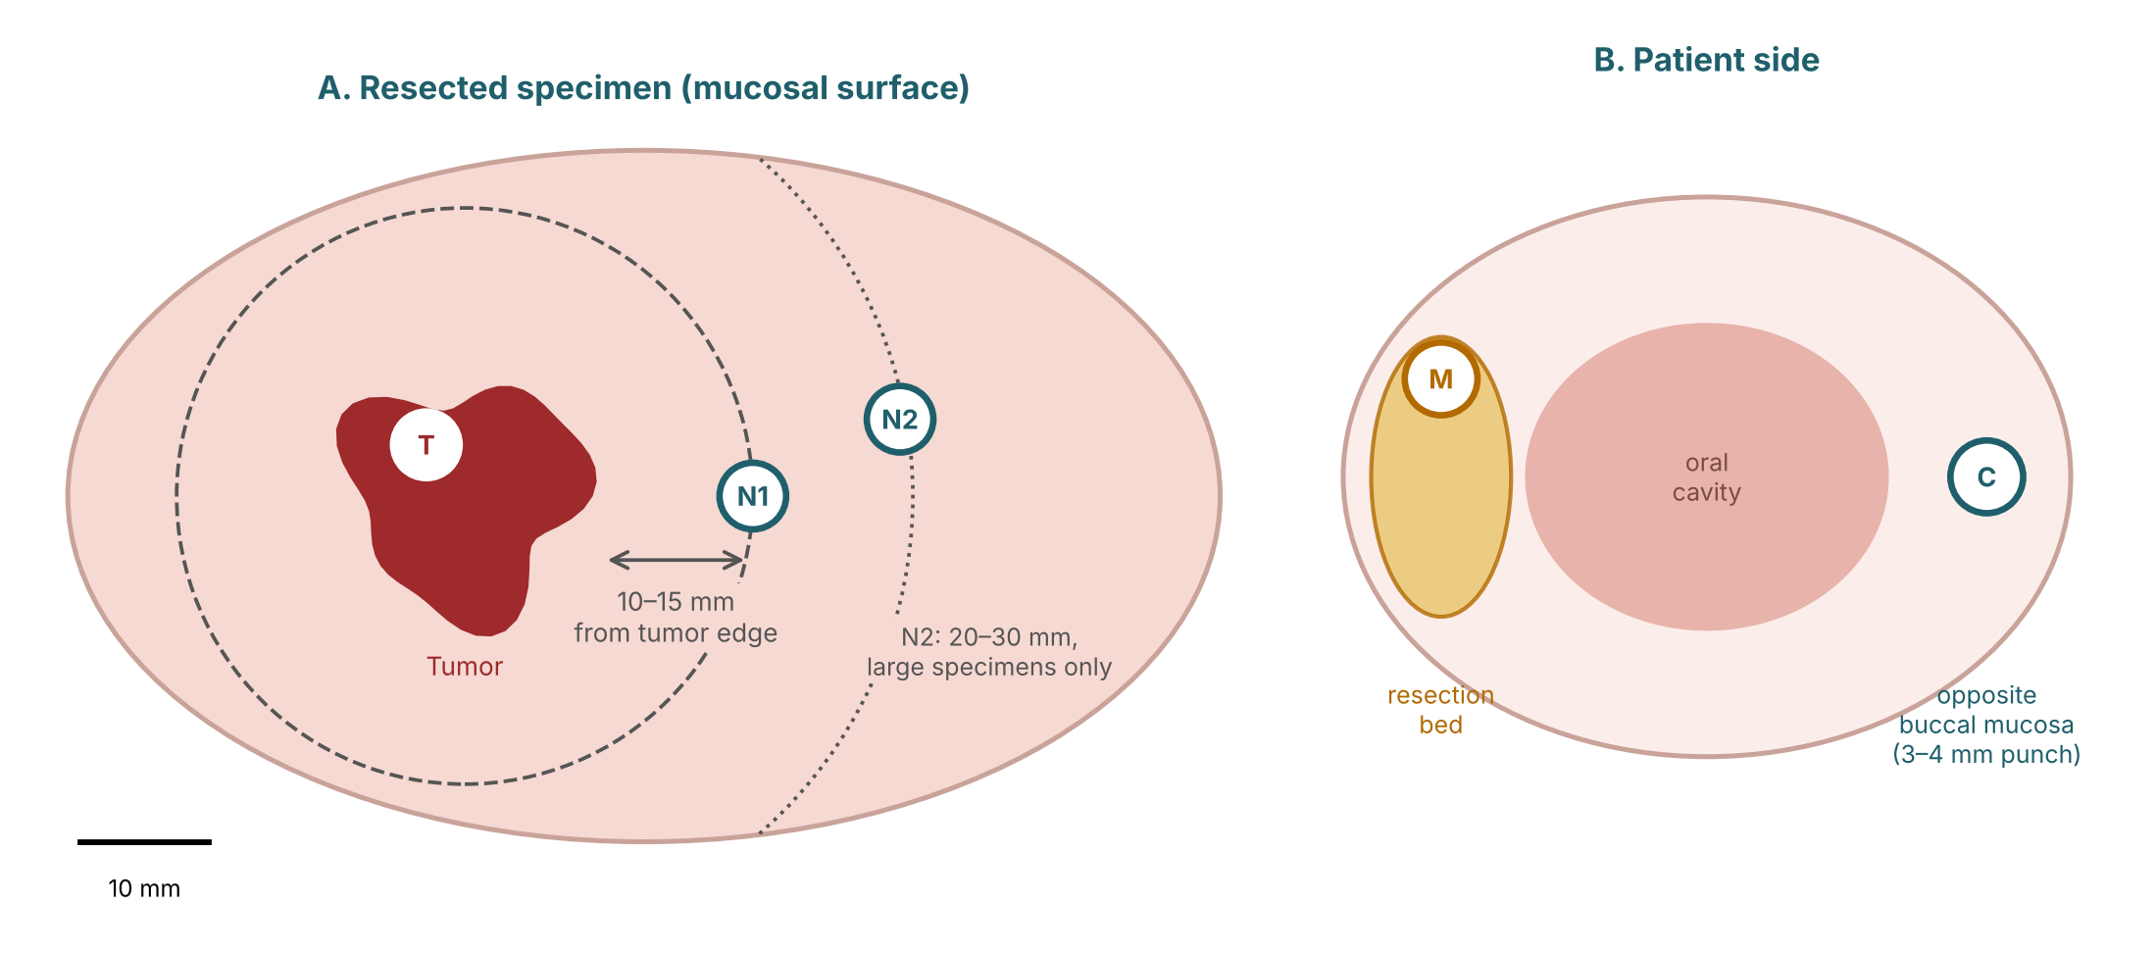
Sampling sites
Code | Site | When / how | Size
T | Viable tumor at the advancing edge; avoid necrotic centre and ulcer base | From the specimen, after the pathologist has oriented it and assessed gross margins | ~5 × 5 mm
N1 | Clinically normal mucosa 10–15 mm from the visible tumor edge | From the specimen; superficial mucosa only; never from the inked resection margin | ~5 × 5 mm
N2 (optional) | Clinically normal mucosa 20–30 mm from the tumor edge | Only in large or composite specimens where tissue allows | ~5 × 5 mm
M | Resection-bed margin (patient side) | One extra mucosal shave from the wound bed, next to the frozen-section margin site | ~3 × 5 mm
C (optional, consented) | Contralateral buccal mucosa, clinically normal | 3–4 mm punch biopsy under the same anaesthesia; one absorbable suture if needed | 3–4 mm
Handling
- Use cold knife or scissors for research pieces; avoid diathermy over the sampled area (cautery degrades RNA).
- Process within 30 minutes of excision. Rinse briefly in cold sterile saline, trim fat and muscle, keep the mucosa.
- Split each piece: one half into RNAlater (≥5× tissue volume), one half into formalin for a mirror H&E section.
- Keep RNAlater tubes at 4 °C overnight, then −80 °C. Label as StudyID–Code (e.g., OC023-T, OC023-N1), with date and time.
Do not sample
Inked resection margins · necrotic or ulcerated areas · cautery-charred edges · small (T1) lesions where the pathologist needs the whole specimen.
Record for each patient
Item | Entry | Item | Entry
Written consent / contralateral biopsy consent | ☐ Yes ☐ Yes | Tumor site and side | ____________
Specimen photographed with ruler | ☐ Yes | Side where quid / zarda is kept | ☐ L ☐ R ☐ Both ☐ None
Distances N1 / N2 from tumor edge (mm) | ____ / ____ | Frozen-section margin result | ☐ Clear ☐ Close ☐ Involved
Time of excision / time into RNAlater | __:__ / __:__ | Collected by (name, signature) | ____________
Questions about sampling: contact the research team before the case. Thank you for supporting this study.

