Identifying and Validating Neuroprotective Immune Cell Signatures in Parkinson's Disease CSF Using Single-Cell Transcriptomics and qRT-PCR

Background:
In Parkinson's disease (PD), the dopamine-producing neurons in a brain region called the Substantia Nigra slowly die, so dopamine levels in the body drop. At the same time, a harmful protein called alpha-synuclein builds up in this region, because the protein misfolds and cannot be cleared away properly.
When the Blood-Brain Barrier (BBB) becomes weak, NK cells from the blood and CSF can move into the brain and reach the damaged area near the dying dopamine neurons.
These NK cells may help by clearing away the toxic alpha-synuclein. A gene called RAC1 helps NK cells migrate easily to the damaged area, where they can engulf and clear the protein buildup.
Cerebrospinal fluid (CSF) contains a heterogeneous mix of immune cells, some of which may play this protective role while others may contribute to neurotoxicity. Bulk-level analyses of CSF cannot resolve this heterogeneity, since protective and cytotoxic populations are averaged together and their distinct signals are lost.
Rationale:
Single-cell RNA-seq of CSF gives cell-level resolution, allowing neuroprotective cell subsets to be separated from cytotoxic ones and candidate marker genes driving these distinct behaviors to be identified computationally.
These candidate genes can then be tested directly in patient samples by qRT-PCR, giving a result that is both computationally derived and experimentally validated.
Objectives:
- To identify neuroprotective immune cell subsets in PD CSF using single-cell transcriptomic analysis.
- To shortlist approximately five candidate genes associated with the neuroprotective cell subset for experimental testing.
- To validate expression of these candidate genes by qRT-PCR in paired blood and CSF samples from PD patients.
Expected Outcomes:
- A computationally defined signature of neuroprotective cells in PD CSF, with a short list of candidate marker genes.
- Experimental confirmation, by qRT-PCR in blood and CSF samples, of which candidate genes hold up in real patient samples.
- If antibody staining is included, independent confirmation that the candidate gene signature corresponds to the expected cell type.
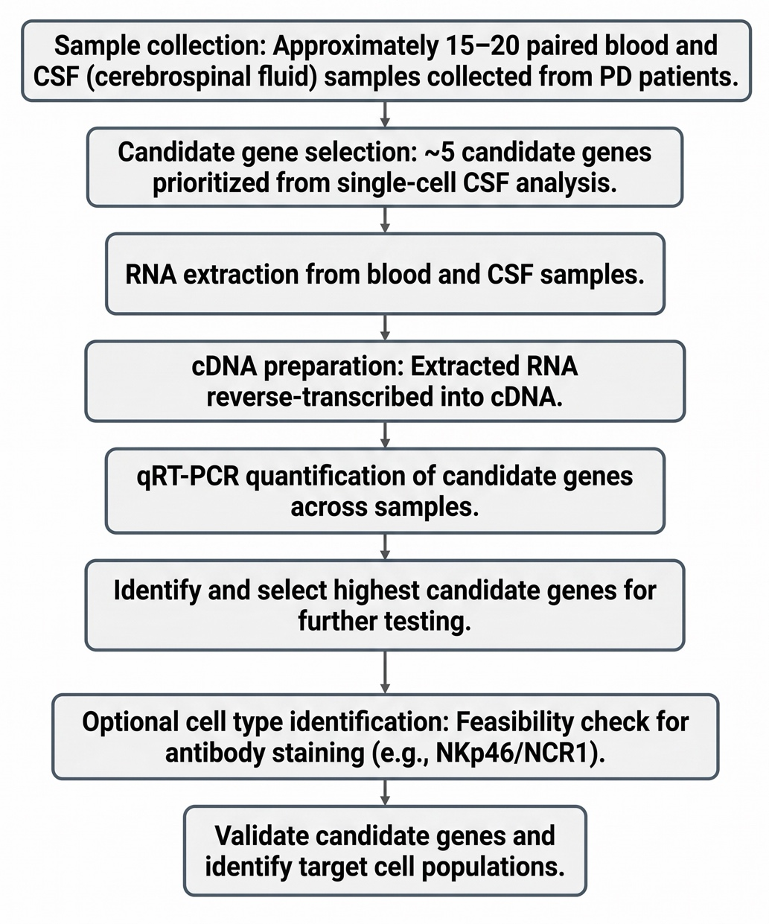
Methodology:
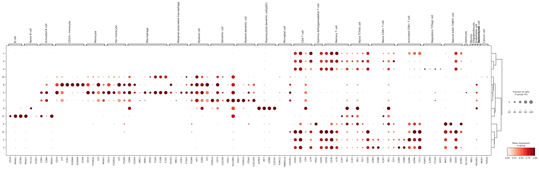
Test Run: Results (GSE141578)
Figure 1 (Dot Plot): Expression profiles of marker genes across identified cell clusters/types. Dot size represents the fraction of cells expressing the gene (%), while color intensity reflects the mean expression level within each group.

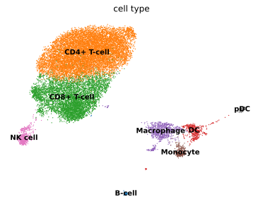
Figure 2 (UMAP Plot): Single-cell embedding visualising distinct cell populations (including CD4+ and CD8+ T-cells, NK cells, B-cells, Monocytes, Macrophages, DCs, and pDCs) color-coded by cell type.

