UK Property Market Lakehouse & HPC Benchmark

Project Documentation
Project title | UK Property Market Lakehouse & High-Performance Computing Benchmark
Domain | Property / financial markets — UK open government data
Dataset | HM Land Registry Price Paid Data, 2016–2026 (10.67 million transactions, 1.86 GB)
Technology | Python 3.12, DuckDB, Apache Parquet (ZSTD), pandas, Dask, Apache Spark 3.5, multiprocessing, matplotlib, pytest, GitHub Actions
Repository | uk-property-lakehouse
Academic link | M.S. Big Data & High Performance Computing — parallel/distributed processing, scalability analysis (Amdahl's law), storage formats

1. Abstract
HM Land Registry publishes every residential property sale in England and Wales as open data. This project engineers a complete, reproducible lakehouse over eleven years of that data — 10.67 million transactions, 1.86 GB of raw CSV — on a single laptop, and uses it as a test-bed for a high-performance-computing benchmark: the same analytical workload is executed by six engines (pandas, chunked pandas, Python multiprocessing, Dask, DuckDB on CSV and on Parquet, and Apache Spark) at 1, 2, 4 and 8 workers, with wall-clock time, peak memory, speed-up and Amdahl parallel fraction measured for each.
The pipeline follows the bronze → silver → gold medallion pattern with incremental, checksum-verified ingestion, DuckDB-powered cleaning into year-partitioned Parquet, a Kimball star schema in a DuckDB database with six analytical views, a SQL-pushdown data-quality framework that gates every layer, 24 unit tests and continuous integration. The analytical layer delivers Liverpool-versus-UK market insights — including a 61 % rise in Liverpool's median price against 32 % nationally.

2. Objectives
- Build an end-to-end pipeline over a genuinely large public dataset (> 10 M rows, > 1 GB).
- Implement incremental, idempotent ingestion with integrity verification.
- Produce bronze (raw), silver (clean Parquet) and gold (star schema) layers.
- Design a dimensional model and analytical SQL views for market analysis.
- Enforce data quality with reusable checks executed where the data lives.
- Benchmark parallel and distributed processing engines and analyse strong scaling with Amdahl's law.
- Deliver visualisations, a written report, documentation and a CI-tested GitHub repository.

3. Dataset
Source: HM Land Registry, Price Paid Data — https://www.gov.uk/government/statistical-data-sets/price-paid-data-downloads Licence: Open Government Licence v3.0 (free for any use with attribution; no registration) Attribution: Contains HM Land Registry data © Crown copyright and database right 2026.
Property | Value
Files | pp-2016.csv … pp-2026.csv (one per calendar year, no header row)
Size | 1,856 MB raw CSV → 334 MB silver Parquet (5.6× compression)
Rows | 10,666,409 transactions after de-duplication
Distinct postcodes | 1,243,481
Period | 1 Jan 2016 – 30 Sep 2026
Columns | 16: transaction id, price, date, postcode, property type, new-build flag, tenure, address (4), town, district, county, PPD category, record status

Known data characteristics handled by the pipeline: missing postcodes (~1 %), non-residential "Other" property type, additional-price-paid category B (repossessions, portfolio sales), implausible prices (£1 transfers, multi-property deals), inconsistent casing/whitespace, current-year file that grows monthly, local-government reorganisations that change county names over time.

4. Architecture
Land Registry S3 ──► BRONZE data/raw/pp-YYYY.csv streaming download, .part → rename,
_manifest.json SHA-256, size-change detection
──► SILVER data/processed/sales/year=YYYY/ DuckDB SQL clean, ZSTD Parquet,
_silver_manifest.json one file per thread, hive partitions
──► GOLD data/analytics/property.duckdb dim_date · dim_location · dim_property
fact_sale (10.67 M) · 6 views
quality.py 27 SQL-pushdown checks across all three layers (gate)
benchmark.py 6 engines × worker counts → outputs/benchmark_results.csv
visualize.py 9 figures + CSV tables · report.py → outputs/report.md

4.1 Pipeline steps
# | Module | Layer | Responsibility | Runtime
1 | src/ingest.py | Bronze | Incremental download; manifest with SHA-256; refresh current year when upstream size changes | 10 s (files present) / ~6 min (download)
2 | src/clean.py | Silver | DuckDB: de-duplicate, type, normalise postcodes, derive features, write partitioned Parquet; per-year incremental via checksum | 35 s
3 | src/transform.py | Gold | Star schema + 6 views in DuckDB | 53 s
4 | src/quality.py | All | 27 checks; hard stop on silver/gold failure | 12 s
5 | src/benchmark.py + src/spark_job.py | — | Six engines × 1/2/4/8 workers; Spark in isolated subprocess | ~4 min
6 | src/visualize.py | — | 9 charts, 6 CSV tables | 4 s
7 | src/report.py | — | Markdown report | 2 s

4.2 Star schema
dim_date (3,918) ─────────┐ date_key, full_date, year, quarter, month, month_name, day_name, is_sdlt_holiday
dim_location (9,182) ─────┼─► fact_sale (10,666,409)
dim_property (20) ────────┘ sale_key, transaction_id, date_key, location_key, property_key, price,
price_band, postcode, is_standard_sale, is_residential, is_price_plausible

- dim_location: postcode district → postcode area → town → district → county, with is_liverpool, is_london.
- dim_property: property type × tenure × new-build.
- dim_date.is_sdlt_holiday: England's stamp-duty holiday (8 Jul 2020 – 30 Sep 2021) as a date attribute.
- Views: vw_price_by_year_type, vw_city_comparison, vw_liverpool_districts, vw_monthly_market,
vw_county_league, vw_new_build_premium.

4.3 Cleaning rules and derived features
Rule / feature | Logic
Live records only | record_status = 'A'
De-duplication | QUALIFY row_number() OVER (PARTITION BY transaction_id …) = 1
Postcode normalisation | upper-case, strip spaces, validate against UK format, re-insert space; invalid → NULL
postcode_district, postcode_area | 'L1 8JQ' → 'L1', 'L'
Text standardisation | trim + upper-case town, district, county, street, locality
year, month, quarter | from date_of_transfer
property_type_name, tenure_name | code → label
is_new_build, is_residential, is_standard_sale | boolean flags
price_band | <100k / 100k–250k / 250k–500k / 500k–1m / 1m+
is_price_plausible | £10,000 ≤ price ≤ £20,000,000 — flagged, not deleted

The rules are implemented twice — in DuckDB SQL (production) and pandas (tests and benchmark) — and a unit test asserts the two implementations agree on 14 columns.

5. Data-quality framework
Seven generic checks (min_rows, not_null, unique, accepted_values, range, regex_match, referential_integrity, plus row_count_matches_source), each a small SQL query executed by DuckDB directly against a CSV, a Parquet glob or a table. Nothing is loaded into Python; 27 checks over 10.7 M rows complete in 12 seconds.
Suite | Checks | Outcome | Behaviour
raw | 5 | 2 pass, 3 fail by design (missing postcodes, 'O' property type, implausible prices) | documents what silver fixes
silver | 11 | all pass (incl. postcode regex, partition = transfer year) | failure stops pipeline
gold | 11 | all pass (key uniqueness, 3 × FK integrity, no rows lost silver → gold, views non-empty) | failure stops pipeline

Total: 24 / 27 pass.

6. Results — market analytics

6.1 England & Wales
Year | Sales | Median price
2016 | 922,724 | £219,950
2018 | 875,536 | £235,000
2020 | 753,528 | £257,500
2021 | 1,087,015 | £276,000
2022 | 910,013 | £290,000
2023 | 708,444 | £286,500
2024 | 764,317 | £291,000
2025 | 822,625 | £299,950
2026 (to Sep) | 392,461 | £290,000

Median residential price across the period: £261,000; total value transacted: £3.98 trillion. The monthly series shows three policy-driven volume spikes — March 2016 (buy-to-let surcharge deadline), June 2021 (end of the full stamp-duty holiday, 167 k sales in one month) and March 2025 (threshold reversion) — followed by sharp troughs, and the 2022–23 interest-rate slowdown.

6.2 Liverpool versus other cities (median residential price)
City | 2016 | 2026 | Growth
Liverpool | £130,748 | £210,000 | +61 %
Manchester | £149,950 | £250,000 | +67 %
Birmingham | £150,000 | £236,000 | +57 %
Leeds | £161,375 | £242,000 | +50 %
Bristol | £250,000 | £355,000 | +42 %
Newcastle upon Tyne | £160,000 | £205,000 | +28 %
London | £508,000 | £550,000 | +8 %
England & Wales | £219,950 | £290,000 | +32 %

Northern cities led growth from a low base while London stagnated — a clear narrowing of the north–south gap in relative terms.

6.3 Liverpool postcode districts — fastest growth, 2016 → 2026
District | Area | 2016 median | 2026 median | Growth
L6 | Everton / Kensington | £62,500 | £155,000 | +148 %
L4 | Anfield / Walton | £65,000 | £132,000 | +103 %
L20 | Bootle | £72,250 | £143,000 | +98 %
L1 | City centre | £72,200 | £142,025 | +97 %
L13 | Old Swan / Tuebrook | £87,000 | £165,000 | +90 %
L7 | Edge Hill / Kensington | £85,000 | £160,000 | +88 %

The inner-city regeneration districts around Anfield, Everton and the city centre more than doubled.

6.4 Counties — extremes of growth
Highest: Blaenau Gwent +75 %, Bournemouth/Christchurch/Poole +72 %, Merthyr Tydfil +72 %, Leicester +69 %, Caerphilly +67 %. Lowest: Windsor & Maidenhead +11 %, Wokingham +15 %, Greater London +17 %, West Berkshire +17 %. (Westmorland & Furness shows an artefact of the 2023 local-government reorganisation — see limitations.)

6.5 Property types and new-build premium
2026 medians: Detached £420,000 · Semi-detached £275,000 · Terraced £240,000 · Flat £222,000. New-build homes carried a premium of 18–35 % over existing homes, lowest during the 2021 boom (18.5 %) and highest in 2026 (34.5 %).
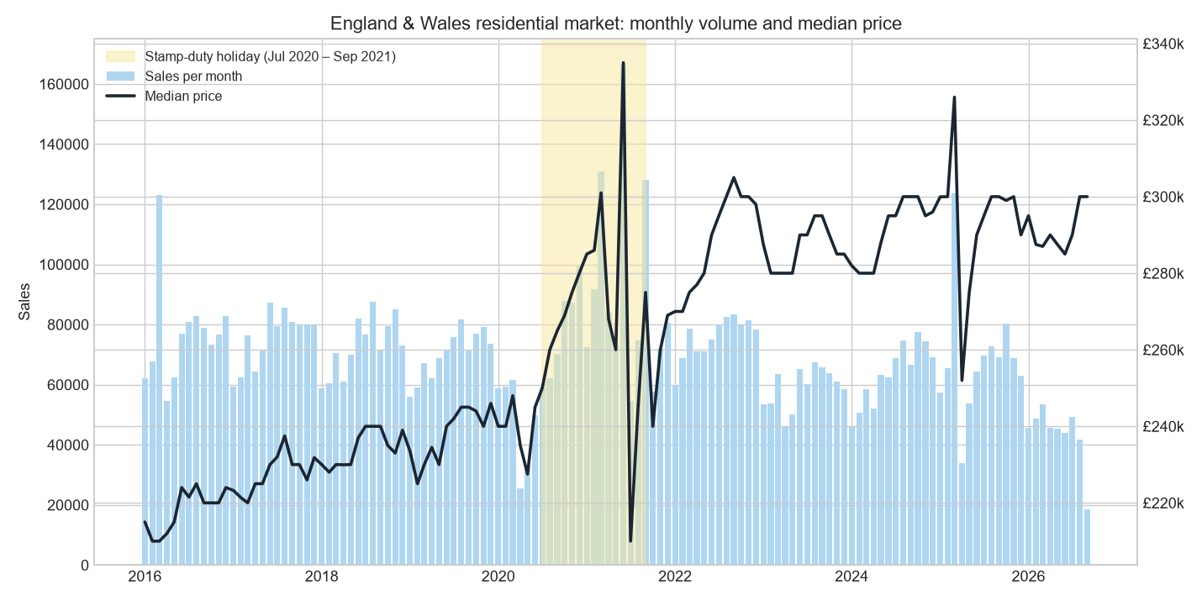
Monthly market
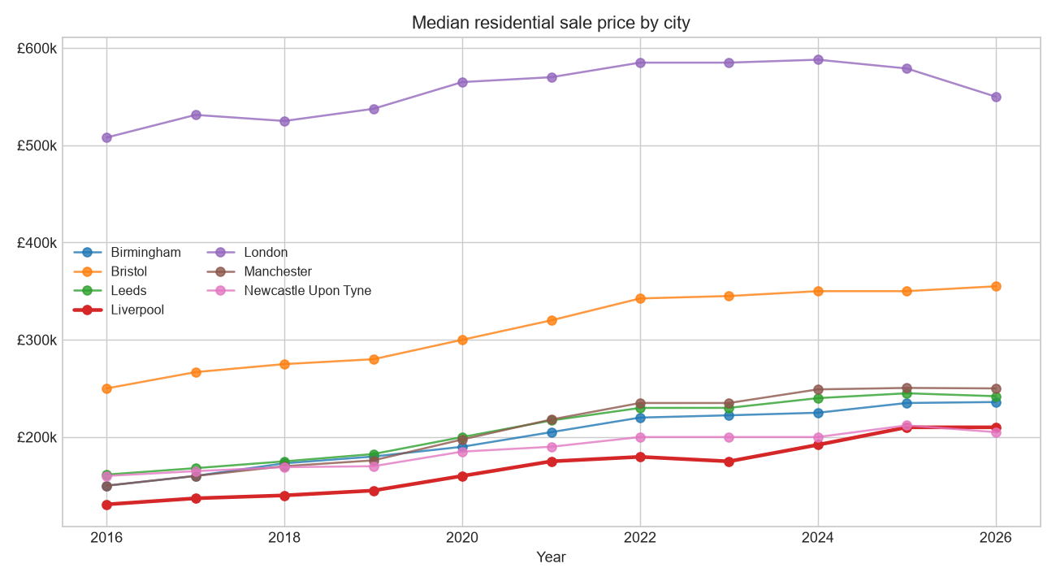
City comparison
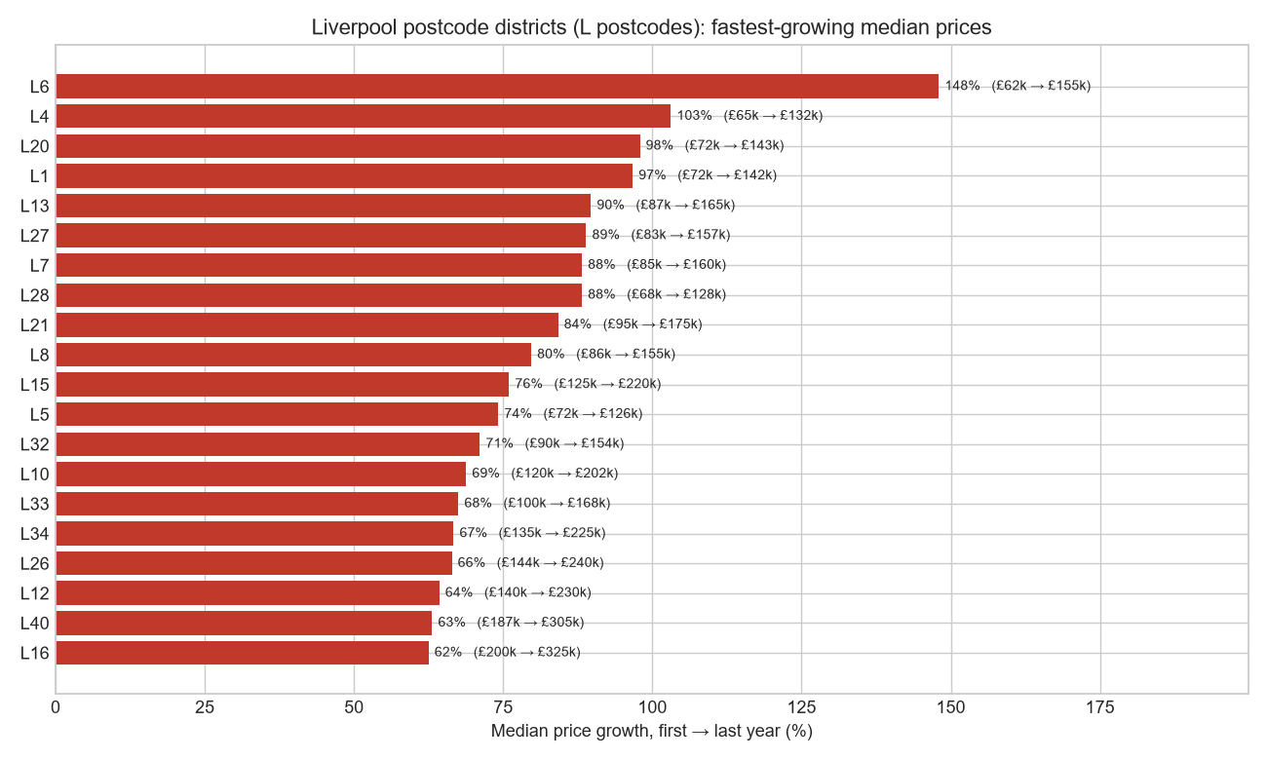
Liverpool districts
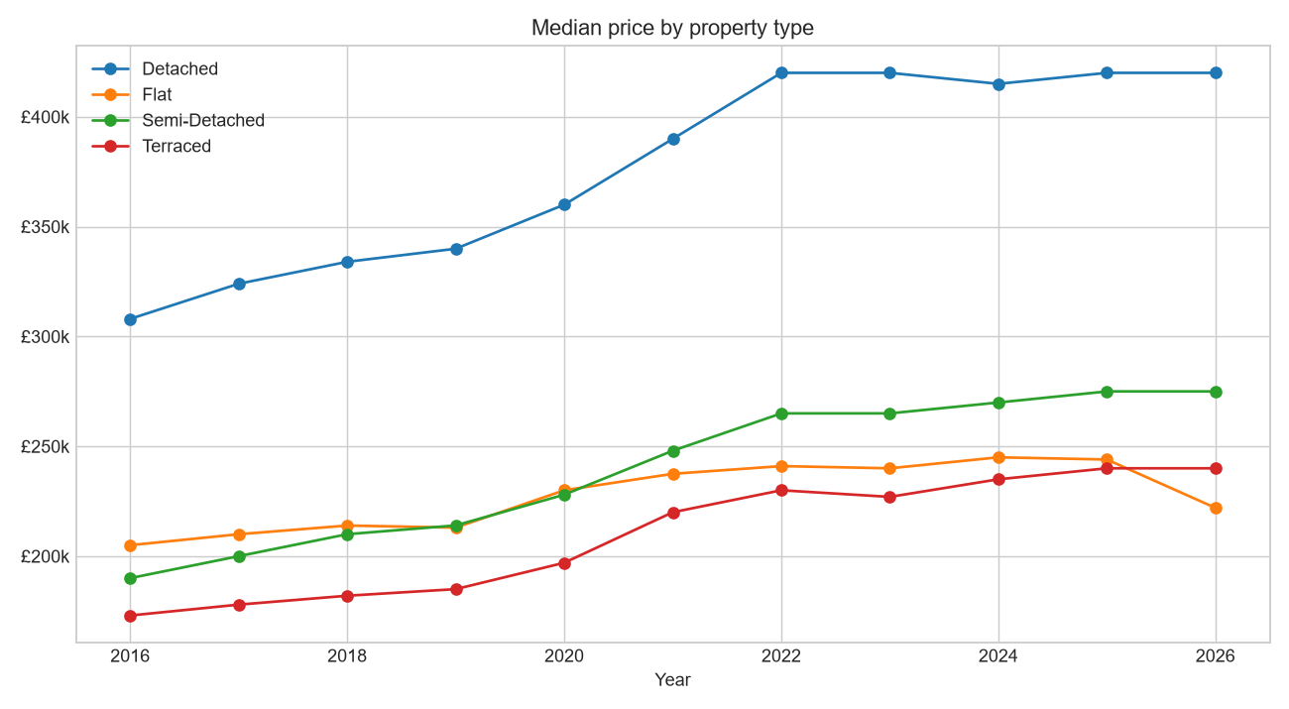
Property types
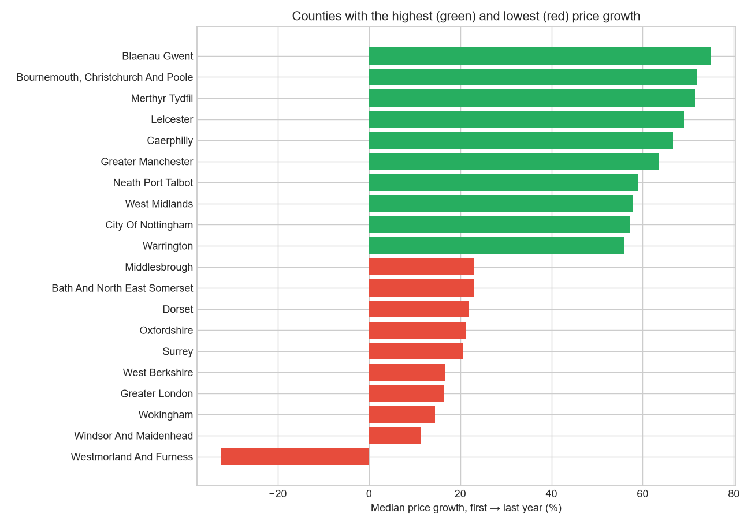
County league
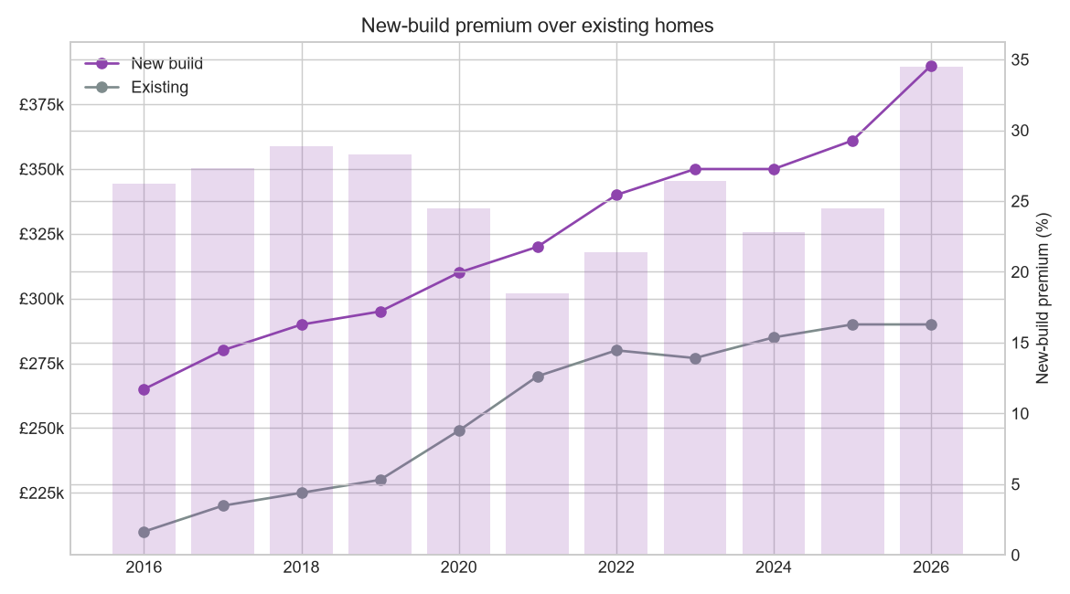
New build premium

7. Results — HPC benchmark
Workload: count sales and mean price by year × property type over all 11 raw CSVs (1,856 MB), filtered to standard sales. Identical result required from every engine (verified: all 22 configurations match the baseline to the row). Best-of-N wall clock; peak RSS of the driver process (Spark: Python + JVM process tree). Machine: 14 cores, 31 GB RAM, Windows, NVMe SSD.
Engine | Workers | Seconds | Peak RSS (MB) | Speed-up vs pandas | Speed-up vs 1 worker | Amdahl p
pandas | 1 | 7.64 | 1,727 | 1.0× | — | —
pandas-chunked | 1 | 7.52 | 690 | 1.0× | — | —
multiprocessing | 1 / 2 / 4 / 8 | 8.56 / 6.62 / 5.90 / 6.70 | 172 | 1.3× | 1.45× @4 | 0.41
dask (threads) | 1 / 2 / 4 / 8 | 9.87 / 7.64 / 6.25 / 5.87 | 408 → 1,864 | 1.3× | 1.68× @8 | 0.46
duckdb-csv | 1 / 2 / 4 / 8 | 6.42 / 4.40 / 2.51 / 2.47 | ≤ 1,885 | 3.1× | 2.60× @8 | 0.70
duckdb-parquet | 1 / 2 / 4 / 8 | 0.39 / 0.21 / 0.17 / 0.13 | 416 | 58.8× | 3.0× @8 | 0.76
pyspark local[N] | 1 / 2 / 4 / 8 | 26.4 / 20.5 / 19.4 / 18.5 | 1,355 | 0.4× | 1.43× @8 | 0.34

Cold-cache note: on the very first run after download (OS page cache empty) pandas took 21.3 s and multiprocessing scaled 22.7 → 10.9 → 6.1 → 5.5 s (1→8 workers) — near-linear while I/O-bound. The table above reports warm-cache figures, the standard convention, where CPU parsing dominates.

7.1 Interpretation
- File format is the biggest lever. DuckDB on Parquet is 59× faster than pandas on CSV and 19×
faster than DuckDB on the same CSV: Parquet stores columns contiguously, so the engine reads only the 4 of 16 columns needed (projection pushdown), decodes typed binary instead of parsing text, and skips row groups by partition. It also uses the least memory of any engine (≈ 400 MB).
- Vectorised execution beats Python-level parallelism. Single-threaded DuckDB on CSV (6.4 s)
already beats single-threaded pandas (7.6 s); with 8 threads it reaches 2.5 s. Python multiprocessing and Dask top out at ~5.9 s because each file is still parsed by pandas' C parser and the gains are eaten by process start-up, result pickling and memory-bandwidth contention.
- Amdahl's law is visible in every curve. Measured parallel fractions range from 0.34 (Spark)
to 0.76 (DuckDB-Parquet). With p ≈ 0.45 for multiprocessing, the theoretical maximum speed-up is 1/(1−p) ≈ 1.8× no matter how many cores — which is exactly where the curve flattens.
- Dask threads vs processes. With the thread scheduler Dask is bound by the GIL during CSV
parsing; its memory grows with workers (408 → 1,864 MB) because partitions are materialised in parallel. Its value is in scaling beyond RAM and beyond one machine, not in single-node speed.
- Spark is the slowest here, and that is the correct result. ~5 s of JVM start-up plus task
scheduling, serialisation and Python↔JVM overhead dominate a 1.9 GB job. Spark's design goal is horizontal scale over terabytes on many machines; on a single laptop it cannot amortise its overheads. Knowing when not to use Spark is as important as knowing how to.
- Memory. pandas needed 1.7 GB to hold the dataset; chunking cut that 2.5× at no time cost;
multiprocessing's driver used 172 MB because the work happened in children.
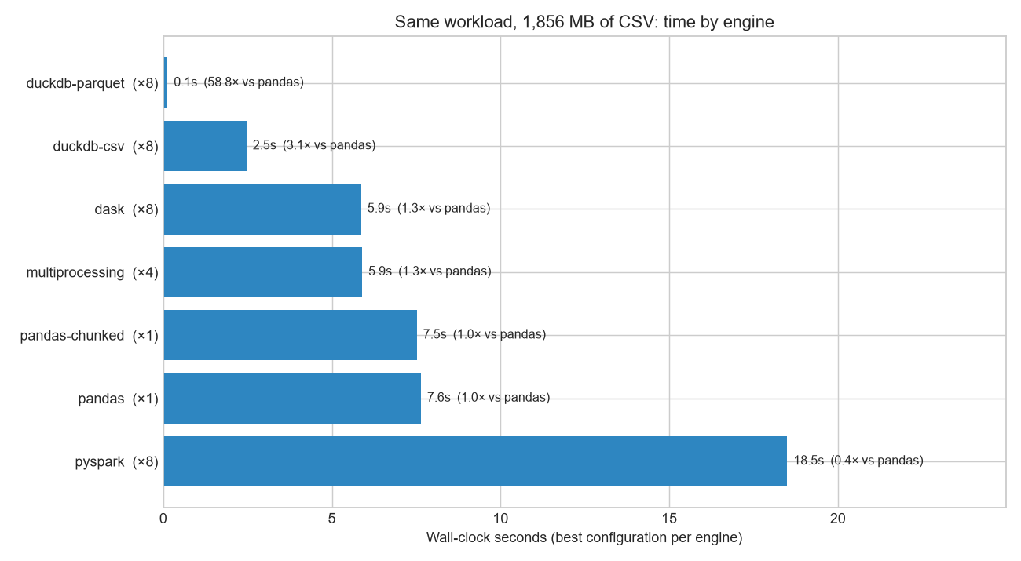
Benchmark engines
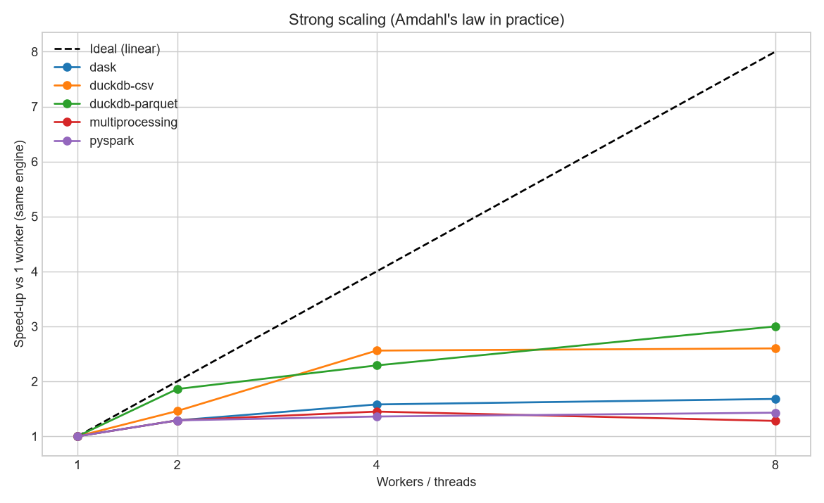
Benchmark scaling
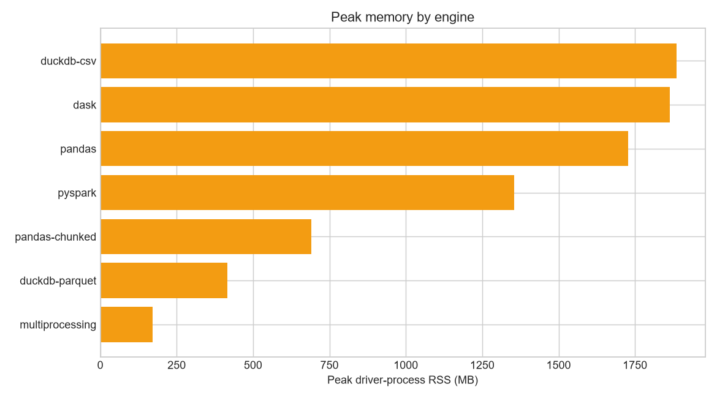
Benchmark memory

8. Testing and CI
- 24 unit tests — postcode normalisation (9 cases), price bands, cleaning rules on a 5-row fixture
with every known defect, SQL ≡ pandas equivalence, all 8 quality checks on in-memory tables, Amdahl formula.
- GitHub Actions — installs dependencies, runs the tests, then with PP_YEARS=2026 downloads the
smallest real file (~80 MB) and executes ingest → clean → transform → quality.
- End-to-end runtime: ~2 minutes without benchmark, ~6 minutes with; plus ~6 minutes for the
first download.

9. How to run
python -m venv .venv
.\.venv\Scripts\Activate.ps1 # macOS/Linux: source .venv/bin/activate
pip install -r requirements.txt
python run_pipeline.py # all steps
pytest -v

Fewer years: $env:PP_YEARS="2024,2025,2026". Spark engine: install a JDK 17 (or unzip a portable one into tools/) — on Windows also place winutils.exe + hadoop.dll (Hadoop 3.3.x) in tools/hadoop/bin/; the project auto-detects both. Without Java the benchmark skips Spark.

10. Deliverables checklist
Required deliverable | Delivered as
Complete Python data-engineering pipeline | run_pipeline.py + 8 modules in src/
Raw, cleaned and analytics-ready datasets | data/raw/ (11 CSV) · data/processed/sales/year=*/ (Parquet) · data/analytics/property.duckdb
Locally stored SQL database | DuckDB file: 4 tables, 6 views, 10.67 M fact rows
Reusable data-quality checks | src/quality.py — 8 generic SQL-pushdown checks, 3 suites, JSON report
Performance comparison results | outputs/benchmark_results.csv, figures 07–09, section 7 above
Visualisations and project report | 9 figures, 6 CSV tables, outputs/report.md
GitHub repository | CI workflow, 24 tests, README, GUIDE, CODE_WALKTHROUGH, this document

11. Mapping to production technologies
In this project | Production equivalent
DuckDB / Dask / Spark local[N] | Databricks, EMR, Synapse Spark clusters
Hive-partitioned Parquet + ZSTD | Delta Lake tables with partitioning, Z-order, OPTIMIZE
Manifest + SHA-256 incremental ingest | Auto Loader / Airflow sensors / file-arrival triggers
DuckDB star schema + views | Snowflake or BigQuery + dbt models
quality.py | dbt tests, Great Expectations, Soda
run_pipeline.py | Airflow / Databricks Workflows / Prefect
Strong-scaling benchmark | cluster right-sizing and cost-performance analysis

12. Limitations and future work
- County names follow local-government boundaries at the time of sale; reorganisations (e.g. 2023
Cumbria → Westmorland & Furness) create artefacts in long-run county comparisons. A postcode → ONS geography lookup would fix this.
- Prices are nominal (not inflation-adjusted); medians are unmixed (no hedonic adjustment).
- Benchmark is single-machine; the Spark result would invert on a multi-node cluster with data on
distributed storage.
- Future work: Delta Lake with time travel for the silver layer; monthly CDC merge from
pp-monthly-update-new-version.csv (handles C/D records); ONS postcode centroids for geospatial heat-maps; dbt-duckdb for the views; Airflow DAG; repeat the benchmark on a 32-core cloud VM.

13. Repository structure
uk-property-lakehouse/
├── README.md · GUIDE.md · CODE_WALKTHROUGH.md · PROJECT_DOCUMENT.md
├── config.py · run_pipeline.py · requirements.txt · pytest.ini
├── src/ ingest.py clean.py transform.py quality.py benchmark.py spark_job.py visualize.py report.py
├── tests/ test_clean.py test_quality.py
├── data/ raw/ processed/ analytics/ (generated, git-ignored)
├── tools/ (optional portable JDK + Hadoop natives, git-ignored)
├── outputs/ report.md quality_report.json benchmark_results.csv figures/ tables/
└── .github/workflows/ci.yml

