**JPL Editor Plugin**

Features in Version 3.9.29:

* Create Panther Projects
* **Create Panther Libraries**
* Import Panther Libraries
* **Export Panther Libraries**
* Create JPL files (jpl files must have the *.jpl extension) *
* Add Panther files under SVN Repository
* JPL syntax validated for correctness
* Converts binary screens, reports and menus to ascii
* Search and Compare files
* Content assist after “->” , i.e. @widget(“screen1”)->title=”Login Screen”
* Content assist after “_”, i.e. “ sm_” or “ dm_”
* **Hyperlinking – for smart switching between call and procs**

Software Requirements:

1. Eclipse IDE (Kepler/Mars/Neon):

To install this plugin you must install Eclipse onto your system.

2. Install Xtext software using Eclipse Marketplace:

Go to Eclipse IDE → Help → Eclipse Marketplace, find “Xtext 2.9”

Or if you install Eclipse (Kepler SR2/Mars) IDE for Java and DSL then no need to install Xtext software.

**If you don’t find the Xtext 2.9 on market place, download it (tmf-xtext-Update-2.9.2.zip) from GitHub and install it like**

**Eclipse IDE → Help → Install New Software**

**Note: Please don’t use higher or lower versions of xtext 2.9.x.**

**Instructions:**

Follow the step-by-step instructions below to use Prolifics’ JPL-E Plugin.

Install JPL Editor Plugin

1. ~~Download JPL Editor Plugin from our ftp site to your desktop and open your Eclipse IDE.~~

1. Download JPL Editor Plugin from Github https://github.com/Prolifics-Panther/JPLEPlugins/

2. Go to the Help menu and select “Install New Software”.

3. Click on the Add button and choose Archive and browse the zip folder i.e. JPL Editor Plugin

downloaded from ftp site (JPl-E3.9.29.zip). Click OK.

4. Unselect ‘Group items by category’ in the Install window and select the check box

‘JPLEPlugin’. Click Next.

5. Choose the Panther Plugin and Press Next.

6. Then click on the “I accept the terms of the license …” radio button. Click Finish.

7. You may ignore the Security Warning., and click OK

8. If you encounter any errors, redo Step 2 but this time choose Help>Install New

Software and uncheck “Contact all update sites during install to find required software”.

9. Restart Eclipse. The installation of JPL Editor Plugin is now complete. The very first thing to

do is to create a new Panther Project.

Create a Panther Project

1. Please make sure SMBASE is set in your environment. It must point to the location of your Panther installation, i.e SMBASE=C:\Prolifics\Panther 550 (Windows)

SMBASE=/usr/develop/prolifics/panther550 (Linux)

1. From the Eclipse menu, click File-> New->Other->Panther -> Create Panther Project.
2. Enter a project name. For example “CurrDev2016” then press Finish. See diagram below.
3. If Eclipse asks if you want to add Xtext nature to your project, please click on the Yes button.

Import Panther Library

|  |  |
| --- | --- |
| 1. Your Panther library can contain screens, jpl, menus, reports, html, JavaScript, java files etc. Right click on your newly created Panther project. Select import from context menu. 2. Select Import Panther Library from the import wizard. 3. Click on Panther Library and then click on “Next”. 4. Browse to your Panther library e.g. test.lib. 5. Click on “Finish”. See the diagram on your right. 6. All binary file are organized the <bin> folder and ascii files are saved in the <src> folder. | Figure 1 |

Create Panther Library:

1. Right click on <Project> -> New -> Other -> Panther -> Create Panther Library.

It contains <src> and <bin> directories and one library.xml. You can change extension of generated binaries by adding jpl/bin in jpl-binary-filename-extension tag

Create a New JPL File

* 1. Right-mouse click on the <src> folder you would like to create the jpl file in, New->File.
  2. The filename MUST have a JPL extension and press Finish.
  3. When making an update in any of the ascii files, once you save your change the files is compiled to binary and stored in the <bin> folder.

Export Panther Library

1. Right click on Panther project library folder as shown in below image in my case Shazam.lib. Select export from context menu.

2. Select Export Panther Library from the Export wizard.

3. Click on Panther Library and then click on “Next”.

4. Browse destination directory.

5. Click on “Finish” button.

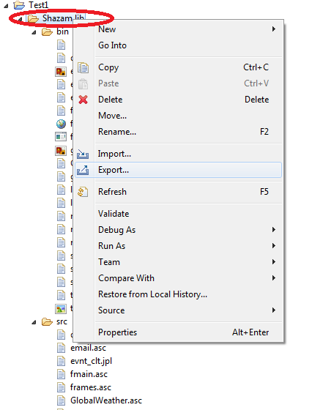

**Uninstalling JPL Plugin**

+If you need to remove an old JPL Plugin, uninstall it using Help->About Eclipse. Click on Installation Details and select the "JPL Plugin Editor", press uninstall. Confirm that you would like to uninstall it. Then Restart Eclipse.

*Pending to change in next release