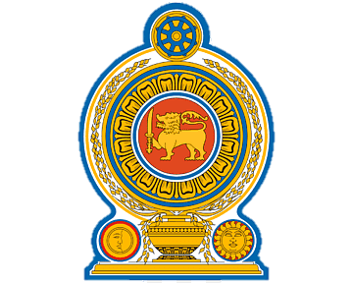


National Institute Of Business Management
Diploma In Software Engineering
GADSE251F Batch

Web-Based Tourism Services Marketplace Platform
Final Project Report
(“Ceylon Tour Mate.lk”)

Submitted by:
Name: K.K.Naveen Rashmika Devinda
Registration No: GADSE251-F-018
Submission Date: 2026-07-27

National Institute of Business Management (NIBM) – Galle Campus
No. 132, Samudhra Mawatha (Sea Street), Galle 80000, Sri Lanka
Declaration
I, Naveen Rashmika Devinda, hereby declare that this final project report submitted for DSE final project is an original work done by me under the guidance of Ms.Ashanthi Kurakulasuriya ,also declare that this report record has not been submitted to any other institute.

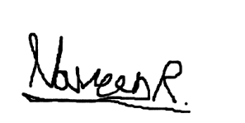
Signature:

………………….
Naveen Rashmika Devinda
GADSE251F-018
Date:
2026.07.27

Supervised by:
Ms. Ashanthi Kurakulasuriya
(Consultant/Lecturer - National Institute of Business Management)

Contents
Chapter 1: Introduction 7
1.1 Introduction of the Organization 7
1.2 Organization Structure 7
1.3 Current Operations in Organization 8
1.4 Users and Responsibilities in Organization 8
1.5 Problem Definition 8
1.6 Project Objectives 9
1.7 Proposed Solution 9
1.8 Chapter Summery 9
Chapter 2: Methodology 10
2.1 Introduction 10
2.2 Data Collection Methods 10
2.3 Software Process Model 10
2.4 Software Development Tools 11
2.5 Testing Strategies 11
2.6 Implementation Plan 11
2.7 Chapter Summary 12
Chapter 3: Analysis 12
3.1 Introduction 12
3.2 UML Diagrams 12
3.2.1 Use Case Diagram of Current System 12
3.2.2 Use case Diagram of Proposed System 13
3.2.3 Class Diagram of Proposed System 14
3.2.4 Sequence Diagrams of Proposed System 15
3.3 ER Diagram of Proposed System 18
3.4 Chapter Summery 18
Chapter 4: Solution Design 19
4.1 Introduction 19
4.2 Interface Design 19
4.3 Database Design 30
4.4 Report Layout Design 35
Chapter 5: Implementation 38
5.1 Introduction 38
5.2 System architecture 38
5.3 Main Coding Areas 39
5.4 Admin Report Implementation 39
Chapter 6: Testing 40
Chapter 7: Conclusion 41
7.1 Achievements 41
7.2 Limitations 41
7.3 Future Developments 41
7.4 Final Conclusion 41
References 42

Figure 1 Organization Structure……………………………………………………………………………………… 7
Figure 2 Use Case Diagram of Proposed System 13
Figure 3 Class Diagram of Proposed System 14
Figure 4 Sequence Diagram for Admin Approve/Reject Listings 15
Figure 5 Sequence Diagram for Admin Approve/Reject Registrations 16
Figure 6 Sequence Diagram for Tourist Booking a Listing 17
Figure 7 ER Diagram of Proposed System 18
Figure 8 Interface 1 19
Figure 9 Interface 3 20
Figure 10 Interface 2 20
Figure 11 Interface 4 21
Figure 12 Interface 5 21
Figure 13 Interface 6 22
Figure 14 Interface 7 22
Figure 15 Interface 9 23
Figure 16 Interface 8 23
Figure 17 Interface 10 24
Figure 18 Interface 11 24
Figure 19 Interface 12 25
Figure 20 Interface 13 25
Figure 21 Interface 14 26
Figure 22 Interface 15 26
Figure 23 Interface 15 27
Figure 24 Interface 16 27
Figure 25 Interface 18 28
Figure 26 Interface 17 28
Figure 27 Interface 19 29
Figure 28 Interface 20 29
Figure 29 report layout 1 35
Figure 30 report layout 2 36
Figure 31 report layout 3 36
Figure 32 report layout 4 37
Figure 33 report layout 5 37
Figure 34 Main classes 38
Figure 35 Welcome message 39
Figure 36 Session class 39
Figure 37 mPDF 39
Chapter 1: Introduction

1.1 Introduction of the Organization
Tourism has become one of the fastest growing industries in Sri Lanka. Every year it keeps growing, according to the Sri Lankan Tourism Development Authority about 2.3 million tourists visited Sri Lanka in last year exceeding previous records.
With this growth a lot of opportunities has created for Sri Lankans including hotel owners, tour guides, shop owners and local experience providers. They offer tourism related services as their main income.
For tourists getting these information become bit hard and tricky due to spread of these info on many platforms.
So I thought of making a centralized platform named “CeylonTourMate.lk” to connect tourists and service providers across Sri Lanka.

1.2 Organization Structure
These are the main roles in the platform
- Admin
- Tourist
- Tour Guide
- Hotel Owner
- Shop Owner
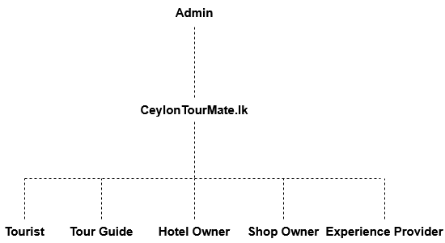
- Experience Provider

Figure 1 Organization Structure

1.3 Current Operations in Organization
Currently information about tour guides, hotels, traditional shops and local experiences in Sri Lanka are spread across multiple platforms like social media, third party booking sites.
Also there isn’t any centralized platform for tourists to get these information from verified local service providers as well as local businesses to list their listings for international audience.

1.4 Users and Responsibilities in Organization

Role | Responsibilities
Admin | Approve/reject partner registrations and listings, manage users, set commission and listing fee rates, monitor bookings, generate reports
Tourist | Search/browse listings, make bookings, send messages to partners, write reviews, complete payments
Tour Guide | Manage listings, set availability, handle bookings, communicate with tourists, view earnings
Hotel Owner | Manage listings, manage rooms availability, handle bookings, communicate with tourists, view earnings
Shop Owner | Manage listings, set operating hours, pay monthly listing fees, reply to messages
Experience Provider | Manage listings, set availability, handle bookings, communicate with tourists, view earnings

1.5 Problem Definition
At the moment tourists who visit Sri Lanka face several challenges.
- Overpriced and unlicensed guides- Tourists specially first time visitors sometimes meet overpriced or unlicensed guides who try to overcharge or scam them, which is going to be a bad experience for them.
- Hidden places- Sri Lanka has many small villages and attraction places that are not included on current tourism platforms, leaving tourist not knowing information about them.
- Language barrier- this is the most common issue when it comes to traveling. Not every Sri Lankan can speak English as well as every tourist can speak Sinhala and Tamil. This can be bit challenging when getting a service.
- Finding services- Common services like transportation, places to stay and experiences are now spread over many platforms and it can be difficult for both tourists and people who are willing to provide these services.

1.6 Project Objectives
My project objectives are,
- To develop and design a centralized platform to connect tourists with verified local Hotel/Villa owners, Tour guides, Shop owners and Experience providers in Sri Lanka.
- To give small local business a chance to list their listing to the international audience.
- To minimize the risk of tourists getting scammed and making it easy to get those services through one trusted platform.
- To earn from the platform by getting a commission from bookings and listing fee from shop listings.

1.7 Proposed Solution
CeylonTourMate.lk is a centralized platform that built for the Sri Lankas tourism industry that provides all kinds of trustworthy information about local services to tourists.

1.8 Chapter Summery
In this chapter I introduced my project, CeylonTourMate.lk along with the problem of current industry. With the growing of tourism industry, for problems faced by tourists and locals, and as a solution for that I proposed a centralized platform to connect them all.

Chapter 2: Methodology

2.1 Introduction
In this chapter im going to describe how I gather information for my project and approaches I used to develop it. This covers data collection, software development model, tools I used, technologies and testing methods.

2.2 Data Collection Methods
Since my project is a self created project rather than a sponsored one, I had to do following methods to collect data.
- Current market analysis – I did reviews on existing tourism platforms, gathered information from Sri Lankan Tourism Development Authority, viewed attractional places on google maps, and read articles to understand the current gap in the industry.
- Personal knowledge and observation – I found current tourists problems on social media like unlicensed guides, language barrier , etc.. and had a common knowledge of other challenges to tourists.
- Supervisor consultations – since the project started I had meetings with my supervisor Ms.Ashanthi Kurakulasuriya got feedbacks and recommendations throughout development of the project.

2.3 Software Process Model
To develop CeylonTourMate.lk I used the Waterfall Method, which is a clear, structured way to develop, since I had a clear idea of my project and its requirements.
The stages of the waterfall method are,
- Requirements Analysis – in this stage I gathered all the requirements for the system and made the SRS document.
- System Design – in this stage I designed all the diagrams.
- Coding – in this stage I started to coding the platform.
- Testing – in this stage I tested my system.
- Deployment – in this stage I hosted my web on a live server.

2.4 Software Development Tools
Category | Tool
Frontend | Notepad++(HTML,CSS,JS)
Backend | Notepad++(PHP)
Database | MySQL(PhpMyAdmin)
Local Server | XAMPP
Code Editor | Notepad++
Version Control | GitHub
Documentation | Microsoft Word
Diagramming | Draw.io
Report Generation | mPDF

2.5 Testing Strategies
I applied following testing strategies to my project.
- Unit Testing – using this I tested individual php files to confirm their work.
- Functional Testing – tested each functions in the system to confirm their work.
- Validation Testing – tested all form inputs and validations.
- Regression Testing – after found some bugs I fixed them and retested them.

2.6 Implementation Plan
My implementation plan was as following order.
- Gathering all the requirements and making the SRS document
- Use case diagram drawing
- ER diagram designing
- Class diagram designing
- Made the database in MYSQL as the ER diagram
- Coded all the classes like in class diagram
- Made the Main interface home.html
- Admin panel coding with all other interfaces
- Tourist panel coding with all other interfaces
- Tour guide panel coding with all other interfaces
- Shop Owner panel coding with all other interfaces
- Hotel Owner panel coding with all other interfaces
- Experience Provide panel coding with all other interfaces
- Testing bug fixing
- Final report documentation and presentation making

2.7 Chapter Summary
In this chapter I described how I gathered my data to develop my project, software development model, tools I used for development and documentation, testing strategies, and overall methodology of my project.

Chapter 3: Analysis

3.1 Introduction
In this chapter im going to present my analysis I did for CeylonTourMate.lk, including usecase diagram, class diagram, sequence diagram and ER diagram. These diagrams show how the platform works and its database works.

3.2 UML Diagrams

3.2.1 Use Case Diagram of Current System
Since I made this project to fill a gap in the industry, where services are currently spread across multiple platforms, there is not any current system.

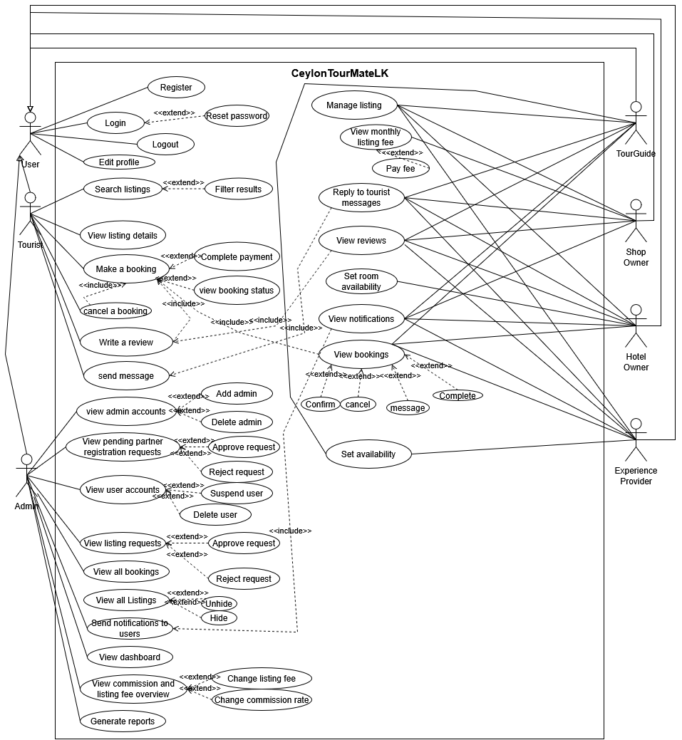
3.2.2 Use case Diagram of Proposed System
Figure 2 Use Case Diagram of Proposed System

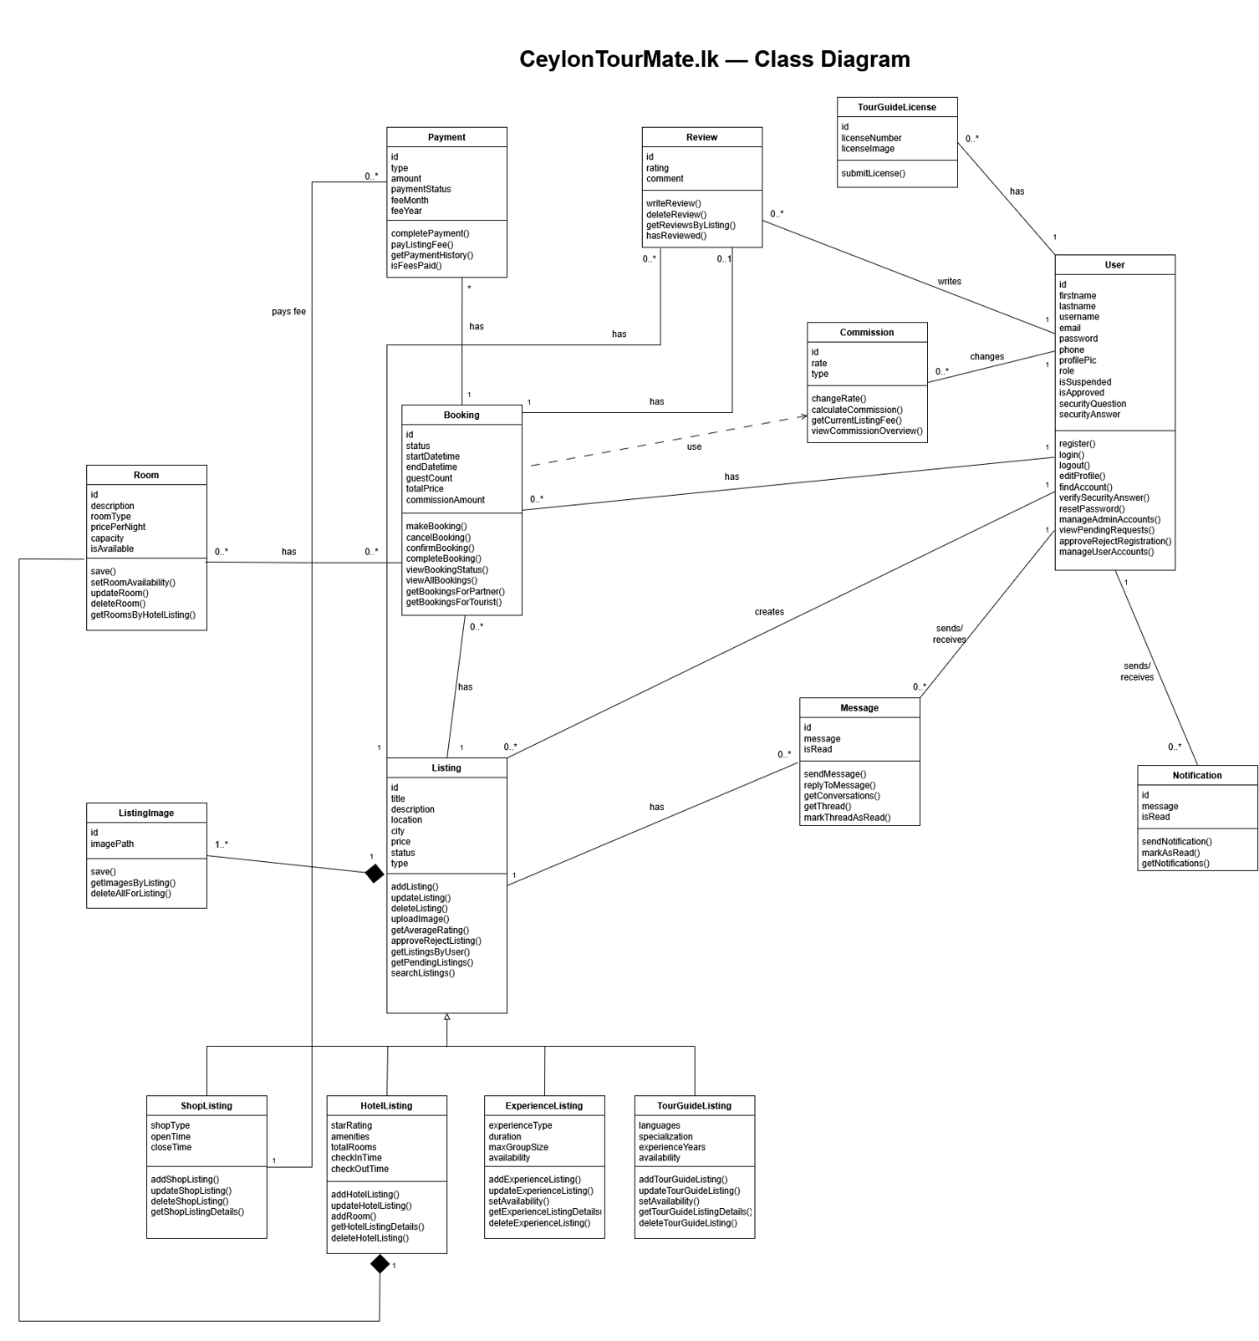
3.2.3 Class Diagram of Proposed System
Figure 3 Class Diagram of Proposed System

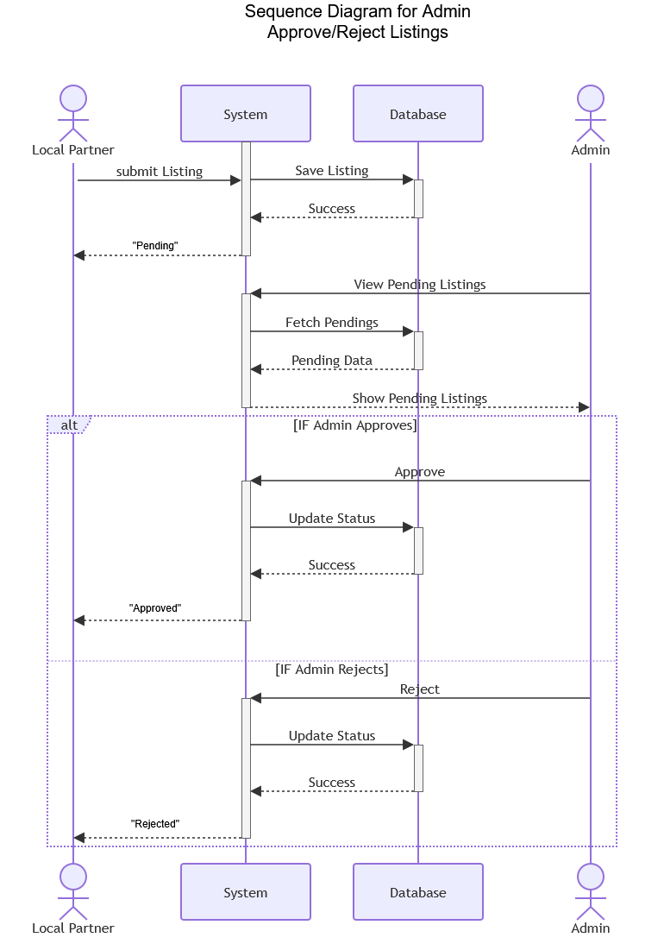
3.2.4 Sequence Diagrams of Proposed System

Figure 4 Sequence Diagram for Admin Approve/Reject Listings

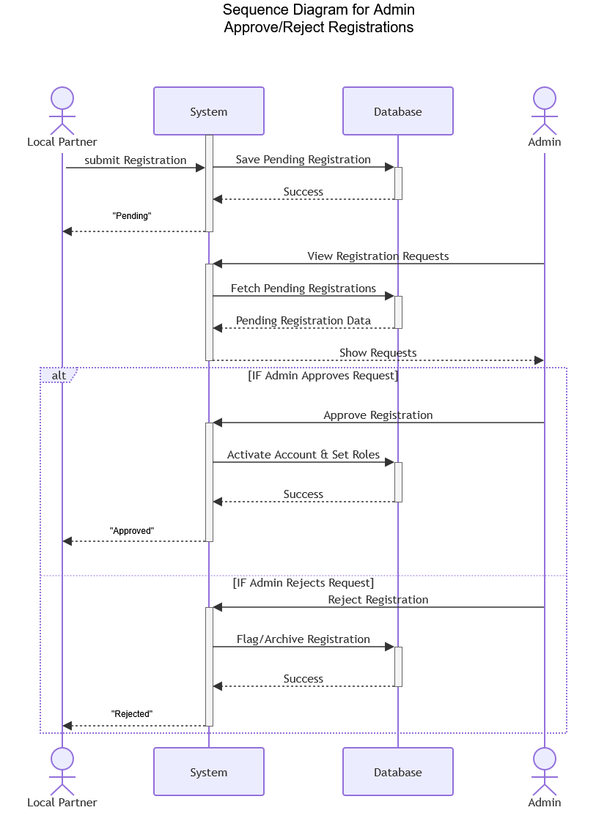

Figure 5 Sequence Diagram for Admin Approve/Reject Registrations

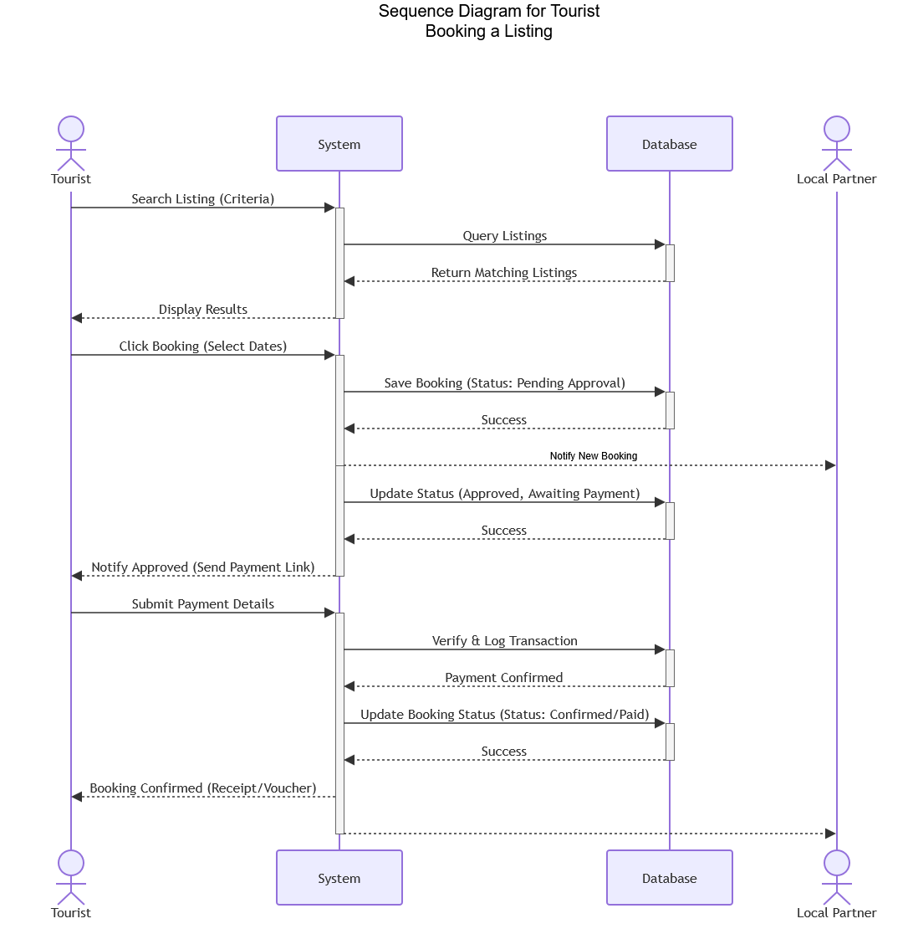
Figure 6 Sequence Diagram for Tourist Booking a Listing

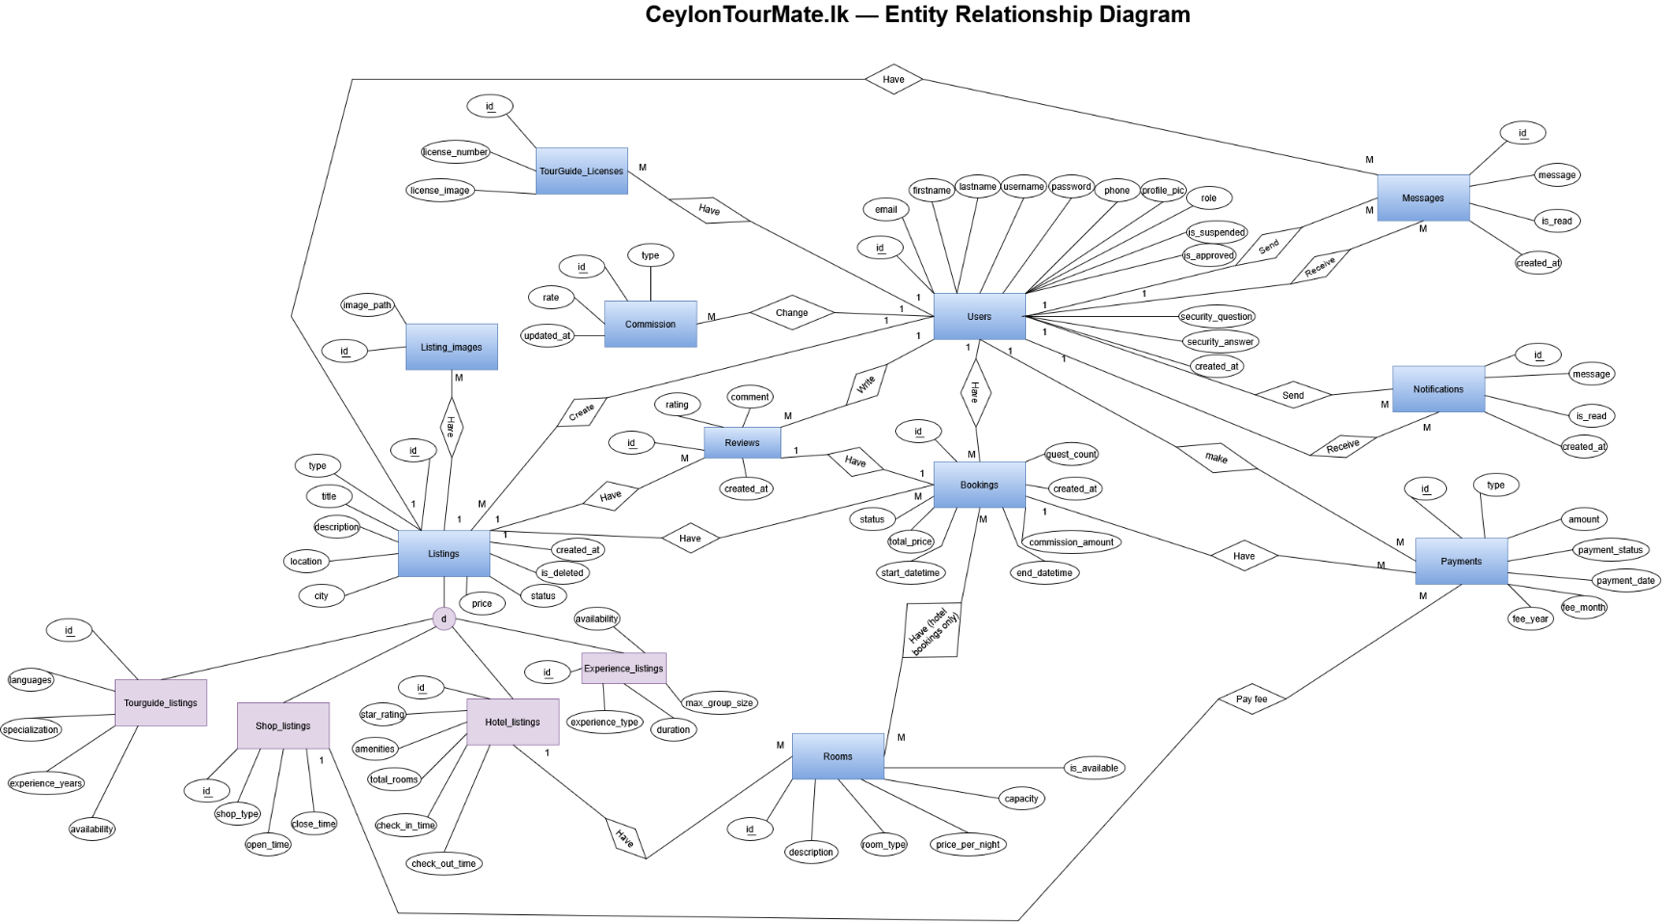
3.3 ER Diagram of Proposed System
Figure 7 ER Diagram of Proposed System

3.4 Chapter Summery
In this chapter I presented all of my diagrams including usecase, class, sequence and ER. These represent the analysis and modeling stage my CeylonTourMatelk.Use case diagram describes the system actors and their interactions, class diagram describes system’s OOP classes, sequence diagram describes the flow of each use case and finally ER diagram describes the database design.

Chapter 4: Solution Design

4.1 Introduction
In this chapter im going to present the design of the proposed solution for CeylonTourMateLK, which include all interface designs, database design, and the report layouts.

4.2 Interface Design
- INT-01 Home Page – Landing page of the platform
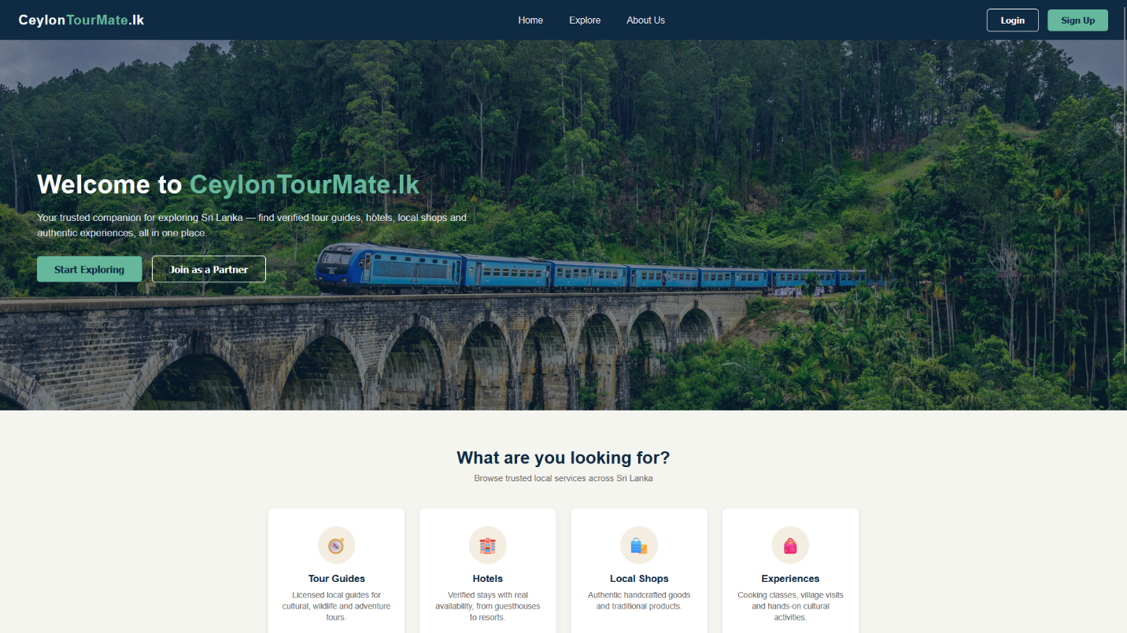
Figure 8 Interface 1

- INT-02 Registration Page – allow all users to register in the platforms, for local partners admin approval required.

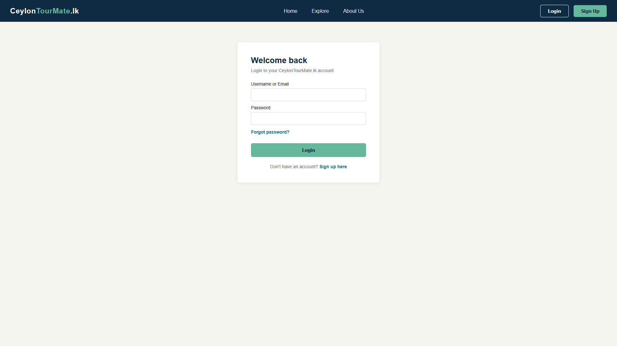
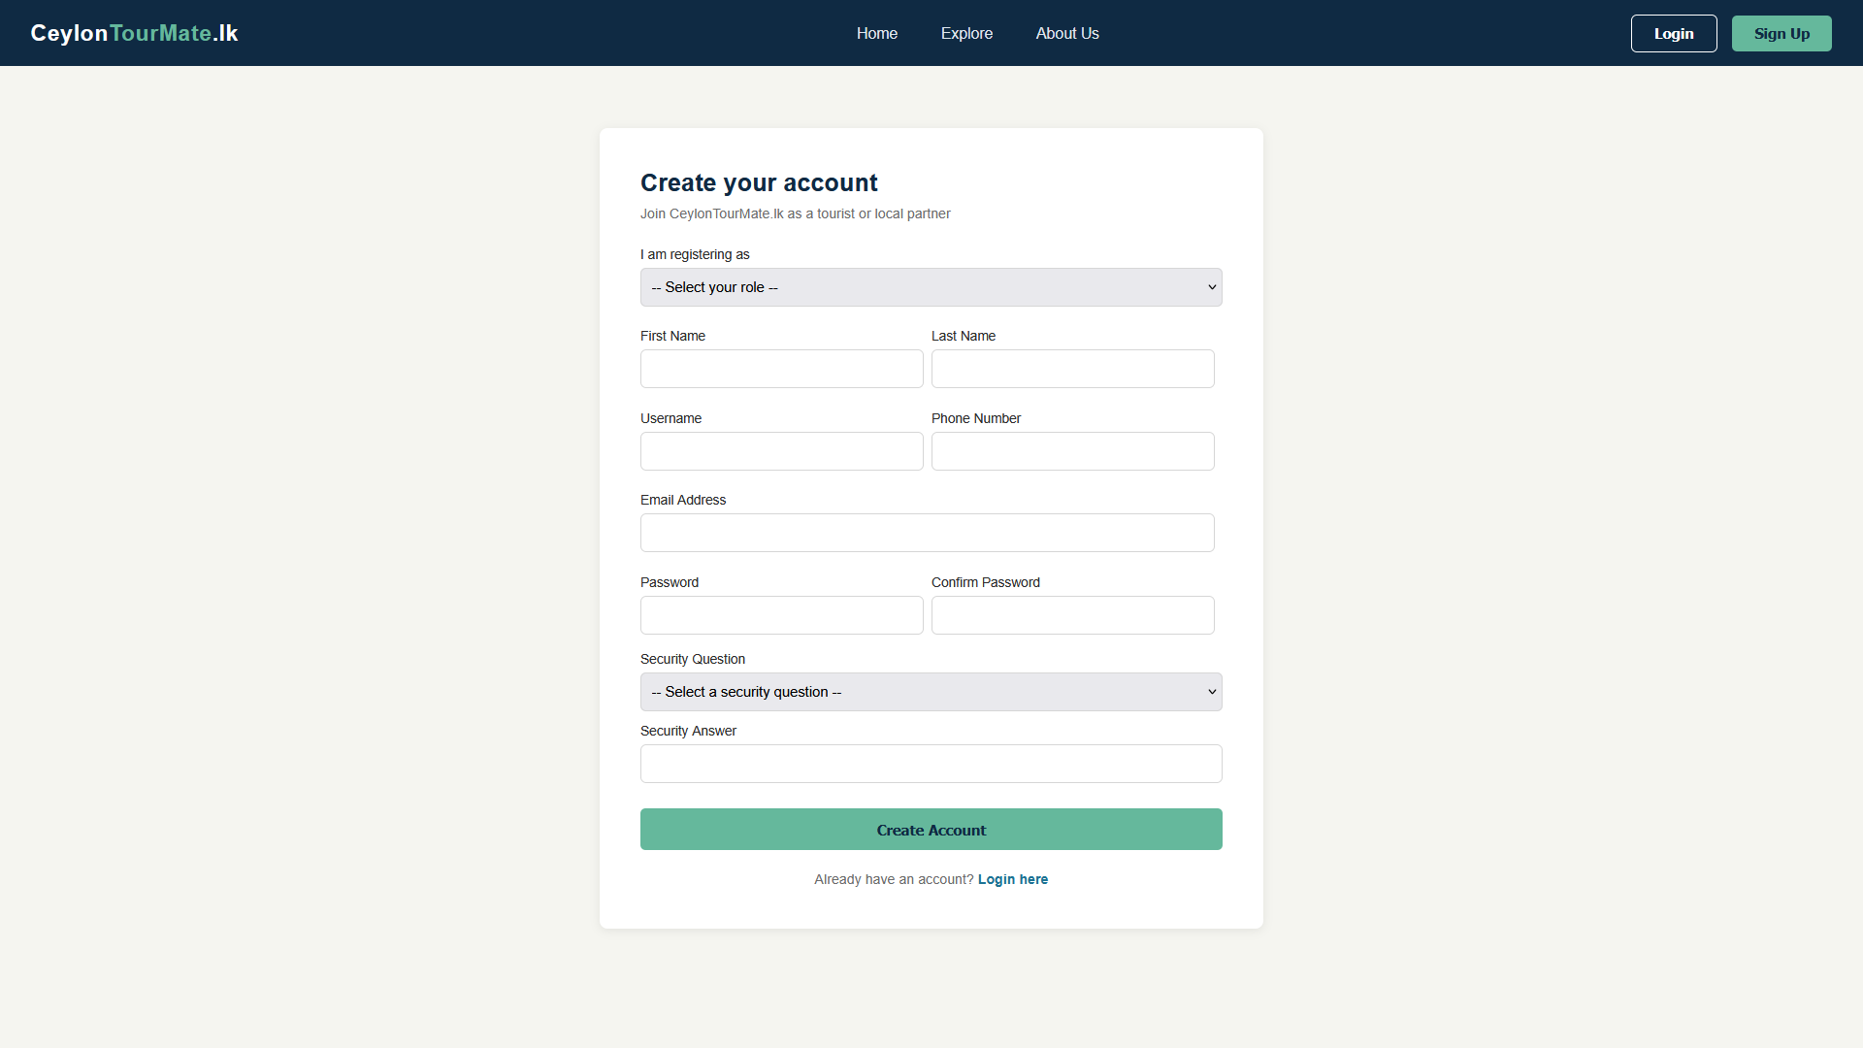
- INT-03 Login page – allows users to login to the system, role based login.
Figure 9 Interface 3
Figure 10 Interface 2

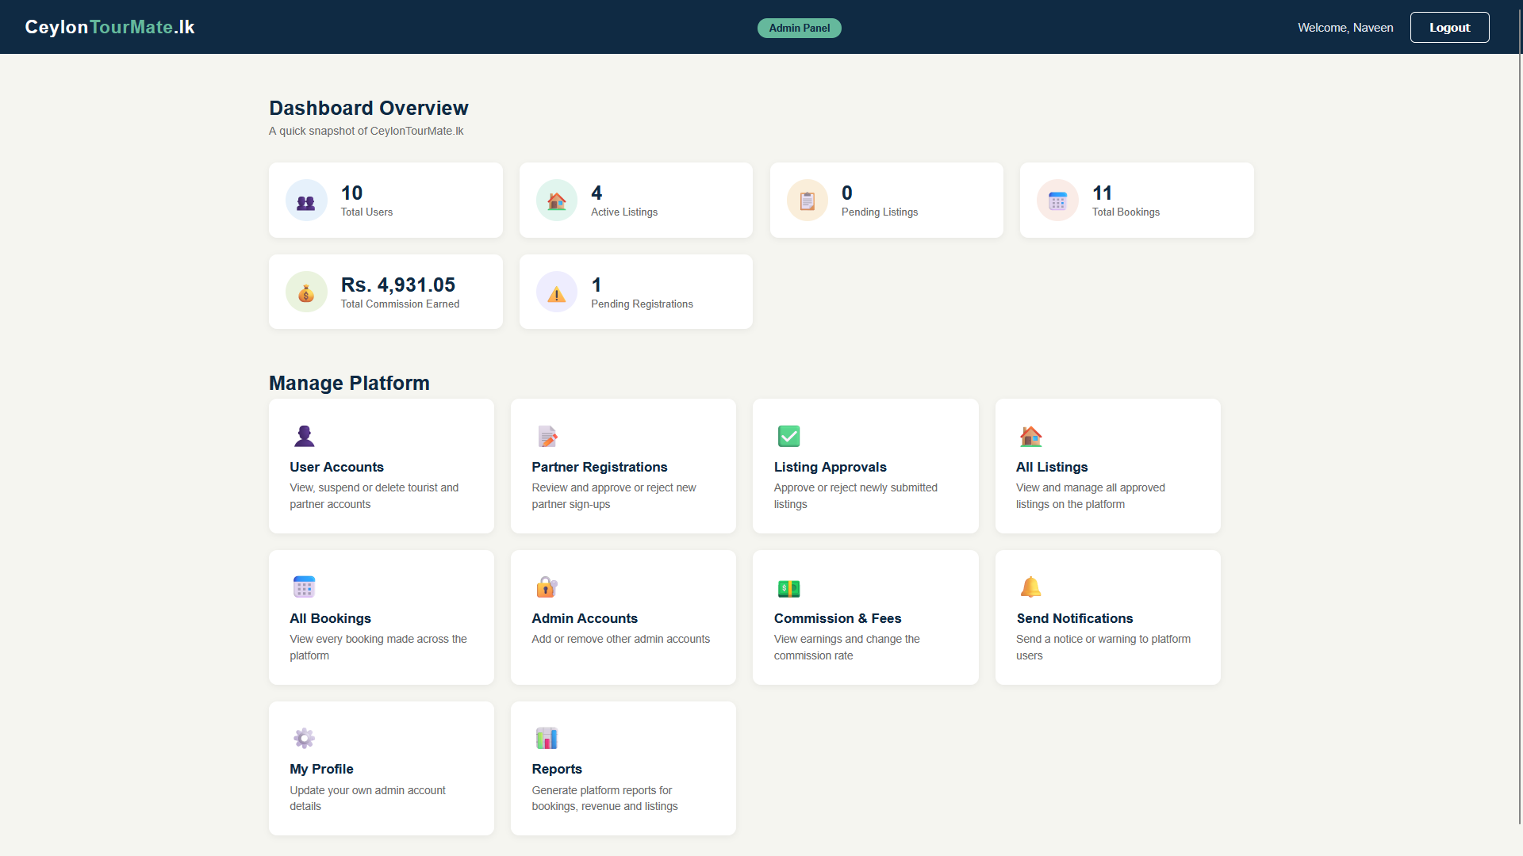
- INT-04 Admin dashboard – where admin can see his dashboard and other controls.
Figure 11 Interface 4

- INT-05 User Accounts – Admin can manage user accounts
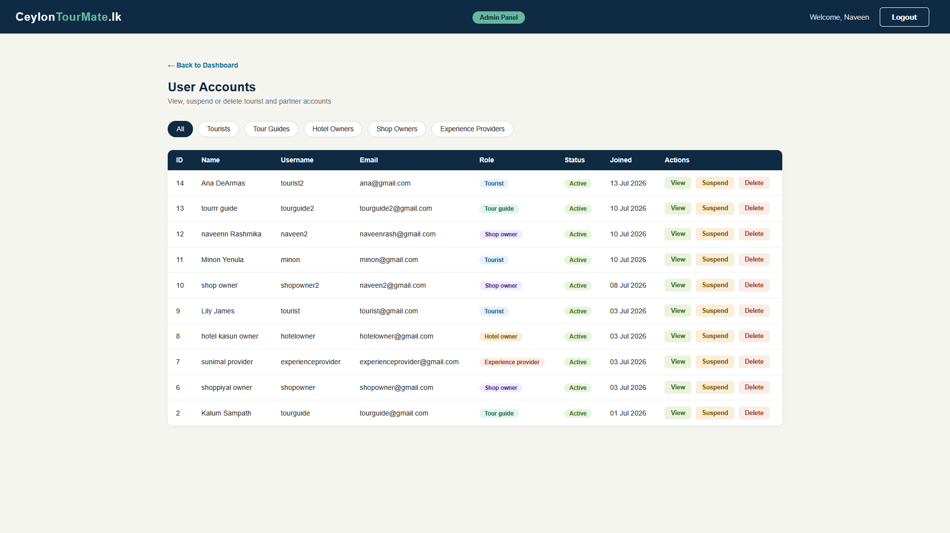
Figure 12 Interface 5

- INT-06 Parter registrations – admin can manage parter registrations

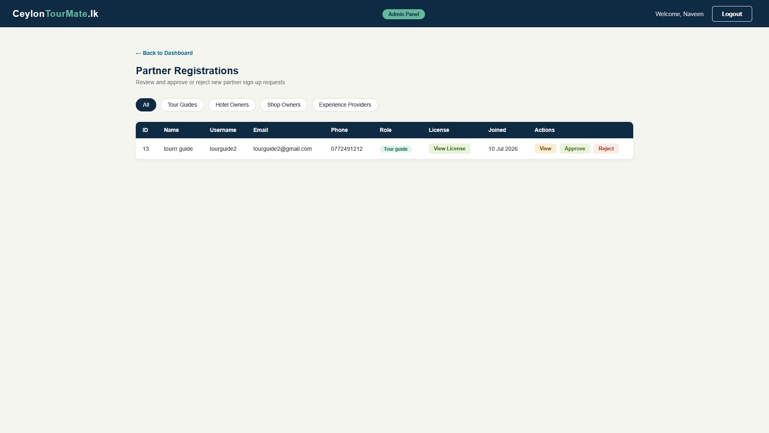
- INT -07 Listing approvals – admin can manage partner listings
Figure 13 Interface 6
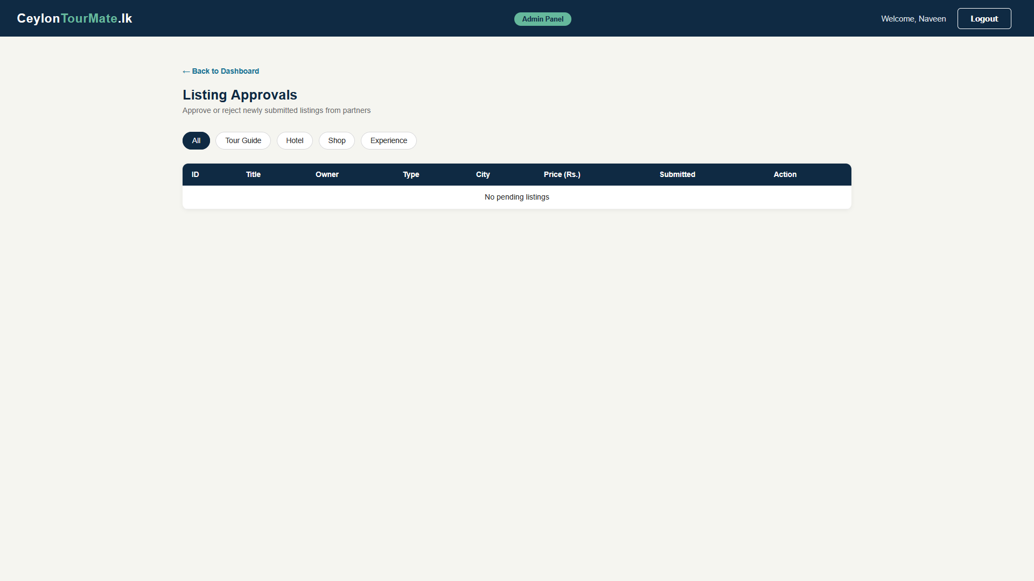
Figure 14 Interface 7

- INT -08 All listings – admin can manage partner listings

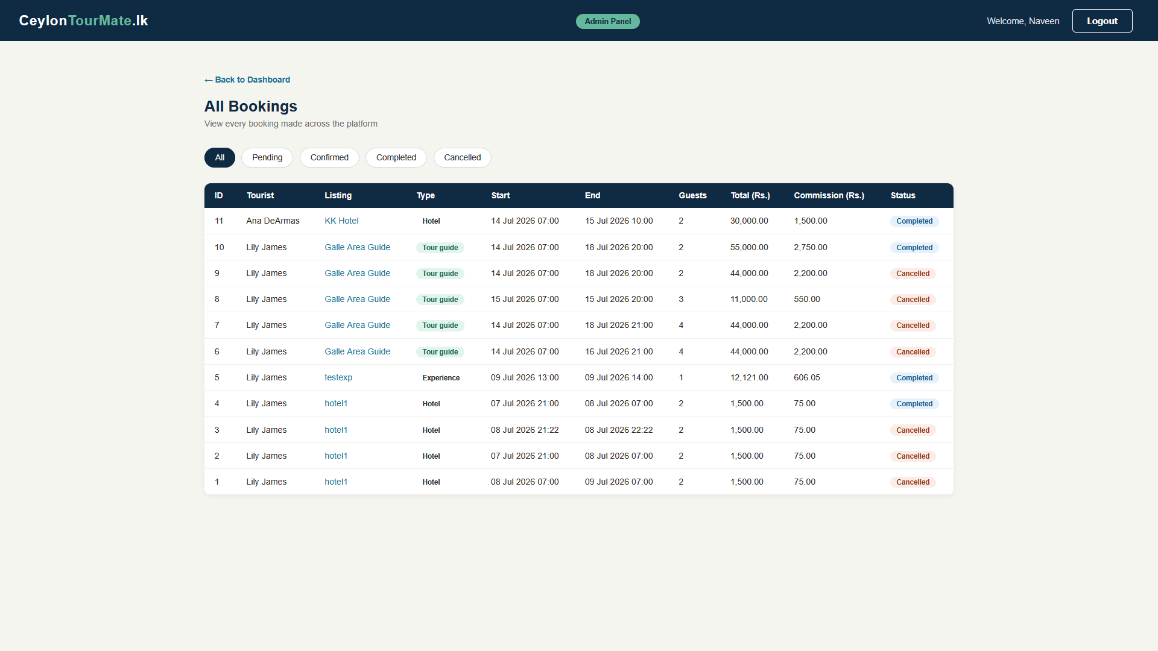
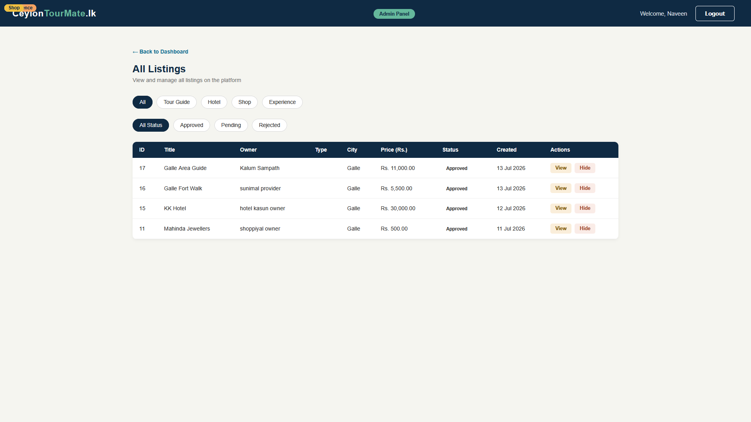
- INT -09 All bookings – admin can view all bookings in the system
Figure 15 Interface 9
Figure 16 Interface 8

- INT -10 Admin accounts -admin can manage admin accounts

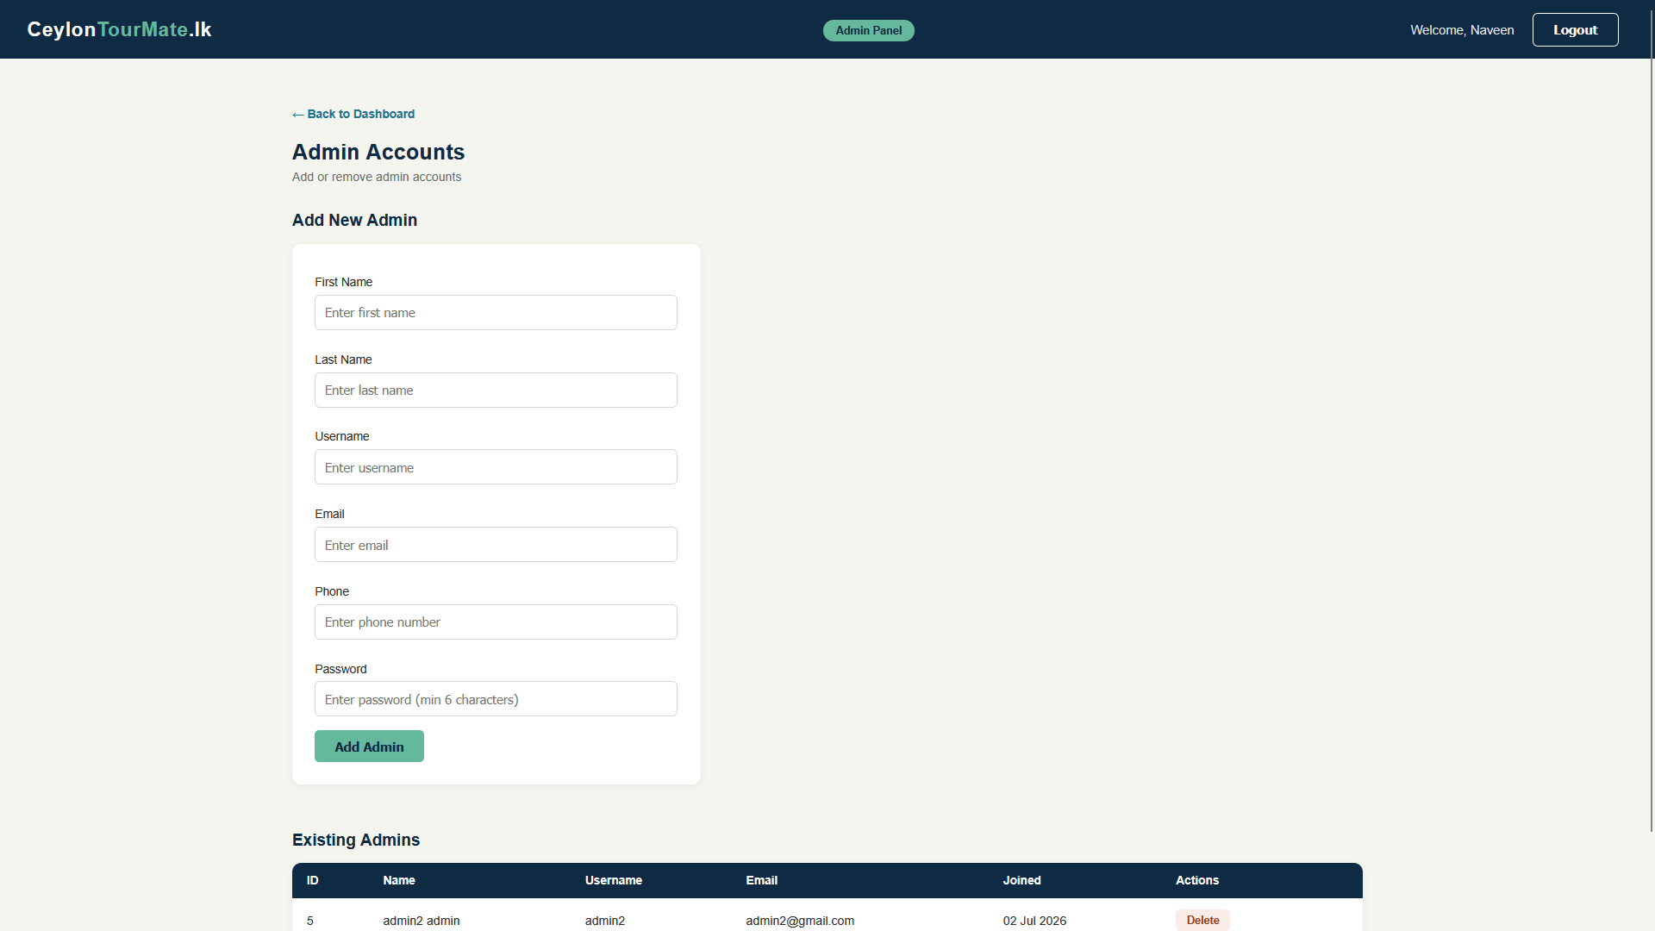
- INT -11 Commission fee overview – admin can view current com rates and manage them
Figure 17 Interface 10
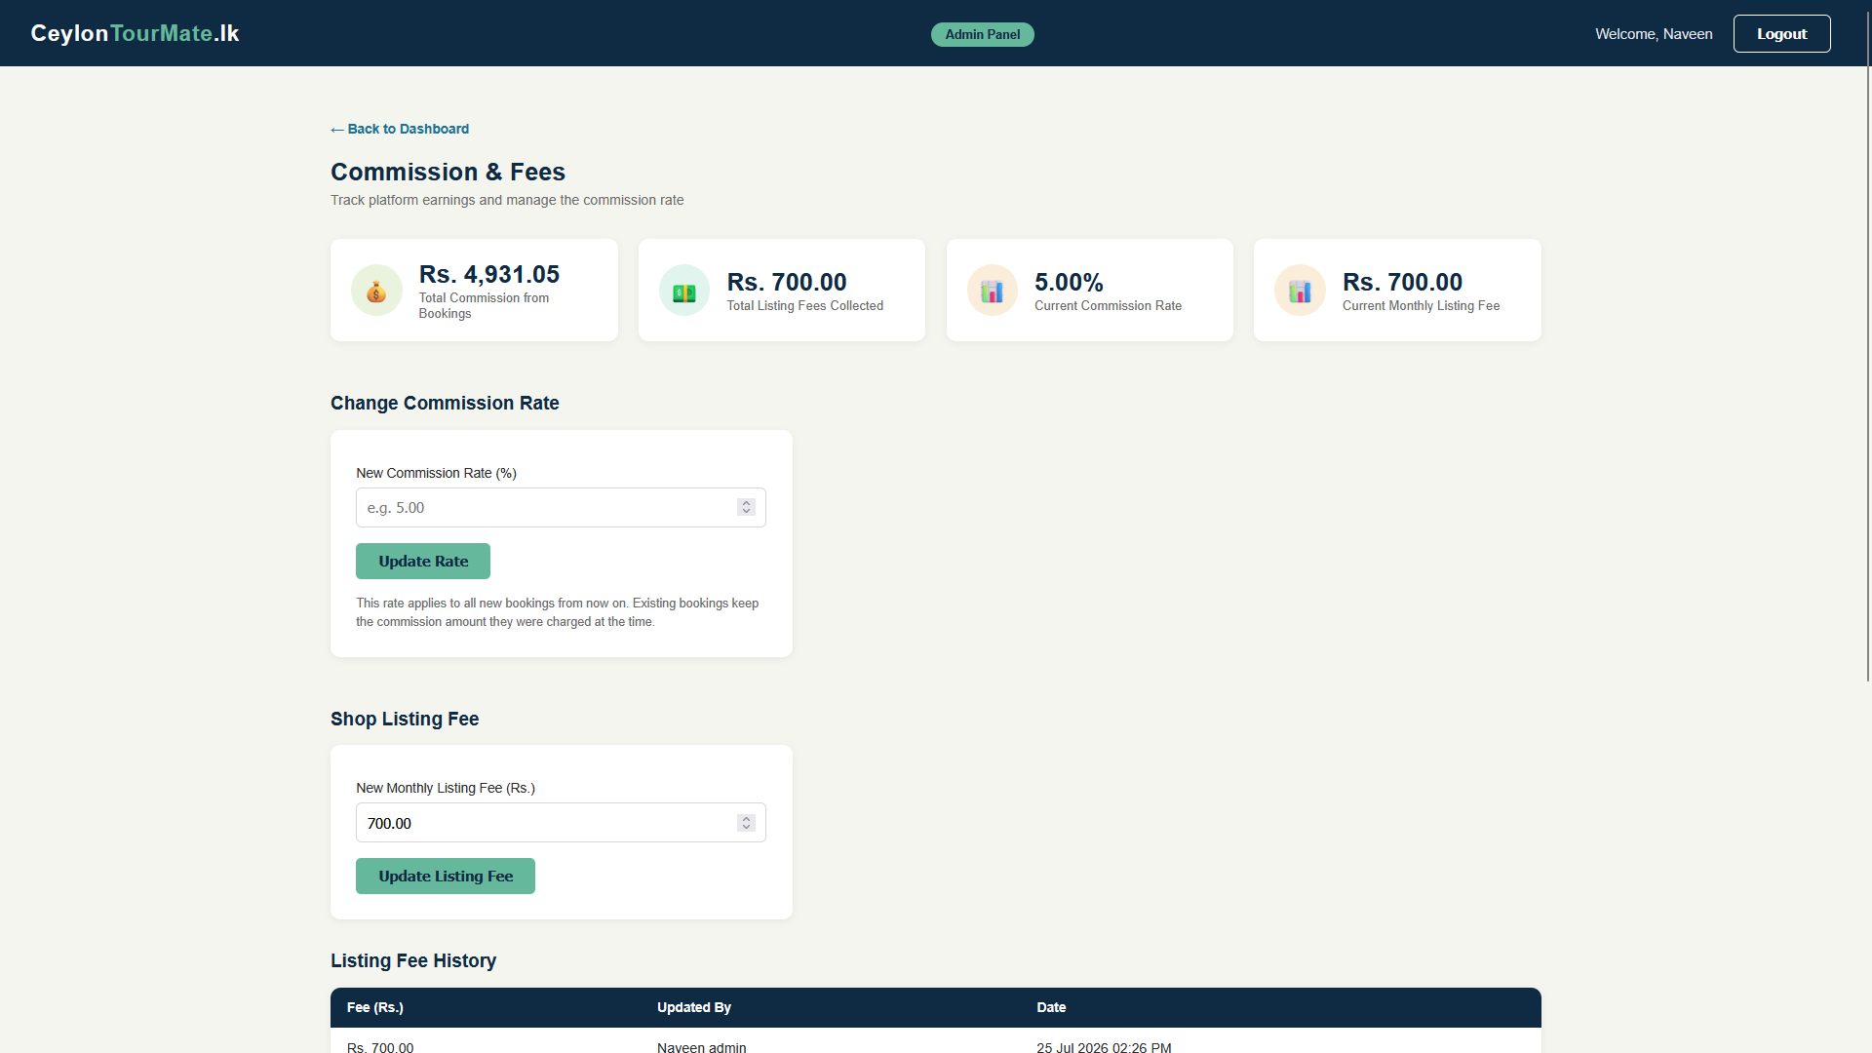
Figure 18 Interface 11

- INT -12 Send notification – Admin can send notifications to users

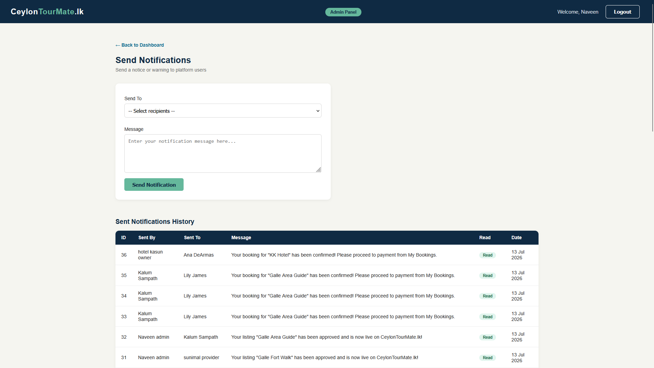
- INT -13 My profile – users can change their profile (same interface for everyone)
Figure 19 Interface 12
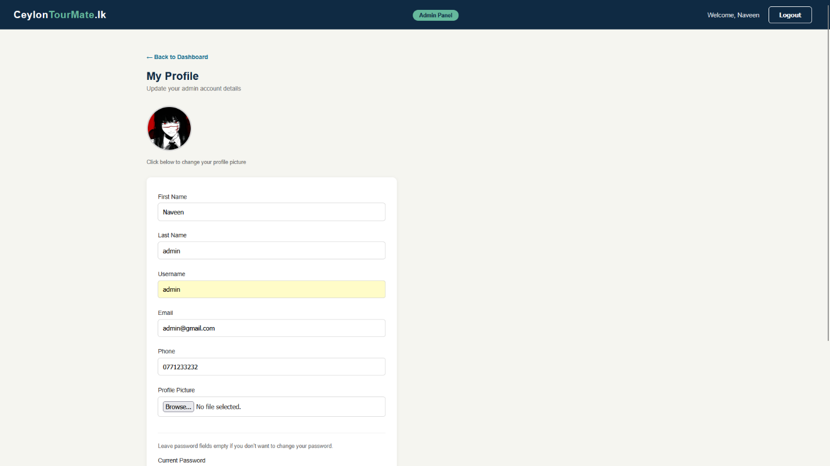
Figure 20 Interface 13

- INT -14 Reports – Admin can generate reports

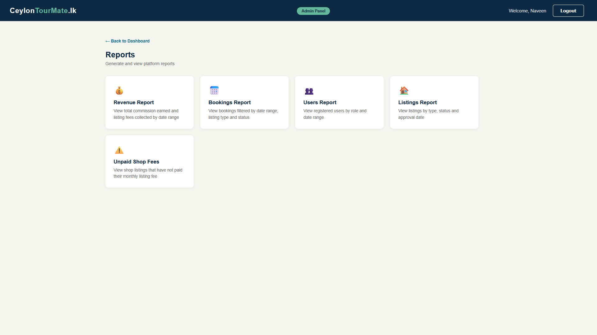
- INT -14 Experience provider dashboard
Figure 21 Interface 14
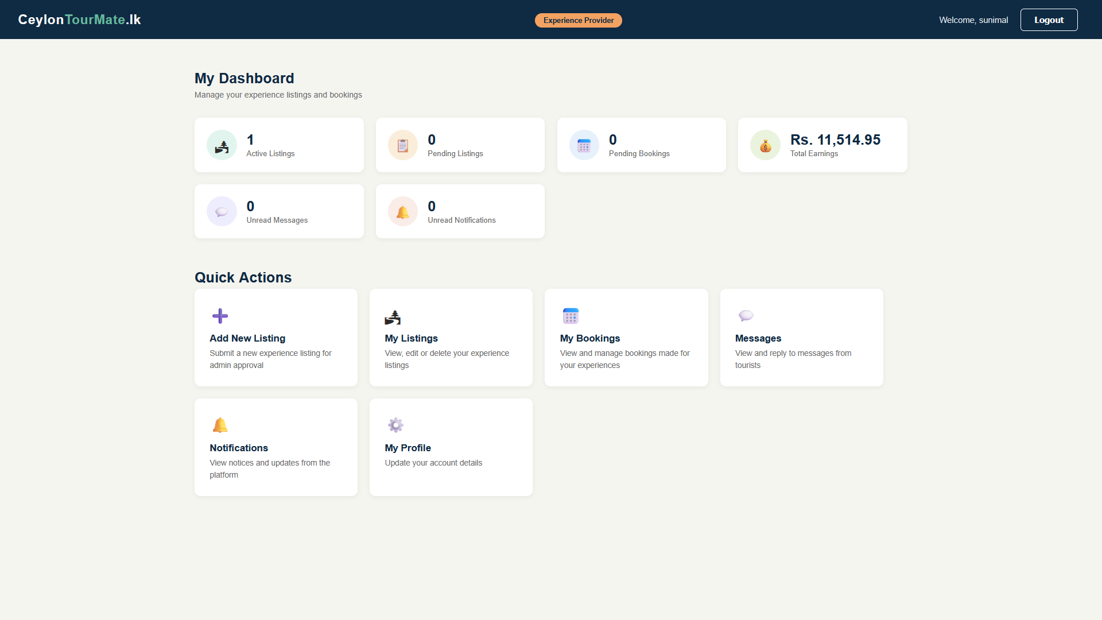
Figure 22 Interface 15

- INT -15 Hotel owner dashboard

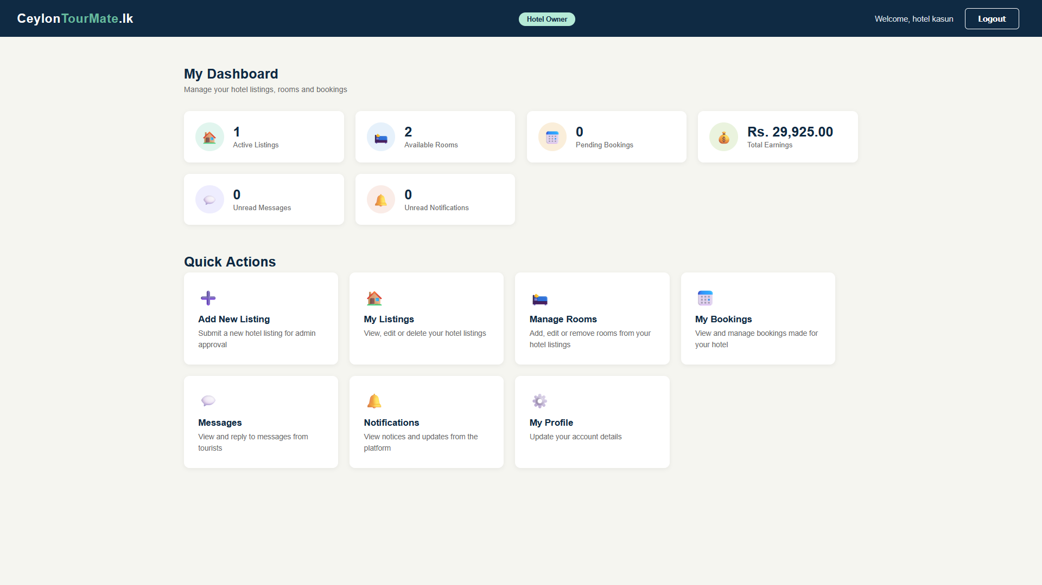
- INT -16 Shop owner dashboard
Figure 23 Interface 15
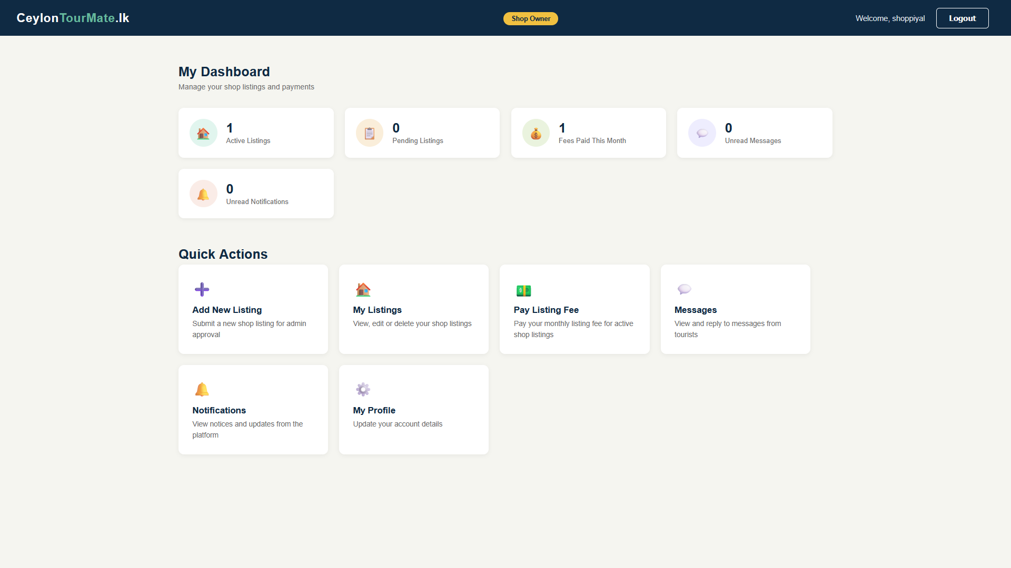
Figure 24 Interface 16

- INT -17 Tour guide dashboard

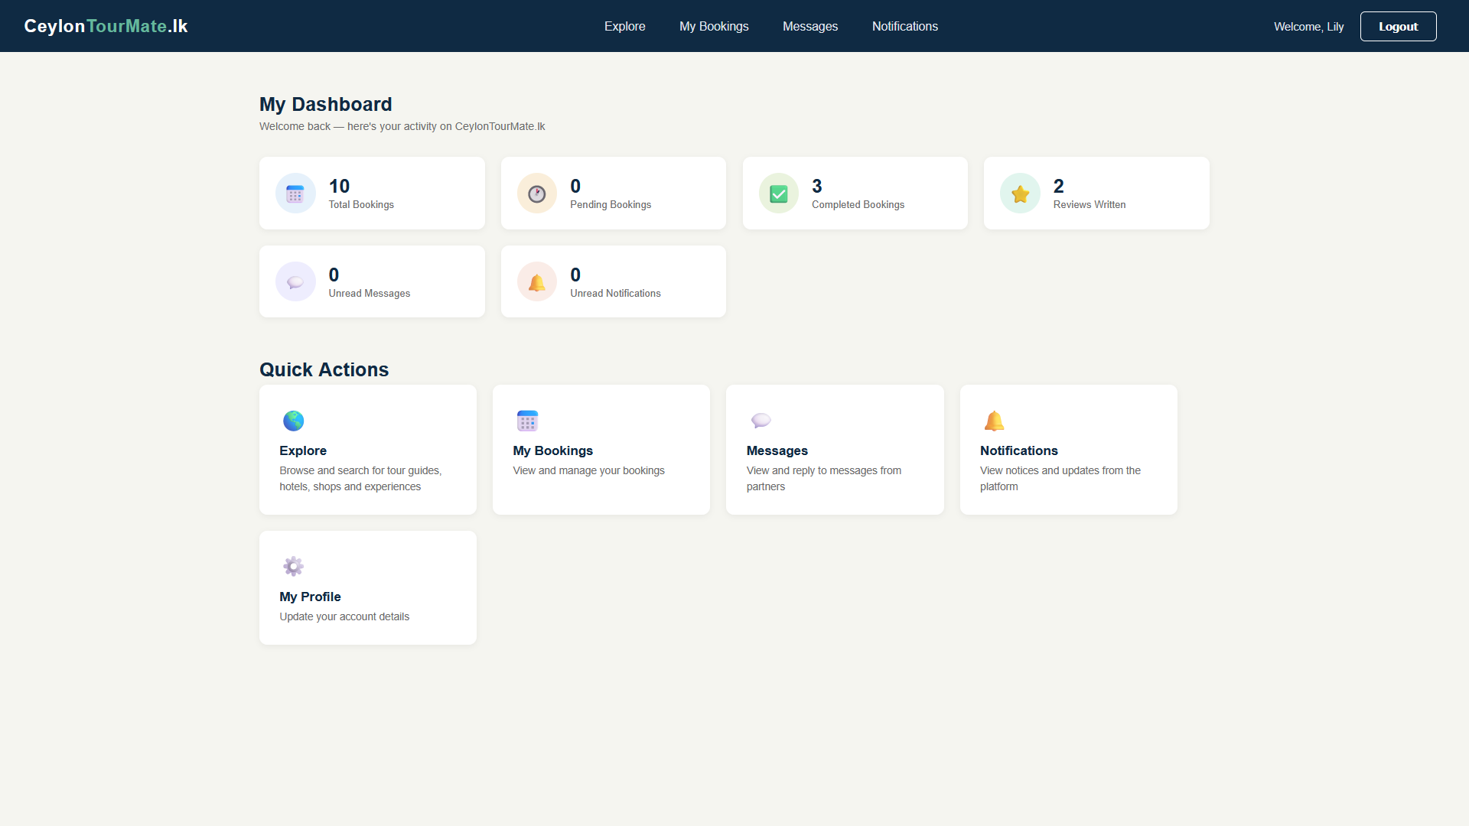
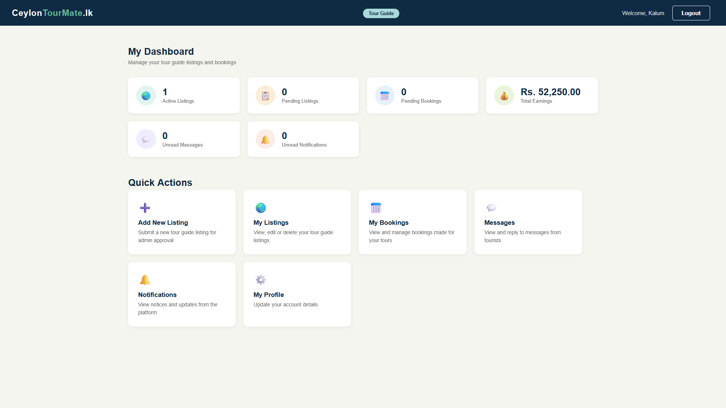
- INT -18 Tourist dashboard
Figure 25 Interface 18
Figure 26 Interface 17

- INT -19 Explorer page – Tourist can explore services

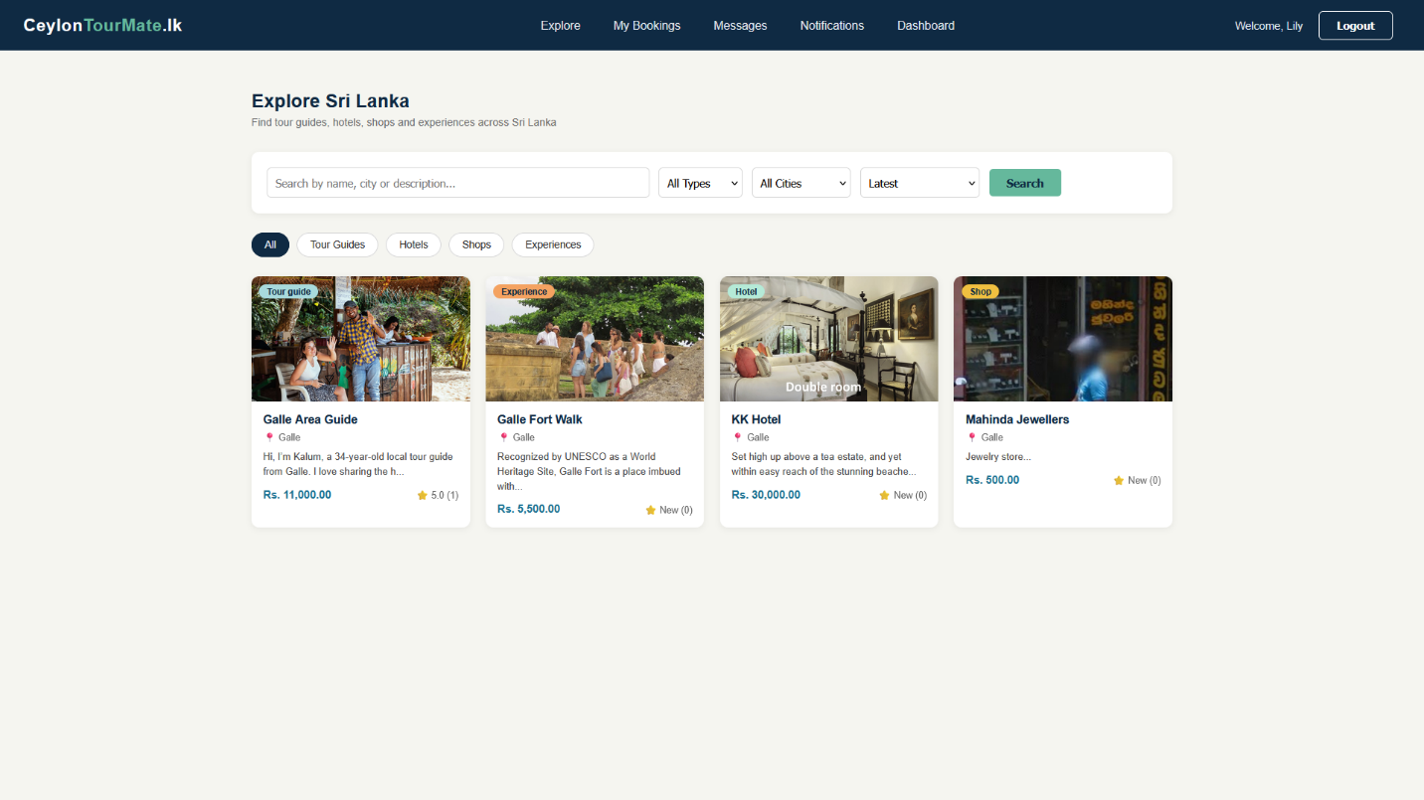
- INT -20 Tourist booking page
Figure 27 Interface 19
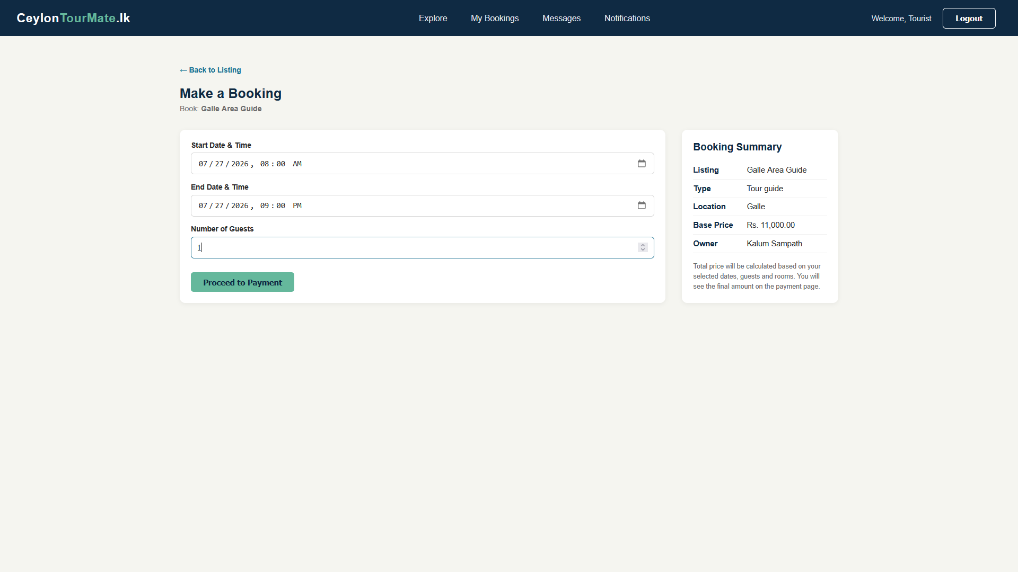
Figure 28 Interface 20

4.3 Database Design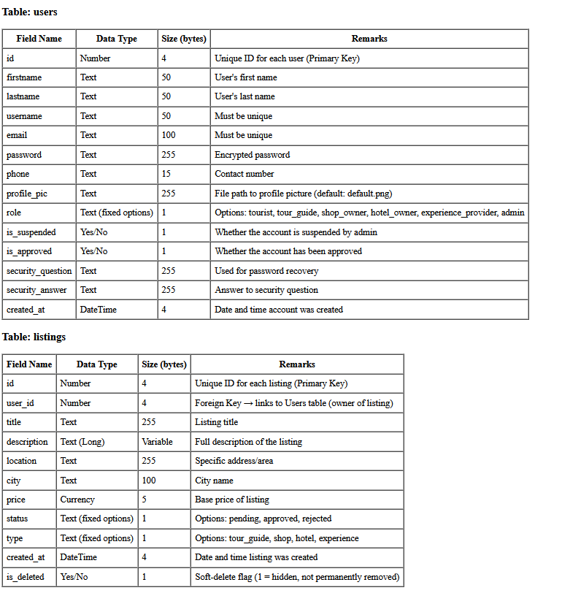
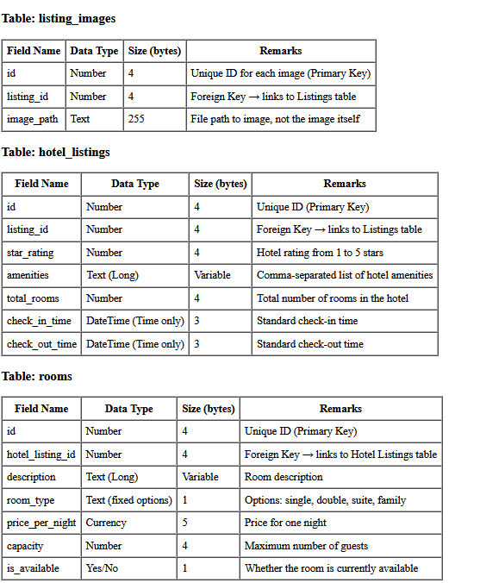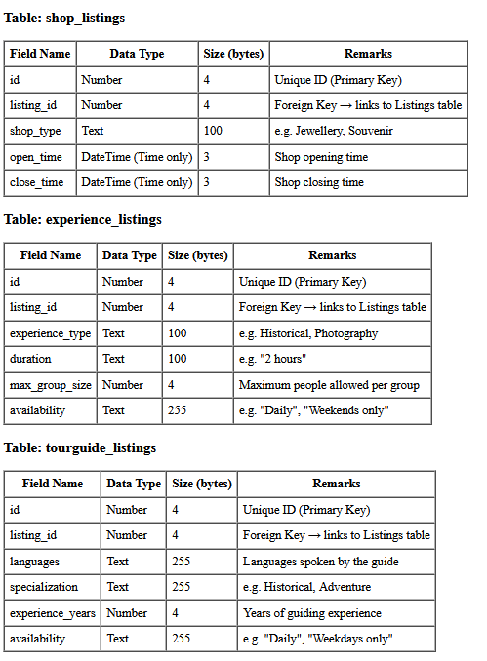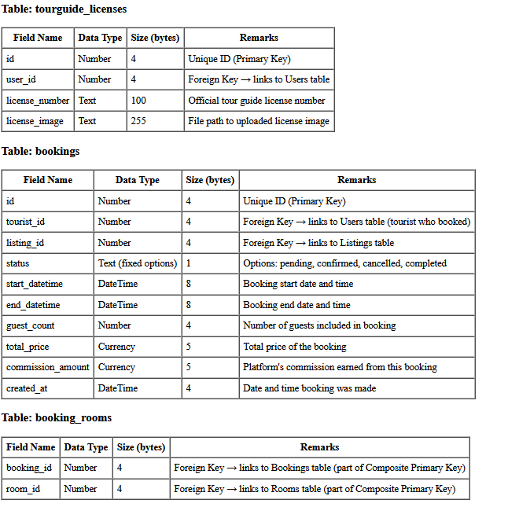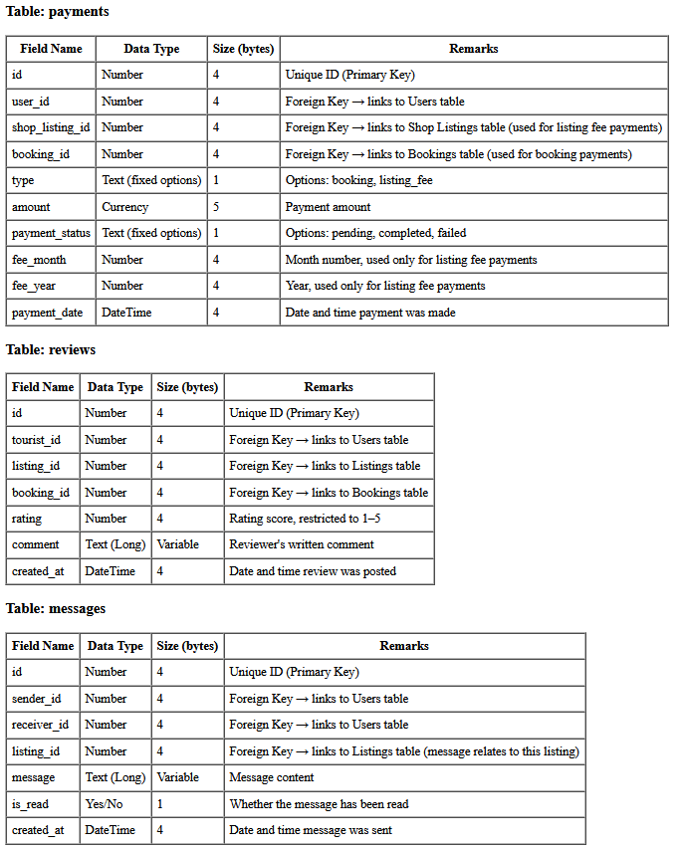

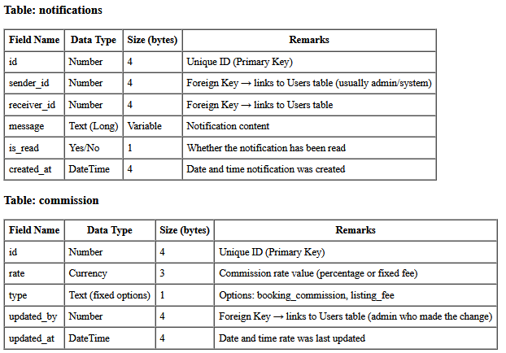

4.4 Report Layout Design
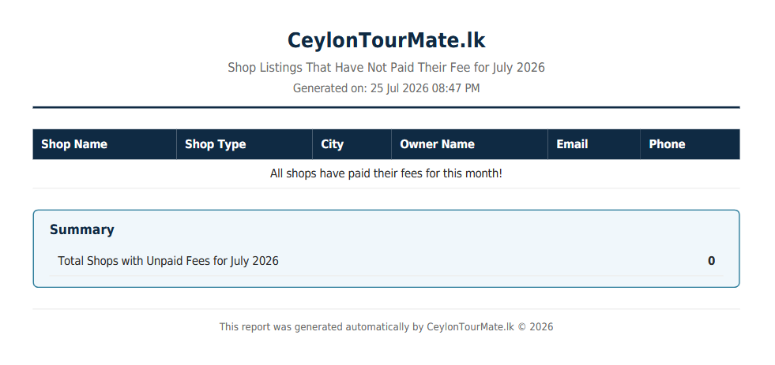
- RL-01 Shop listing report fee report – admin can view shop listings that have not paid the listing fee.
Figure 29 report layout 1

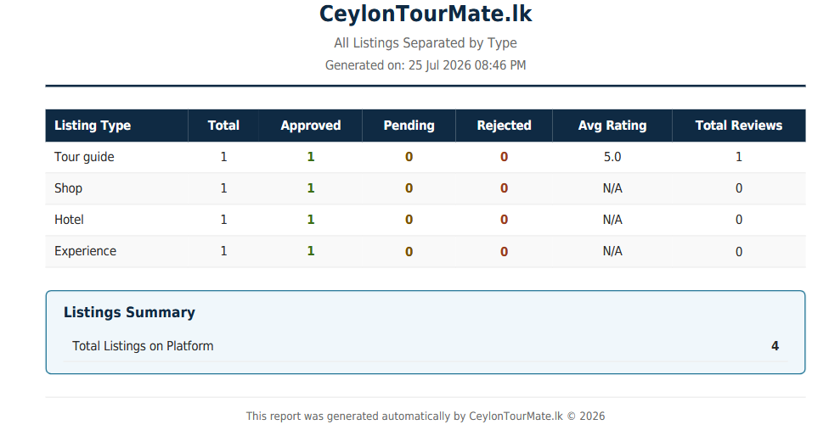
- RL-02 All listings report- admin can view all listing by type
Figure 30 report layout 2

- RL-03 All users reports – admin can view all user count on the platform by role

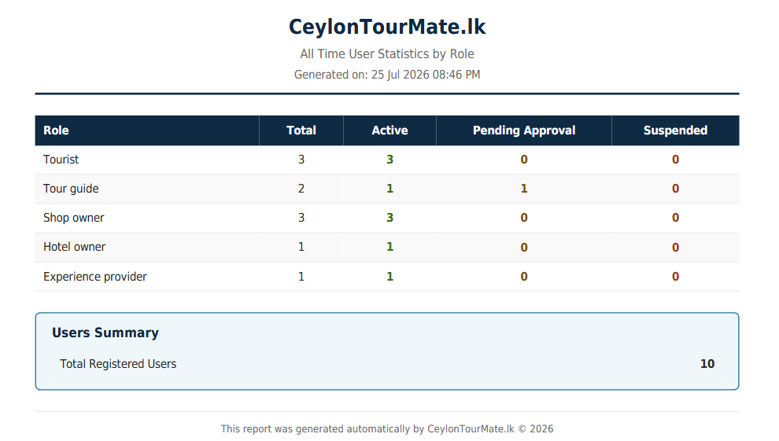
Figure 31 report layout 3

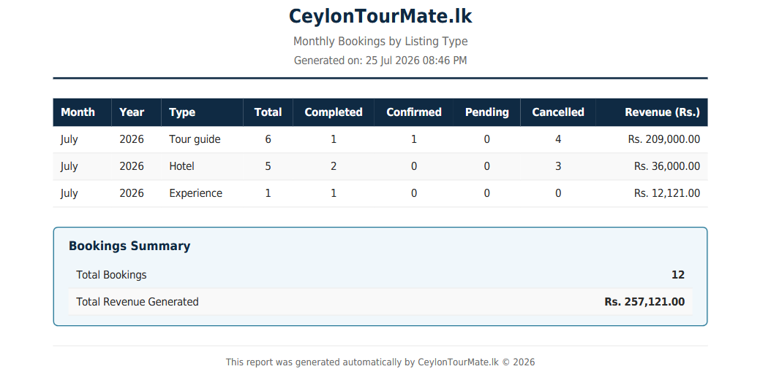
- RL-04 Monthly bookings report- admin can view all monthly bookings
Figure 32 report layout 4

- RL-05 Revenue report – admin can view the total platform’s revenue.
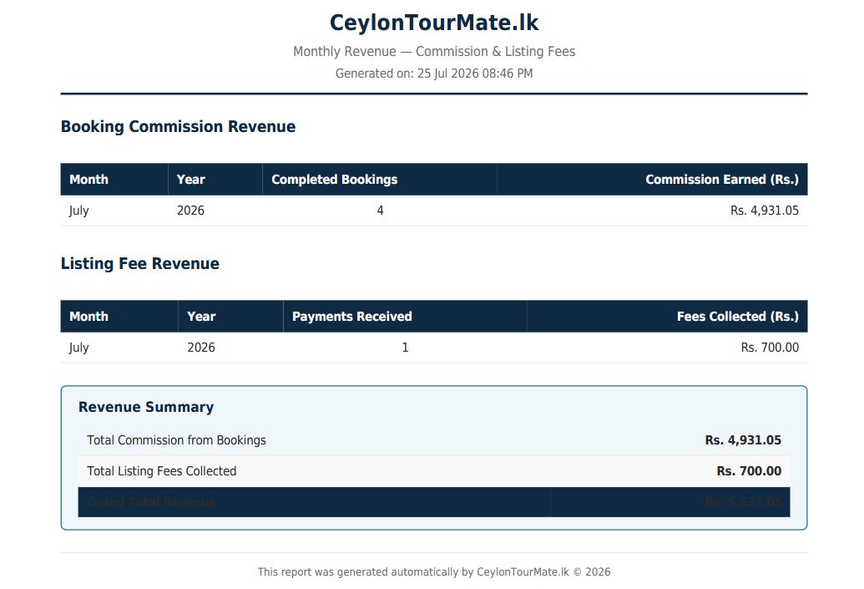
Figure 33 report layout 5

Chapter 5: Implementation

Introduction
In this chapter im going to explain the main implementation of my project, which covers system architecture, main classes and decisions I made during the coding part.

System architecture
As the architecture I used 3 tier architecture for the development of CeylonTourMateLK with OOP phps and MYSQL database.
My main classes are as follows,
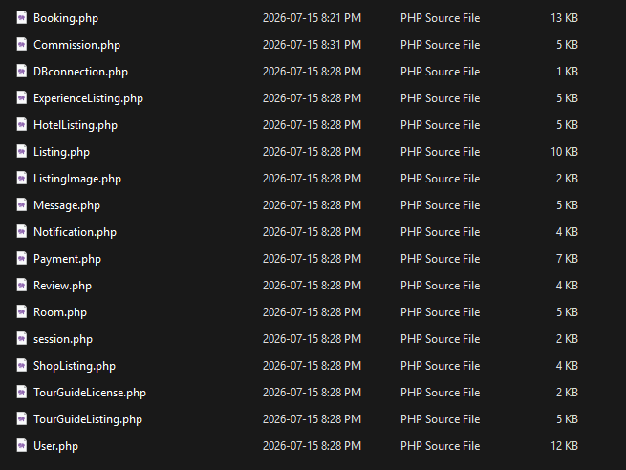

Figure 34 Main classes

Main Coding Areas
I used a session class to hold logged in users session information, which I use it to show a welcome message at the top of the platform.

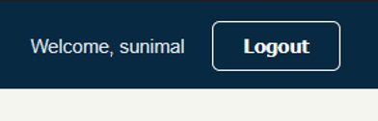
Figure 35 Welcome message

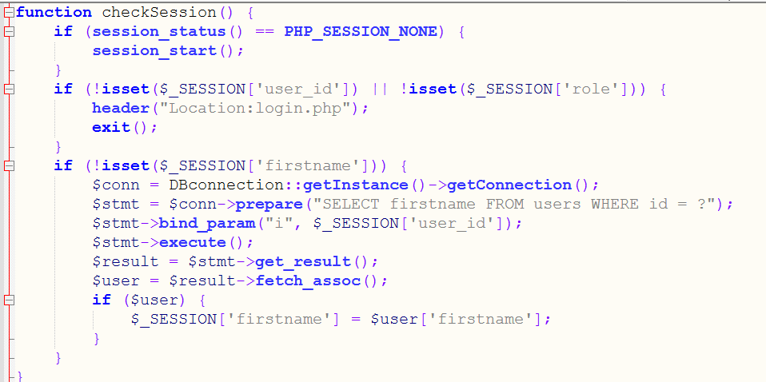
Admin Report Implementation
Figure 36 Session class
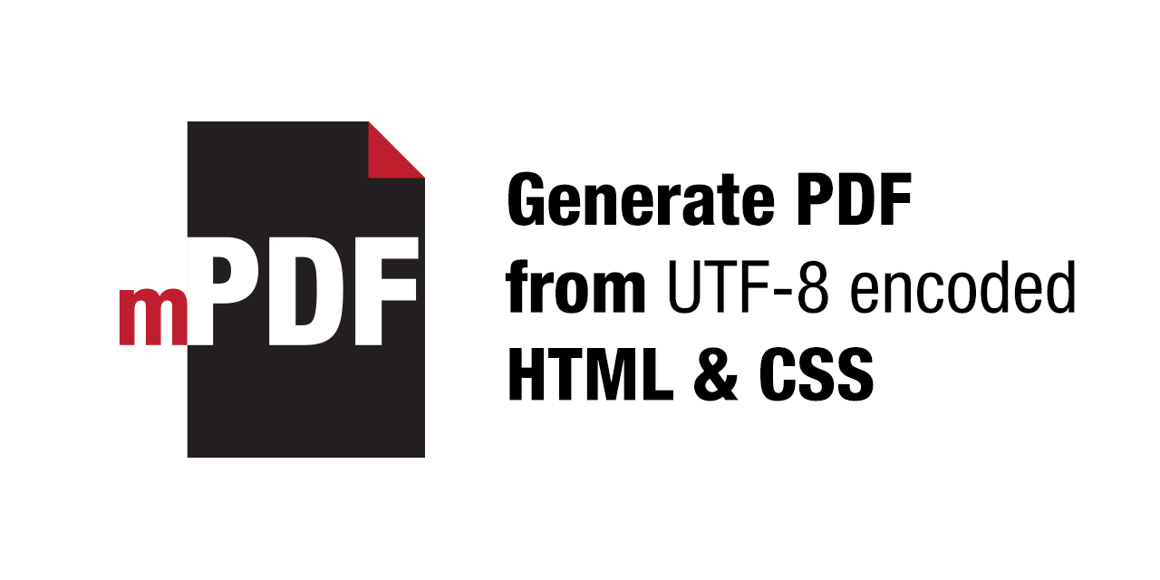
For admins report function I used the mPDF library which was easy to code and it generates pdfs using data directly from the database.
Figure 37 mPDF

Chapter 6: Testing
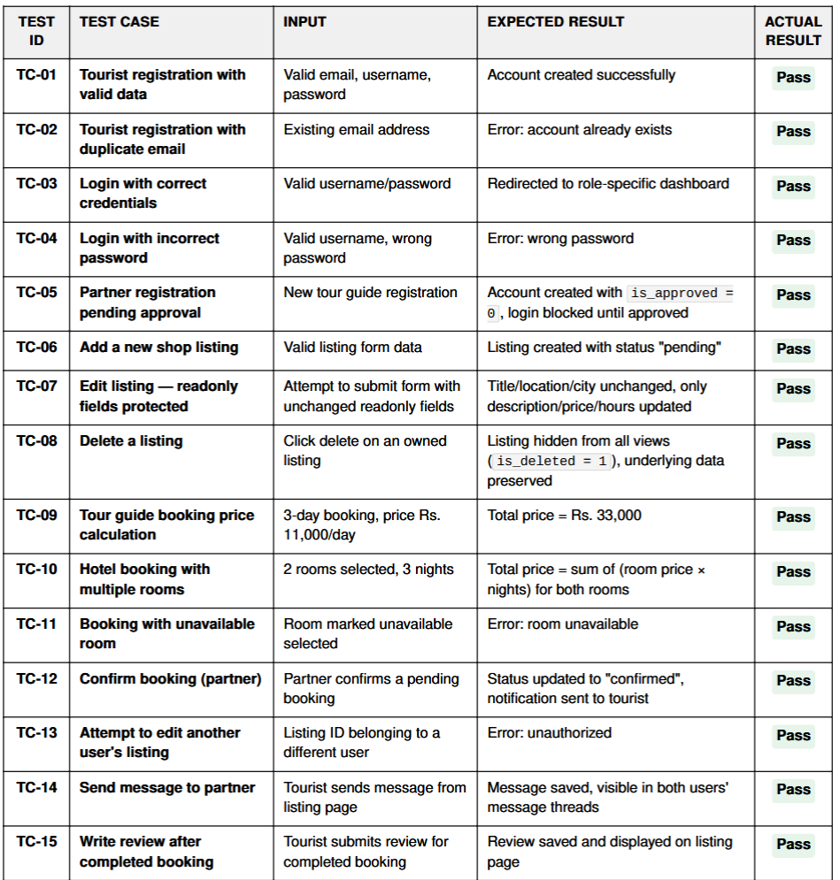
These are some test cases I used to test and confirm the functionalities of my system.

Chapter 7: Conclusion

7.1 Achievements
As a conclusion I would like to describe what I achieved from my project, CeylonTourMateLK.
- A fully functional centralized platform connecting all tourists and local service providers
- Role based login to make the system easy to use for users
- A complete way for tourists to go form searching booking confirmation to payments.
- System sends automatic notifications to users(ex: when local partner approves a booking tourist receives a notification)
- Throughout the project I have learned all the knowledge of SDLC process specially with the diagrams and coding part.

7.2 Limitations
- The main limitations is the payment system still implement a payment processing rather than a real payment gateway.
- I need to find users for this platform by advertising.

7.3 Future Developments
- My main goal is to find users and give them the knowledge to how to use this platform and advantages of this one compared to the existing third party sites.
- In the future I would like to integrate this with a real payment gateway for live transactions.
- I would like to build a dedicated mobile app for tourist to connect with this website too.

7.4 Final Conclusion
CeylonTourMateLK will be a great platform for community as well as my self too. From the beginning I have learned everything again to make this project a success, all the things is a original work done my me, my self.
This platform address a huge gap in the tourism industry in srilanka and as a solution for that provide a centralized trustworthy platform for the tourists.

References
- Stack Overflow. (n.d.). How to model messages exchanged between users? - ER Diagram. [online] Available at: https://stackoverflow.com/questions/35310283/how-to-model-messages-exchanged-between-users-er-diagram [Accessed 26 July 2026].
- asdad. (2026). Reddit - please wait for verification. Reddit.Com. https://www.reddit.com/r/sql/comments/13ppmpj/what_do_you_think_of_this_er_diagram_i_feel_like/?utm_source=chatgpt.com
- table, I. (2014, November 15). Stack overflow. Stack Overflow. https://stackoverflow.com/questions/26950903/is-it-okay-for-the-foreign-key-field-to-have-a-different-name-than-the-field-it

