

**Image Processing and Computer Vision Laboratory**

**CSE 4128**

**Project title: Cartooning an Image**

**Supervised by:**

Dr. Sk. Md. Masudul Ahsan Dipannita Biswas

Professor Lecturer

Department of CSE, KUET Department of CSE, KUET

**Submitted by:**

Proloy Karmakar

Roll; 1907051

Year: 4th

Term: 1st

Date of Submission: 30-06-2024

**Index:**

1. Objectives
2. Introduction
3. Theory
   1. Pencil Sketching an image
   2. Color Quantization of an Image
   3. Comic Book Style Cartoon Image
   4. Outline and Edge Detection Cartoon Image
4. Sample Input and Output
5. Discussion
6. Conclusion
7. Application

**Objectives:**

* 1. **Understand Image Processing Techniques**: Learn about various image processing techniques and their applications, focusing on the methods used for cartooning an image.

* 1. **Implement Cartooning Algorithm**: Develop and implement an algorithm to convert a photograph into a cartoon-like image using filters and edge detection methods.

* 1. **Enhance Image Quality**: Improve the visual quality of the cartooned image by adjusting parameters and refining the algorithm.

* 1. **Compare Methods**: Evaluate different techniques for cartooning images and compare their effectiveness and efficiency.

* 1. **Create a User-Friendly Interface**: Design a user-friendly interface that allows users to upload images and apply the cartooning effect easily.

* 1. **Analyze Results**: Analyze the results of the cartooning process and discuss the strengths and limitations of the implemented methods.

**Introduction:**

Cartooning an image is a fascinating area of image processing that transforms real-world photographs into cartoon-like representations. This process involves several steps, including edge detection, image segmentation, and color quantization, to simplify the image while maintaining its essential features. Cartoon images are characterized by bold edges and smooth, flat areas of color, which give them a distinctive, stylized appearance.

The primary objective of this project is to explore and implement various techniques for cartooning an image. This involves understanding the underlying principles of image processing, such as filtering, edge detection, and color quantization, and applying these techniques to create visually appealing cartoon images. By comparing different methods and analyzing their outcomes, we aim to identify the most effective approach for achieving high-quality cartoon images.

Overall, this project combines theoretical knowledge with practical application, providing a comprehensive understanding of the cartooning process and its potential uses in various fields such as digital art, entertainment, and media production

**Theory:**

I used different methods in this project to make a cartoon of an image. These are as follows:

1. **Pencil Sketching an Image:**

Pencil sketching an image is a popular technique in image processing that transforms a photograph into a grayscale image resembling a hand-drawn pencil sketch. This process involves several steps that mimic the texture and appearance of pencil strokes. The key steps in the pencil sketching process are as follows:

**Image Grayscale Conversion**

**Inversion**

**Gaussian Blur**

**Dodge Blending**

1. **Color Quantization of an Image:**

Color quantization is the process of reducing the number of distinct colors in an image. This is particularly useful for compressing images and for achieving certain artistic effects, such as creating cartoon-like images. The goal is to retain as much visual information as possible while using a limited palette of colors. Here are the key concepts and steps involved in color quantization:

**Key Concepts:**

* 1. **Color Space:** Operates over the Color Space to reduce the number of unique color values.
  2. **Palette**: Use the palette as the set of colors used in the quantized image.
  3. **Clustering**: Clustering algorithms are used to group similar colors together. Each cluster is represented by a single color, which is typically the centroid (average) of all colors in the cluster.

1. **Comic Book Style Cartoon Image:**

Creating a comic book-style cartoon image involves transforming a photograph into an image that resembles the unique, stylized artwork found in comic books. This process combines various image processing techniques to achieve the distinctive look of comic art, which typically features bold outlines, flat colors, halftone shading, and sometimes exaggerated features.

**Key Characteristics of Comic Book Style:**

1. **Bold Outlines**: Thick, dark lines that define the edges of objects and characters.
2. **Flat Colors**: Large areas of solid colors with minimal gradients.
3. **Halftone Shading**: Patterns of dots or lines used to create shading and texture, mimicking traditional comic book printing techniques.
4. **Exaggerated Features**: Emphasized or stylized features to convey emotions and actions dramatically.

4. **Outline and Edge Detection Cartoon Image:**

Creating a cartoon effect on an image using outline and edge detection involves a combination of techniques to simplify the image's color palette and emphasize its edges. This process highlights the boundaries of objects and reduces the complexity of the colors, giving the image a stylized, cartoon-like appearance.

**Key Steps in Cartooning by Outline and Edge Detection:**

1. **Image Smoothing:**

Reduce noise and smooth the image to prepare it for edge detection.

1. **Edge Detection**:

Detect the edges in the image to create the outlines typical of cartoon art. Techniques like the Canny edge detector are commonly used for this purpose.

1. **Color Quantization**:

Color quantization is the process of reducing the number of distinct colors in an image. This is particularly useful for compressing images and for achieving certain artistic effects, such as creating cartoon-like images.

1. **Combining Edges and Colors:**

Overlay the detected edges onto the color-quantized image to create the final cartoon effect. This step emphasizes the edges while simplifying the color information.

**Sample Input and Output:**

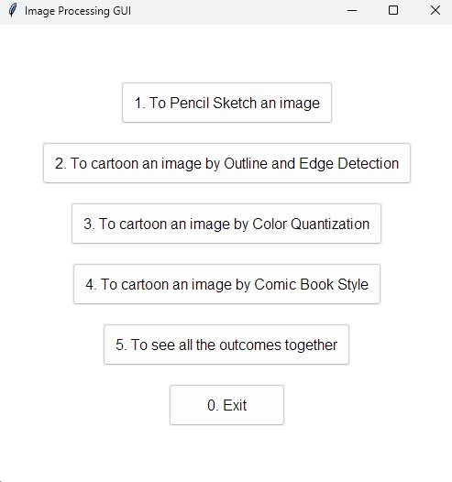

**Fig 1: Graphical User Interface to select an image**



# Fig 2: Input Image

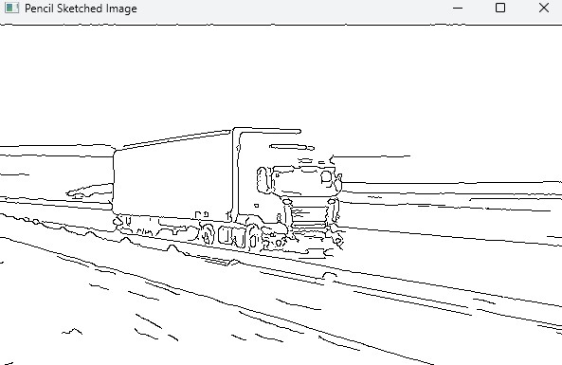

# Fig 3: Pencil Sketch Image



# Fig 4: Input Image

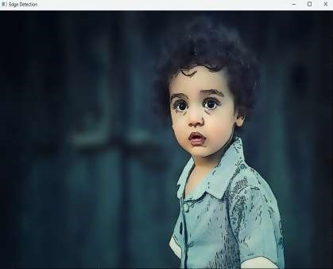

**Fig 5: Outline and Edge Detected Image**



# Fig 6: Input Image

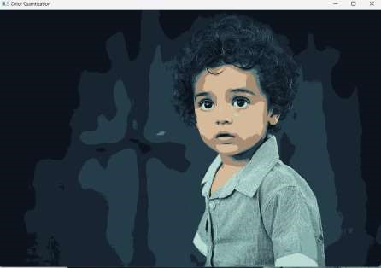

# Fig 7: Color Quantized Image



# Fig 8: Input Image

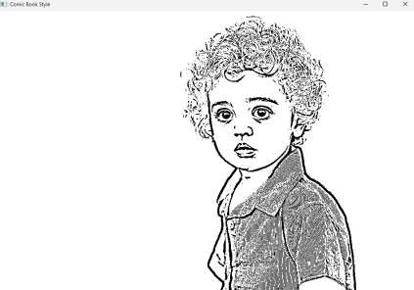

# Fig 9: Comic Book Style Image

**Discussion:**

The project of cartooning an image using outline and edge detection provides a practical application of several fundamental image processing techniques. By smoothing the image, detecting edges, and quantizing colors, we can transform a photograph into a stylized, cartoon-like image. Each step in the process contributes to the final effect, and understanding these steps offers insights into the broader field of digital image manipulation.

**Conclusion:**

The project successfully demonstrates the process of converting a photograph into a cartoon-like image using outline and edge detection. By implementing a series of well-established image processing techniques, we achieved a stylized effect that highlights the edges and simplifies the color information in the image.

**Application:**

This project has applications in various fields, including digital art, graphic design, and media production. The cartooning effect can be used to create artistic images, enhance visual storytelling,

and develop unique visual content for marketing and entertainment.

In conclusion, the project demonstrates a successful implementation of cartooning an image using outline and edge detection. The combination of image smoothing, edge detection, and color quantization techniques provides a robust method for achieving a cartoon-like effect, with potential for further enhancements and applications.