SPL-1 Project Report, 2020

Packet Analyzer
SE 305 : Software Project Lab-1
Submitted by
Proma Chowdhury
BSSE Roll No. : 1132
BSSE Session: 2018-2019

Supervised by
Dr. B M Mainul Hossain
Designation: Associate professor
Institute of Information Technology



Institute of Information Technology,
University of Dhaka
24-08-2021

Table of Contents:

1.Introduction .......................................................................…1

1.1. Background Study...……..….......................................…..1-2

1.2. Challenges……............................................................…..2

2. Project Overview ....…………........................................…..2-3

3. User Manual ...……….....................................................….3-8

4. Conclusion ...………........................................................... 9

5. Appendix.........................................................................…..9

6. References.....................................................................9

1
Introduction
Packet Analyzer is a software that can intercept traffic and analyze. Based on the analysis, different decisions regarding network forensics can be made. Different features of this project like port scan and ping scan can
be used to identify the security vulnerabilities in a network.

Background Study

Header Information of Protocols of Different Layers : I had to learn about the header information of different protocols like Tcp, Udp, Http, Ipv4, Ethernet,icmp to implement the packet parser in my project.

Packet Parsing :
Analysis of the pcap file is a part of my project. I had to learn how to extract the header from a packet, process specific fields from the header and dump the payload.

Raw Socket – Raw sockets give access to the lower layer protocols such as ip and tcp. Since my project focuses on capturing network packets and its analysis, I had to learn the mechanism of capturing packets using raw socket.

HTTP long documents – My project can dump the html payload carried by HTTP in separate html files. Generally in case of mass data, the data is carried in multiple TCP segments instead of one HTTP packet. Sequence number and acknowledgments play a great role in indicating which packets are carrying the segmented payload. I had to learn about these mechanisms.

Checksum Calculation – For security issue, checksum is an added data field which is used to maintain integrity on both sender and receiver side. I had to learn the process of calculating checksum.

SYN Flood Attack – SYN flood attack happens when a server receives ample amount of syn packets and the attacker doesn’t complete the

2
connection by sending ACK. In that case, the server window gets loaded up with these half open connections. If an Ip address receives ample
amount of syn packets then my project gives an warning stating the possibility of getting attacked.

1.2. Challenges
During coding the project, sometimes, the steps seemed very baffling and challenging. These are the challenges I faced -
1. Capturing packets using raw socket for the first time
2. Tracking the sequence and acknowledgment numbers to print a HTTP long document in a single html file felt quite confusing.
3. Tracking the ratio of syn packets an Ip address has received vs the number of syn-ack packets that specific Ip address has sent
4. Printing packet payload in hex notation
5. Correctly moving the pointer position to dump the header information of a packet

2. Project Overview

2.1. Pcap analysis:
This feature of the project basically focuses on taking a pcap file as input and dumping its header information and payload. The sub-features of this feature are
1. It can correctly dump the header information of Ethernet, IpV4 and transport layer protocols(Tcp and Udp) and print the payload in a separate file.
2.Separating the html/css payload carried by http and showing those in the form of html file is another sub-feature.
3. Moreover if a packet has received more syn packets than the number of syn-acks it has sent, the user will get a warning.

2.2. Live Packet Sniffing :
This feature captures packet using raw socket and then the header and payload of the packets are separated, analyzed and dumped.
3
2.3. Port Scanning :
This is the part where a user can check if a port is filtered or closed. This feature takes the host name and ports as input. If the host name is invalid, it triggers an warning. Regarding the inner implementation, first a TCP packet is made by filling up all the header information including the checksum and setting the value of SYN flag bit to 1. Then that packet is sent to the destination Ip address via raw socket. After that the received reply is checked. If the reply packet has its RST flag bit set to 1, then the port is closed, otherwise if reply has its SYN and ACK flag bits set to 1, then the connection is open.

2.4. Host Alive :
This feature pings a particular host and checks if it’s alive or not. Like the previous feature, this one also takes host name as input and triggers a warning for an invalid host name. In case of implementation, first an icmp packet is filled up with its type to ICMP_ECHO and then the datagram is sent to the destination. If the receiver replies with icmp type = 69 then it is a malformed packet. Otherwise the reply is recorded and determined that the host is alive.

3. User Manual

3.1. User Manual of the project:
First go to the Ubuntu Terminal and browse to the the folder where the executable file has been stored. Then type the command sudo ./executable fileName -um to see the user manual.
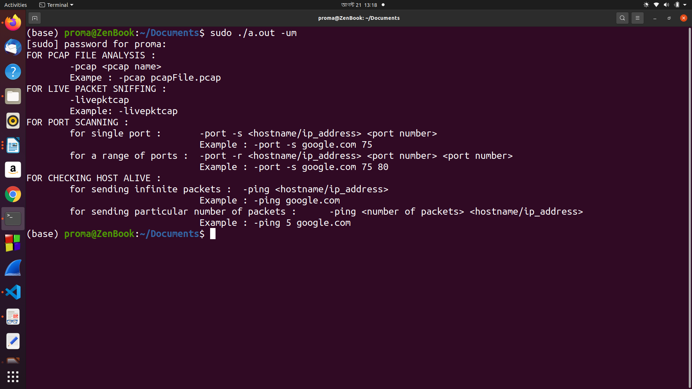
4

3.2. Pcap Analysis :
Pcap file can be analyzed using the following command
“sudo ./executable fileName -pcap <pcap fileName>”

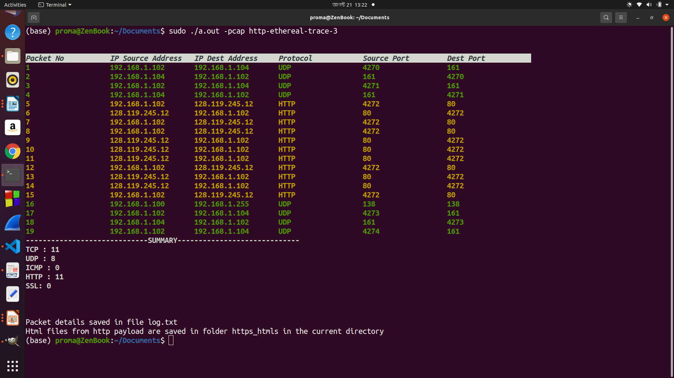
5
3.3. Live Packet Sniffing :
Packets can be captured using raw socket analyzed using the following command
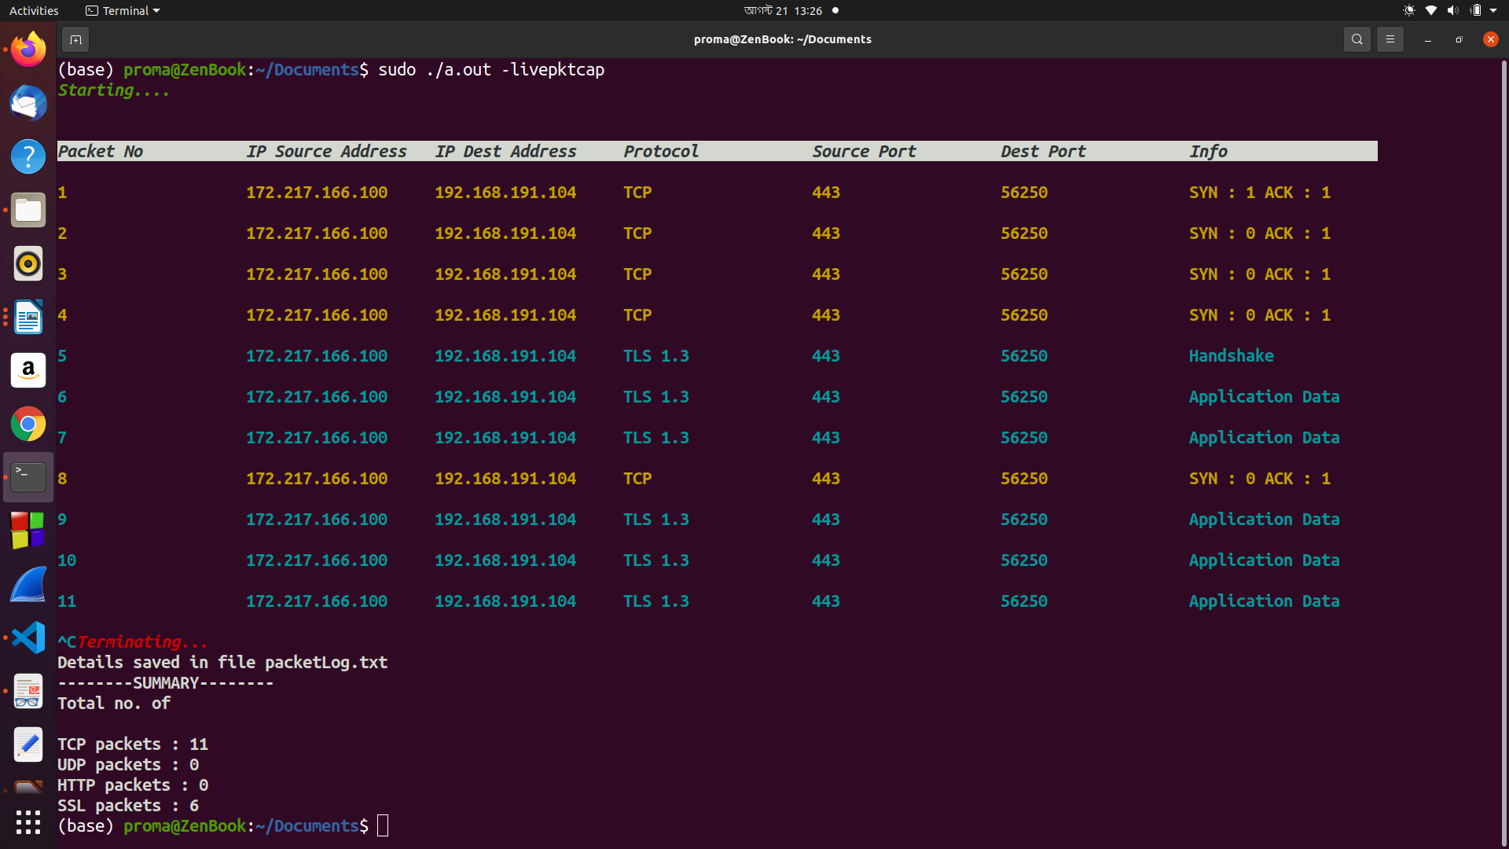
sudo ./executable fileName -livepktcap

6
3.4. Port Scanning :
1. To scan a single port type in the following command

sudo ./executable fileName -port -s <hostname/Ip addresss> <port number>

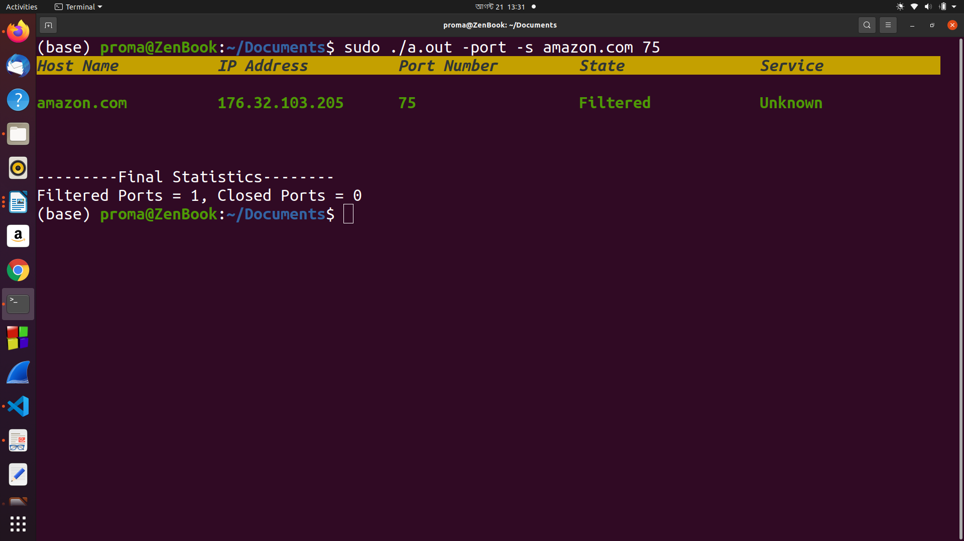

7
2. To scan a range of ports type the following command

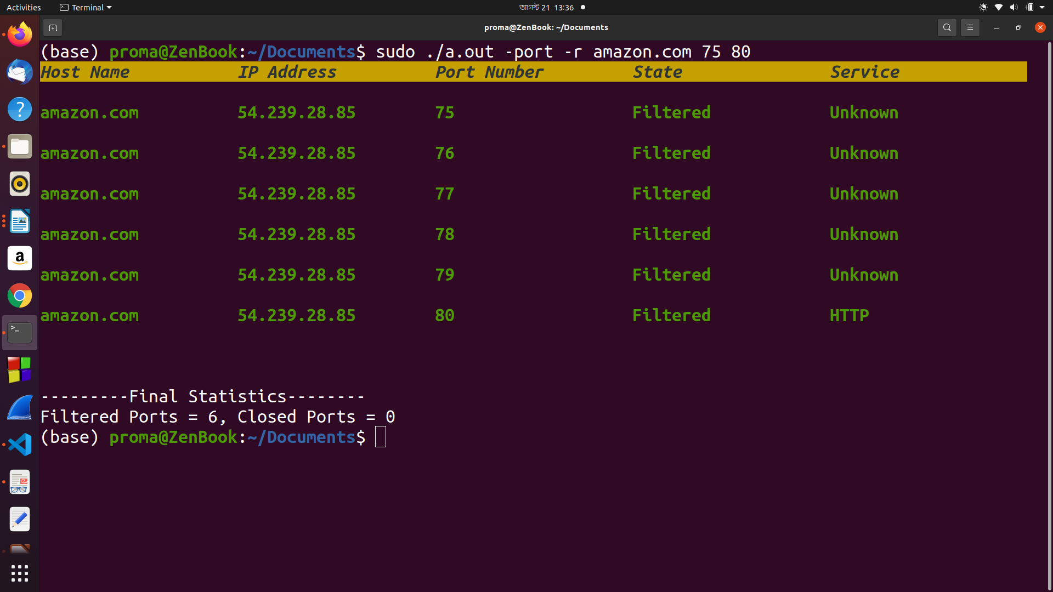
sudo ./executable fileName -port -r <hostname/Ip address> <port number> <port number>

3.5. Host Alive :
1. To send infinite amount of packets to an Ip address use the command

sudo ./executable fileName -ping <hostname/Ip address>
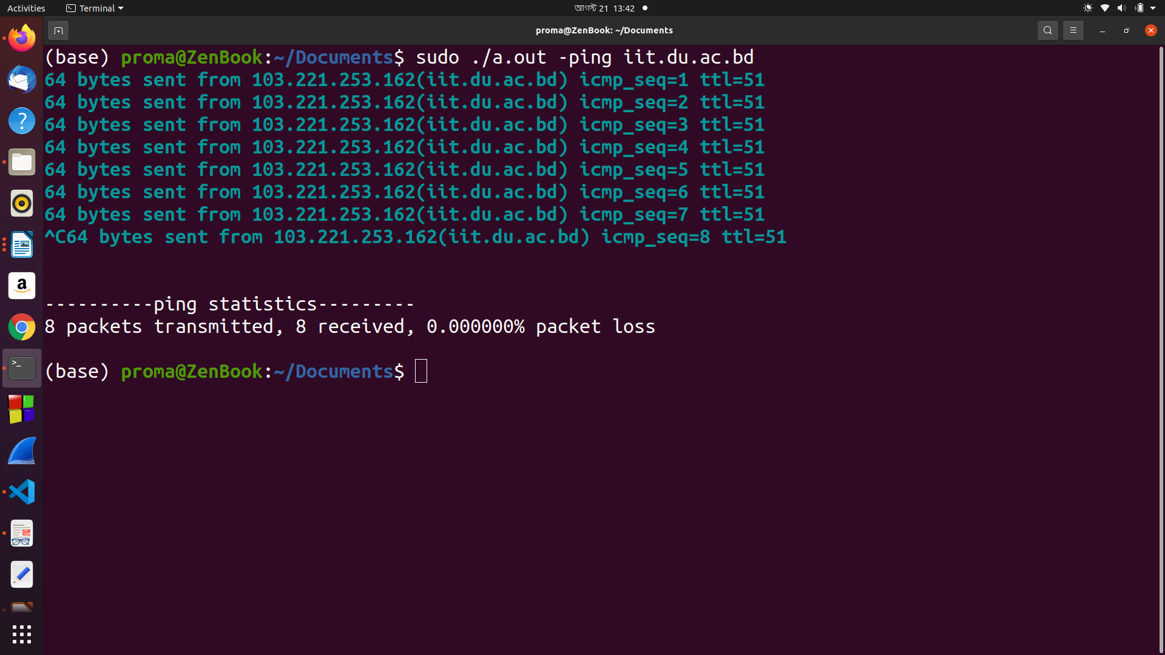
8

2. To send a specific number of packets to the destination address enter the command

sudo ./executable fileName -ping <packet number> <hostname/Ip address>
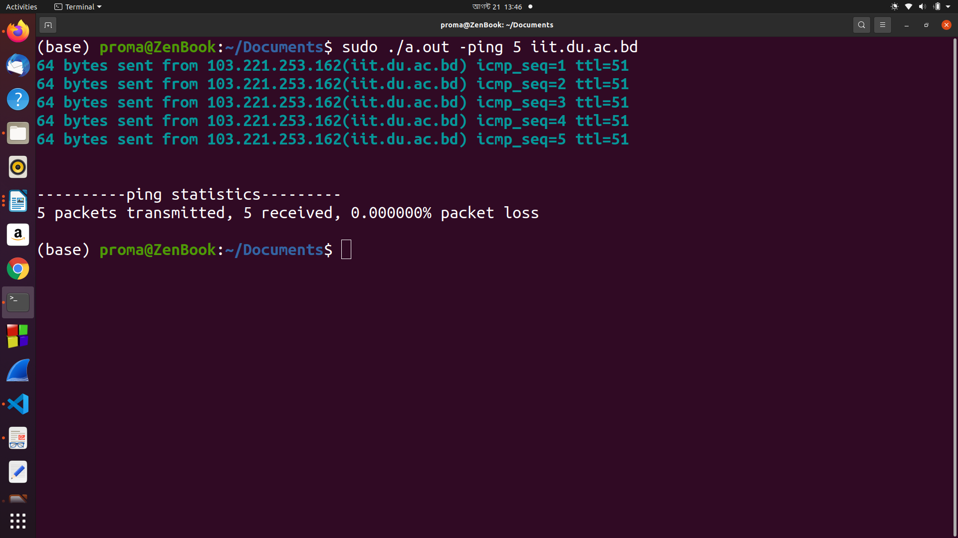

9
CONCLUSION :
This project helped me to understand the basics of networking. Working with packets was quite challenging and fun at the same time. I could understand how we can make a server almost dysfunctional just by sending Syn packets. I hope this project will help me to design more security based software in the future.

APPENDIX :
I wanted to extract png/jpeg files from http payload along with html files but couldn’t implement that unfortunately because of shortage of time and higher complexity. I also will look forward to implement proper algorithms for syn flood attack.

REFERENCES :
1.https://erg.abdn.ac.uk/users/gorry/course/inet-pages/icmp-code.html
2. https://www.iana.org/assignments/icmp-parameters/icmp-parameters.xhtml
3. https://networklessons.com/cisco/ccna-routing-switching-icnd1-100-105/ipv4-packet-header
4. https://www.binarytides.com/packet-sniffer-code-c-linux/
5. https://www.middlewareinventory.com/blog/tcpdump-capture-http-get-post-requests-apache-weblogic-websphere/
6. https://searchnetworking.techtarget.com/definition/SYN-scanning
7.https://www.cloudshark.org/captures/ba85949942a0
8. https://osqa-ask.wireshark.org/questions/60763/how-to-detect-ddos-attacks-on-my-network/

