**The Wonders of Nature Introduction**

Nature is a magnificent force that surrounds us. From the towering mountains to the vast oceans, it offers beauty and sustenance. This document explores various aspects of nature, including ecosystems, biodiversity, and conservation efforts.

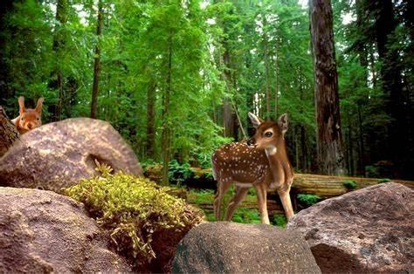

**1. Ecosystems**

An ecosystem is a community of living organisms interacting with their environment. There are several types of ecosystems:

**1.1 Terrestrial Ecosystems**

* **Forests**: Home to a variety of species, forests are vital for oxygen production.
  + - **Deserts**: These arid regions host specially adapted organisms.
  + **Grasslands**: Known for their open spaces, grasslands support numerous

herbivores.

**1.2 Aquatic Ecosystems**

* **Freshwater**: Rivers and lakes are crucial for many species and human

activities.

* **Marine**: Oceans cover about 70% of the Earth’s surface and are rich in biodiversity.

![Insert an image of a coral reef here]

**2. Biodiversity**

Biodiversity refers to the variety of life on Earth. It is essential for ecosystem health and resilience.

**2.1 Importance of Biodiversity**

* **Ecological Stability**: Diverse species contribute to ecosystem functions.

* **Economic Value**: Biodiversity supports agriculture,

pharmaceuticals, and tourism.

**2.2 Threats to Biodiversity**

* + - **Habitat Loss**: Urbanization and deforestation threaten many species.
* **Pollution**: Contaminants can harm wildlife and ecosystems.
  + **Climate Change**: Altered climates affect species distribution and

survival.

![Insert an image depicting biodiversity here]

**3. Conservation Efforts**

Conservation is vital to protect our natural heritage. Various initiatives aim to preserve ecosystems and species.

**3.1 Protected Areas**

National parks and reserves are established to safeguard habitats and biodiversity.

**3.2 Community Involvement**

Local communities play a crucial role in conservation through sustainable practices and education.

**3.3 Global Initiatives**



Organizations like the World Wildlife Fund (WWF) and the United Nations Environment Programme (UNEP) work globally to promote conservation.

**Conclusion**

Nature is an invaluable asset that requires our protection. By

understanding ecosystems, appreciating biodiversity, and engaging in conservation efforts, we can ensure a sustainable future for generations to come.