

*Software Engineering Project Report*

Topic: Android Music Player

Course: **CSE327**

Section: **4**

Submitted By:

**Saqib Hasan** – **1731792042**

**Koushiq Das** – **1721627642**

**Zannatul Ferdous Prome** - **1621109042**

**TABLE OF CONTENTS:**

* INTRODUCTION
* PROBLEM STATEMENT
* SOLUTION
* STAKEHOLDERS
* TOOLS & TECHNOLOGY
* MODELS & METHODS
* STAKEHOLDER
* USER STORIES
* BREAKDOWNS USER STORIES TO TASK
* FUNCTIONAL REQUIREMENTS
* USER REQUIREMENTS
* SEQUENCE DIAGRAM
* USE CASE DIAGRAM
* CLASS DIAGRAM
* DESIGN
* TEST CASES
* RISK ANALYSIS
* PRODUCT BACKLOG
* APPENDIX

**INTRODUCTION**

Android is open source code mobile phone operating system that comes out by Google in November 2007. Its appearance has broken the traditional closed mobile phone operating system. Anyone can modify the mobile phone operating system as well as function according to personal preference, which is also the most attractive merit of Android.

Music player based on Android application is popular in the market at the present. The completing development of Android operating system gives developers a nice platform, which can learn the popular computer technology combining with learned knowledge, and master the latest knowledge, enrich oneself, and enjoy entertainment.

**PROBLEM STATEMENT**

If we don’t use any music player application on android handsets it will be both very difficult and annoying for the users to perform their tasks. Lack of music player applications will guide users to enter in file manager, go to music folder and then choose music and play. Besides, they won’t have any search and filtering options. These steps will create a hustle for the users.

**SOLUTION**

We will design an android application which will enable the users to:

* Sign up and Login to the application
* Check recent playlist
* See the full music list
* Play, Stop, Pause Audio files (mp3)
* Search their preferences
* Create own playlist
* Notification on the home screen

**TOOLS & Technology**

* **JDK**：Java Runtime Environment virtual machine、Java Development Kit(JDK) Installation steps of the developing environment
* **Android Studio: Android Studio** is the official integrated development environment (IDE) for Android application development. It is based on the IntelliJ IDEA, a Java integrated development environment for software, and incorporates its code editing and developer tools.
* **Firebase:** **Firebase** is a mobile-backend-as-a-service that provides powerful features for building mobile apps. **Firebase** has three core services: a realtime database, user authentication and hosting. We use the Firebase here for authentication.

**Methods**

* Register for Application
* Sign In
* View Playlist
* PLAY ANY SONG
* Play. Pause, Previous & next
* Seekbar
* Voice Command

**STAKEHOLDER**

* All classes of people.

**USER STORIES**

* As a user I want to create an account of my own in the application so that I can have the privacy of using the app and have my playlist and works saved.
* As a user I want to see the full playlist, play, pause, stop options so that I can have full command over the application usage.
* As a user I want to search music and create my own playlist in the app so that I can have flexibility over my application.

**BREAKDOWNS USER STORIES TO TASK**

* Create simple & friendly user interface.
* Create welcome page
* Create login for users.
* Create help & feedback
* Create music library as home page
* Create play, stop, pause option in player screen
* Create next/previous option in player screen
* Create songs in music library

**FUNCTIONAL REQUIREMENTS**

* Android operating system on the Smartphone.
* The target device should be sound enabled.
* Ability to play Audio file.
* Welcome Screen.
* Login, Signup Screen.
* Main Screen.
* Player Screen.

**USER REQUIREMENTS**

|  |  |
| --- | --- |
| Sign Up | User will be able to sign up with their email and password. |
| Sign In | User will be able to sign in with their registered email and password. |
| Playlist | App will be read all the songs from the phone storage and user will be able to view playlist |
| Play Songs | User will be able to play, pause, next, previous music. They also use seekbar also. |
| Voice command | User will be able to control the play, pause next previous button by their voice command. |

**USE CASE DIAGRAM**

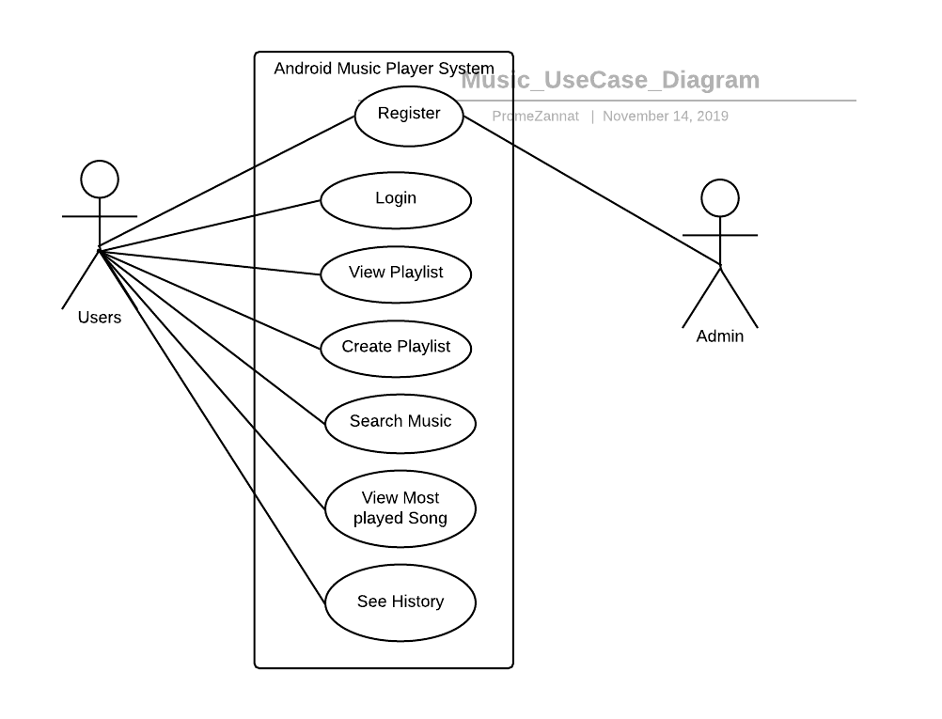

**Android Music Player UML Use Case Diagram**

**CLASS DIAGRAM**

|  |
| --- |
| USER |
| -UserId  +String email  -String password |
| -viefInfo()  -add()  -delete() |

|  |
| --- |
| PLAYLIST |
| -PlaylistId  -string song name  -bool next  -bool previous  -bool pause  -string voice |
| -viewSongs()  -viewButton()  -Command() |

**SEQUENCE DIAGRAM**

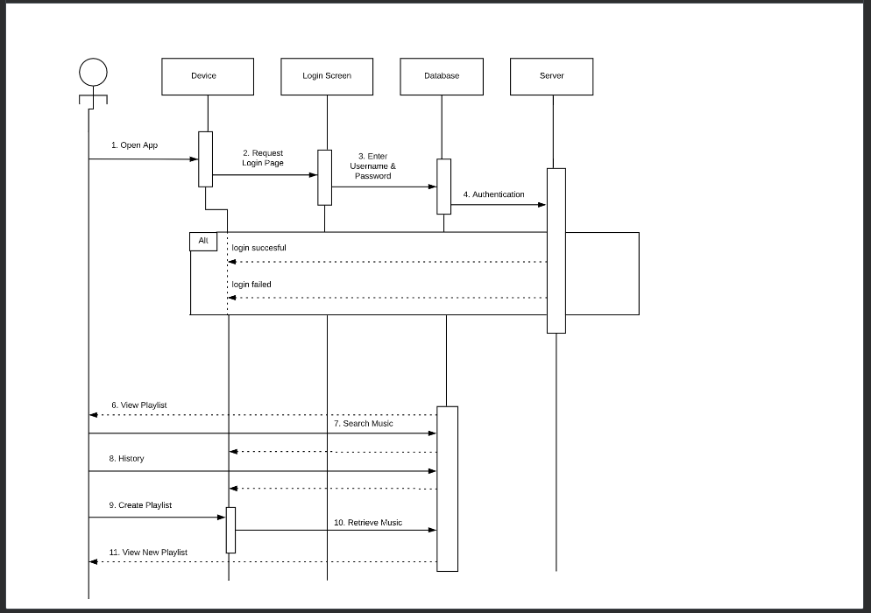

**RISK ANALYSIS**

|  |  |  |
| --- | --- | --- |
| RISK | AFFECT | DESCRIPTION |
| Schedule | Project | Due to some management problem we have to change the schedule of this project. |
| Gradle File Sync | Project & Product | When we 3 develop the project with different devices and finally connect it together its gradle file sync failed because of different version of android studio. These affect the performance and hamper the schedule. |
| Firebase Authentication | Project & Product | When we use the firebase authentication in the sign in and sign up activity its causes some change in the manifest file. That affects the performance and hamper the schedule. |
| Voice Manipulation | Product | When you input any voice command there remains a probability that if you don’t speak it clearly it will mislead and not work. |
| App Crash | Product | While playing one song to another frequently it crashes sometimes |

**TEST CASES**

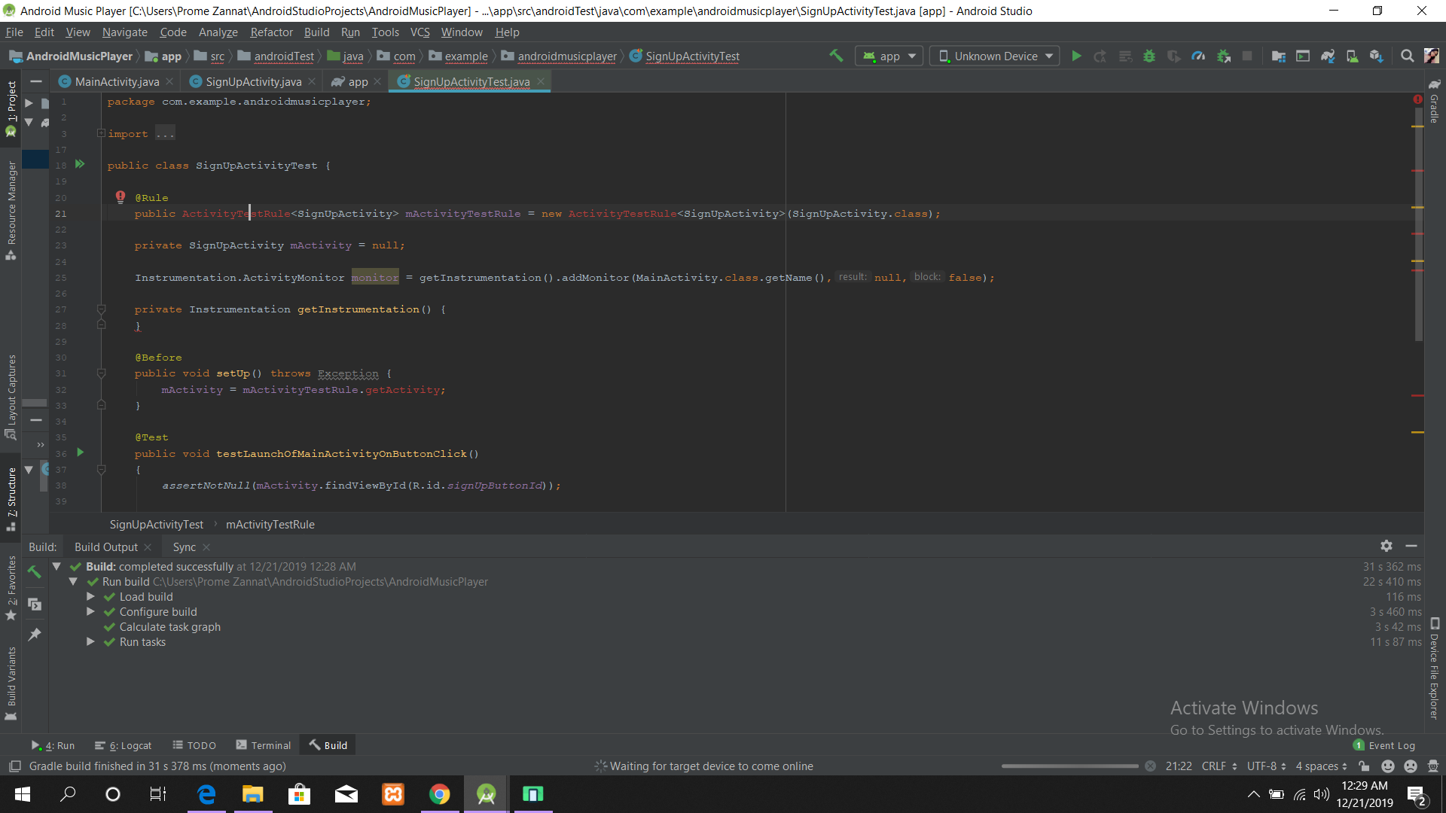JUnit is the most popular unit[Testing](https://www.guru99.com/software-testing.html)framework in Java. It is explicitly recommended for [Unit Testing](https://www.guru99.com/unit-testing-guide.html). JUnit does not require server for testing web application, which makes the testing process fast.

JUnit framework also allows quick and easy generation of test cases and test data. The **org.Junit** package consist of many interfaces and classes for JUnit Testing such as Test, Assert, After, Before, etc.

**PRODUCT BACKLOG**

* Online Streaming : In future we are planning to add online streaming feature where people will be able to listen songs online from a stored database.
* Create playlist : Later on users will be able to create their own playlist by their own choices. That will enhance user experience regarding the application.
* Search music : A voice search feature is also planned to add for a better and ease user experience.
* Sorting : Users will be able to sort music in terms of music genre such as Rock, Pop, Jazz etc.

**APPENDIX**

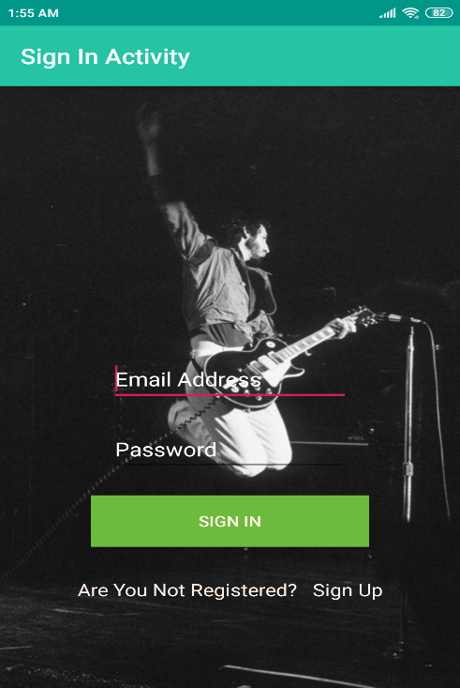

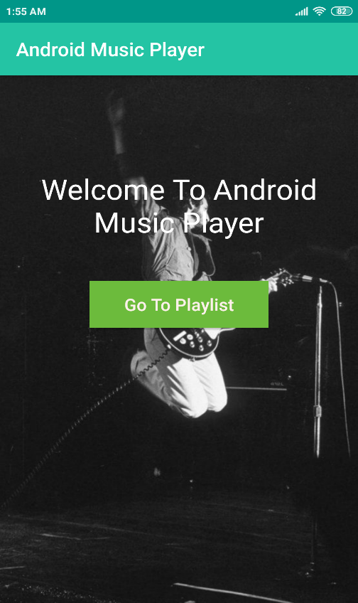

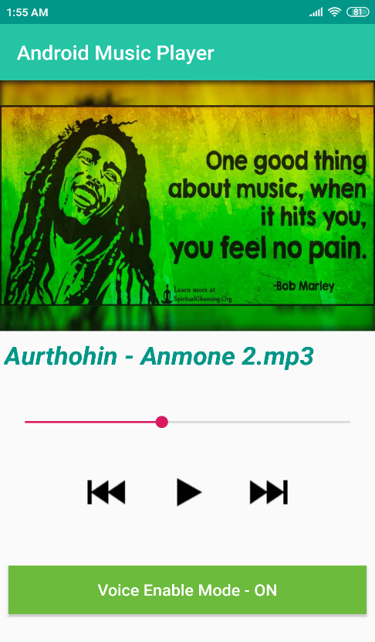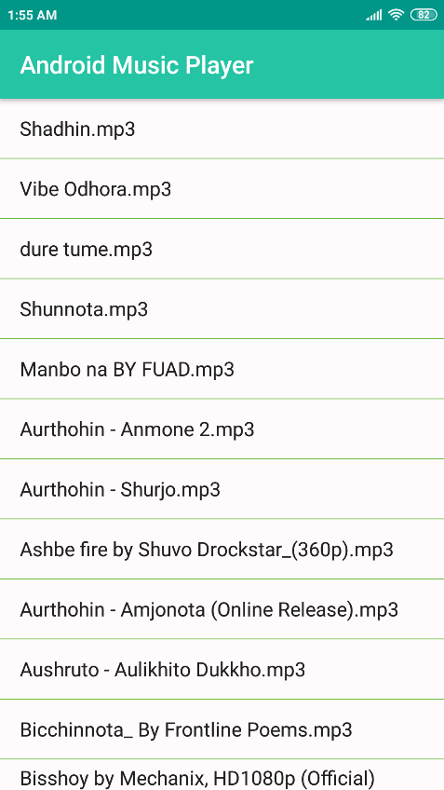 **Appendix (continues…)**

1. What kind of music application do you prefer?
2. Online B. Offline
3. Do you prefer a personal account for your music application?
4. Yes B. No
5. Do you want your recent played songs to be saved?
6. Yes B. No
7. Do you want a favorite option?
8. Yes B. No
9. What kind of search do you prefer?
10. Voice search B. Text search
11. What do you think about voice command over music?
12. Effective B. Not necessary
13. Do you want any of your social media account to be linked?
14. Will be Helpful B. Not necessary
15. What kind of sorting do you want?
16. Sort by yourself B. Automated sort
17. Do you want a user experience option in the app?
18. Yes B. No
19. How do you want to notified about updates?
20. App notification B. Text message