William Simpson

2MAY2018

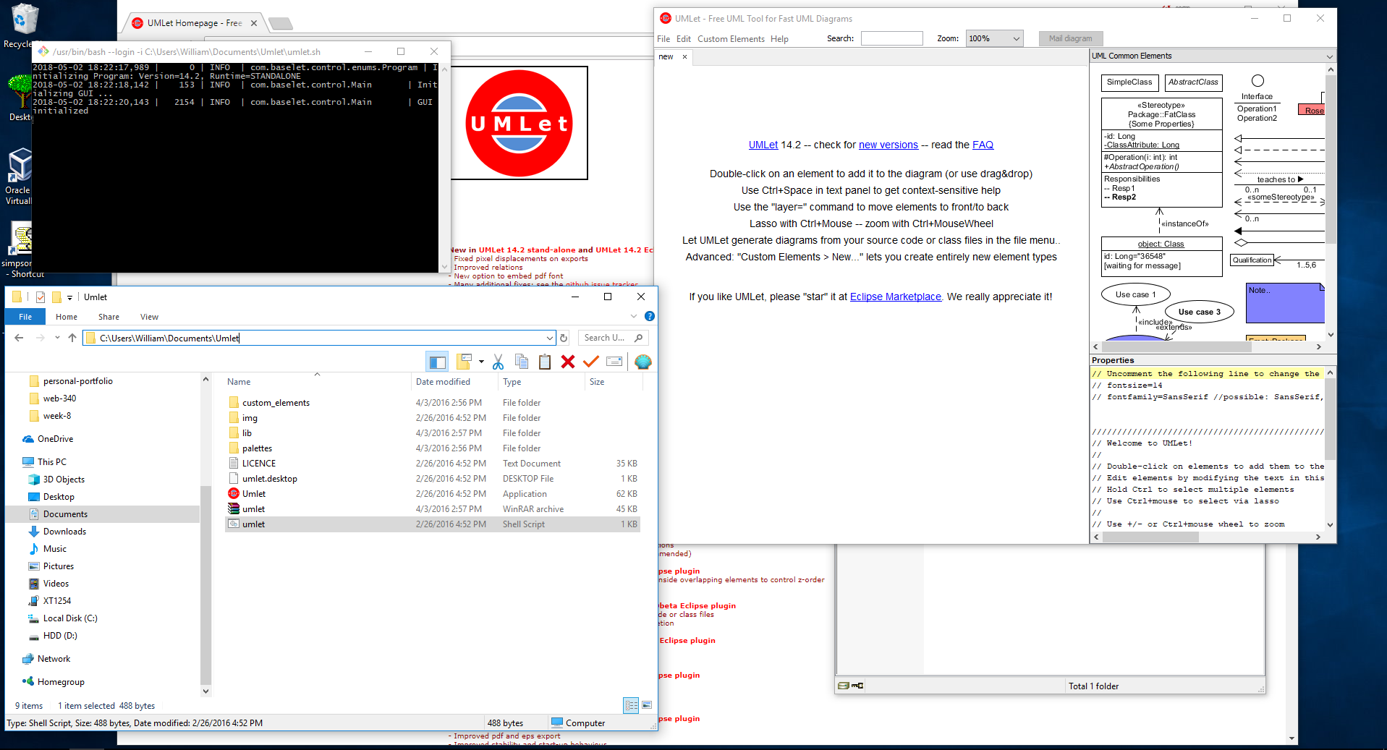Assignment 1.3 UMLet Installation