William Simpson

Professor Krasso

WEB425

24AUG18

Assignment 7.4 Technical Design Document

Table of Contents

1. Introduction
   1. Purpose
   2. Terminology
   3. Related Documents
   4. Document Change Control
   5. Reviewers
   6. Required Skills
2. Architecture
   1. Physical Architecture
   2. Logical Architecture
3. Process Design
   1. Object Relational Diagram
   2. NoSQL Data Structure
   3. Wireframes

3.1 Object Relational Diagram

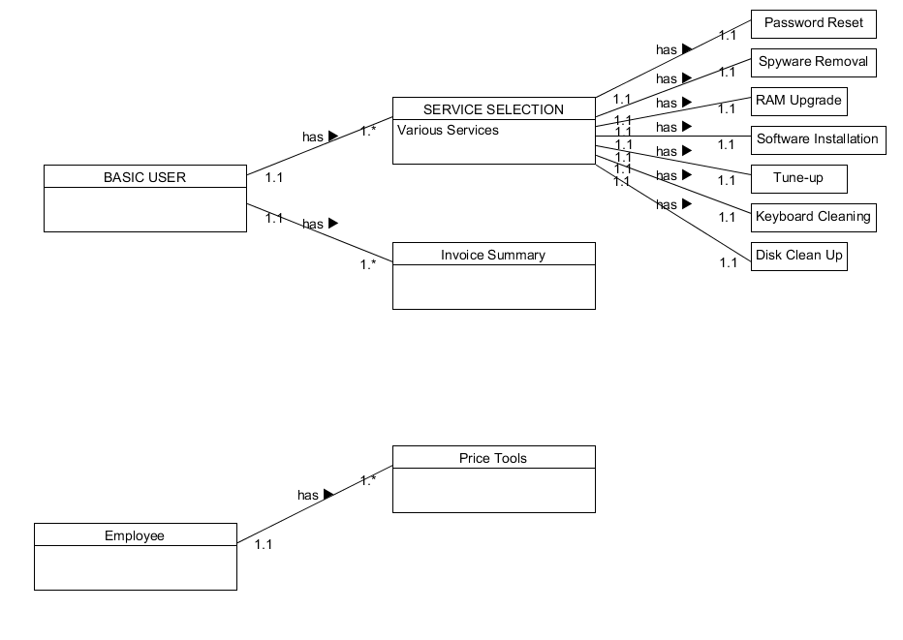

3.2 NoSQL Data Structure

* 1. Wireframes

Color Scheme



