**ANIRUDH SAXENA**

102017117

3CS-5

PROBABILITY & STATISTICS

ASSIGNMENT-1

BASICS OF R

(1) Create a vector c = [5,10,15,20,25,30] and write a program which returns the maximum and minimum of this vector.

CODE:

c=seq(5,30,5)

print('Original vector:')

print(c)

print(paste("Maximum value of the said vector:",max(c)))

print(paste("Minimum value of the said vector:",min(c)))

OUTPUT:

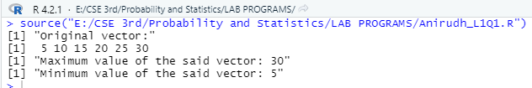

(2) Write a program in R to find factorial of a number by taking input from user. Please print error message if the input number is negative.

CODE:

num = as.integer(readline(prompt="Enter a number: "))

factorial = 1

if(num < 0)

{

print("Sorry, factorial does not exist for negative number= ", num)

}else if(num == 0)

{

print("The factorial of 0 is 1")

} else

{

for(i in 1:num)

{

factorial = factorial * i

}

print(paste("The factorial of", num ,"is",factorial))

}

OUTPUT:



(3) Write a program to write first n terms of a Fibonacci sequence. You may take n as an input from the user.

CODE:

n=as.integer(readline(prompt='Enter the value of n: '))

n1 = 0

n2 = 1

count = 2

if(n<= 0) {

print("Plese enter a positive integer")

} else {

if(n== 1) {

print("Fibonacci sequence:")

print(n1)

} else {

print("Fibonacci sequence:")

print(n1)

print(n2)

while(count < n) {

nth = n1 + n2

print(nth)

n1 = n2

n2 = nth

count = count + 1

}

}

}

OUTPUT: 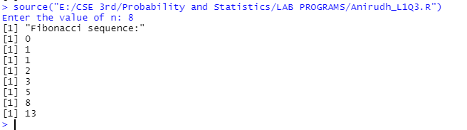

(4) Write an R program to make a simple calculator which can add, subtract, multiply and divide.

CODE:

add <- function(x, y) {

return(x + y)

}

subtract <- function(x, y) {

return(x - y)

}

multiply <- function(x, y) {

return(x * y)

}

divide <- function(x, y) {

return(x / y)

}

# take input from the user

print("Select operation.")

print("1.Add")

print("2.Subtract")

print("3.Multiply")

print("4.Divide")

choice = as.integer(readline(prompt="Enter choice[1/2/3/4]: "))

num1 = as.integer(readline(prompt="Enter first number: "))

num2 = as.integer(readline(prompt="Enter second number: "))

operator <- switch(choice,"+","-","*","/")

result <- switch(choice, add(num1, num2), subtract(num1, num2), multiply(num1, num2), divide(num1, num2))

print(paste(num1, operator, num2, "=", result))

OUTPUT:

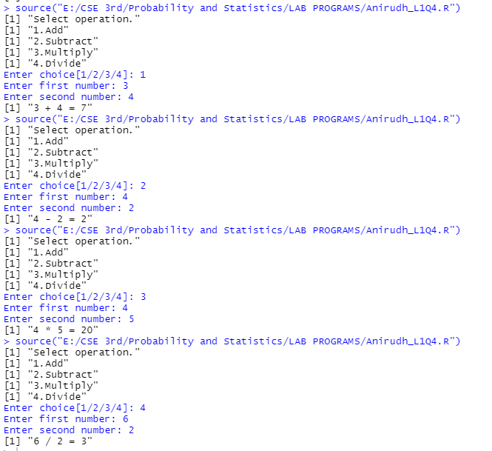

(5) Explore plot, pie, barplot etc. (the plotting options) which are built-in functions in R.

CODE:

max.temp <- c(22, 27, 26, 24, 23, 26, 28)

barplot(max.temp,

main = "Maximum Temperatures in a Week",

xlab = "Degree Celsius",

ylab = "Day",

names.arg = c("Sun", "Mon", "Tue", "Wed", "Thu", "Fri", "Sat"),

col = "darkred",

horiz = TRUE)

OUTPUT:

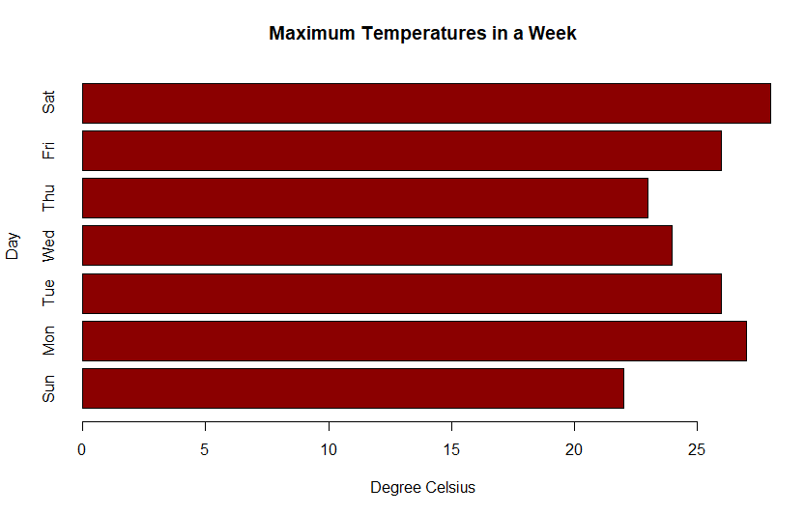

CODE:

geeks <- c(23, 56, 20, 63)

labels <- c("Mumbai", "Pune", "Chennai", "Bangalore")

piepercent<- round(100 * geeks / sum(geeks), 1)

# Plot the chart.

pie(geeks, labels = piepercent,

main = "City pie chart", col = rainbow(length(geeks)))

legend("topright", c("Mumbai", "Pune", "Chennai", "Bangalore"),

cex = 0.5, fill = rainbow(length(geeks)))

OUTPUT:

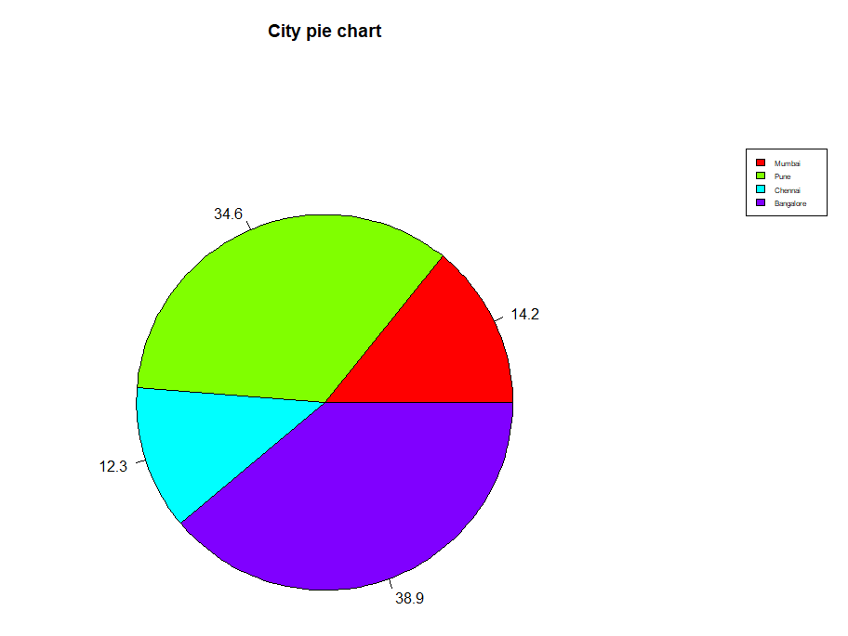

CODE:

x =1:25; y = x * x

plot(x, y, type = "l")

OUTPUT:

