**ANIRUDH SAXENA**

102017117

3CS-5

PROBABILITY & STATISTICS

ASSIGNMENT-5

Continuous Probability Distributions

1. Consider that X is the time (in minutes) that a person has to wait in order to take a flight. If each flight takes off each hour X ~ U(0, 60). Find the probability that (a) waiting time is more than 45 minutes, and (b) waiting time lies between 20 and 30 minutes.

CODE:

a=punif(45,min=0,max=60,lower.tail=FALSE)

print(paste("Probability of waiting more than 45 minutes is:",a))

b=punif(30,min=0,max=60)-punif(20,min=0,max=60)

print(paste("Probability of waiting time is between 20 and 30 minutes is:",b))

OUTPUT:



2. The time (in hours) required to repair a machine is an exponential distributed random variable with parameter λ = 1/2. (a) Find the value of density function at x = 3. (b) Plot the graph of exponential probability distribution for 0 ≤ x ≤ 5. (c) Find the probability that a repair time takes at most 3 hours. (d) Plot the graph of cumulative exponential probabilities for 0 ≤ x ≤ 5. (e) Simulate 1000 exponential distributed random numbers with λ = ½ and plot the simulated data.

CODE:  
a=dexp(3,1/2)

print(paste("The value of density function at x = 3:",a))

p<-function(x){

dexp(x,1/2)

}

curve(p,0,5,main='Exponential probability distribution for 0 ≤ x ≤ 5',

ylab='Probability',

xlab ='No of Hours')

b=pexp(3,1/2)

print(paste("The probability that a repair time takes at most 3 hours",b))

q<-function(x){

pexp(x,1/2)

}

curve(q,0,5,main='Cumulative exponential probabilities for 0 ≤ x ≤ 5',

ylab='Probability',

xlab ='No of Hours')

c=rexp(1000,1/2)

plot(density(c))

OUTPUT:



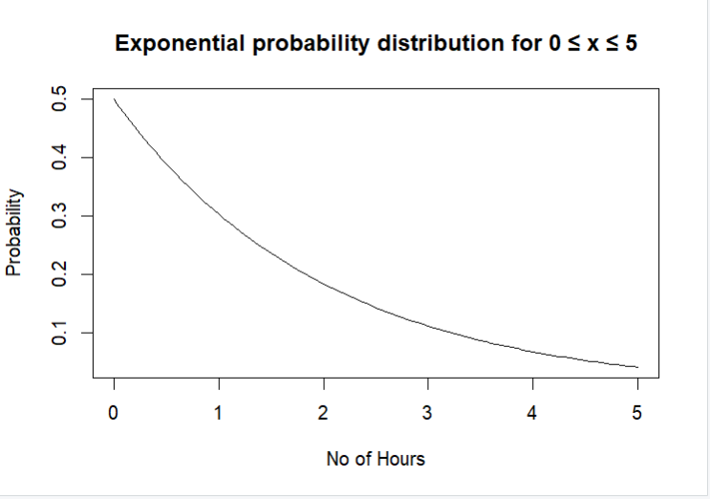

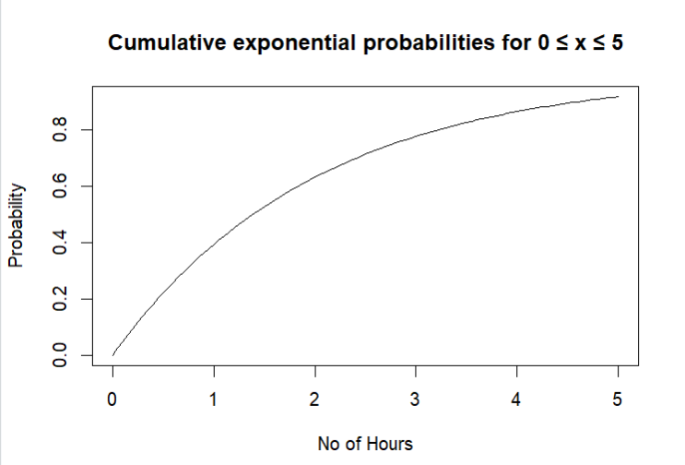

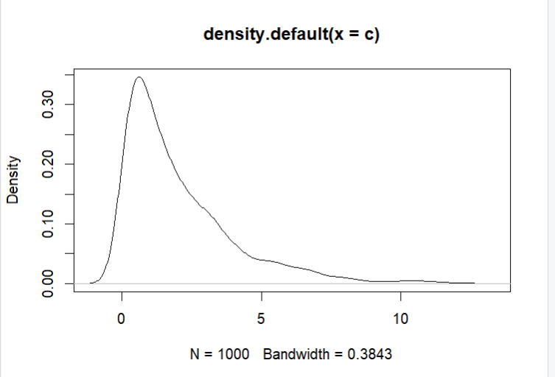

3. The lifetime of certain equipment is described by a random variable X that follows Gamma distribution with parameters α = 2 and β = 1/3. (a) Find the probability that the lifetime of equipment is (i) 3 units of time, and (ii) at least 1 unit of time. (b) What is the value of c, if P(X ≤ c) ≥ 0.70? (Hint: try quantile function qgamma())

CODE:

print(paste("Probability that the lifetime of equipment is 3 units of time",dgamma(3,2,3)))

print(paste("Probability that the lifetime of equipment is at least 1 unit of time",pgamma(1,2,3,lower.tail=FALSE)))

print(paste("The value of density function at x = 3:",qgamma(0.7,2,3)))

OUTPUT:  
