Data
Dataset: The project uses a synthetic logistics dataset containing 1,800 shipments across four regions, transported by road, rail, air and sea.
Types of data: It includes numerical data, such as distance, cargo weight and delay risk scores, and categorical data, such as weather conditions, transport methods and delay labels.
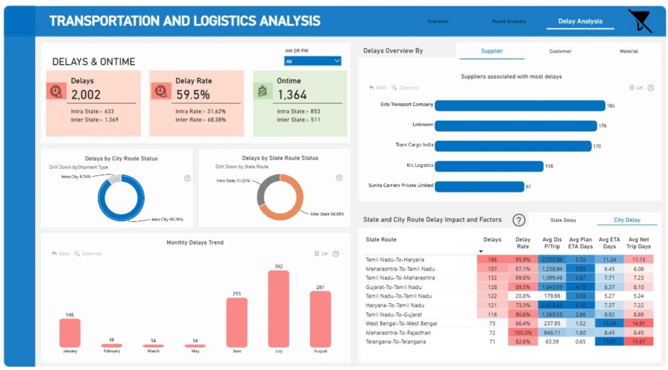

Delay patterns: The dataset records 923 minor delays, 716 major delays, 101 critical delays and 60 shipments that are on time.

Purpose of the data: The information helps the AI system identify possible delays, classify their severity and recommend actions such as monitoring, rerouting, holding or expediting shipments.
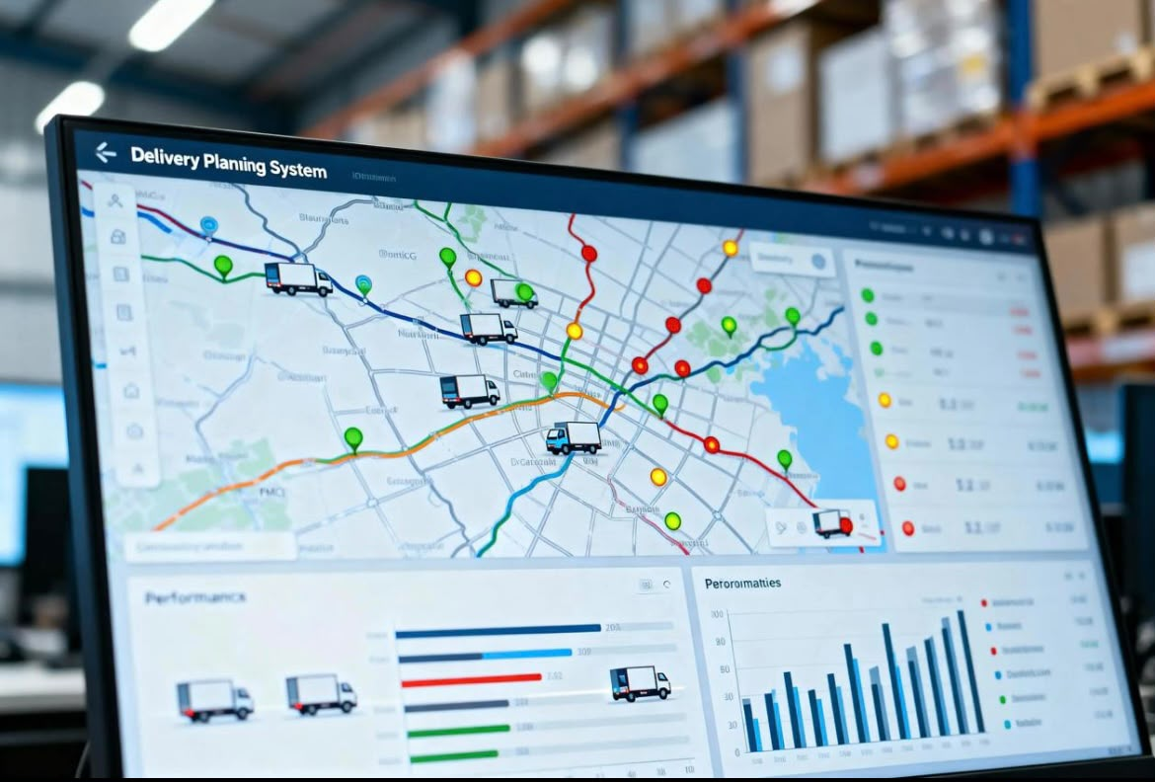

Data analysis: Python and pandas will be used to organise and prepare the data before training and testing the Decision Tree, Random Forest and Logistic Regression models.
Testing accuracy: The models will be evaluated using accuracy, precision and recall to check how well they predict shipment delays.
Limitation: Since the data is synthetic, it may not fully reflect real logistics conditions. Testing with real shipment data would help determine how well the system works in practice.
