Bacterial Colony Count using Image Processing

Basic Operations on Image:

1.Dilation:

In dilation, the output pixel is the maximum value of all pixels in the neighborhood.

Morphological dilation makes objects more visible and fills in the small holes in the objects.

A structuring element is required for performing dilation operation.

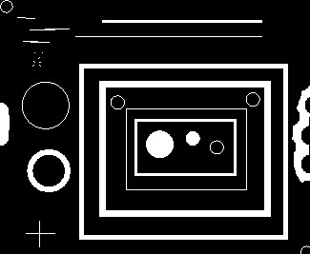 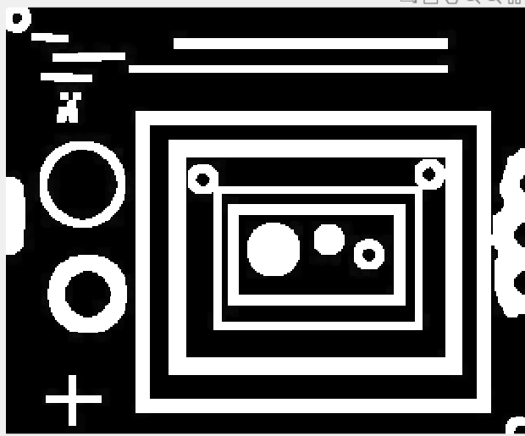

Original Image Dilated image

2.Erosion:

In erosion, the output pixel is the minimum value of all pixels in the neighborhood. In a binary image, a pixel is set to 0 if any of the neighboring pixels have the value 0.

Morphological erosion removes islands and other small objects from the image resulting in only substantive objects to stay in the image.

A structuring element is required for performing erosion operation.

 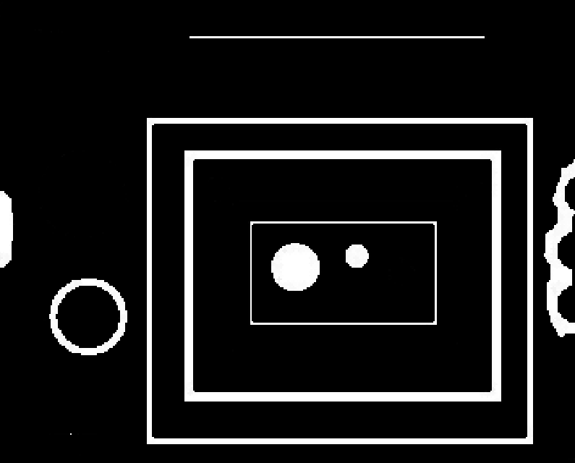

Original Image Eroded Image

3.Morphological opening:

The opening operation erodes an image and then dilates the eroded image, using the same structuring element for both operations.

 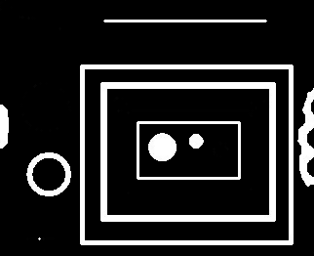

Original Image Closed Image

4.Morphological closing:

In morphological closing of an image, the first operation is dilation followed by erosion. This is helpful for filling in small holes within the image while preserving the shape and size of the objects in the image.

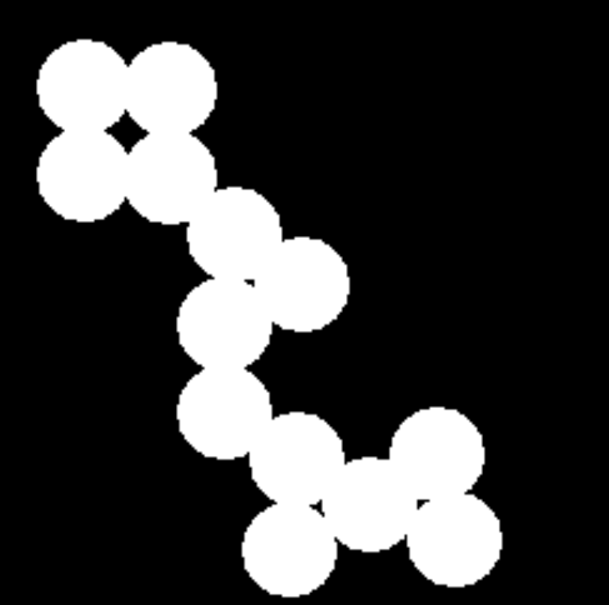 

Original image After closing

5.Thresholding:

Binary thresholding is the operation to change the pixel values of an image into 0 or 1 depending upon whether the corresponding pixel value is less or greater than a set threshold pixel value.

6.Pixel Connectivity:

Pixels are said to be 8-connected if their edges or corners touch. Two adjoining pixels are part of the same object if they are both on and are connected along the horizontal, vertical or diagonal direction.

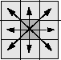

7. Connected Components:

After converting a color image to a black and white image, we might extract the number of distinct areas in the image which are white in color which represent objects in the color image.This can be done by:

1.Run-length encoding the input image.

2.Scan the runs, assigning preliminary labels and recording label equivalences in a local equivalence table.

3.Resolve the equivalence classes.

4.Relabel the runs based on the resolved equivalence classes.

(Source: [https://in.mathworks.com/help/images/ref/bwlabel.html#:~:text=Scan%20the%20runs,resolved%20equivalence%20classes.)](https://in.mathworks.com/help/images/ref/bwlabel.html%23:~:text=Scan%20the%20runs,resolved%20equivalence%20classes.))

*This is how we can detect number of objects of a particular type in a black and white image. This forms the basis of bacterial colony count using image processing techniques.*

**Luckily, in MATLAB we have the ‘bwlabel’ module which does the same .**

*Source:* [*https://in.mathworks.com/help/thingspeak/detect-and-measure-circular-objects-in-an-image.html*](https://in.mathworks.com/help/thingspeak/detect-and-measure-circular-objects-in-an-image.html)

** **

**Number of coins detected using ‘bwlabel’ in MATLAB is : 9**

**Bacterial Colony:**

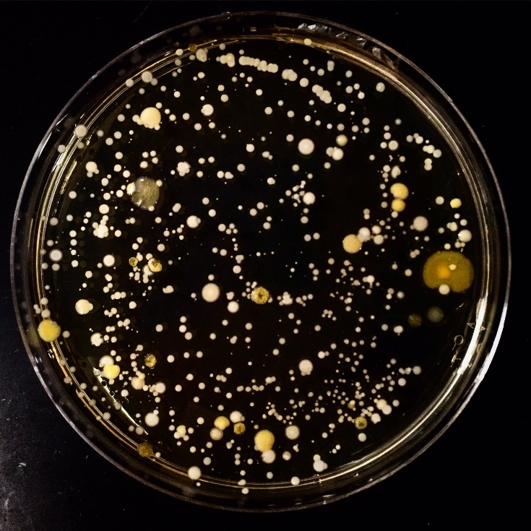

Proposed algorithm for Bacterial Colony Count:

Thresholding

Black and White

Original Color Image

Morphological Processing

Processed Image

Finding number of connected components

Original Image:

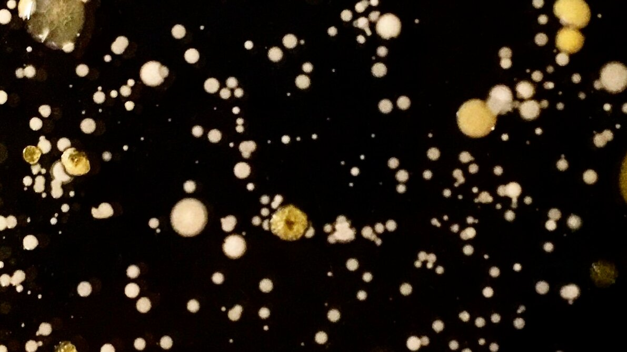

<https://www.the-scientist.com/image-of-the-day/image-of-the-day--hand-microbes-66574>

Black and White:

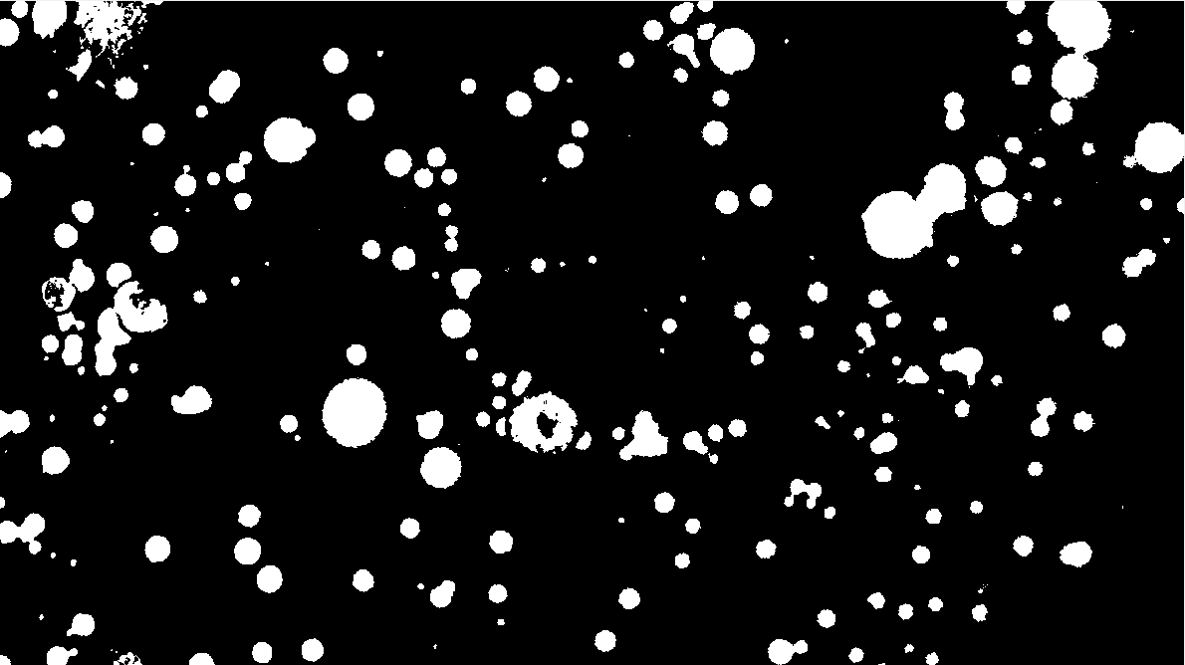

Image after dilation with a structuring element of radius 3:

*Number of bacteria counted = 197*

Dilation followed by erosion with a structuring element of radius 1:



*Number of bacteria counted = 201*

Some more examples:

1.

 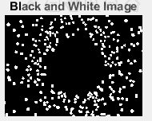 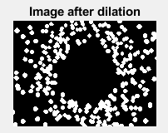 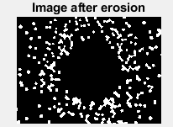

Original Image Black and White After dilation After erosion

Number of bacteria counted after the eroded image =137

Number of bacteria counted within black and white image =137

2.

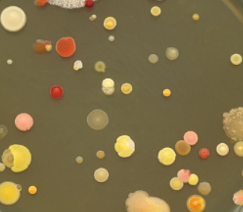  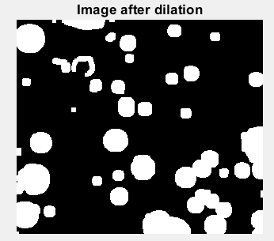 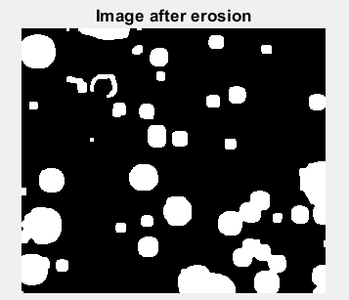

Original Image Black and White After dilation After erosion

Number of bacteria counted after the eroded image =40

Number of bacteria counted within black and white image =49

3.

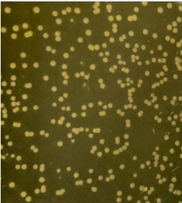 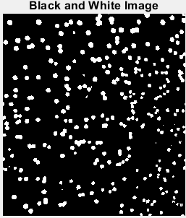 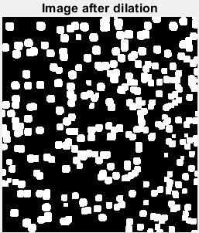 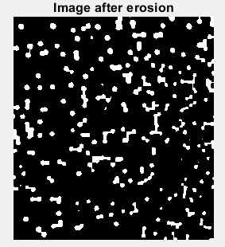

Number of bacteria counted after the eroded image = 181

Number of bacteria counted within black and white image = 244

Conclusions:

1. Morphological image processing techniques enable us to extract various useful features from an image like object detection, count etc.
2. Bacterial colony count can be fairly dealt with by morphological image processing.
3. Morphological opening and closing can be done on black and white images of the bacterial colony. On these morphologically processed images, we apply image processing techniques to count the number of objects. The objects to be counted must be white in color and the background black.
4. Counting objects using image processing techniques shouldn’t only be done after morphological image processing. Counting shall also be done in the black and white version of the original image. This is due to the fact that on morphological image processing, due to erosion and dilution, we might lose some features from the image. Hence, it is very important for us to look at the three images; Black and white version of the original image, image obtained after dilation on the black and white image as well as the image obtained after performing erosion on the dilated image. We should apply counting of objects only on the best image out of these three in which the bacteria are clearly segmented to the maximum extent.