High Level Design (HLD)

Mizuho SASE Implementation
Hong Kong, Philippines & Taiwan

File Name | Mizuho SASE High Level Design
Version | 1.00
Template Version | HLD-templatev6.0
Sensitivity Classification | Company Confidential - Client / Vendor Information
Document Owner | NTT DATA

Preparation

Action | Name | Role / Function | Date
Prepared by: | Promit Bhattacherjee | Solution Architect | 18.12.2025
Prepared by: | Promit Bhattacherjee | Solution Architect | 18.12.2025
Reviewed by:
Approved by:

Release

Version | Date Released | Change Notice | Remarks
1.0 | 18.12.2025 | Initial document | First draft

Table of Contents
Table of Contents 1
1. Solution Strategy 1
1.1 Overview 1
1.1.1 Current Customer Situation 1
1.1.2 Desired Scenario / TO BE 1
2. Scope, Requirements, and Limitations 1
2.1 Scope 1
2.1.1 Managed Services Scope 1
2.2 Requirements 1
2.3 Limitations 1
2.4 Requirements Table 1
2.5 Assumptions Table 1
3. Implementation Plan and Strategy 1
3.1 Phase 1: Project Inception 1
3.2 Phase 2: Project Definition 1
3.3 Phase 3: Project Build 1
3.4 Phase 4: Project Deployment 1
3.5 Phase 5: Transition to Operations 1
4. Solution Architecture 1
4.1 The Solution 1
4.1.1 Client Service Zone (CSZ) 1
4.1.2 Shared Management Zone (SMZ) 1
4.1.3 Client Workload Zone (CWZ) 1
4.2 Key Components of the Solution 1
5. Networking Solution 1
5.1 Network Design Overview 1
5.1.1 VPC Architecture 1
5.1.2 Transit Gateway Integration 1
5.2 Internet Connectivity 1
5.3 VPN Requirements 1
5.3.1 IKE Phase 1 (Main Mode) Parameters 1
5.3.2 IKE Phase 2 (Quick Mode) Parameters 1
6. FortiManager & FortiAnalyzer Deployment 1
6.1 AWS Infrastructure Setup 1
6.2 Network Port Requirements 1
6.2.1 FortiManager Ports 1
6.2.2 FortiAnalyzer Ports 1
7. Security and Compliance 1
7.1 Firewall Deployment 1
7.2 DDoS Protection Service (Hong Kong Only) 1
7.3 Vulnerability Assessment 1
8. NTT DATA Management Zone 1
8.1 Overview 1
8.2 Shared Management Zones 1
8.3 AMZ Security Controls 1
9. Project RACI Matrix 1
9.1 Infrastructure and Licenses 1
9.2 Professional Services 1
10. Service Level Agreement 1
10.1 Incident Response Time Targets 1
10.2 Service Request Targets 1
10.3 Service Delivery Systems Availability 1
11. Naming Convention 1
11.1 Cloud Resources Naming 1
11.2 Resource Type Prefixes 1
12. Deliverables 1
12.1 Documentation Deliverables 1
12.2 Completion Criteria 1
Appendix A: Configuration Item List 1
Appendix B: Client Locations 1

1. Solution Strategy

1.1 Overview
This document provides a detailed high-level design for the Mizuho SASE (Secure Access Service Edge) implementation across Hong Kong, Philippines, and Taiwan locations. The solution integrates on-premises infrastructure with AWS cloud services to provide centralized firewall management, security logging, and network connectivity.
The architecture is designed to provide secure, scalable, and manageable network infrastructure leveraging FortiGate firewalls, FortiManager for centralized management, and FortiAnalyzer for comprehensive logging and analysis hosted in AWS.

1.1.1 Current Customer Situation
Mizuho requires a modernized network security infrastructure across multiple APAC locations including:
- Hong Kong - Main Data Center (MDC) and Backup Data Center (BDC)
- Taiwan - Uchiko and Ryutan sites
- Philippines - Manila Branch and Manila SBS
The current infrastructure requires upgraded routing equipment, enhanced firewall capabilities, and centralized security management and monitoring.

1.1.2 Desired Scenario / TO BE
The target architecture implements a hub-and-spoke model with:
- On-premises deployment of Cisco C8300 routers for NAT and tunnel connectivity at each site
- FortiGate FG100F firewalls at each location for security enforcement
- AWS-hosted FortiManager and FortiAnalyzer in High Availability configuration
- Site-to-Site VPN connectivity between on-premises locations and AWS
- Centralized security policy management and log analysis

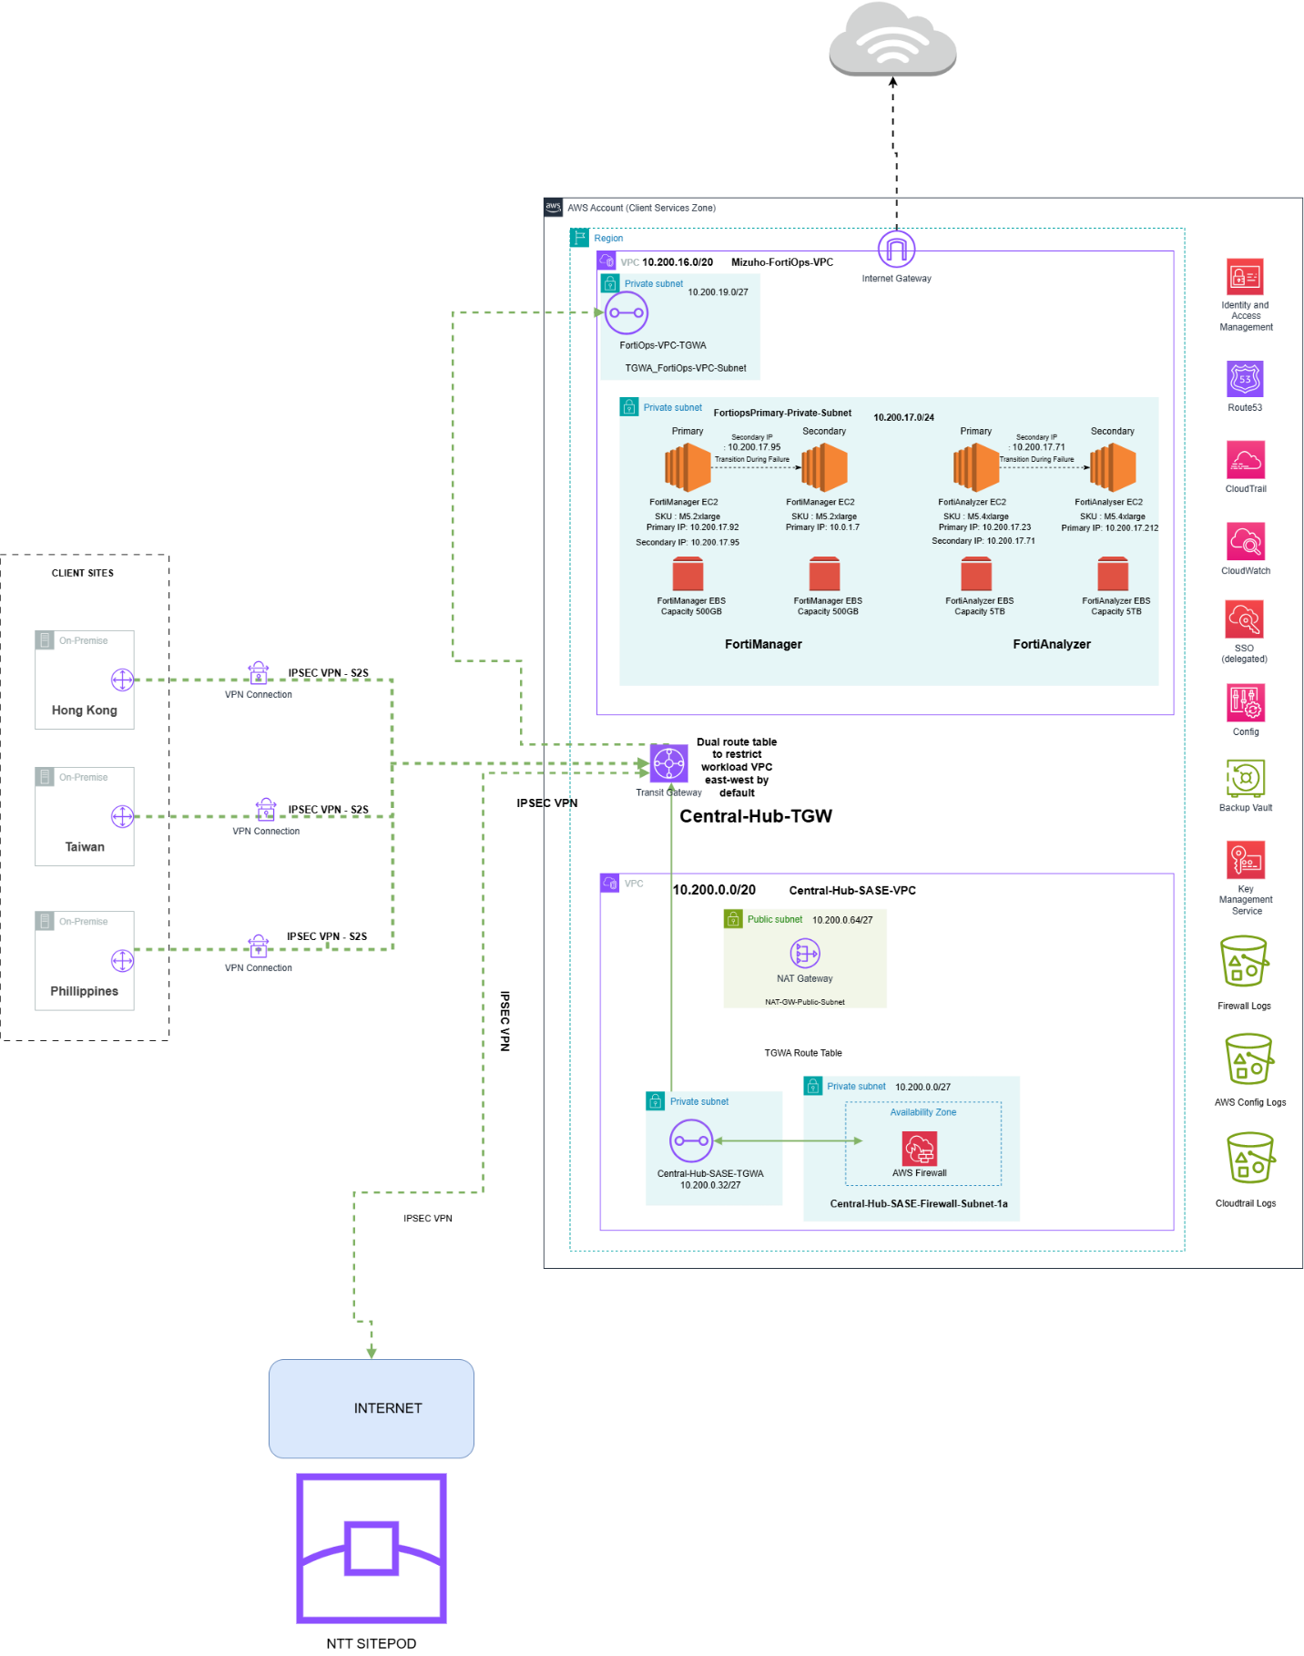

2. Scope, Requirements, and Limitations

2.1 Scope
The scope of this engagement includes:
- Installation and configuration of Cisco C8300-1N1S-4T2X routers (NAT and Tunnel) at each site
- Deployment and configuration of FortiGate FG100F firewalls at each site
- AWS infrastructure setup including VPC, subnets, and Transit Gateway
- Deployment of FortiManager VM in High Availability mode on AWS
- Deployment of FortiAnalyzer VM in High Availability mode on AWS
- Site-to-Site VPN configuration between on-premises and AWS
- Integration of FortiGate devices with FortiManager and FortiAnalyzer
- Network vulnerability assessment for all deployed devices
- DDoS Protection Service for Hong Kong sites
- Managed Campus Network Services for ongoing operations

2.1.1 Managed Services Scope
Managed Services | Service Descriptions
AWS Infrastructure | Cloud infrastructure management services (IaaS and PaaS)
Network Components | Managed Router and Managed Fortinet Edge services
FortiManager | Centralized firewall policy and configuration management
FortiAnalyzer | Centralized logging, analysis, and reporting
VPN Connectivity | Site-to-Site VPN management and monitoring

2.2 Requirements
To successfully deliver the services, the following requirements must be met:
- Client to provide access and site contact for service confirmation
- Client will provide power and identify mounting location for equipment
- Client to undertake all change management requirements
- Client to ensure cables are already laid and in working condition
- Client to supply most up-to-date configuration templates with necessary parameters
- All documentation and support will be provided in English

2.3 Limitations
The following items are explicitly out of scope:
- Disaster Recovery (DR) implementation
- Consulting Services beyond defined scope
- Workstation related cable port mapping, patching, and migration
- Rearrangement or decommissioning of existing equipment
- Configuration of Zscaler and Azure
- Lab setup and pretesting of configuration
- Structured cabling
- Splunk integration during Phase 1

2.4 Requirements Table
Req ID | Scope | Requirement Description | High Level Design Definition
1 | Language | All documentation must be in English | All deliverables will be in English
2 | Access | Client must provide required access and authorization | Access credentials to AWS and on-premises systems must be provided
3 | DR | DR is out of scope unless specified | No DR solution will be designed or implemented
4 | High Availability | FortiManager and FortiAnalyzer require HA | Both systems deployed in HA mode on AWS

2.5 Assumptions Table
ID | Scope | Assumption Description | High Level Design Definition
1 | Access | Client will provide timely access to all required systems | Project timelines depend on prompt access from client
2 | Licensing | All necessary licenses will be procured by client | NTT will not be responsible for delays due to missing licenses
3 | AWS | AWS calculator estimates based on log session calculations | Actual costs may vary based on discovery process
4 | Connectivity | Site locations are within 50km of nearest NTT office | Additional charges may apply for distant locations

3. Implementation Plan and Strategy
The implementation follows NTT's Primer methodology comprising five phases:

3.1 Phase 1: Project Inception
- Plan phase for requirements gathering and solution inception
- Pre-deployment discussion and kick-off meeting
- Requirement and configuration details gathering

3.2 Phase 2: Project Definition
- Setup scan environment on NTT local machine
- VA Security License activation
- Functionality and user requirements definition
- Project management planning and scoping

3.3 Phase 3: Project Build
AWS Environment Provisioning:
- Create dedicated AWS account under NTT governance
- Set up foundational infrastructure: VPCs, subnets, route tables, NAT gateways
- Establish secure VPN connectivity between AWS and on-premises
Core Services Integration:
- Deploy FortiManager with HA on AWS M5.large instances
- Deploy FortiAnalyzer with HA on AWS M5.4xlarge instances
- Configure Site-to-Site VPN tunnels
- Implement monitoring and logging

3.4 Phase 4: Project Deployment
Taiwan Deployment:
- Uchiko DC - 1 NAT Router, 1 Tunnel Router, 1 FortiGate FG100F
- Ryutan BDC - 1 NAT Router, 1 Tunnel Router, 1 FortiGate FG100F
Philippines Deployment:
- Manila Branch - 1 NAT Router, 1 Tunnel Router, 1 FortiGate FG100F
- Manila SBS - 1 NAT Router, 1 Tunnel Router, 1 FortiGate FG100F
Hong Kong Deployment:
- MDC - 1 NAT Router, 1 Tunnel Router, 1 FortiGate FG100F
- BDC - 1 NAT Router, 1 Tunnel Router, 1 FortiGate FG100F
- Cloud - FortiManager and FortiAnalyzer

3.5 Phase 5: Transition to Operations
- Knowledge transfer and technical Q&A with Mizuho technical team
- Validation and acceptance testing
- Documentation finalization
- Handover to managed services team

4. Solution Architecture

4.1 The Solution
The proposed solution implements a hybrid architecture integrating on-premises infrastructure with AWS cloud services. The architecture is segmented into three primary zones:

4.1.1 Client Service Zone (CSZ)
The CSZ acts as the central hub in a hub-and-spoke model and includes:
- Transit Gateway - Central routing hub connecting multiple VPCs and on-premises networks
- Firewall VPC - Hosts AWS Network Firewall and associated route tables
- S3 Buckets - Storage for firewall logs, AWS Config logs, and CloudTrail logs
- CloudTrail - Account activity capture and storage for auditing
- CloudWatch - Monitoring and alerting for AWS resources
- AWS Config - Configuration change tracking and compliance
- AWS KMS - Encryption key management
- IAM - Identity and access control management

4.1.2 Shared Management Zone (SMZ)
The SMZ is hosted in NTT Data Center and handles monitoring and support activities:
- Connects to CSZ via IPsec VPN tunnels over the internet
- All traffic routed through Transit Gateway and firewall inspection
- Provides centralized management tooling

4.1.3 Client Workload Zone (CWZ)
The CWZ hosts customer workloads and security management tools:
- Transit Gateway Attachment - Connects CWZ VPC to Transit Gateway in CSZ
- Private Subnet - Hosts FortiManager and FortiAnalyzer EC2 instances
- FortiManager - Deployed on EC2 M5.large with HA for configuration management
- FortiAnalyzer - Deployed on EC2 M5.4xlarge with HA for log analysis
- NAT Gateway - Internet access for instances in private subnet
- IPsec VPN Tunnels - Connects to on-premises data centers

4.2 Key Components of the Solution
Component | Specification | Purpose
Cisco C8300-1N1S-4T2X | Catalyst Router - 12 units total | NAT and Tunnel routing at each site
FortiGate FG100F | Next-Gen Firewall - 6 units total | Security enforcement at each site
FortiManager VM | AWS M5.large - 2 instances (HA) | Centralized policy management
FortiAnalyzer VM | AWS M5.4xlarge - 2 instances (HA) | Log analysis and reporting (30,000 logs/sec)
AWS Transit Gateway | Regional TGW deployment | Central routing hub for VPC connectivity

5. Networking Solution

5.1 Network Design Overview
The networking design ensures secure, scalable, and centralized connectivity between on-premises locations and AWS cloud infrastructure.

5.1.1 VPC Architecture
- Dedicated AWS account for FortiManager and FortiAnalyzer hosting
- Single VPC with multiple subnets across Availability Zones
- Private subnets for FortiManager and FortiAnalyzer instances
- Public subnets for NAT Gateway and internet connectivity

5.1.2 Transit Gateway Integration
- Centralized Transit Gateway for inter-VPC and hybrid connectivity
- TGW attachment in dedicated /28 subnet
- Route tables configured for traffic flow between all zones
- Enables connectivity to on-premises data centers via VPN

5.2 Internet Connectivity
Country | Bandwidth | Address | IP Allocation | SLA
Taiwan (Uchiko) | 400MB | 4F., No.268, Ankang Rd., Neihu Dist., Taipei City | /29 subnet | 99.9%
Taiwan (Ryutan) | 400MB | No.69, Lane 368, Sinhe Rd, Longtan Township | /29 subnet | 99.9%
Philippines (Manila) | 300MB | 25th Floor, Zuellig Building, Makati Avenue | /29 subnet | 99.9%
Philippines (SBS) | 300MB | 8343 Rack It Data Center Inc., Elorde Sports Complex | /29 subnet | 99.9%
Hong Kong (MDC) | 700MB | 2 Dai Hei Street, Tai Po Industrial Park | 1 fixed IP | 99.99%
Hong Kong (BDC) | 700MB | 6 Chun Kwong Street, Tseung Kwan O Industrial Estate | 1 fixed IP | 99.99%

5.3 VPN Requirements
Site-to-Site VPN connectivity is established using IPsec tunnels with the following specifications:

5.3.1 IKE Phase 1 (Main Mode) Parameters
Parameter | Value
IKE Version | 2
Diffie-Hellman Group | Group 15
Authentication Method | Pre-Shared Key
Hash | SHA256
Encryption | AES256
SA Lifetime | 28,800 seconds

5.3.2 IKE Phase 2 (Quick Mode) Parameters
Parameter | Value
Encryption & Hashing | AES256
Hash | SHA256
SA Lifetime | 3600 seconds
Perfect Forward Secrecy | Group 15
Mode | ESP

6. FortiManager & FortiAnalyzer Deployment

6.1 AWS Infrastructure Setup
The deployment utilizes the BYOL (Bring Your Own License) model with the following configuration:
FortiAnalyzer Configuration:
- AWS M5.4xlarge instances in High Availability mode
- Capacity: 30,000 log sessions per second
- Storage: Approximately 32TB for 1-year archive and 3-month analytics
FortiManager Configuration:
- AWS M5.large instances in High Availability mode
- Centralized policy and configuration management
- Integration with all FortiGate devices across sites

6.2 Network Port Requirements

6.2.1 FortiManager Ports
Outbound Ports:
- HA sync: TCP/5199
- Firmware images update: TCP/443
- IPv4 FGFM management: TCP/541
- IPv6 FGFM management: TCP/542
Inbound Ports:
- AV and IPS push updates: UDP/9443
- Management (SSH, HTTP, HTTPS, SNMP): Standard ports
- HA: TCP/5199

6.2.2 FortiAnalyzer Ports
Inbound Ports:
- HA: TCP/5199
- Log fetching: TCP/514
- OFTP/Log: TCP/514
Outbound Ports:
- HA: TCP/5199
- AV/IPS, Licensing: TCP/443

7. Security and Compliance

7.1 Firewall Deployment
Each site will have FortiGate FG100F firewall deployed with:
- FortiGuard Unified Threat Protection (UTP) Bundle licenses
- 4x 10G SFP ports aggregated for internal core switches (up to 5 VLANs)
- Up to 100 firewall policy rules and 20 NAT rules
- Integration with AAA and security logging devices
- Hardening based on Mizuho guidelines

7.2 DDoS Protection Service (Hong Kong Only)
DDoS Protection Service features:
- Applicable to incoming traffic from NTT Tier 1 global network
- Automated mitigation process
- No-blackhole policy
- 200 minutes included per month per circuit
Types of DDoS attacks handled:
- TCP SYN+ACK, TCP FIN, TCP RESET, TCP ACK
- UDP, ICMP, IGMP floods
- HTTP Flood, Brute Force, Connection Flood
- Slowloris, Spoofing, SSL Flood

7.3 Vulnerability Assessment
Network Vulnerability Assessment scope includes:
- Up to 12 IP addresses (NAT & Tunnel Routers and FortiGate firewalls)
- Grey-Box Testing with authenticated credentials
- On-site assessment at each location
- Optional retest within 90 days of initial report

8. NTT DATA Management Zone

8.1 Overview
NTT DATA Access Management Zone (AMZ) provides secure and traceable remote access to customer infrastructure with the following features:
- Multi-factor authentication (MFA)
- Session recording for all access
- PCI-DSS certified platform
- ISO 27001 certified

8.2 Shared Management Zones
Zone | Location | Region
SMZ1 (Primary) | Azure West Europe | EUROPE
SMZ2 (Backup) | Azure East US | AMERICA
SMZ3 | Azure Southeast Asia | APAC

8.3 AMZ Security Controls
- Secure builds with hardening based on CIS benchmarks
- Monthly patching on all assets
- RBAC SSO Terminal Server with MFA and PAM
- Next-gen Antivirus/antimalware and Host-based IDS
- Network segmentation with Firewall IDS
- SIEM and SOC integration
- Regular vulnerability scans and penetration tests

9. Project RACI Matrix

9.1 Infrastructure and Licenses
Description | NTT | Client
Provisioning of Public Cloud tenant | C, I | R, A
Procurement of Software Licenses | C, I | R, A
Internal NTT tooling licenses | R, A | C, I
Monitoring connections from NTT | R, A | C, I

9.2 Professional Services
Description | NTT | Client
Project Management | R, A | C, I
High Level Design Document Creation | R, A | C, I
Low Level Design Document Creation | R, A | C, I
Creation and configuration of managed elements | R, A | C, I

RACI Legend:
- R - Responsible: Performs the actual work
- A - Accountable: Ultimately answerable for correct completion
- C - Consulted: Input sought before decision or action
- I - Informed: Kept up-to-date on progress

10. Service Level Agreement

10.1 Incident Response Time Targets
Priority | Notification | Response | Restoration
1 - Critical | 15 minutes | 15 minutes | 4 hours
2 - High | 15 minutes | 30 minutes | 8 hours
3 - Medium | 15 minutes | 30 minutes | 24 hours

10.2 Service Request Targets
Feature | Response Time | Fulfilment Time
Request for Information | 24 hours | 48 hours
Standard Change | 24 hours | 48 hours

10.3 Service Delivery Systems Availability
System | Availability Target
NTT DATA Service Management System | 99.50%
NTT DATA Monitoring Platform | 99.50%
NTT DATA Automation Toolsets | 99.50%

11. Naming Convention

11.1 Cloud Resources Naming
The naming convention follows the template:
{resource_type}-{environment}[-{platform|service_group}][-{resource_name}][instance_number]
Rules:
- All names will be lowercase
- Only alphanumeric characters and dashes
- Platform name used for shared resources
- Service group name used for non-shared resources

11.2 Resource Type Prefixes
AWS Resource | Prefix
VPC | vpc
Subnet | subnet
Route Table | rtb
Security Group | sg
EC2 Instance | i
NAT Gateway | nat
Transit Gateway | tgw

12. Deliverables

12.1 Documentation Deliverables
- Site survey sheet
- Device Specifications
- Unit Test Procedures and captured logs
- Device Installation Check Sheet
- Cabling check list and rack diagram
- Migration work procedures
- Test logs and photographs
- As-built Configuration document
- Physical and Logical Diagrams
- Network Vulnerability Scan Report

12.2 Completion Criteria
- All tasks listed under Services Detail are completed
- Client has received Installation Service deliverables
- Acceptance Form signed by Client project owner
- Knowledge Transfer session completed
- Handover to NTT maintenance team for ongoing support

Appendix A: Configuration Item List
CI Manufacturer | CI Model | CI Class | Quantity
Cisco | C8300 | IP Router | 12
Fortinet | FortiGate 100F | Firewall | 6
Fortinet | FAZ-VM-GB5 | FortiAnalyzer | 2
Fortinet | FMG-VM-10-UG | FortiManager | 2

Appendix B: Client Locations
Site | Country | City | Address
Taiwan - Uchiko | Taiwan | Taipei | 4F., No.268, Ankang Rd., Neihu Dist., Taipei City 11484
Taiwan - Ryutan | Taiwan | Longtan | No.69, Lane 368, Sinhe Rd, Longtan Township, Taoyuan County 325
Philippines - Manila Branch | Philippines | Manila | 25th Floor, Zuellig Building, Makati Avenue corner Paseo de Roxas
Philippines - Manila SBS | Philippines | Manila | 8343 Rack It Data Center Inc., Elorde Sports Complex, Dr. A Santos
Hong Kong - MDC | Hong Kong | Hong Kong | 2 Dai Hei Street, Tai Po Industrial Park, Tai Po, N.T.
Hong Kong - BDC | Hong Kong | Hong Kong | 6 Chun Kwong Street, Tseung Kwan O Industrial Estate

