WHATSINMENU
Product & Design Recommendations
A focused roadmap for a warmer, smarter daily-meal experience
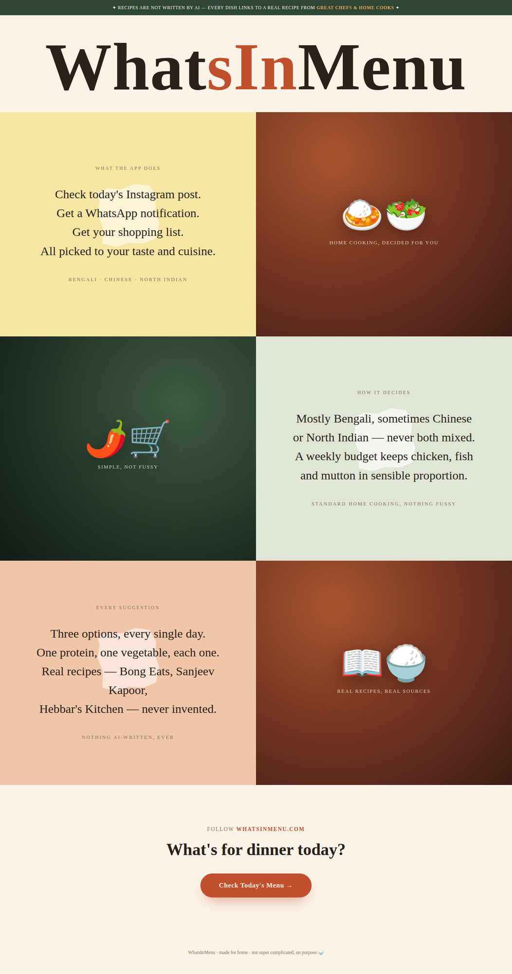
MOODBOARD PROVIDED BY THE CREATOR

EXECUTIVE RECOMMENDATION

Keep the soul. Add usefulness in layers.
The moodboard already has a distinctive personality: warm, editorial, nostalgic, and unmistakably home-cooked. The product should preserve that charm while making the daily decision - “What should I cook tonight?” - faster and more tangible.
CORE PRINCIPLE Nutrition, personalization, and planning should support the dinner decision without turning WhatsInMenu into a clinical calorie tracker or a generic recipe database.

What is already working
- A memorable serif-led identity with a confident cream, chilli-red, dark-green, and burnt-brown palette.
- A simple promise: three practical options every day, selected for familiar home cooking.
- A strong trust position: every dish links to a real recipe from a real chef or publisher.
- A culturally specific cuisine mix - mostly Bengali, with Chinese and North Indian variety - instead of an unfocused global catalogue.

The most important homepage addition
Show a real daily-menu preview near the top of the page. The current concept explains the service well, but users should be able to see the product before they reach the final call to action.
LIVE PREVIEW TONIGHT’S MENU | Chicken kosha · Aloo posto · Masoor dal
Approx. ₹___ · 45 min · Serves 3
View recipes · Swap a dish · Make shopping list

FEATURE ROADMAP

Recommended features, in priority order
1. Today’s three dishes. Show one protein and two vegetable options with a photo, cooking time, estimated cost, serving size, and source link.
2. “Not feeling this” swap. Replace one dish without regenerating the entire menu.
3. One-tap shopping list. Combine ingredients across selected dishes and group them into vegetables, protein, pantry, and spices.
4. WhatsApp delivery. Send the daily menu at a chosen time with clear actions: Cook this, Swap, and Shopping list.
5. Preference memory. Remember cuisine mix, weekly budget, household size, proteins, allergies, and disliked ingredients.
6. Use-what-I-have mode. Let users choose a few ingredients already at home and surface matching real recipes.
7. Lightweight feedback. Use “Loved it / Okay / Skip next time” to improve future suggestions without demanding reviews.
8. Trust details. Display the chef or publisher, source link, and a short reason each dish was selected.

Suggested dish-card hierarchy
Dish | Energy | Protein | Time / source
Chicken Kosha | 430 kcal | 28 g | 45 min · Bong Eats
Keep the collapsed card concise; open a Nutrition panel for the detailed breakdown.

NUTRITION LAYER

Yes to kcal and nutrients - with honest estimates
Nutrition makes the menu more useful, especially when portion size is clear. Because recipes come from external sources and quantities can vary, every value should be labelled as estimated rather than presented as medical-grade precision.

What to show on each dish
- Energy: approximately 430 kcal per serving.
- Serving size: for example, 320 g or 1 bowl / 1 plate.
- Protein, carbohydrates, fat, and fibre as the primary nutrient line.
- Sodium and sugar inside the expanded details when reliable data is available.

What to show for the whole selected meal
MEAL TOTAL YOUR DINNER | Approximately 720 kcal per person
Protein 36 g · Carbs 88 g · Fat 24 g · Fibre 11 g

Controls and safeguards
- Let users change servings or choose a Light, Regular, or Hearty portion.
- Calculate nutrition from ingredient quantities whenever the linked recipe provides them.
- State when oil, salt, garnish, substitutions, or missing quantities reduce confidence.
- Add a small “How was this calculated?” explanation.
- Avoid labelling dishes as good, bad, clean, or unhealthy.
- Keep detailed nutrients expandable so the experience still feels like a dinner helper, not a calorie-counting app.
RECOMMENDED LABEL Estimated nutrition per serving. Actual values vary with ingredients, quantities, substitutions, and cooking method.

EXPERIENCE & CONTENT

Design and copy improvements

Visual direction
- Use food photography selectively - primarily within the daily menu cards - so it does not overwhelm the editorial mood.
- Keep the large serif typography and existing palette as the core brand signature.
- Replace mixed emoji over time with a consistent hand-drawn icon set inspired by the chilli, bowl, book, and shopping cart motifs.
- On mobile, bring today’s menu and primary action above the long sequence of decorative panels.

Clarity and conversion
- Move “Check Today’s Menu” much earlier on the page and repeat it near the bottom.
- Explain whether the primary action opens the website, Instagram, or WhatsApp.
- Place a simple WhatsApp opt-in beside the first menu preview.
- Show an example menu rather than relying only on explanatory copy.

Suggested copy revisions
Current / purpose | Suggested wording
“All picked to your taste and cuisine.” | “All picked for your taste, budget, and kitchen.”
Primary CTA | “See tonight’s three dishes”
WhatsApp opt-in | “Get tomorrow’s menu on WhatsApp”

LAUNCH PLAN

Build the smallest version that feels complete
LAUNCH NOW
- Today’s three-dish menu with real source links
- A visible menu preview on the homepage
- Basic cuisine, budget, household, and dietary preferences
- Swap one dish
- Combined shopping list
- WhatsApp menu notification
- Estimated kcal and core macros per serving
ADD AFTER REAL USAGE
- Loved it / Okay / Skip next time feedback
- Use-what-I-have suggestions
- Meal history and repeat favourites
- Nutrition confidence indicators and deeper nutrient details
AVOID AT FIRST
- Complex calorie goals or medical nutrition coaching
- A social feed, ratings system, or large recipe library
- Too many filters before a user can see tonight’s menu

The decision rule
PRODUCT NORTH STAR A user should understand tonight’s menu, trust its source, see the approximate nutrition, and create a shopping list in under one minute.
If a feature does not make the nightly cooking decision easier, more trustworthy, or more personal, it can wait.

