<https://www.opencli.com/linux/ip-command>

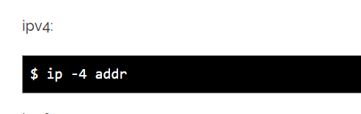

<https://danielmiessler.com/study/manually-set-ip-linux/>

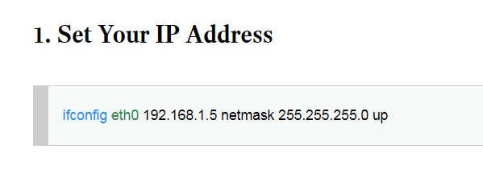

3. 利用-iperf-測試網路效能

<https://cms.35g.tw/coding/%E5%88%A9%E7%94%A8-iperf-%E6%B8%AC%E8%A9%A6%E7%B6%B2%E8%B7%AF%E6%95%88%E8%83%BD/>