4. Design
4.1 Security
4.1.1 Transport Layer Security
The first area of security the researcher explored was transport layer security (TLS). TLS ensures that information sent over the internet is encrypted rather than transmitted in plaintext [20]. This is essential for securely transmitting biometric templates and other sensitive data between client and server in a biometric e-voting system.
Enabling HTTPS within the project presented a practical challenge, as obtaining a signed TLS certificate typically requires buying a registered domain name. After investigating alternatives, the researcher identified the use of nip.io, a wildcard DNS service that maps IP addresses to hostnames, combined with Nginx as a reverse proxy to handle TLS termination [36]. This approach allowed HTTPS to be configured without purchasing a domain, satisfying the transport security requirement within the constraints of the project. It is important to note that nip.io does not support wildcard certificates, thus the domain isn’t owned or validated by the system [36]. If the system was to be used at the intended scale across the UK, an officially owned domain with wildcard TLS certificate support is required to enable scalable and manageable service exposure [37].
4.1.2 Application Layer Encryption
It was identified that TLS alone is insufficient for a system handling highly sensitive biometric and personal data. While TLS protects data in transit, it does not protect the payload if the server itself is compromised. To address this, envelope encryption was explored as an additional layer of application level protection [26].
This approach encrypts the data before transmission and ensures that only the intended server can decrypt it, meaning sensitive data such as fingerprint uploads, voter lookups, and login credentials remain protected beyond the transport layer [26]. This significantly reduces the potential of data being exposed during transport and is essential when biometric data is being transported.
4.1.3 Data at Rest
The researcher then investigated how personal voter data should be securely stored within the database. Storing data such as names, dates of birth, postcode as a searchable index and biometric information in plaintext represents a critical vulnerability, as a database breach would expose all voter information directly [38]. A further risk of databases being stored in plaintext is that developers working on the database would have access to the raw voter information, increasing the risk of a data leak.
AES-256-GCM was identified as an appropriate encryption standard due to its widespread adoption and strong security properties [21][26]. A per voter encryption approach was selected, where each voter’s data is encrypted individually. This reduces the impact of a potential breach, as compromising one record does not expose others [21][39].
Key management was identified as a critical consideration security. Best practice dictates that encryption keys should be stored separately from the data they protect, typically using a dedicated secrets management service [21][40]. This requirement influenced the database design, requiring additional fields to accommodate encrypted data with its corresponding keys.
Not all fields require encryption. Fields such as county, constituency, and “HasVoted” are stored in plaintext, as they do not directly identify individuals. This allows efficient querying and reporting without unnecessary decryption overhead. This represents a deliberate trade off between security and system usability.
For polling officials, partial protection was applied to the password field. Passwords are hashed rather than encrypted, as they do not need to be recovered, while usernames are stored in plaintext as they do not inherently contain sensitive information.
Biometric data is stored in encrypted form and is only decrypted temporarily during comparison within server memory. It is never exposed in plaintext outside this context, ensuring that database access alone would not reveal usable biometric data.

4.1.4 Authentication and Access Control
The researcher investigated how to manage access across two distinct user roles within the system: voters and officials. JSON Web Tokens (JWT) were identified as a suitable mechanism for, role-based authentication, allowing the server to verify identity and permissions on each request without maintaining session state [22][23].
Token expiry was identified as a critical security consideration. Shorter expiry windows reduce the risk of token misuse if compromised. As officials interact with the system for longer durations than voters, different expiry periods are applied depending on the user role [23].

4.1.5 Password Security
For polling officials, secure password storage is required. The researcher investigated modern password hashing algorithms and identified Argon2 as the most suitable due to the salt [24]. Argon2 was selected due to its resistance to brute force and hardware accelerated attacks, making it suitable for protecting user credentials in a security critical system [24].

4.1.6 Database Lookup Protection
A further concern identified was the risk of exposing voter identity during database lookups. Sending plaintext identity fields such as name, date of birth, and postcode introduces the risk of interception or logging at the server layer.
To address this, the researcher explored searchable encryption techniques. HMAC based token generation allows the system to perform lookups using a searchable deterministic index created from user information, without exposing the underlying plaintext data [25][12][13]. The searchable deterministic index enabled the system to use uniquely identifiable voter information to locate a fingerprint, without exposing personal data in plaintext during the process. The information used is first name, last name, date of birth, postcode and town of birth. The combination of this data makes the chance of collision extremely small.
The equations behind this statement are contained in the table below.
Function | Field | Probability
P(FN) | First name | $${ 3 ×10}^{-3}$$
P(Ln) | Last name | ${1 ×10}^{-3}$
P(DoB) | Date Of Birth | ${2.7 ×10}^{-5}$
P(PC) | Post Code | ${5.9 ×10}^{-7}$
P(ToB) | Town Of Birth | ${2 ×10}^{-4}$
Table 1. Formula used in the probability calculations.
The probability of a database record colliding with another is calculates as follows:
$$Probability of collision= P(FN)×P(LN)×P(DoB)×P(PC)×P(ToB)$$
The resulting probability is$2.4 ×{10}^{-21}$, this is notably small and reduces the natural chances of a collision to almost 0. There is a more than likely possibility of a collision through twins and this has been considered and solved, the solution is detailed in implementation.
An alternative approach would be to query using plaintext or directly encrypted fields; however, this was rejected due to the increased risk of sensitive data exposure during processing.
The National Insurance number is treated as an exception and is not used as a searchable. The reason for this is due to one big issue, not all voters have a National Insurance number, but all votes need the information used in the searchable deterministic index to vote, thus National Insurance number was not used [9]. Figure X illustrates the full voter authentication flow, it includes how the system does deal with collisions by iterating through the candidate records.
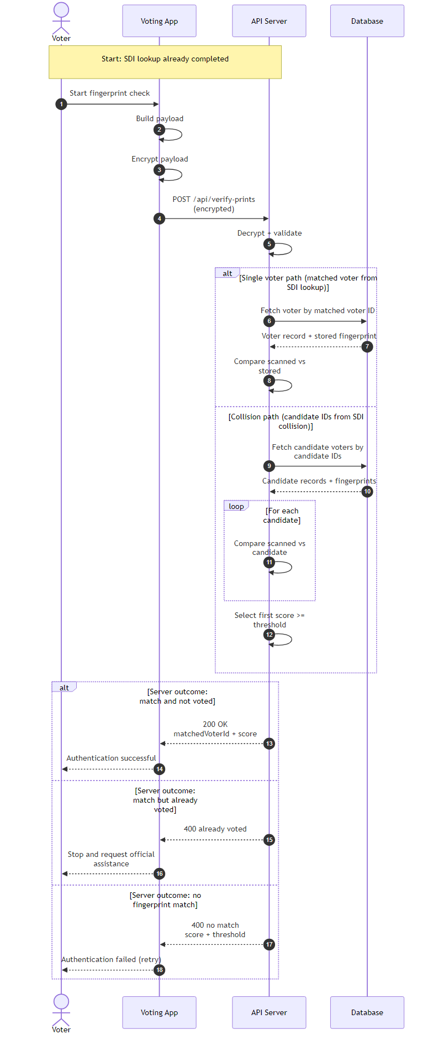
Figure X – Sequence Diagram of Authentication Flow as a Voter

4.1.7 Linking Code Integrity
Session linking codes, used to associate sessions across system components, are hashed using SHA-256. SHA-256 was selected due to its computational efficiency, which is appropriate given that these codes are frequently regenerated [54].
Brute force attacks are not considered a practical concern in this context, as the codes rotate regularly, limiting the usefulness of any successful attack.
4.2 System Structure
The system consists of four main components: server, database, two client applications, and a hosting platform. The technologies selected for each component were chosen based on compatibility, security, and project constraints. In Figure X the components are shown in how they communicate.
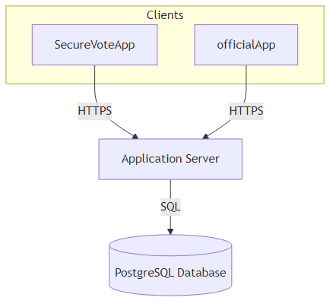
Figure X - System Architecture Diagram

4.2.1 Back End
ASP.NET Core on .NET 8 was selected due to its cross platform compatibility and ability to support both API and application development within a single ecosystem [27]. As a long term support release, it benefits from ongoing security updates, making it suitable for a security critical system such as an e-voting platform.
Methods for communication between the server and clients were evaluated next. Initially, HTTP polling was considered due to its simplicity. However, it introduced latency and unnecessary network overhead. SignalR was selected instead, as it enables persistent, two way communication, allowing the server to push updates to clients in real time [28].
This approach improves responsiveness and ensures system state remains consistent across multiple active clients. The responsiveness was deemed essential as statuses are sent to the official app when issues occur on the voter device. These status messages were found to arrive 30 seconds after the status change had occurred, making warning statuses outdated.
A key design feature of the server is its channels. The SignalR channels are organised firstly by county and then by constituency. This channel structure is designed to speed up finding a channel, making connections faster. This organisation also can be used to assign more server power to certain counties with a high number of connections, as a higher population a county might need more polling stations than others. This supports scalability, as system load can be distributed geographically without requiring architectural changes.
The active election configuration is hardcoded in the current implementation. While a dynamic configuration system would provide greater flexibility, it introduces a risk of accidental or malicious modification to negate election results. Hardcoding removes this risk and ensures changes require deliberate redeployment.

4.2.2 Front End
Several front end frameworks were evaluated for this system. WPF was rejected due to its only being compatible with Windows, and MAUI was discounted as its Linux desktop support was not production ready at the time of development. Avalonia was elected as the framework in this project. Avalonia is a cross platform User Interface (UI) framework for .NET that supports multiple operating systems from a single codebase, reducing development complexity and ensuring compatibility with the chosen backend technologies [29].
Usability was a key design consideration, as the system is intended for use across the UK’s population ranging from all technical ability. To support this, a simple and structured interface was designed, incorporating guided inputs and constrained controls where possible. This approach reduces user error and limits the range of acceptable input, which also contributes to minimising the system’s attack surface [49].
At the initial design stage, two key aspects guided the development process. The first was to create an intuitive user interface (UI) that is accessible to users of all ages. The second was to minimise user input in order to reduce the system’s attack surface. To support these goals, high fidelity mock ups of both the voter and official application were produced. These were hand drawn on an iPad using Notability and are included in Appendix A.
The design of the mock ups followed the defined user stories (Appendix B), ensuring that the researcher remained focused on the system’s intended functionality while developing a user friendly interface. However, the first round of user surveys revealed several usability issues within the UI. In particular, the interface shown in Figure X was consistently identified by participants as complex, unclear, and visually cluttered. Based on this feedback, the researcher simplified this view.
Although the initial revisions focused primarily on improving Figure X, feedback from the second round of surveys highlighted broader concerns regarding the not yet styled and inconsistent appearance of the interface. As a result, a more comprehensive redesign of the entire system was undertaken by the researcher using feedback from the surveys.

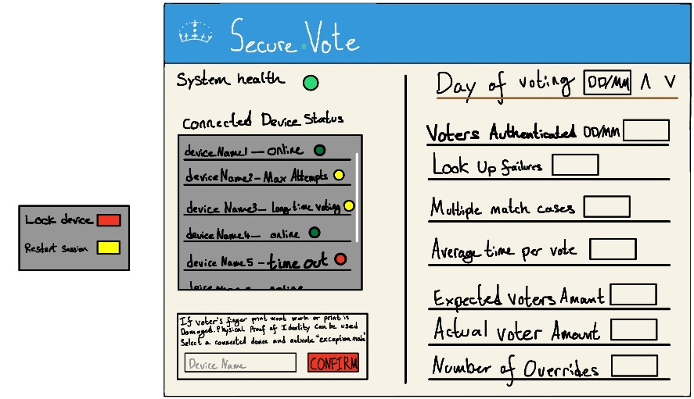
Figure X Official Polling Station Management Screen

4.2.3 Database
PostgreSQL was selected as the database system due to its reliability, strong support for structured data, and compatibility with the chosen technology stack [30].
Entity Framework Core (EF Core) was used as the Object Relational Mapper, allowing interaction with the database through object oriented code rather than raw SQL queries [30]. This improves development efficiency and supports parameterised queries, reducing the risk of SQL injection. [30]
The system follows data minimisation principles, storing only the information required for identity verification and administration. Fields used for lookup are transformed into searchable indices, ensuring that sensitive data is not stored in plaintext while still allowing efficient queries.
The database schema was adapted to support the encryption model described in Section 4.1.3, reflecting how security requirements influenced the overall system design.
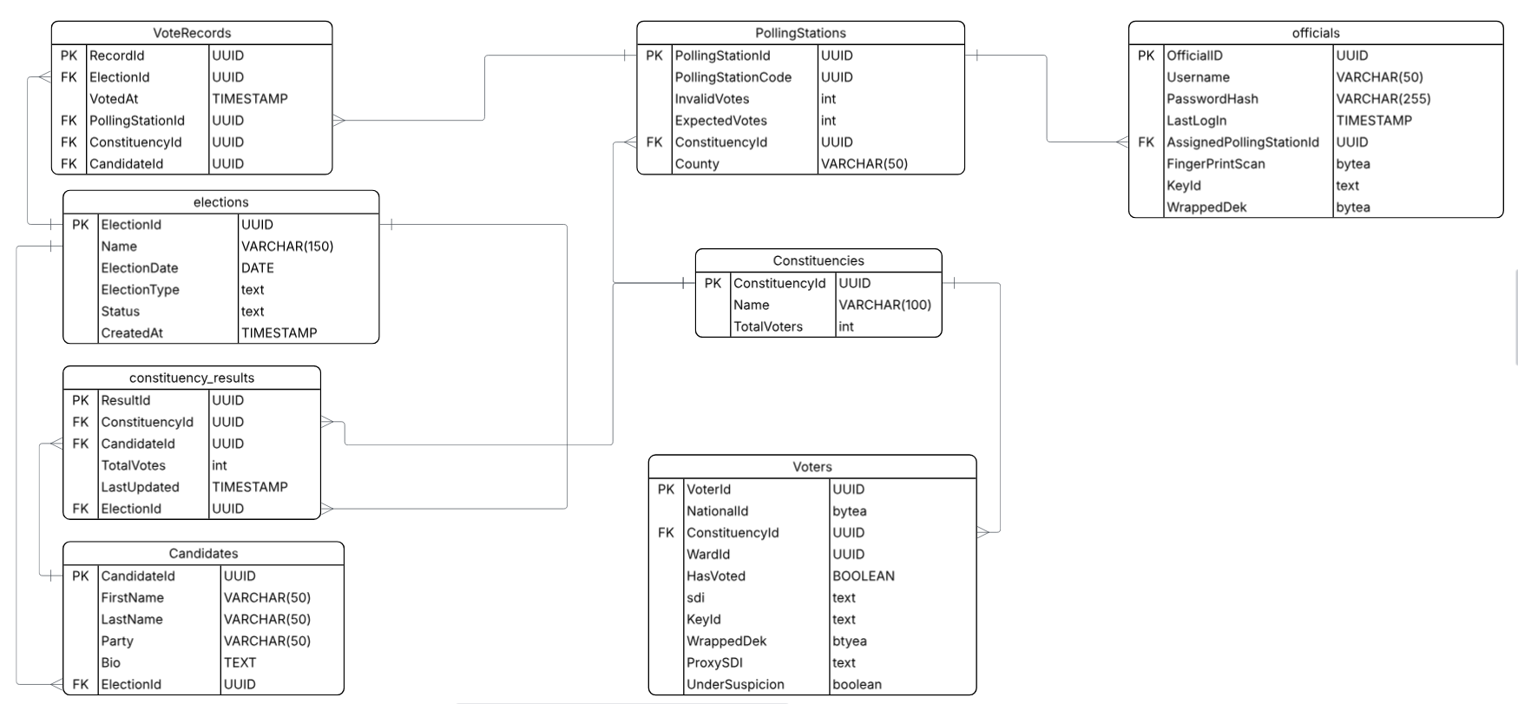Figure X Entity Relationship Diagram showing structure and connections of tables in the systems database
A key data design choice for this system is the reduction of information, as shown in figure X that the “Voter” table doesn’t contain any personal information on the voter. This design is based on two main considerations: protecting data, since information cannot be compromised if it is not stored, and enabling linking of systems. The UK government already have an electoral database, storing information key to the election [50]. The system would piggyback off this electoral register and connect itself by either adding the searchable deterministic index or by linking records using National Insurance number [50]. This would allow for a smooth combination of databases and start to combine records into the UK’s electoral system.

4.2.4 Hosting Platform
Amazon Web Services (AWS) was selected as the hosting platform due to its maturity, reliability, and strong security infrastructure. The use of AWS Learner Lab provided access to core services within the constraints of the project.
Two separate EC2 instances were deployed, one for the backend server and one for the PostgreSQL database. This separation ensures the database is not directly exposed to the public internet, as the server instance’s elastic IP is the only entity permitted to communicate with it, enforced through security group rules [53]. This approach significantly reduces the system’s attack surface.
Elastic IP addresses are assigned to both instances to ensure consistent addressing, which is required for DNS mapping using nip.io [36].
Sensitive configuration values, including database credentials and encryption keys, are stored using AWS Secrets Manager. Access to these secrets is restricted through IAM permissions, ensuring that only the server instance can retrieve them [53].
4.2.5 Biometric Hardware and Matching
The fingerprint scanner used in the project is a Columbo USB capacitive fingerprint scanner. Capacitive sensors measure electrical properties of the fingertip, making them more resistant to spoofing compared to optical alternatives [11].
Due to hardware limitations, the device outputs images in PNG format rather than standard biometric templates modern scanners produce. This influenced the design of the biometric processing pipeline.
SourceAFIS (AFIS) was chosen as the fingerprint matching library for this system. It is implemented in C# making it a native fit within the existing .NET ecosystem. It was also chosen for its ability to compare PNG templates due to the Columbos restrictions. AFIS accepts fingerprint images directly as input, meaning no format conversion was required [51]. AFIS operates on extracted minutiae points rather than raw images, comparing ridge endings and bifurcations between a probe template and a candidate template to produce a similarity score [51]. This approach is well established in identity verification and is significantly more robust to image variation than pixel level comparison [16]. Academic evaluation of AFIS on the FVC 2006 benchmark database achieved an Equal Error Rate (EER) of 0.379%, demonstrating strong matching precision under controlled conditions [52]. The library supports both one-to-one verification and one-to-many search, both of which are required by this system. Being open source was a practical advantage within the budget constraints of the project, though the primary justification for its selection remains its low equal error rate, its .NET native implementation, and its transparent, auditable algorithm design [5].
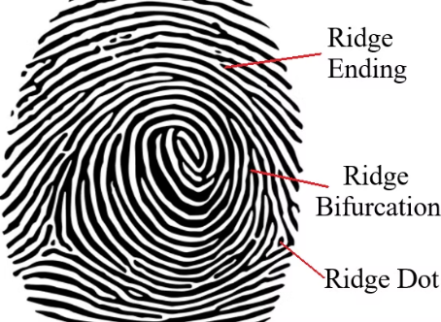
Figure X. Diagram illustrating features of fingerprints [55].

4.3 Integration and Accessibility
Drawing on the insights from the Brazilian system, the proposed e-voting system would initially operate alongside the traditional paper based method. Unlike the Brazilian approach, the intention would be to introduce the biometric e-voting system immediately on an optional basis. This gradual, voluntary adoption would expose a significant portion of the electorate to the technology over time, helping to cultivate the public trust that this project seeks to establish. Importantly, this phased rollout would also generate substantial real world usage data, revealing unforeseen usability challenges as well as areas in which the system performs particularly well. Once sufficiently tested and refined through this process, the system would be well positioned to transition into the primary voting method across the UK.
In its current form however, the system has notable accessibility limitations. As it stands, the design is tailored specifically for use within a polling station, which presents a significant challenge given the proposal to replace the postal vote. Removing this option would disadvantage voters with limited mobility who depend on it and are unable to attend a polling station in person. Addressing this shortcoming will require further development. Potential solutions include the creation of a dedicated application that would allow an authorised official to oversee and facilitate voting outside of a polling station, or alternatively, the migration of the system to an online platform using biometric authentication through approved scanners integrated into a voter's personal device. Another potential method would be to assess eligibility for postal voting, make it only necessary for people unable to make it to a polling station.

Bibliography
[1]
M. Da Costa-Abreu and S. Smith, “Using biometric-based identification systems in Brazil: A review on low cost fingerprint techniques on-the-go,” Computer Law & Security Review, vol. 33, no. 5, pp. 629–634, Oct. 2017, doi: https://doi.org/10.1016/j.clsr.2017.03.003.
[2]
D. Sadhya and T. Sahu, “A critical survey of the security and privacy aspects of the Aadhaar framework,” Computers & Security, vol. 140, p. 103782, May 2024, doi: https://doi.org/10.1016/j.cose.2024.103782.
[3]
O. S. Afolabi, “Biometric Technologies, Electoral Fraud and the Management of Elections in Nigeria and Zimbabwe,” Strategic Review for Southern Africa, vol. 42, no. 2, Dec. 2020, doi: https://doi.org/10.35293/srsa.v42i2.80.
[4]
S. Anwarul and S. Dahiya, “A Comprehensive Review on Face Recognition Methods and Factors Affecting Facial Recognition Accuracy,” Lecture Notes in Electrical Engineering, vol. 597, pp. 495–514, Nov. 2019, doi: https://doi.org/10.1007/978-3-030-29407-6_36.
[5]
Public Administration and Constitutional Affairs Committee, “Review of the 2024 general election,” House of Commons, Jul. 2024. Accessed: Jan. 09, 2026. [Online]. Available: https://publications.parliament.uk/pa/cm5901/cmselect/cmpubadm/487/report.html
[6]
M. C. Herron and D. A. Smith, “Postal delivery disruptions and the fragility of voting by mail: Lessons from Maine,” Research & Politics, vol. 8, no. 1, p. 205316802098143, Jan. 2021, doi: https://doi.org/10.1177/2053168020981434.
[7]
E. Hill, M. Sobolewska, S. Wilks-Heeg, and M. Borkowska, “Explaining electoral fraud in an advanced democracy: Fraud vulnerabilities, opportunities and facilitating mechanisms in British elections,” The British Journal of Politics and International Relations, vol. 19, no. 4, pp. 772–789, Jun. 2017, doi: https://doi.org/10.1177/1369148117715222.
[8]
P. Norris, “Will New Technology Boost Turnout? Evaluating Experiments in E-Voting v. All-Postal Voting Facilities in UK Local Elections,” Aug. 2003. doi: https://doi.org/10.2139/ssrn.437140.
[9]
N. Johnston, “EU referendum - the count,” House of Commons Library, May 2016. Accessed: Apr. 09, 2026. [Online]. Available: https://researchbriefings.files.parliament.uk/documents/CBP-7588/CBP-7588.pdf
[10]
UK Goverment, “Types of election, referendums, and who can vote,” GOV.UK. https://www.gov.uk/elections-in-the-uk/general-election (accessed Jan. 09, 2026).
[11]
K. K. Sadasivuni, M. T. Houkan, M. S. Taha, and J.-J. Cabibihan, “Anti-spoofing device for biometric fingerprint scanners,” IEEE Xplore, Aug. 01, 2017. https://ieeexplore.ieee.org/abstract/document/8015898 (accessed Jan. 20, 2026).
[12]
R. Alrawili, A. A. S. AlQahtani, and M. K. Khan, “Comprehensive survey: Biometric user authentication application, evaluation, and discussion,” Computers and Electrical Engineering, vol. 119, no. A, p. 109485, Oct. 2024, doi: https://doi.org/10.1016/j.compeleceng.2024.109485.
[13]
K. Nguyen, H. Proença, and F. Alonso-Fernandez, “Deep Learning for Iris Recognition: A Survey,” ACM computing surveys, vol. 56, no. 9, pp. 1–35, Apr. 2024, doi: https://doi.org/10.1145/3651306.
[14]
S. Anwarul and S. Dahiya, “A Comprehensive Review on Face Recognition Methods and Factors Affecting Facial Recognition Accuracy,” Lecture Notes in Electrical Engineering, vol. 597, pp. 495–514, Nov. 2019, doi: https://doi.org/10.1007/978-3-030-29407-6_36.
[15]
Hosam El-Sofany, Belgacem Bouallegue, and Yasser M Abd El-Latif, “A Proposed Biometric Authentication Hybrid Approach Using Iris Recognition for Improving Cloud Security,” Heliyon, vol. 10, no. 16, pp. e36390–e36390, Aug. 2024, doi: https://doi.org/10.1016/j.heliyon.2024.e36390.
[16]
W. Yang, S. Wang, J. Hu, G. Zheng, and C. Valli, “Security and Accuracy of Fingerprint-Based Biometrics: A Review,” Symmetry, vol. 11, no. 2, p. 141, Jan. 2019, doi: https://doi.org/10.3390/sym11020141.
[17]
Y. Yu, Q. Niu, L. Xiaoshi, J. Xue, W. Liu, and D. Lin, “A Review of Fingerprint Sensors: Mechanism, Characteristics, and Applications,” Micromachines (Basel), vol. 14, no. 6, pp. 1253–1253, Jun. 2023, doi: https://doi.org/10.3390/mi14061253.
[18]
L. Li, P. L. Correia, and A. Hadid, “Face recognition under spoofing attacks: countermeasures and research directions,” IET Biometrics, vol. 7, no. 1, pp. 3–14, Jan. 2018, doi: https://doi.org/10.1049/iet-bmt.2017.0089.
[19]
A. Devasia, “Biometric Access Control System Price: Full Guide (2024),” Safe and Sound Security, May 29, 2024. https://getsafeandsound.com/blog/biometric-access-control-system-price/
[20]
D. Diaz-Sanchez, A. Marin-Lopez, F. A. Mendoza, P. A. Cabarcos, and R. S. Sherratt, “TLS/PKI Challenges and Certificate Pinning Techniques for IoT and M2M Secure Communications,” IEEE Communications Surveys & Tutorials, vol. 21, no. 4, pp. 3502–3531, 2019, doi: https://doi.org/10.1109/comst.2019.2914453.
[21]
B.-Y. Sung, K.-B. Kim, and K.-W. Shin, “An AES-GCM authenticated encryption crypto-core for IoT security,” IEEE Xplore, Jan. 01, 2018. https://ieeexplore.ieee.org/abstract/document/8330586/ (accessed May 23, 2023).
[22]
O. Ethelbert, F. F. Moghaddam, P. Wieder, and R. Yahyapour, “A JSON Token-Based Authentication and Access Management Schema for Cloud SaaS Applications,” IEEE Xplore, Aug. 01, 2017. https://ieeexplore.ieee.org/abstract/document/8114462
[23]
S. Ahmed and Q. Mahmood, “An authentication based scheme for applications using JSON web token,” 2019 22nd International Multitopic Conference (INMIC), Nov. 2019, doi: https://doi.org/10.1109/inmic48123.2019.9022766.
[24]
A. Biryukov, D. Dinu, and D. Khovratovich, “Argon2: New Generation of Memory-Hard Functions for Password Hashing and Other Applications,” 2016 IEEE European Symposium on Security and Privacy (EuroS&P), Mar. 2016, doi: https://doi.org/10.1109/eurosp.2016.31.
[25]
L. Chen, K. Huang, M. Manulis, and V. Sekar, “Password-authenticated searchable encryption,” International Journal of Information Security, Nov. 2020, doi: https://doi.org/10.1007/s10207-020-00524-5.
[26]
Google, “Envelope encryption,” Google Cloud Documentation, 2025. https://docs.cloud.google.com/kms/docs/envelope-encryption
[27]
GraffersID, “.NET Advantages and Disadvantages | App Development,” Graffersid, Feb. 04, 2020. https://graffersid.com/advantages-and-disadvantages-of-using-net/
[28]
J. M. Aguilar, SignalR Programming in Microsoft ASP.NET. Microsoft, 2014.
[29]
AvaloniaUI, “Avalonia UI - Home,” avaloniaui.net. https://avaloniaui.net/
[30]
M. Mahdhi, “Integrating Databases with EF Core,” Mastering ASP.NET Core 10, pp. 215–244, 2025, doi: https://doi.org/10.1007/979-8-8688-1892-9_11.
[31]
S. M. Kumar, “The Potential Consequences of a Data Breach in Big Data Systems with Compromised Cyber Security and Privacy,” 2025 IEEE 17th International Conference on Computational Intelligence and Communication Networks (CICN), pp. 1072–1076, Dec. 2025, doi: https://doi.org/10.1109/cicn67655.2025.11368157.
[32]
ICO, “Information Commissioner’s Office,” Ico.org.uk, Mar. 21, 2023. https://ico.org.uk/
[33]
J. Galbally, R. Haraksim, and L. Beslay, “A Study of Age and Ageing in Fingerprint Biometrics,” IEEE Transactions on Information Forensics and Security, vol. 14, no. 5, pp. 1351–1365, May 2019, doi: https://doi.org/10.1109/tifs.2018.2878160.
[34]
S. Birch, “Perceptions of Electoral Fairness and Voter Turnout,” Comparative Political Studies, vol. 43, no. 12, pp. 1601–1622, Jul. 2010, doi: https://doi.org/10.1177/0010414010374021.
[35]
G. Marinthe, F. Lalot, A. Kasper, E. Manunta, and G. Brown, “Collective Action hinders the increase in post-election trust among election losers: Longitudinal evidence from the 2024 UK election,” advances.in/psychology, vol. 1, no. 1, p. e411811, 2026, doi: https://doi.org/10.56296/aip00048.
[36]
B. Cunnie, “Welcome to nip.io / sslip.io,” Sslip.io, 2026. https://sslip.io/ (accessed Apr. 16, 2026).
[37]
Sushil Jajodia and J. Zhou, Security and Privacy in Communication Networks. Springer Science & Business Media, 2010.
[38]
R. A. Popa, C. M. S. Redfield, N. Zeldovich, and H. Balakrishnan, “CryptDB,” Communications of the ACM, vol. 55, no. 9, pp. 103–111, Sep. 2012, doi: https://doi.org/10.1145/2330667.2330691.
[39]
S. Perez, J. L. Hernandex-Ramos, D. Pedone, D. Rotondi, L. Straniero, and A. F. Skarmeta, “A digital envelope approach using attribute-based encryption for secure data exchange in IoT scenarios,” presented at the 2017 Global Internet of Things Summit (GIoTS), pp. 1–6. Accessed: Jan. 16, 2026. [Online]. Available: https://ieeexplore.ieee.org/abstract/document/8016281
[40]
OWASP, “Cryptographic Storage · OWASP Cheat Sheet Series,” Owasp.org, 2013. https://cheatsheetseries.owasp.org/cheatsheets/Cryptographic_Storage_Cheat_Sheet.html
[41]
“Baby names in England and Wales - Office for National Statistics,” www.ons.gov.uk. https://www.ons.gov.uk/peoplepopulationandcommunity/birthsdeathsandmarriages/livebirths/bulletins/babynamesenglandandwales/2021
[42]
National Records of Scotland, “Names,” Nrscotland.gov.uk, 2019. https://www.nrscotland.gov.uk/statistics-and-data/names/ (accessed Apr. 16, 2026).
[43]
NISRA, “Baby Names | Northern Ireland Statistics and Research Agency,” Nisra.gov.uk, Apr. 16, 2026. https://www.nisra.gov.uk/statistics/births/baby-names (accessed Apr. 16, 2026).
[44]
F. McElduff, P. Mateos, A. Wade, and M. C. Borja, “What’s in a name? The frequency and geographic distributions of UK surnames,” Significance, vol. 5, no. 4, pp. 189–192, Dec. 2008, doi: https://doi.org/10.1111/j.1740-9713.2008.00332.x.
[45]
The Scottish Government, “Most popular names in Scotland,” Gov.scot, Mar. 20, 2018. https://www.gov.scot/news/most-popular-names-in-scotland/
[46]
Office for National Statistics, “National life tables – life expectancy in the UK: 2021 to 2023 - Office for National Statistics,” Ons.gov.uk, 2021. https://www.ons.gov.uk/releases/nationallifetableslifeexpectancyintheuk20212023
[47]
Office for National Statistics, “Postal geography - Office for National Statistics,” www.ons.gov.uk, Jan. 03, 2023. https://www.ons.gov.uk/methodology/geography/ukgeographies/postalgeography
[48]
TownsList, “Complete list of UK towns (Excel, SQL & CSV download),” www.townslist.co.uk. https://www.townslist.co.uk/
[49]
P. K. Manadhata and J. M. Wing, “An Attack Surface Metric,” IEEE Transactions on Software Engineering, vol. 37, no. 3, pp. 371–386, May 2011, doi: https://doi.org/10.1109/tse.2010.60.
[50]
P. Norris, R. W. Frank, and Ferran Martínez I Coma, Advancing electoral integrity. Oxford ; New York: Oxford University Press, 2014.
[51]
R. Važan, “SourceAFIS - Opensource fingerprint matcher,” Machinezoo.com, 2019. https://sourceafis.machinezoo.com/
[52]
A. Gualberto, I. Araujo, Janduy Brasileiro, and P. Alves, “Analysis of a Genetic Algorithm-based Approach in the Optimization of the SourceAFIS’s Matching Algorithm,” Academia.edu, Feb. 13, 2016. https://www.academia.edu/21912688/Analysis_of_a_Genetic_Algorithm_based_Approach_in_the_Optimization_of_the_SourceAFISs_Matching_Algorithm (accessed Apr. 16, 2026).
[53]
Amazon Web Service, “SEC03-BP02 Grant least privilege access - AWS Well-Architected Framework,” docs.aws.amazon.com. https://docs.aws.amazon.com/wellarchitected/latest/framework/sec_permissions_least_privileges.html
[54]
H. Gilbert and H. Handschuh, “Security Analysis of SHA-256 and Sisters,” in Selected Areas in Cryptography. SAC 2003, M. Matsui and R. J. Zuccherato, Eds., Berlin, Heidelberg: Springer.
[55]
K. Salev, “HOW DOES THE FINGERPRINT DOOR LOCK WORK?,” Science Of Gadgets, Oct. 01, 2022. https://www.scienceofgadgets.com/post/how-does-the-fingerprint-door-lock-work

