Topic 3: Forest Fire Model
Student Name: Hu Shijie
Student ID: 2530203021

1. Introduction and Objectives
Forest fires are one of the most fatal natural disasters, and it can be influenced by numerous factors such as the fuel conditions, wind speed and direction, ember effects, firefight etc. The project aims to investigate how these factors relate to burn ratio by simulating forest fire model using R base functions.
In this project, we aim to:
- 1. Construct the grid-based forest fire simulation model
- 2. Investigate the influence of factors such as α, β, wind speed, wind direction, ember effect, firefight on the extent of spread of fire.
- 3. Analyze impact under various parameters combination with statistical chart and Multivariate Regression
- 4. Identify significant factors affecting spread of fire
- 5. Suggest practical recommendations for fire protection based on simulation result.
2. Methodology
2.1 Model Assumptions
Simulation is based on following assumption:
- Forest is represented in N*N grid where each grid can have state:
  - 2: Unburned
  - 1: Burning
  - 0: Burned
- Fire ignites in center 3*3 grid.
- In each time step:
  - α (probability of ignition) Influences to neighboring grid’s possibility to catch on fire;
  - β (probability of burn-out) Influences how fast burning cells become burned down;
  - Wind strength (wind_strength) further influences the probability of ignition in downwind direction;
  - Embers(Ember/fire spot) ignites grids far apart in wind direction;
  - Probability of fighting(φ, Phi) Influences the possibility to extinguishing on fire.


3. Results
Alpha and Beta on Fire Spread
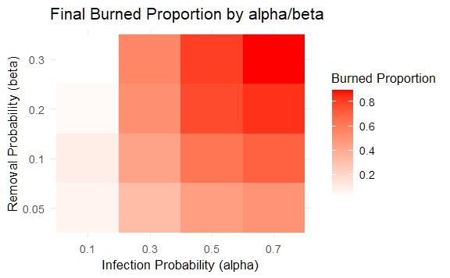

Ember Factor on Fire Spread
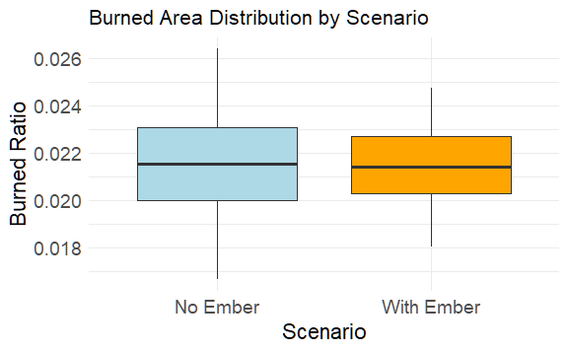
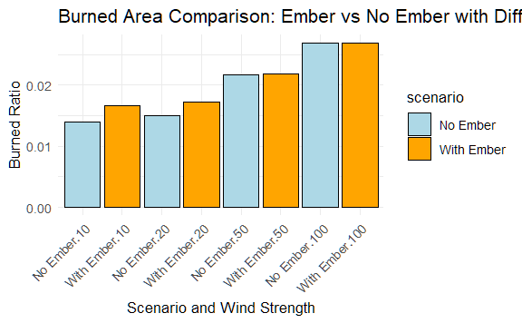

Wind Speed on Fire Spread
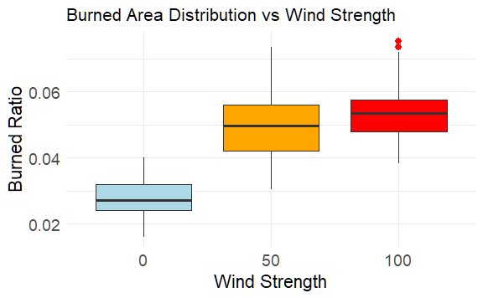

Different α–β Combinations at Various Wind Speeds
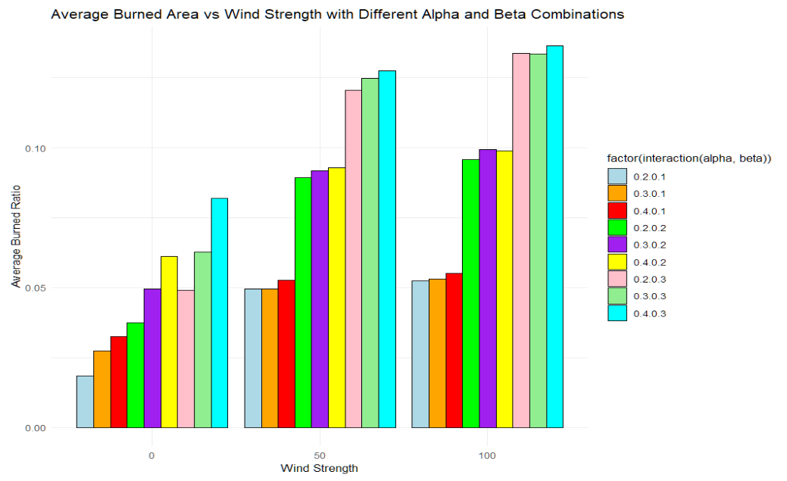

Wind Direction on Fire Spread
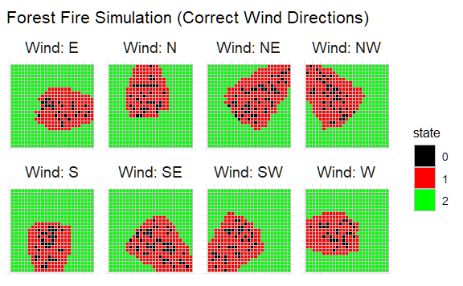
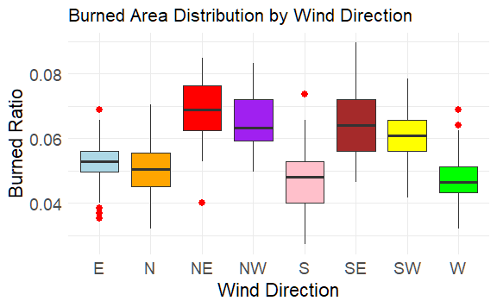

Firefighting Strategies
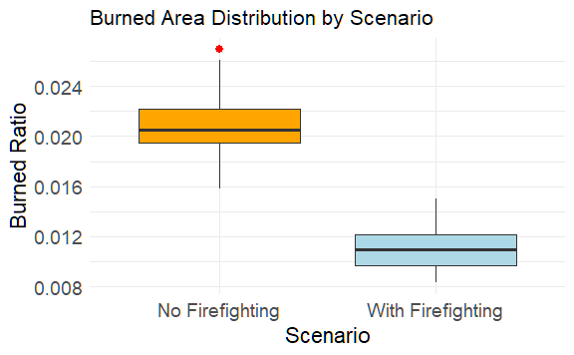

Regression Analysis
- Nonlinear models perform better than linear models in explaining fire spread.
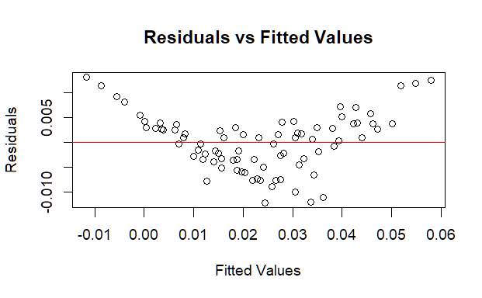
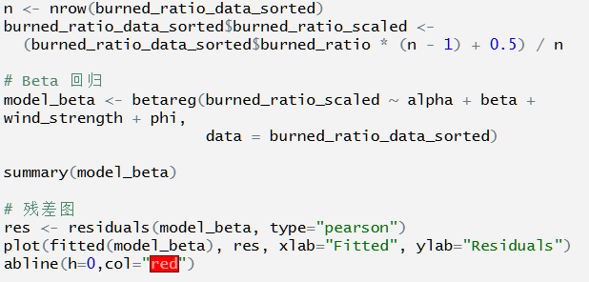
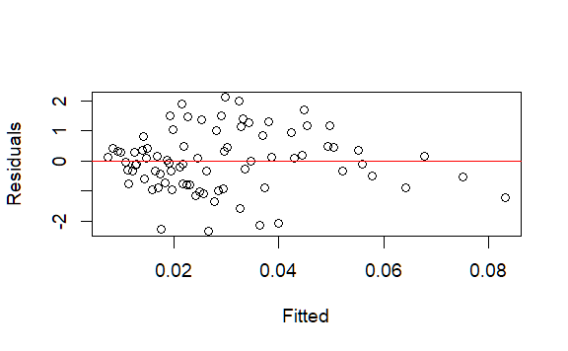
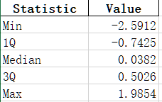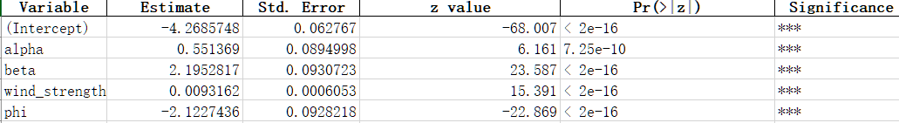

4. Discussion of Findings
- Effectiveness of Firefighting
- Firefighting strongly controls spread of fire and reduces burned ratio suggesting that proactive measures can effectively control fire risk with simulated conditions.
- Relationship Between Wind Speed and Fire Spread
- High wind speed is strong propagator of Fire.
- At high wind speeds spread due to α is less compared to low winds highlight external factors matter more.
- At low Wind speeds α Influences more, Higher it is harder will be spreading due to highly ignitable source.
- Role of α, β
- Higher α Leads higher spreading mostly at lower winds leads because Ignition possibility can further lead spread irrespective of external conditions.
- Higher β Will mostly leads dying out as probabilities increase on self-extinguishing higher the spreading would be higher however it decreases with respect to higher α value.
- Effect of Embers
- Embers may have minor effect but increased effect it leads to increased fire spread at low wind speed condition highlights slower fires can propagate because local ember/fire spot impacts by small or large percentile fueling small fires notably.
- Effect of Wind Direction
- Wind direction indicates the direction in which the fire spreads, but its total burned area effect is small, which indicates that wind direction influences not the size but the shape of the fire. Note that terrain effects were not considered in simulation, and in an actual situation, terrain may cause a significant change in how wind direction effects are altered.
From the results of β regression analysis, we can see that linear models are statistically inferior to non-linear models in terms of fit, and α, β, and wind speed and Firefighting Probability are also the statistically significant effect at least at 95% confidence level for Burned Ratio.

5. Conclusion and Recommendations
1. Conclusion
- The fire management policy significantly affects fire spread and size. The model clearly shows that proactive attitudes can be quite effective in controlling a fire.
- Wind speed is an important factor in determining rate of propagation of fire. For very strong winds, fires can become uncontrollable if appropriate countermeasures are not taken while at low winds fire source ignition probability (α) has much impact on the burned ratio.
- The effect of ember factor slightly increases the spread of fire under low winds condition even though it showed only marginal improvement on total burned area.
- Wind direction mainly affects on spread direction of the fire and does not have much impact on total burned area.
- Based on β Regression analysis significant impacts of factors were statistically proved on Burned Ratio and this relation is better fitted by non-linear models than linear models.
2. Recommendations
- For actual firefighting scheduling it is the highest priority to determine whether a very high wind condition will develop because under very high wind conditions fire control measure won’t work effectively.
- High α values areas should be monitored carefully even under low wind condition. Countermeasures should be focused especially on low winds when high α exists.
- For ember factor also, even though overall effect is not so great, attention should be put on monitoring ember at low wind conditions to prevent further spread of fires.
- Monitoring Wind direction information can be used to predict in which direction a fire will move which can help us to effectively allocate resources for prevention and countermeasures.
- Balance between simulation and regression analysis provided quantitative baseline information for safety and can be used for evaluating expected risk that may develop from real fires and similar simulation models are highly recommended for future use of firefighting management planning purposes.

