Pin-out ESP32 WROOM



Pinout of ERC32 (not the module pinout)

|  |  |  |  |
| --- | --- | --- | --- |
| **Name** | **No.** | **Type** | **Function** |
| GND | 1 | P | Ground |
| 3V3 | 2 | P | Power supply |
| EN | 3 | I | Module-enable signal. Active high. |
| SENSOR_VP | 4 | I | GPIO36, ADC1_CH0, RTC_GPIO0 |
| SENSOR_VN | 5 | I | GPIO39, ADC1_CH3, RTC_GPIO3 |
| IO34 | 6 | I | GPIO34, ADC1_CH6, RTC_GPIO4 |
| IO35 | 7 | I | GPIO35, ADC1_CH7, RTC_GPIO5 |
| IO32 | 8 | I/O | GPIO32, XTAL_32K_P (32.768 kHz crystal oscillator input), ADC1_CH4, TOUCH9, RTC_GPIO9 |
| IO33 | 9 | I/O | GPIO33, XTAL_32K_N (32.768 kHz crystal oscillator output), ADC1_CH5, TOUCH8, RTC_GPIO8 |
| IO25 | 10 | I/O | GPIO25, DAC_1, ADC2_CH8, RTC_GPIO6, EMAC_RXD0 |
| IO26 | 11 | I/O | GPIO26, DAC_2, ADC2_CH9, RTC_GPIO7, EMAC_RXD1 |
| IO27 | 12 | I/O | GPIO27, ADC2_CH7, TOUCH7, RTC_GPIO17, EMAC_RX_DV |
| IO14 | 13 | I/O | GPIO14, ADC2_CH6, TOUCH6, RTC_GPIO16, MTMS, HSPICLK, HS2_CLK, SD_CLK, EMAC_TXD2 |
| IO12 | 14 | I/O | GPIO12, ADC2_CH5, TOUCH5, RTC_GPIO15, MTDI, HSPIQ, HS2_DATA2, SD_DATA2, EMAC_TXD3 |
| GND | 15 | P | Ground |
| IO13 | 16 | I/O | GPIO13, ADC2_CH4, TOUCH4, RTC_GPIO14, MTCK, HSPID, HS2_DATA3, SD_DATA3, EMAC_RX_ER |
| SHD/SD2* | 17 | I/O | GPIO9, SD_DATA2, SPIHD, HS1_DATA2, U1RXD |
| SWP/SD3* | 18 | I/O | GPIO10, SD_DATA3, SPIWP, HS1_DATA3, U1TXD |
| SCS/CMD* | 19 | I/O | GPIO11, SD_CMD, SPICS0, HS1_CMD, U1RTS |
| SCK/CLK* | 20 | I/O | GPIO6, SD_CLK, SPICLK, HS1_CLK, U1CTS |
| SDO/SD0* | 21 | I/O | GPIO7, SD_DATA0, SPIQ, HS1_DATA0, U2RTS |
| SDI/SD1* | 22 | I/O | GPIO8, SD_DATA1, SPID, HS1_DATA1, U2CTS |
| IO15 | 23 | I/O | GPIO15, ADC2_CH3, TOUCH3, MTDO, HSPICS0, RTC_GPIO13, HS2_CMD, SD_CMD, EMAC_RXD3 |
| IO2 | 24 | I/O | GPIO2, ADC2_CH2, TOUCH2, RTC_GPIO12, HSPIWP, HS2_DATA0, SD_DATA0 |
| IO0 | 25 | I/O | GPIO0, ADC2_CH1, TOUCH1, RTC_GPIO11, CLK_OUT1, EMAC_TX_CLK |
| IO4 | 26 | I/O | GPIO4, ADC2_CH0, TOUCH0, RTC_GPIO10, HSPIHD, HS2_DATA1, SD_DATA1, EMAC_TX_ER |
| IO16 | 27 | I/O | GPIO16, HS1_DATA4, U2RXD, EMAC_CLK_OUT |
| IO17 | 28 | I/O | GPIO17, HS1_DATA5, U2TXD, EMAC_CLK_OUT_180 |
| IO5 | 29 | I/O | GPIO5, VSPICS0, HS1_DATA6, EMAC_RX_CLK |
| IO18 | 30 | I/O | GPIO18, VSPICLK, HS1_DATA7 |
| IO19 | 31 | I/O | GPIO19, VSPIQ, U0CTS, EMAC_TXD0 |
| NC | 32 | - | - |
| IO21 | 33 | I/O | GPIO21, VSPIHD, EMAC_TX_EN |
| RXD0 | 34 | I/O | GPIO3, U0RXD, CLK_OUT2 |
| TXD0 | 35 | I/O | GPIO1, U0TXD, CLK_OUT3, EMAC_RXD2 |
| IO22 | 36 | I/O | GPIO22, VSPIWP, U0RTS, EMAC_TXD1 |
| IO23 | 37 | I/O | GPIO23, VSPID, HS1_STROBE |
| GND | 38 | P | Ground |

Choix pin I/O

|  |  |  |
| --- | --- | --- |
| **Fonction HW** | **PIN** | **Rational** |
| Pump relay command | GPIO12 | High level at boot |
| Temp sensor DS18B20 communication | GPIO14 | Fully available |

Note: pullup resistor 4,7 kohm required on temp. sensor data line.

Test HW interfaces

* Temperature sensor DS18B20 : OK on 30/10/2021
* Relay board : OK on 31/10/2021

State variable list

* Current pump management mode
  + Summer 🡺 filtration time = mean water temp. / 2 / day
  + Mid-season 🡺 filtration time = mean water temp. / 3 / day
  + Winter 🡺 filtration time = 2h / day
* Last DS save time
* Last pump 28 ON/OFF pump event time (covers one week)
* Cumulated pump ON time between oldest and nearest event
* TTS: Temperature threshold between Summer and mid-season automatic switch: default 27°C
* TTW: Temperature threshold between Winter and mid-season automatic switch: default 12°C
* TTHP: Temperature threshold for heat pump activation: default 27.5 °C

Web server information

* Current date and time
* Current water temperature
* Water temperature variation during last hour and during last 24h
* Current pump management mode
* Current pump state: ON or OFF
* Time and type of next pump event: ON or OFF
* Mean pump activation time per day

Web data management

* Change temperature thresholds
* Reset state variables
* Force pump OFF or ON (nominal state will be restored at next scheduled pump event)
* Force pump management mode (nominal state will be restored at next scheduled mode change)

Automatic pump mode management

* Spring mode above TTS temperature
* Winter mode below TTW temperature
* Change mode only when the last 8 temperature measurements satisfy the required criteria (i.e. 2 hours)

Pump management

* Activation time as defined above
* 2 activation window per day with 2 start times: 5h and 18h
* The morning activation is required for the pool heat pump
* The pump activation is shared within the 2 windows
* At each start time, the pump activation requirement is computed, based on water temperature and the pump is activated
* Each 15 mn, the pump activity time, if ON, is incremented and compared to the current requirement for the on-going window
* The pump is halted if functioning time is reached
* At 18h00, the same process is run excepted the computation
* If mode = "Spring"  
  and  
   if temperature < PAC threshold,  
  and if pump is not activated  
  then pump is activated (for heat pump activation)

Fixation circuits

Cadre support en PLA  
Avec pieds de surélévation  
Carte ESP fixée par en dessous et composant dessous  
Carte relais fixée au dessus avec composants dessus.

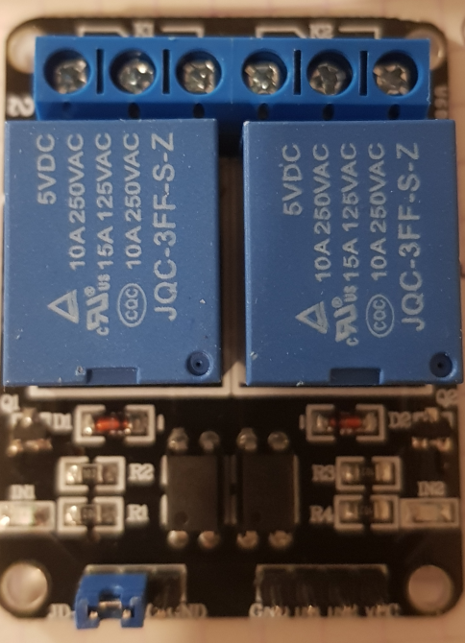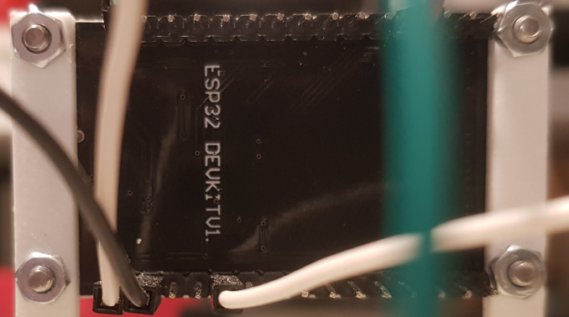

**Bloc alim 5.2V**

**Connecteur micro USB**

**Antenne WiFi**

**Bornier sonde de température**

**Carte interconnexion**

**Schematic**

Final hardware implementation

