sy

**PRONOY**

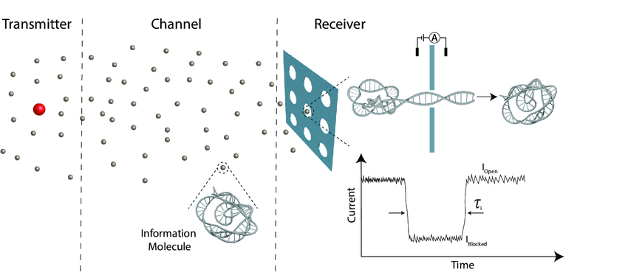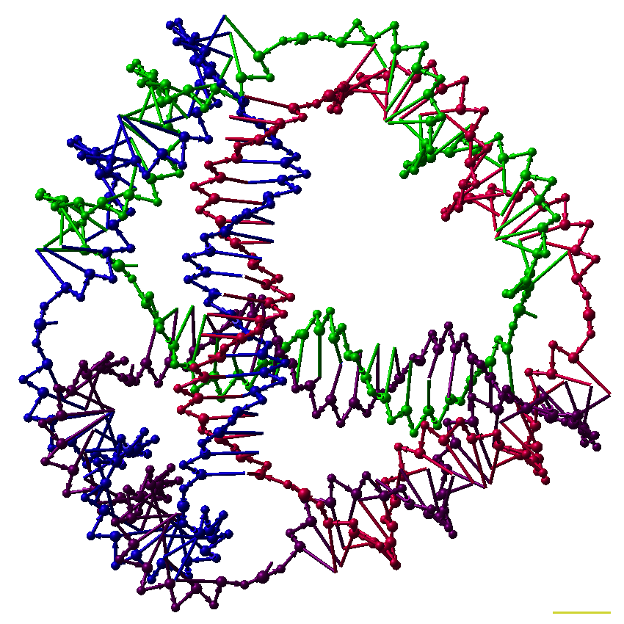

**4. System Model and Proposed Scheme**

* **Synchronization**
* **Simultaneous drug delivery**

**3. Solution**

**A Potential application of MC**

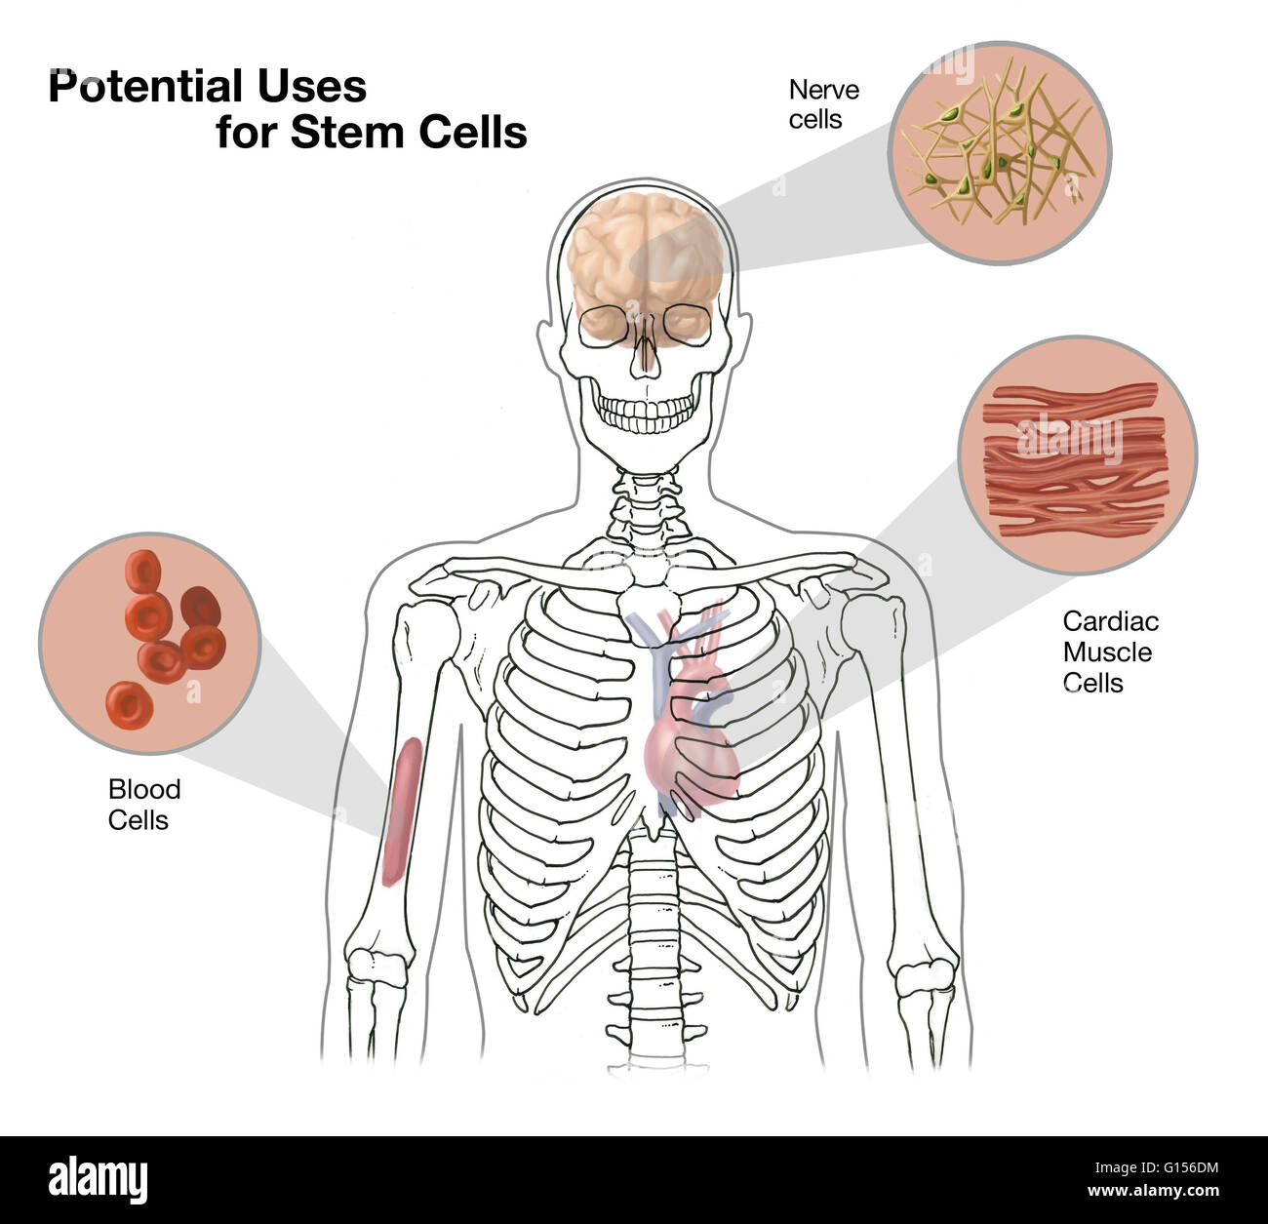

* **Simultaneous drug delivery .**

1. How to perform synchronization?
2. When to release the drug molecules?

* **Acritical requirement inTDD**

2.Problem Statement

**Molecular Communication(MC)**



1. Introduction

Synchronization among Multiple Nanomachines for Simultaneous Targeted Drug delivery